EXTENDED HAMMER CHART
E. R. Crain, P. Eng. and David Pratt
Digital Technology Pty. Ltd.
Published as Digitechnical Bulletin #5, July 1972

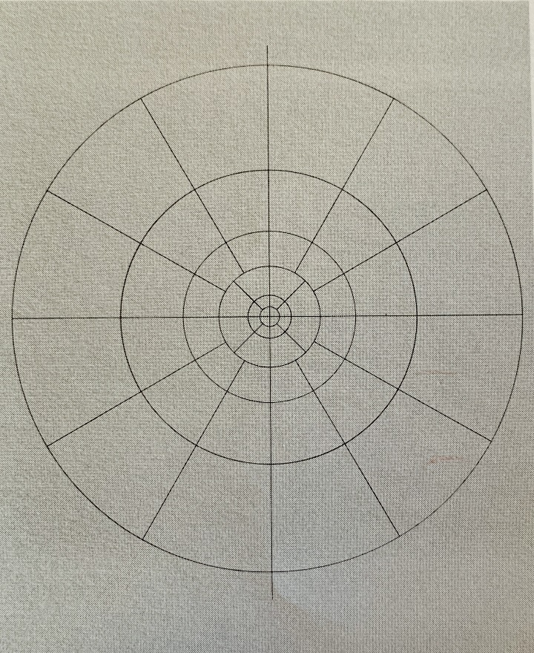
INTRODUCTION
Previously published Hammer Charts for computation of terrain corrections for gravity data have been limited in their range of elevations, T-values, and radii. We have developed a program to compute extended tables of the standard form to any value of T and to any radius. The attached chart is representative of the results computed to a T value of 100 (where possible).
Author’s Note:
A large scale image (3900x1800px) of the sample Extended Hammer Chart is available for download.

Figure 1: Schematic diagram of elevation cylinders for terrain corrections using Hammer’s method

THEORY
The formula used for the computation is from the paper “Terrain Corrections for Gravimeter Stations” by Sigmund Hammer, Geophysics Vol IV, No. 3 (1939) pp 184 – 194; Hammer’s equation is as follows:
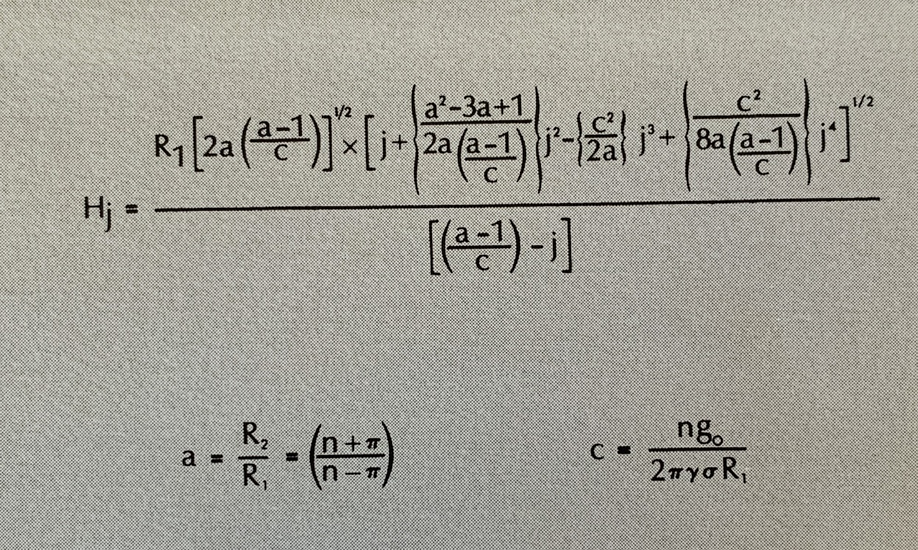
Figure 2: Extended Hammer Equation

Where:
Hj = height of cylindrical segment of one compartment which produces a gravity effect j.g₀
R₁ = inner radius of zone
R₂ = outer radius of zone
a = ratio of outer to inner radius
n = number of compartments in the zone
g₀ = 10^{.5} gals.
y = 6.670 x 10^{.8} dyne cm2 / gm2
j = any positive number
rho = rock density (2.00 gm/cc assumed)

This formula is exact and not the first few terms of a series expansion.

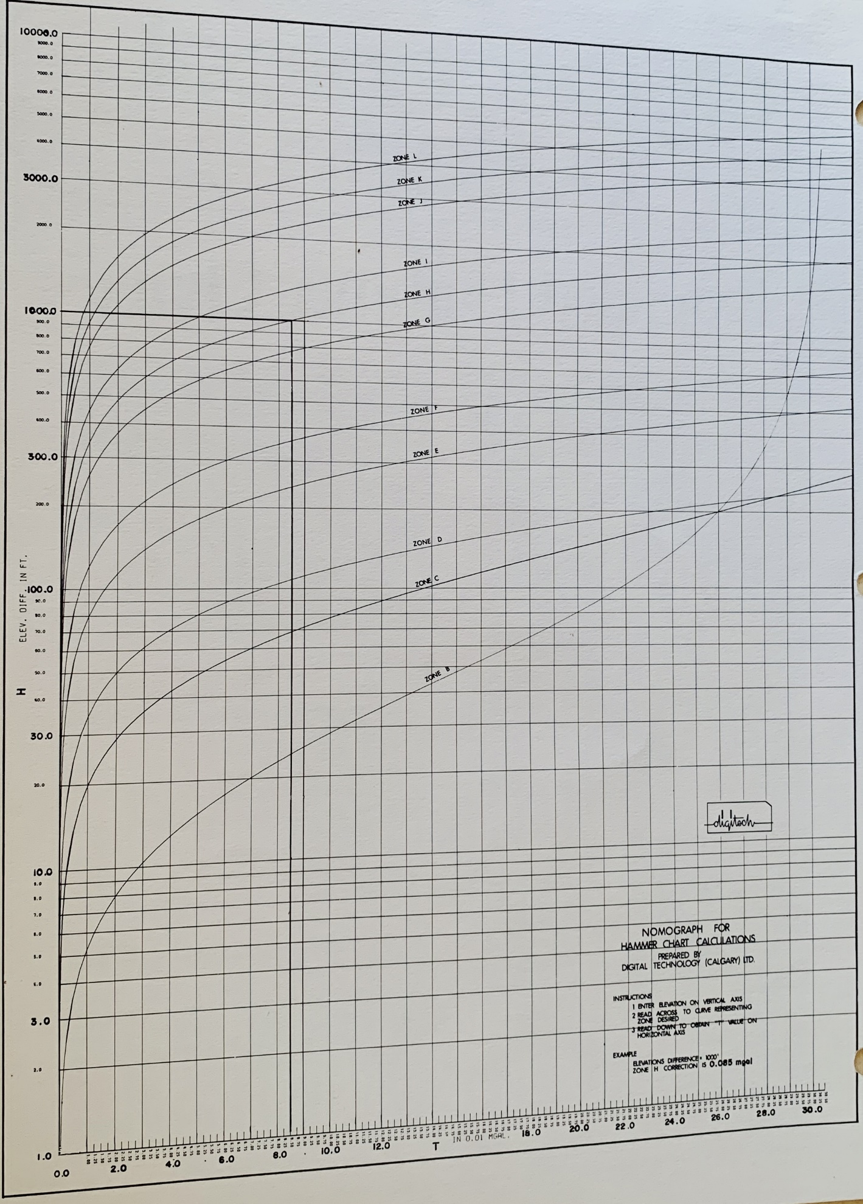
Figure 3: Nomograph for Hammer Chart Calculations

