UNICORNS IN THE GARDEN OF GOOD AND EVIL
PART 10 – GAS HYDRATE RESERVOIRS
E. R. (Ross) Crain, P.Eng.
Spectrum 2000 Mindware Ltd
Published in CSPG Reservoir Sept 2011
Unicorns are beautiful, mythical beasts, much sought after by us mere mortals. The same is true for petrophysical models for unconventional reservoirs. This is the tenth in a series of review articles outlining the simple beauty of some practical methods for log analysis of the unusual.
Permafrost Basics
Permafrost exists in cold climates on land. Gas hydrates are found in or below permafrost and under deep water coastal regions. They cause difficulties when drilling to deeper targets. Gas hydrates are reported to be a huge source of natural gas, although the technically producible quantity is much smaller.
Gas hydrate production was reported by the Russians in 1970 at a rate of more than 10 mmcf/d in Siberia. It was called "solid gas" at the time Canadian exploration wells encountered them in the early 1970's and also reported some of the difficulties in drilling and testing such intervals.
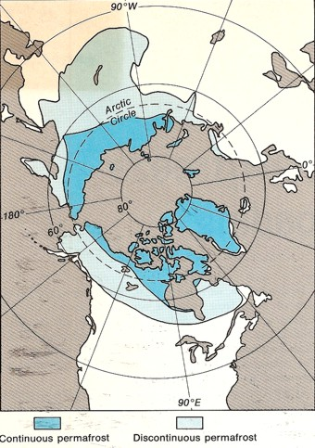
View from the North Pole showing areas of continuous (blue) and discontinuous permafrost
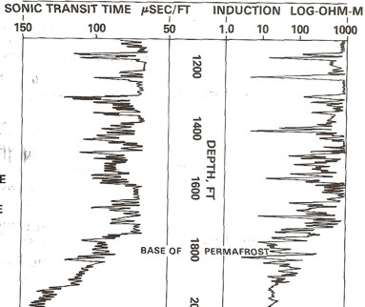
Figure 1: Long spaced sonic log (left) and deep resistivity log (right) are used to identify the base of frozen rocks, around 1800 feet in this example, based on reduction in resistivity and increase in sonic travel time. Frozen rock may contain water-ice (permafrost) or gas hydrates (solid gas) or both.
Permafrost is defined as soil or rock that is permanently frozen in all seasons for more than two consecutive years. Permafrost covers much of the northern latitudes above 60 degrees and most of Antarctica.
Water in pore space freezes when the temperature of the rock is below zero degrees Celsius (32 degrees F), A phenomenon called freezing point depression (FPD) causes the actual freezing temperature to be somewhat lower than 0’C. FPD is a function of pressure, salinity, and pore size, and is usually about minus 1 to minus 2 degrees Celsius in clean coarse grained sandstones. It can be as much as minus 8’C in very fine grained silts and shales.
Clay bound water in shale does not freeze, so shale properties change only slightly, depending on the amount of free water in the effective porosity of the shale. Silty shales have more porosity than pure shale and are more strongly affected by freezing.
Studies designed to locate the base of permafrost were sponsored by the Geological Survey of Canada in the 1960's, 1970's, and again in the early 1980's as more log data became available. Permanent temperature recording systems using thermistors equally spaced along a cable were installed in numerous observation wells throughout the Arctic. These surveys form the basis for static temperature data that is still relied upon today.
Freezing alters the physical properties of the composite rock. Ice has a very high resistivity and high acoustic velocity compared to water, thus resistivity and acoustic travel time logs are changed significantly (Figure 1). Many other physical properties are much less affected.
In a sandstone interval, the base of permafrost is easy to pick on the resistivity log. In shales, it is much more difficult. The base of permafrost is often picked at the base of a frozen sandstone; this depth is called the base of ice-bearing permafrost (IBPF).
The depth to the base of permafrost varies considerably by location and may reach 1500 meters or more. The base of permafrost is often assumed to be the depth below which the formation temperature exceeds zero degrees Celsius. However freezing point depression can cause confusion since some rocks remain unfrozen well below zero Celsius. Gas hydrates remain frozen well above zero Celsius, so "base of permafrost" is a bit of a moving target.
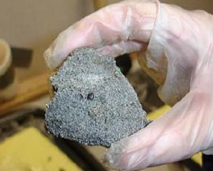
Gas Hydrate Basics
Gas hydrates, also called clathrates, are mechanical mixtures of natural gas and water, forming a crystalline solid in cold environments. These mixtures are called "inclusion compounds". The water molecules surround the gas molecules to form "cages" that trap the gas into the crystals. There is no chemical bond between the water and the gas, so the crystal is not a chemical compound (Figure 2 and 3).
Figure 2: Macro photo of a gas hydrate sample from a core (USGS image)
Gas hydrates are often found in or below permafrost zones on land, or in deep water along continental margins. They can extend below the base of permafrost, even though formation temperature is above 0 C. Hydrates have been discovered or inferred along the coastlines of all continents, even at temperate latitudes, and in deep water trenches in the Pacific.
The quantity of gas in a hydrate does not depend on the depth, pressure, or temperature of the reservoir, as is normally the case for natural gas. Hydrates can contain far more gas at shallow depths than a conventional reservoir at the same depth. This can result in unexpectedly high pressure in the wellbore as the hydrate thaws, with all the dangers of blowouts and damaged equipment that this suggests.
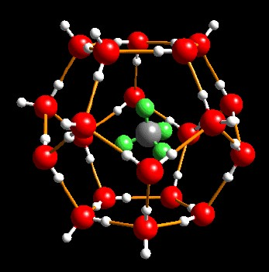
Figure 3: Gas hydrate crystal with water molecules (red)
trapping methane molecules (grey) (USGS image)
The various phases of water, water-ice, hydrates. and free gas are determined by a phase diagram, which depends on the specific gravity of the gas, salinity of the water, temperature, and pressure. The latter two factors are functions of depth, so the phase diagrams are often plotted versus depth, using assumed pressure and temperature gradients. Schematic examples are shown in Figures 4 through 6.
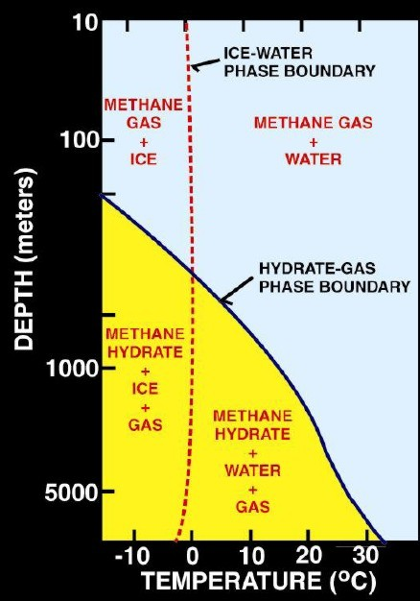 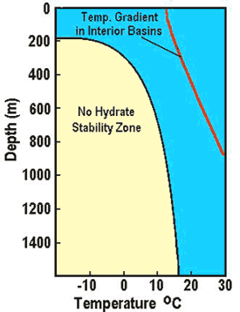
Figure 4a (Left): Schematic phase diagram for water, water-ice, gas hydrates. and free gas.
Figure 4b ( Right): Phase diagram with temperature log, showing a situation where temperature is too high to permit hydrate formation. (USGS images)
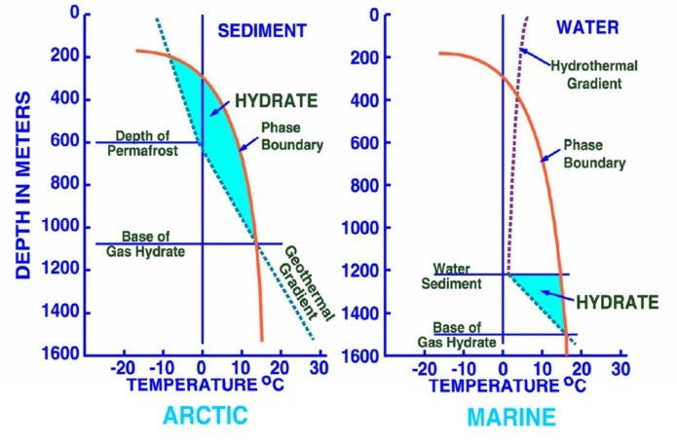
Figure 5a (Left): Phase diagram for on-shore situation where temperature is low enough to permit hydrate formation (blue shading), Figure 5b (Right): Deep water off-shore has distinctly different temperature profile, so hydrates can form near seafloor in very recent sediments (blue shaded area). Higher specific gravity and higher salinity will move the hydrate phase boundary (red line) to the right, increasing the depth at which hydrates may form. (USGS image)
An increase in temperature increases the pressure required to form hydrates, while small percentages of ethane or propane lower the hydrating pressure considerably. Hydrogen sulfide and carbon dioxide also decrease the required pressure.
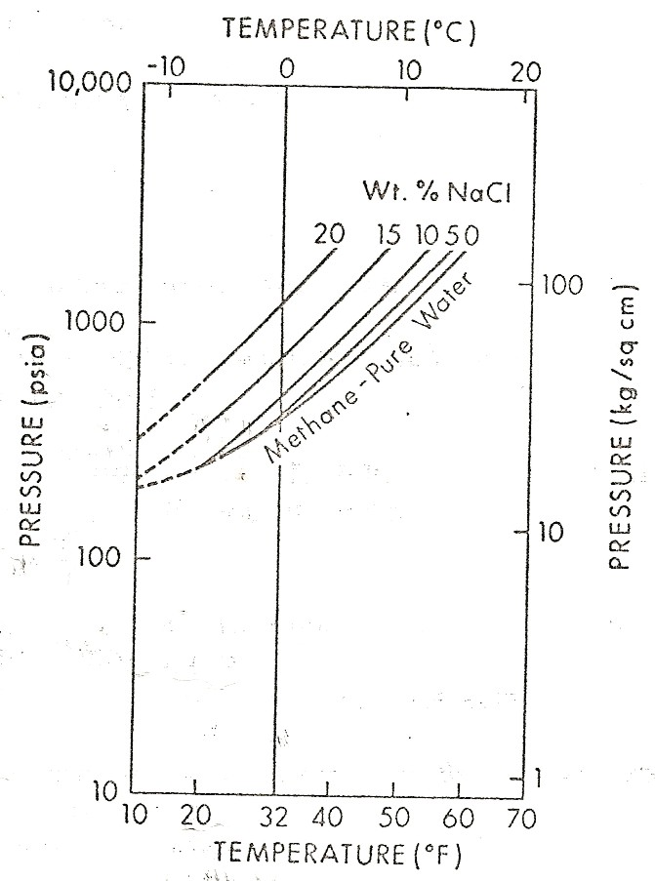 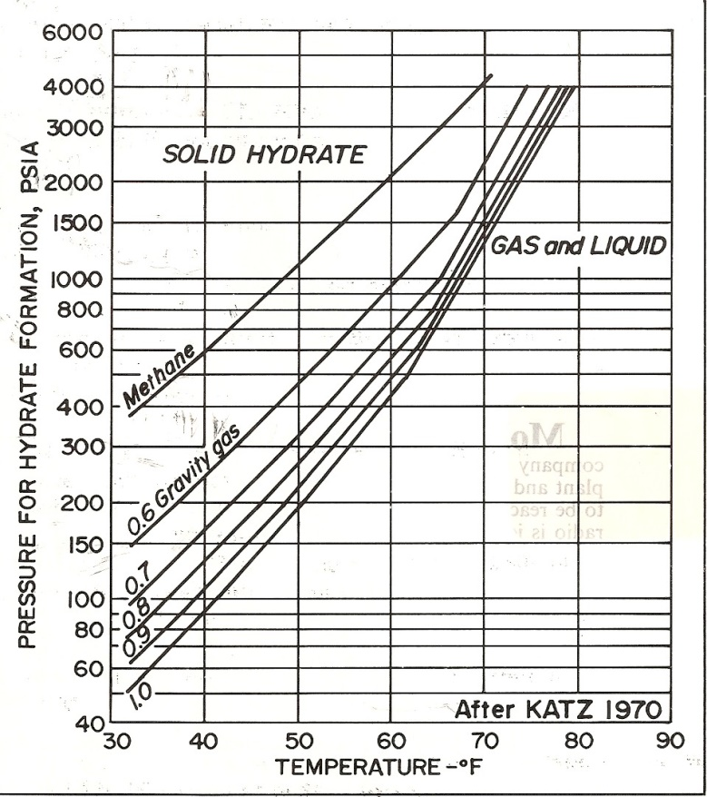
Figure 6a (Left): Graph showing effect of salinity on hydrate phase.
Figure 6b (Right): Effect of gas specific gravity on hydrate phase.
(source: Natural Gas Engineering Handbook, D.Katz, 1959)
Drilling And Production Hazards In Gas Hydrates
Drilling into permafrost and gas hydrates, or to deeper targets below them, is fraught with problems. Thawing of permafrost in otherwise unconsolidated sediments will generally mean a large, washed-out borehole, with poor logs. Drilling with a chilled mud system has been attempted, but this has its own hazards - if NaCl or CaCl2 are used to prevent freezing of the mud, it may still freeze if borehole temperature falls outside the liquid phase diagram for the mixture (Figure 7).
Thawing of gas hydrates generates gas at pressures well above those expected at these shallow depths. It may be impossible to raise mud weight sufficiently to prevent a blowout, so chilled mud and a quick casing job are indicated. If a well is cased and cemented, that gas pressure may cause wormholes in the cement, leading to a permanent leak to surface as long as borehole temperature is higher than the hydrate stabilization temperature. High quality cement jobs in large, cold boreholes are notoriously difficult.
Continued thawing may cause casing collapse or rock subsidence, with loss of wellbore integrity. Successive thaw-freeze cycles aggravate these conditions and may cause vertical expansion of the rocks during refreezing.
The typical production scheme proposed for gas hydrate wells is by depressurization or heating (Figure 8). During production, wellhead control is difficult due to the high pressure and cold temperatures. Hydrates may reform in the plumbing. Produced water must be lifted and disposed of before it refreezes. Thawing allows fines migration which annoys pumping and compression equipment. Some experimental production methods involve the addition of heat or methanol to release the gas. Heat may affect non-gas bearing intervals in the permafrost, leading to casing collapse or movement.
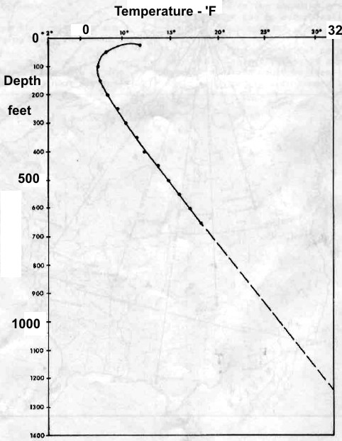 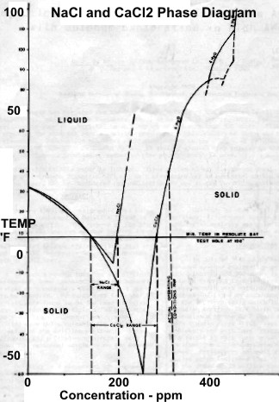
Figure 7a (Left): Permanent temperature survey in observation well #20 at Resolute Bay, Nunavut showing base of permafrost at about 1200 feet at 32 F.
Figure 7b (Right): Phase diagram for NaCl and CaCL2 showing salt concentration "window" for the coldest wellbore temperature at Resolute Bay (and similar latitudes). Getting stuck in the hole with oversaturated salt mud is really embarrassing. (Source: Marshall and Crain, AIME, 1970)
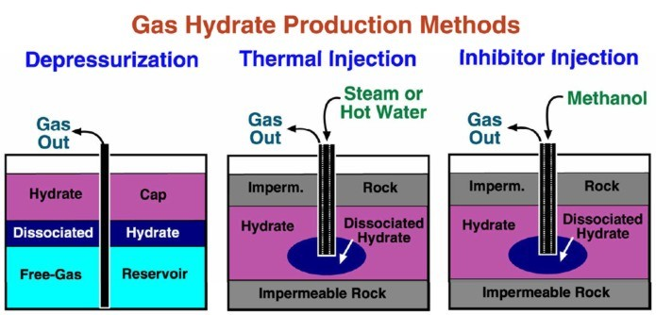
Figure 8: Proposed methods for gas hydrate production. (USGS image)
Deepwater offshore hydrate production has its own issues, and although a huge resource is postulated, I am not aware of any intentional attempts to produce it. No wonder shale gas is so
popular!

Logging and Log Analysis In Gas Hydrates
The excess hydrogen in gas hydrates compared to water or water ice should make neutron logs read too high. The lower density of ice and hydrate (900 Kg/m3 versus 1000 Kg/m3) makes the density porosity read too high also. However, thawing near the borehole will reduce this effect and it is seldom seen. Instead the zone often looks like a normal water-invaded gas sand. If thawing is deep enough, gas crossover could occur.
Short spaced sonic logs reading the thawed zone can be used to calculate porosity, but compaction and gas corrections will be required. Long spaced sonic logs reading the frozen zone are difficult to analyze for porosity due to an unknown amount of excess (unfrozen) water along with the ice or hydrate
Freezing of water causes salt rejection, leaving some excess unfrozen water with moderately high salinity. Higher salinity water tends to increase the SP deflection but the higher resistivity of the ice tends to reduce SP deflection. The net result is low SP deflection in frozen intervals. SP in the unfrozen intervals behaves normally.
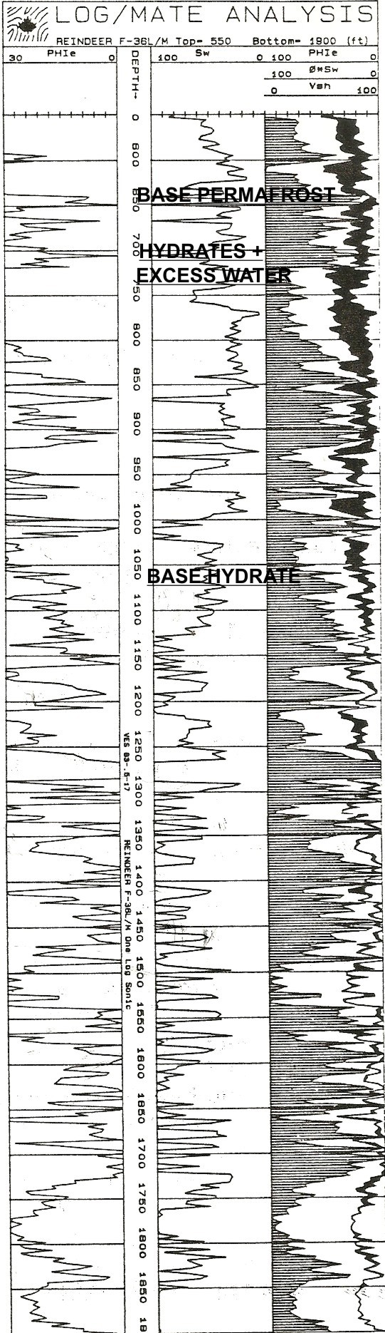
Figure 9: Quantitative log analysis of permafrost -
gas hydrate interval in Mackenzie Delta,
run in 1983 using standard porosity and
Archie saturation models. See
explanation below
Resistivity will read high values in both water ice and gas hydrate in sand sequences; shales will show typically low resistivity with moderate gamma ray values.
A long spaced sonic will read the frozen rock velocity (or travel time) but short spaced sonics will see the thawed zone velocity (Figure 12). Many hydrate zones are poorly consolidated, so caliper logs may show large washouts as the rock thaws. In large or rough boreholes, both density and sonic logs may show large spikes or noise.
Neither resistivity nor porosity logs are very helpful in distinguishing gas hydrates from water ice. The best indicator is the gas mud log because large quantities of disassociated gas are released as the hydrate is thawed. No significant gas is released from water ice. Free gas and even oil are also possible and gas mud logs will show less than in a hydrate zone.
Quantitative log analysis is complicated by the inability of standard models to differentiate between water-ice and gas hydrates. Free gas and gas hydrate (if thawed deeply enough) can be distinguished by gas crossover in cleaner sands.
By treating ice and hydrates as if they were hydrocarbons, standard porosity and Archie-type saturation models can give an estimate of ice plus hydrate content (black shading in Track 3, Figure 9) and free water (white shading). In this model:
1: Shydr = 1 - Sw provided zone is hydrate bearing and not water-ice.
Standard deterministic or probabilistic multi-mineral models using quartz, clay, ice (water-ice or hydrates) and free water will also work. In these models:
2: PHIe = Vice + Vwtr
3: Shydr = Vice / PHie provided the zone is hydrate bearing and not water-ice.
If a nuclear magnetic resonance log is run, the effective porosity from this log is the water filled porosity. Ice and hydrates are not seen. Thus:
4: PHInmr = BVI + BVM
5: SWnmr = PHInmr / PHIe
6: Shydr = 1 – SWnmr
Where:
BVI = bulk volume irreducible from NMR (fractional)
BVM = bulk volume moveable from NMR (fractional)
PHIe = effective porosity from conventional logs (fractional)
PHInmr = effective porosity from NMR (fractional)
Shydr = hydrate saturation (fractional)
Sw = water saturation (fractional)
Vice = volume of ice or hydrate (fractional)
Vwtr = volume of water (fractional)
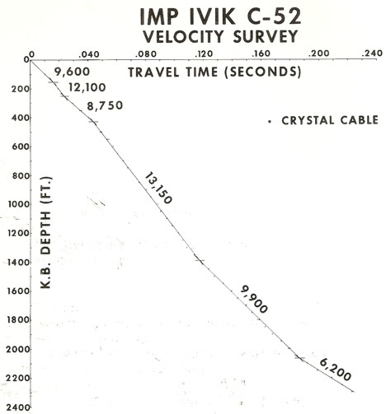
The base of permafrost is chosen by a nearby permanent temperature log (around 1110 feet in this example). Black shading below this depth is gas hydrate and there may be gas hydrates in the permafrost zone. Since salt rejection increases water salinity in the excess water, the water resistivity is unknown and variable, so the quantities of ice, hydrate, and excess water are not very accurate. The mud gas log is vital.
Figure 10: Crystal cable survey time vs depth plot with interpreted velocity values. Base of permafrost could be as shallow as 1400 feet or as deep as 2000 feet.
In older wells, the sonic log was often very noisy and seismic reference surveys were used to determine acoustic velocity. The beginning of low velocity would indicate the base of permafrost or base of gas hydrates, or shales.
These surveys were superseded by crystal cable surveys (Figures 10 and 11), the forerunner of the vertical seismic profile, which would be used today for this purpose. VSP's and their predecessors can be run in cased holes provided the shot point is far enough from the wellbore, otherwise the velocity derived from the survey will be that of the casing. A good description of the use of this tool is "Permafrost Investigation by Crystal Cable Surveys, Mackenzie Deltas", I. H. Wallace and A. J. Stuart, CSEG, 1975, from which the following two illustrations were taken.
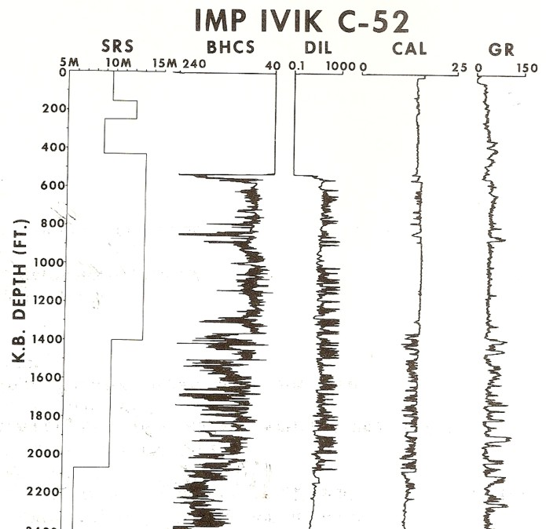
Figure 11: Crystal cable survey vs depth with other log data. Base of permafrost is still unclear due to large, washed-out borehole. Gamma ray needs borehole corrections to make shales stand out better. Sonic is in general agreement with SRS velocities but induction log does not show continuous high resistivity expected for a sand interval, so much of the interval is probably shale or shaly sand. Permafrost base is probably near 2000 feet because there is only low resistivity below this depth.
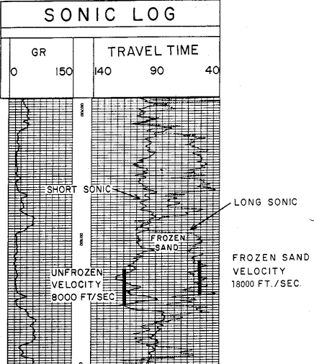
Figure 12: This log clearly illustrates a severe case of rock alteration due to permafrost. In this case, the short spaced sonic sees the thawed zone and the long spaced tool see the frozen zone. Porosity is derived from the short spaced log, with appropriate shale and compaction corrections, but seismic velocity must be taken from the long spaced log.
Gas Hydrate Volume In Place
Empirically, the ratio of water to gas necessary to form a hydrate is as follows:
Excess Hydrogen
1. Methane CH4.6H20 4/12 = 33%
2. Ethane C2H6.8H20 6/16 = 37%
3. Propane C3H8.17H20 8/34 = 23%
The volume of hydrocarbon in a gas hydrate is a function of the hydrocarbon type only. Water saturation is meaningless. The ratio of gas to water would range from 433 scf/bbl for propane to 1230 scf/bbl for methane.
This is equivalent to 170 cubic feet of methane per cubic foot of pore space (or 170 m3 per cubic meter of pore space) at standard temperature and pressure and 60 cubic feet of propane per cubic foot of pore space, regardless of depth of burial.
Convert pore volume to gas volume:
7: PV = SUM (PHIe * THICK)
8: HPV = PV * Shydr * KG0
9: GIPhydr = KV3 * HPV * AREA
Where:
AREA = reservoir area (acres or m2)
HPV = hydrocarbon volume (feet or meters)
PHUe = effective porosity (fractional)
PV = pore volume (feet or meters)
Shydr = hydrate saturation (fractional)
Sw = water saturation (fractional)
GIPhydr = gas in place as hydrates (mcf or m3)
KV3 = 43.56 for English units
KV3 = 1 for Metric units
KG0 =164 for methane
KG0 = 60 for propane
NUMERICAL EXAMPLE:
1. Assume the following data:
PHIe = 0.35
Sw = 0.20
Hydrate is methane
THICK = 300 feet
KV3 = 43.56
KG0 = 164 scf/scf
AREA = 640 acres
HPV = 0.35 * 300 * (1 - 0.20) * 164 = 13776 ft
GHIP = 43.56 * 13776 * 640 / 1 000 000 = 384 Bcf/section
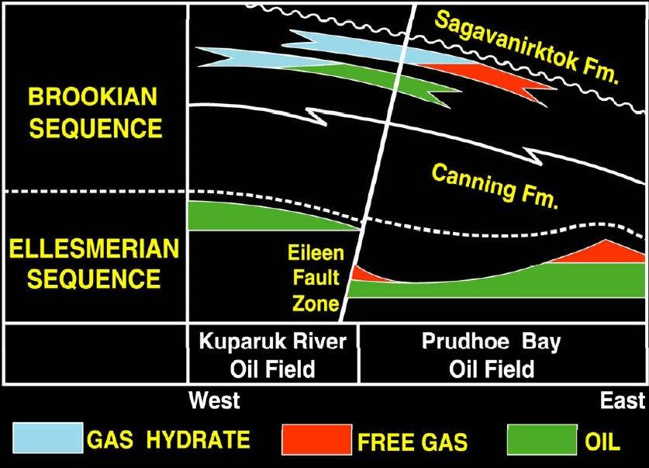
Figure 13: Gas hydrate, free gas, and oil distribution Eileen area, North Slope, Alaska. (USGS image)

Gas Hydrates Example
The original Mallik L-38 well in the Mackenzie Delta was drilled in 1972 and discovered a major gas hydrate and free gas interval. The well sits on a large structure and was suspended pending construction of the Mackenzie Valley Pipeline. In 2002, an international joint government, industry, academic consortium (Mallik 2002 Gas Hydrate Production Research Well Program) was formed to investigate alternate methods of producing gas hydrates, using this structure as a test platform. Observation wells were drilled and various production schemes have been tested. A 34 GB data set can be downloaded from the National Research Council (Canada) website as Geological Survey of Canada Bulletin 585.
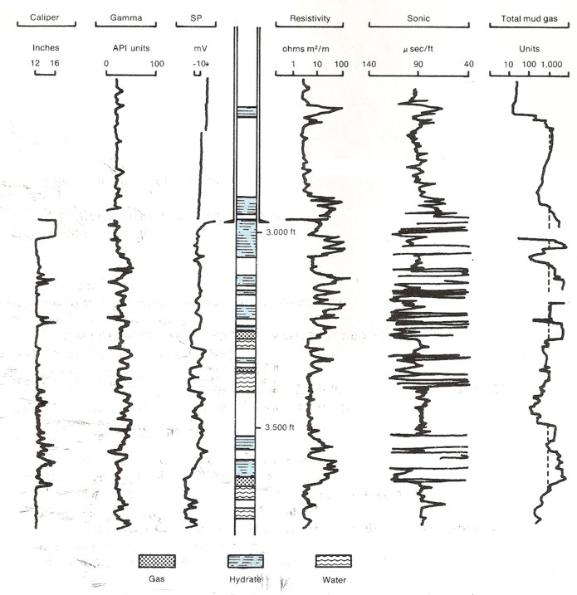
Figure 14: Original wireline logs and gas log for Mallik L-38. Compare location of hydrate zones with log response and gas log showing gas hydrates and free gas below 3000 feet. Permafrost base is around 1900 feet, well above this log segment. (USGS image, redrawn from Bily and Dick, 1974).
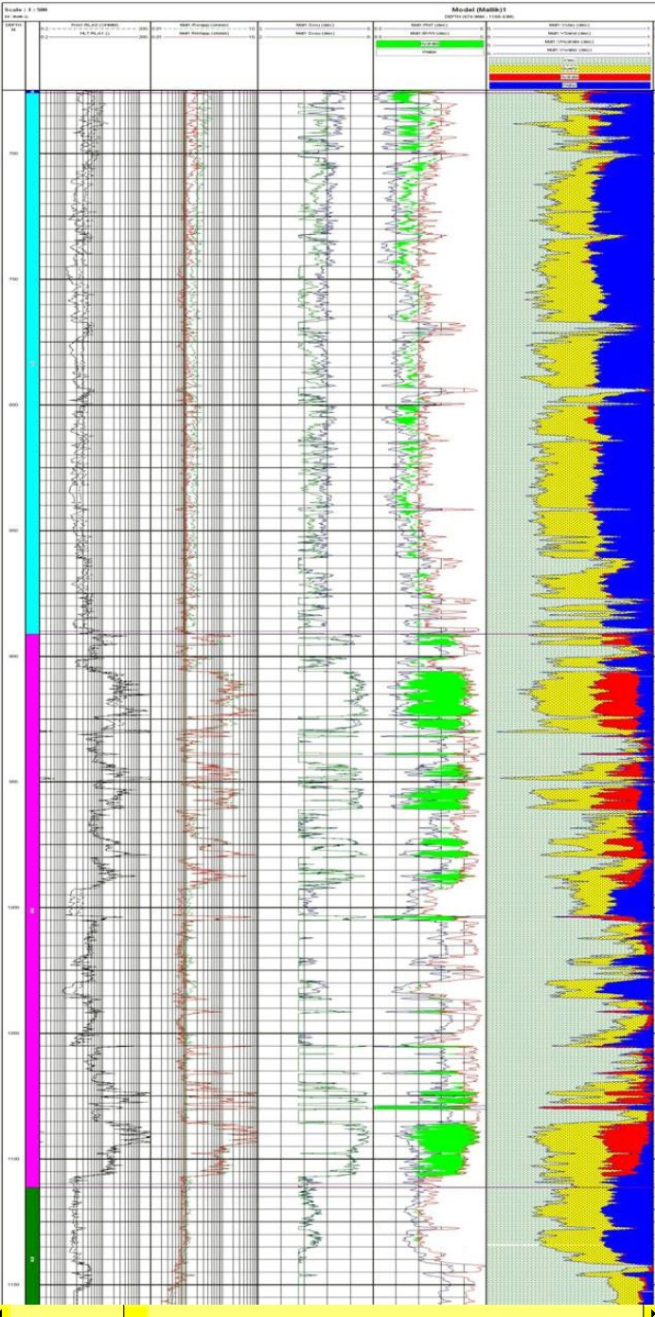
Figure 15: Raw logs and computed results for Mallik 5L-38 drilled in 2002. Logs are (from left to right) array laterolog, array induction, shear and compressional sonic, density and neutron with gas crossover shaded green, computed results with clay, quartz (yellow), hydrate (red), water (blue).
Note depths are in meters and cover approximately the same interval as the Mallik L-38 logs shown above.
This example shows logs from the original 1972 well (Figure 14) and one of the new 2002 wells (Figure 15) for comparison. Numerous other logs, including NMR, C/O, and through casing resistivity have been run. Numerous petrophysical and thaw diameter models have been run, as described in GSC Bulletin 585 (2005) and elsewhere.
Figure 15 is from "FORMATION EVALUATION OF GAS HYDRATE BEARING SEDIMENTS" by Frank Williams, Mike Lovell, Tim Brewer, Christian Buecker, Peter Jackson, Ameena
Camps, SPWLA, 2008.
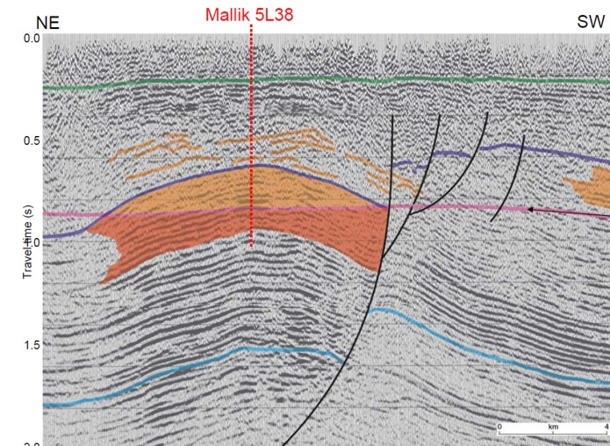
Figure 16: Seismic section on Mallik structure, shaded area shows gas hydrate over free gas. (USGS image)

