PETROPHYSICS IN THE GREEN ECONOMY
PART 6 – LITHIUM: from oilfield and near-surface brines
E.R. Crain, P.Eng.
Published in CSPG Reservoir May – Jun 2023

INTRODUCTION
Lithium is present in oilfield produced water and in moderate to highly saline water zones in sedimentary basins. Well logs cannot identify lithium in oilfield brines (at least not yet) but they do tell us a lot about the water salinity, pore volume filled with that water, and other pertinent information about the reservoir or aquifer. This article describes near surface and deep sources of lithium, how it is extracted from brines, as well as the mining technique which until recently was the major source of the world’s lithium.
Lithium (Li) is a soft, silvery-white alkali metal. Under standard conditions, it is the lightest metal and the least dense solid element. Like all alkali metals, lithium is highly reactive and flammable, and must be stored in vacuum, inert atmosphere, or inert liquid such as purified kerosene or mineral oil.
It never occurs freely in nature, but mostly in ionic compounds, such as pegmatitic minerals (spodumene, and to lesser extent, amblygonite, lepidolite, and petalite), which were once the main source of lithium. Extraction was a classical hard rock mining operation in which the ore was heated, crushed, and leached to obtain stable lithium-rich compounds.
Since about 1990, surface and near-surface brines in lakes, playa deposits, and salt flats have become major sources of lithium compounds.
Soon oilfield produced water, oilfield water zones, and medium temperature geothermal projects will be capturing lithium from these higher salinity water flows.
Lithium and its compounds have many industrial uses including heat-resistant glass and ceramics, lithium grease lubricants, flux additives for iron, steel, and aluminum production, and lithium or lithium-ion batteries. These uses consume more than three-quarters of lithium production (2020) and will continue to increase rapidly as the World’s vehicle fleet is electrified.
Lithium reserves and resources are measured in metric tonnes Li metal equivalent. Hard rock ore grade is reported in percent Li2O, similar to potash ore grade in percent K2O. An average ore grade for a hard rock mine might be 2.4%. In brines, quality is graded in parts per million (ppm or mg/liter) Li+ ions – 500 ppm represents a fairly high concentration in an oilfield brine or a moderate value for a near-surface brine deposit.
USGS and other studies show the lithium resource is available for projected needs, but extraction may lag demand.
Petrophysics, with other geosciences, will play a major role in quantifying reservoir volumes, water quality, and flow capacity that will help to assess the economics of these projects.
LITHIUM EXTRACTION FROM HARD ROCK ORES
Ore from hard rock mining of pegmatic minerals is heated to 1200K and crushed. The minerals are combined with sulphuric acid and sodium carbonate which causes the aluminum and iron to precipitate from the ore. Sodium carbonate is added to the lithium products which causes the lithium to precipitate out in the form of lithium carbonate (Li₂CO₃₎. Hydrochloric acid is added to the Lithium carbonate to form lithium chloride.
LITHIUM EXTRACTION FROM SURFACE BRINES
A large fraction of the world's current lithium is produced by evaporation of brine in ponds. This process is time-consuming but is also inexpensive compared to other methods. The salt-rich waters are pumped from the ground and start to evaporate through solar energy. This process can take several months, up to two years. First, potassium is harvested. Then when the lithium compounds reach a suitable concentration, they are harvested and brought to a plant. Unwanted waste is filtered out, then the concentrate is treated with sodium carbonate, to create lithium carbonate. Finally, the unwanted waste is pumped back into the ground.
Seawater has only 0.2 ppm Li so it is not considered a credible source of economic lithium.
LITHIUM EXTRACTION FROM DEEP BRINES
Lithium from oilfield produced brines (50 – 500+ ppm Li+), co-produced with oil or natural gas, and from deep high salinity oilfield water zones is in its infancy but is much more environmentally friendly than destroying salt flats or pegmatic mountains.
Note that oilfield produced water is sometimes called oilfield wastewater, not to be confused with municipal wastewater, which is a very different thing. Oilfield wastewater is injected back into the reservoir where it came from; municipal wastewater may or may not be treated and is fed into rivers or oceans.
Co-production of lithium with medium temperature geothermal energy projects in sedimentary basins looks very attractive. As in the oilfield case, the water is from deep saline zones and is already being pumped to a disposal well.
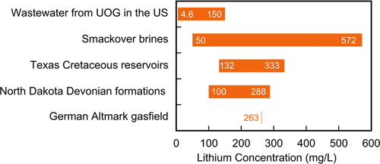
FIGURE 1: Lithium concentration of various produced oilfield brines (Kumar et al 2019)
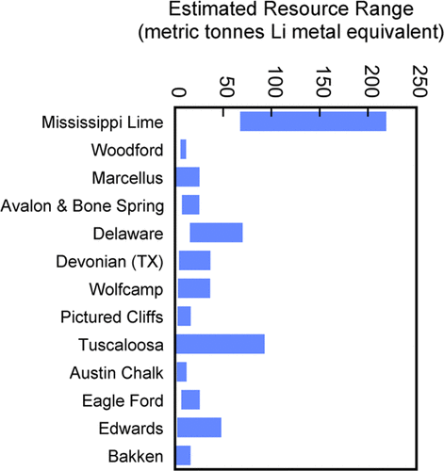
FIGURE 2: Lithium resources of various produced oilfield brines (Kumar et al 2019)
Fox Creek and Valleyview in Canada have 362,000 and 385,000 metric tonnes of Li metal equivalent, respectively, while the Smackover Formation in the U.S. has 750,000 metric tonnes.
Lithium may be extracted from the oilfield produced water and geothermal water flowing to the disposal well using an adsorption, membrane-based process, and electrolysis-based systems. These and other approaches are in the pilot project stage (2022).
Extraction of lithium from oilfield and geothermal brines enables domestic production without relying on South American sources and Chinese refining.
Apparently 100 ppm Li+ can make extra cash, since the water is already being separated and pumped to the disposal site. Repurposing deep wells that have reached end of life as oil or gas wells will need higher concentrations of Li+ to pay out the pumping costs.
Time to drag out all those old water chemistry reports, or to take new water samples from produced water to see what we own.
There will probably be some mineral-rights and regulatory issues to resolve with various agencies and landowners. Further, some innovative approaches are needed to test saline water zones for lithium concentration before a well is prematurely abandoned. Transforming unwanted oil wells into “green energy” sources is very appealing.
REFERENCES
1. Lithium Recovery from Oil and Gas Produced Water
Amit Kumar, Hiroki Fukuda, Alan Hatton, and John H. Lienhard
https://doi.org/10.1021/acsenergylett.9b00779
2. Lithium Technical Data
Various Wikipedia Pages, 2022

