QUANTITATIVE LOG EVALUATION OF THE PRAIRIE EVAPORITE FORMATION IN SASKATCHEWAN
E. R. Crain, P. Eng.
W. B. Anderson, P.Eng.
Schlumberger of Canada
Presented by E.R. Crain at 17th Annual Technical Meeting, The Petroleum Society of C.I.M., Edmonton, May 1966, Published in Journal of Canadian Petroleum Technology, Sept 1966. This electronic version created Jan 2021. Equations updated to computer-ready format. Research was performed in Yorkton and Lanigan SK during the summer of 1964.
** Awarded SOC Salesman of the Year, even though I was never assigned to Sales **

ABSTRACT
The problem of solving for the fraction of sylvite, carnallite, halite and insoluble material in the Prairie Evaporate formation can be performed by a suitable interpretation program based on gamma ray, sonic neutron and caliper logs. Empirical relations were established between the log values and the formation parameters, the result being a set of four simultaneous equations which may be reduced to obtain the desired fractions. Tedious hand calculation can be eliminated by using computer techniques and automatic log digitizing machines. Correlation between core and log analysis is good, and the speed and efficiency of the method is valuable in initial formation studies.
INTRODUCTION
The Prairie Evaporite formation has been the object of extensive study in the past several years (1) (2). It is the richest known potash-bearing bed in the world, and, as such, it is important that any information gathered concerning the zone be accurate and immediately useful.
Electrical and radioactivity well logs have proved to be of value for formation evaluation in the oil industry. A recent paper (3) illustrates their use for both qualitative and quantitative interpretation in evaporite sequences in various parts of North America.
This paper will outline the theory and technique used for a quantitative interpretation procedure in the potash beds of the Prairie Evaporite formation in the Province of Saskatchewan. The data are set up so that they can be handled by an electronic computer. The equations can also be computed by hand at the well site to supplement the data already available.
The computer program is presented as an Appendix. An extensive bibliography, covering potash geology, development and logging techniques is included.
THEORY
It is well known that potassium has a radioactive isotope which emits gamma ray energy. This isotope (K₄₀) comprises a constant fraction of the total amount of potassium, so that a gamma ray log, which measures the amount of natural radioactivity in a formation, frequently gives a measure of the potassium content.
Considerable work was done in 1964 to establish an empirical correlation between gamma ray activity and the K₂O content of a potash bed (3). The graph shown in Figure 1 illustrates the results obtained in oil-base muds. As borehole conditions affect the response of gamma ray logging instruments, hole size and mud weight must be taken into account.
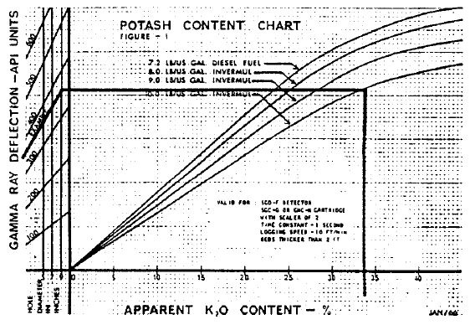
Figure 1: K2O content of potash beds versus gamma ray log response, with hole size and mud weight corrections, derived from log to core assay data correlations.
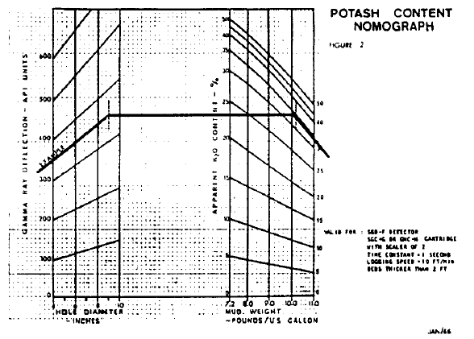
Figure 2: GR vs K2O nomograph, based on Figure 1.
Figure 2 illustrated a nomogram which facilitates conversion of gamma ray activity to apparent K₂O content. It is derived from the graph of Figure 1 and therefore gives the same results. The result is labelled “apparent” K₂O content because the insoluble content of the formation generally is slightly radioactive and the chart thus gives an incorrect K₂O value if insoluble are present. A correction can be applied, which will be dealt with later, but it is small in many cases and will not greatly affect the total K₂O value of a zone. These results are valid only for the logging tools listed on the chart and for beds thicker than 2 feet.
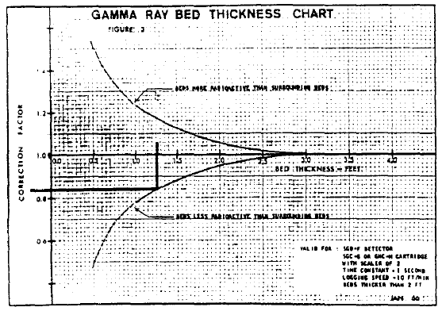
Figure 3: Empirical gamma ray bed thickness correction chart, based on GR vs K2O core assay in thin beds.

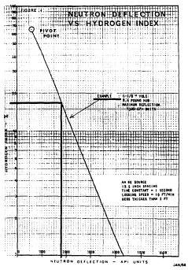
Figure 4: Empirical GNT neutron vs apparent porosity graph
For thin beds (from ½ foot to 3 feet), a correction can be made using the empirical chart shown in Figure 3. The gamma ray reading in API units is multiplied by the correction factor derived from Figure 3 to arrive at the corrected value. For beds less than 1 foot in thickness, the correction becomes quite large and is not accurate. Bed boundaries are chosen at the inflection points of the gamma ray curve and the bed thickness is that distance between any two successive inflection points.
As only those zones which are low in carnallite content are commercially attractive at present, a means of delineating these beds must be employed. The neutron log is an excellent carnallite logging tool, because it responds to the hydrogen content of the formation.
The water of hydration associated with carnallite comprises a large part of its volume, so that a zone rich in carnallite will have a large hydrogen index. The hydrogen index of pure carnallite is 65 percent (4). Sylvite and halite have an index equal to zero, except for a small (1 to 2 percent) volume of occluded water.
Again, the insoluble content of the zone affects this log, and it should be taken into account if it is found to be very large (greater than 5 percent).
An empirical chart similar to Figure 4 can be made for each well to be interpreted to obtain the hydrogen index. A pivot point at 600 API units and a 65 percent hydrogen index defines one end of the straight line (on semi log paper). The Neutron Log value (API units) in a clean salt zone and a 1 percent hydrogen index defines the other end.
The pivot point used for this example applies only for the tool spacing and source type noted on the chart. Different pivot points must be determined for different tools. Precise interpretation using the Neutron Log is limited to beds thicker than 2 feet.
A sonic log is employed as an aid to determine the insoluble content. This is a required factor if an accurate interpretation is to be made. Knowledge of the insoluble content is also necessary because excessive amounts of insoluble can make an apparently good zone commercially unattractive, as it is an expensive process to refine these impurities from the final product.
Studies on laboratory samples and field correlations (3) have given sonic travel time values in halite, sylvite, carnallite and insoluble material as 67, 74, 78 and 120 microseconds per foot respectively. This data, combined with the information which can be determined from the gamma ray log and the neutron log, can be used to set up simultaneous equations to solve for the percent of halite, sylvite, carnallite and insolubles (w, x, y and z respectively*) (5).
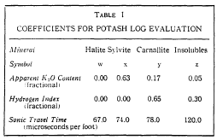
Table 1 shows the values used for the coefficients of the equations. These coefficients represent values of the parameters for 100 percent pure minerals.
As it is assumed that only halite, sylvite, carnallite and some insolubles are present, their total volume must comprise the total formation volume. This is represented by equation 1:
1: W + X + Y + Z = 1.00
Where: W, X, Y, Z are the fractional volumes of halite, sylvite, carnallite, and insoluble respectively.
The total apparent K₂O content of the formation, based on the gamma ray log, is made up of each component fraction multiplied by its respective K₂O value:
2: 0.63 * X + 0.17 * Y + 0.05 * Z = K2Oapp
A similar expression for hydrogen index gives:
3: 0.63 * Y + 0.30 * Z = PHIN
Wyllie’s time average equation extended to four components gives:
4: 67 * W + 74 * X + 78 * Y + 120 * Z = DTC
The value for DTC is read directly from the log; the values for K₂Oapp and PHIN are derived from the charts (Figure 1, 3, and 4).
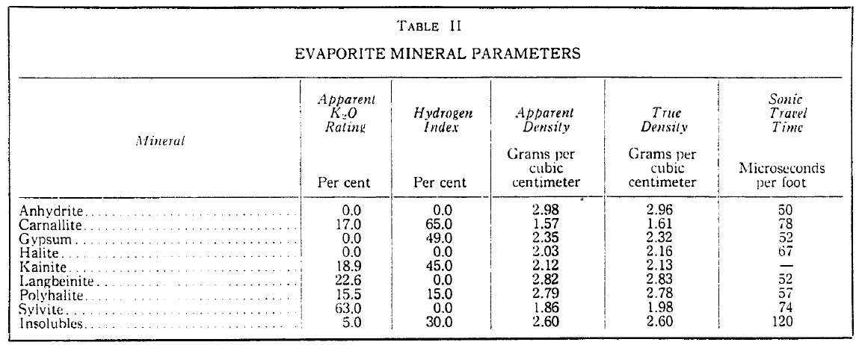
Reducing this equation set to obtain the required values – “W”, “X”, “Y” and “Z” – in terms of the derived values from the three logs gives the following:
5: Z = 2.07 * DTC – 0.23 * K₂Oapp – 0.29 * PHIN – 140.0
6: Y = 1.54 * PHIN – 0.46 * Z
7: X = 1.59 * K₂Oapp – 0.41 * PHIN + 0.04 * Z
8: W = 1.50 * DTC – 1.79 * K₂Oapp – 1.38 * PHIN – 1.30 * Z
As many core assays also list the K₂O values for an interval, it is often convenient to convert the mineral composition to equivalent K₂O using the following equations, wherein the subscripts used with K₂O are “t” for total, “s” for sylvite, and “c” for carnallite:
9: K₂Ot = K₂Oapp - 0.05 * Z
10: K₂Os = 0.63 * X
11: K₂Oc = 0.17 * Y
As an arithmetic check, one should compute the sum W + X + Y + Z, which should equal 1.0. Also the sum K₂Oc + K₂Ox should equal K₂Ot.
A simple crosscheck of the data determined from equations 5 to 8 can be accomplished by running a Formation Density Log. The actual density reading can be compared with a computed density value, calculated from equation 12:
12: DENS = 2.03 * W + 1.86 * X + 1.57 * Y + 2.60 * Z
This equation is derived from the known densities of the four components: halite, sylvite, carnallite and insolubles (see Table II).
If the computed density verifies the log-recorded value one can reasonably assume that the fractions, as calculated, are correct. A different value indicates that some other mineral is present, either in place of, or in addition to, those considered.
The four logs, gamma ray, neutron, sonic, and density, could be used to set up equations for a five-mineral model, but is not often necessary, because halite, sylvite, carnallite, and insolubles usually predominate over other potash minerals.
As the calculations, although simple, are quite tedious, a computer program was developed to handle this task. In order to use log values directly, the charts of Figures 2 and 4 were reduced to tabular form, as shown in Tables 3 and 4. The data were normalized to 6-inch hole size with a mud weight of 7.2 pounds per US gallon (diesel fuel).
Corrections for different hole sizes and mud weights were developed in equation form. Any value of hole size from 6 to 12 inches and mud weight from 7.2 to 12.0 pounds per U.S. gallon can be accounted for by using the following equations:
13: GRh = GR * (1.0 +.0.05 * (HS - 6.0)) + (320 * (HS - 6.0)) / (GR + 100.0)
14: GRc = GRh * (1.0 + 0.10 * (WM – 7.2))
15: PHINc = PHIN * (1 + 0.0005 * (HS – 6.0))
These are approximations only, but are sufficiently accurate for the range of values stated above. The computer program first corrects the log values, and then enters the tables, interpolating between points if necessary to obtain K₂Oapp and PHIN.
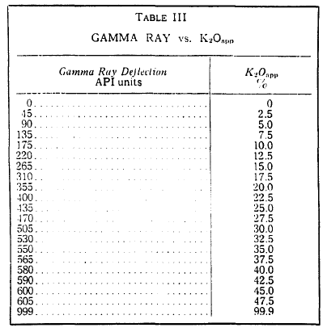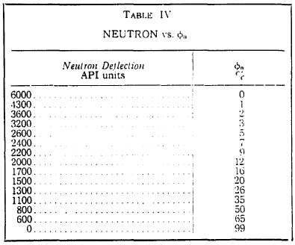
RESULTS
A sample printer listing of the results from an electronic computer analysis of digitized log data is shown in Figure 5.
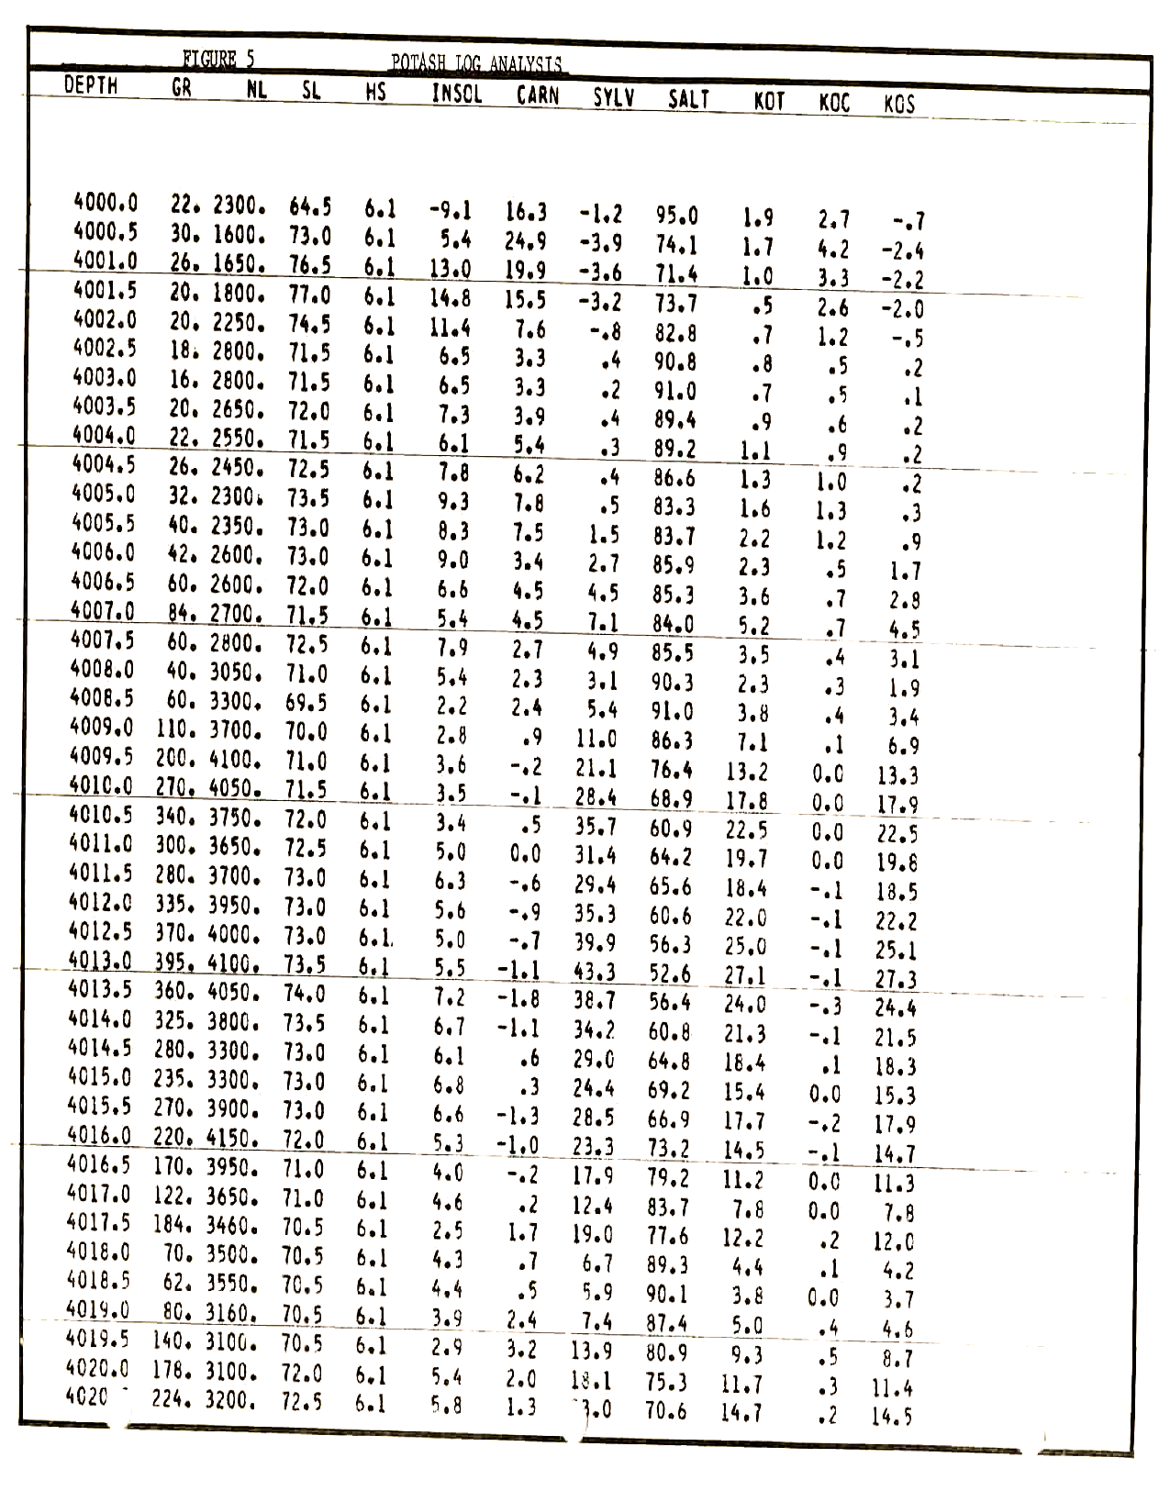
Figure 5: Computer printout of potash log analysis results.

Plotted results with the core assay results for comparison are given in Figure 6. Close correlation is shown in many cases.
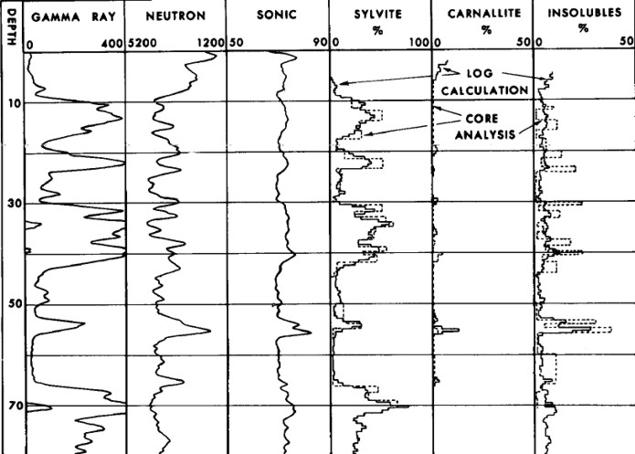
Figure 6: Raw logs and calculated results from computerized potash analysis, with core assay data overlay on sylvite, carnallite, and insoluble tracks.
The intervals in which larger discrepancies occur are probably due to the different volumes of investigation of the core and the logs. The logging instruments are capable of analyzing as much as 100 times the volume of a conventional 2-1/8 inch core. Particular examples of such discrepancies occur at 4,014 to 4,022 feet and at 4,031 to 4,044 feet on the insoluble calculation shown in Figure 6.
The high insoluble content interval between 4,053 and 4,056 feet on Figure 6 is shown quite clearly. The absolute values do not agree with the core analysis, but there is no problem concerning interpretation as this amount of insoluble material would condemn the zone even if it had contained sufficient potash to be considered a prospective commercial orebody. Bed boundaries are clearly defined and correlate exactly with the core.
Bed thickness corrections should be applied to the gamma ray log readings before inserting them in the machine computation program. Thin-bed effects can be seen on the examples where rich ore intervals are less than 3 feet thick.
Some discrepancies with core analysis, caused by problems other than thin beds, can be noted in the higher grade sylvite and carnallite intervals. The gamma ray logging tool does not respond linearly to K₂O content, and resolution is poorer in high K₂O grade ores.
Due to logarithmic response of the neutron log to hydrogen index, the resolution of this logging tool in the zones of high carnallite content is not as good as in the lower grade carnallite. Figure 7 illustrates this effect. Here, a high grade sylvite bed grades into a high carnallite content zone. The comparison between core analysis and log calculations is not as good as in Figure 6. However, no one could mistake the content of the zone. The log-derived bed boundaries agree very closely with the core analysis. Unfortunately, this bed is not thick enough to be considered commercially attractive.
The result of the bed thickness and tool resolution problems is a pessimistic sylvite and carnallite assay in thin rich zones. Fair accuracy is possible in thick, rich ores, and good accuracy is attained in low to medium grade beds.
The value of the caliper log is evident from Figure 7. The sylvite fraction could have been in error by as much as 14 percent in Example 4 had the hole diameter been assumed equal to the bit size of 9 inches.
The computer program can be adapted to any computer. At present, logs must be digitized by hand. The output is in the form of punched cards which are used for off-line listing. Plotting of results from this list can be accomplished by hand; the data can also be recorded by an incremental digital plotter.
A more complex computer program has been developed to translate directly the recorded logs to a computed log. A sample of the output from such a program is illustrated in Figures 7 and 8. In this application, the logs are digitized, calculations are performed and the results are plotted by an incremental digital plotter in a continuous sequence, eliminating the source of error in manual digitizing and plotting.
The direct digitizing, computing and plotting technique is available as a commercial service at those centers which have the suitable hardware.
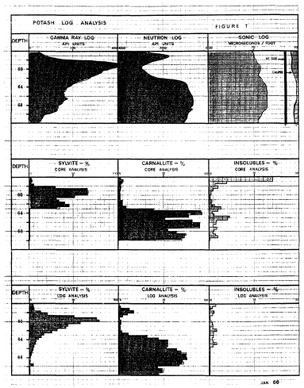 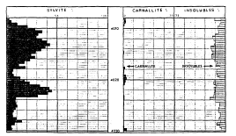
Figures 7 and 8: Potash log analysis with digitized log data showing sylvite, carnallite, and insoluble.

CONCLUSIONS
It has been shown that with the three standard well logs it is possible to evaluate quantitatively the Prairie Evaporite potash beds. The arithmetic is simple and the presentation, as illustrated in the examples, is informative and self-explanatory. Auxiliary surveys such as the caliper log or the formation density log, can be used to supplement and cross check data derived from the three basic logs.
Computer techniques are admirably suited to this interpretation approach, and eliminate much tedious hand calculation. The graphical display of the calculations allows correlation, mining studies and mapping to be accomplished with ease.

ACKNOWLEDGEMENTS
The authors wish to express their appreciation to the companies whose logs were released for presentation in this paper. Access to the confidential information required to complete this study is gratefully acknowledged.
ABOUT THE AUTHORS
E.R. (Ross) Crain (B.Eng., Electrical Engineering, McGill ’62) joined Schlumberger of Canada on graduation and, after several conventional field assignments, became a logging engineer at the Lanigan Potash Depot. Here, Mr. Crain was able to apply logging technology to the problem of fast evaporite evaluation. This provided the ground work for this paper. He joined Geophysical Services Incorporated this June as a geophysical engineer.
W.B (Bill) Anderson (B.Sc., Mechanical Engineering, Saskatchewan ’52) was born in Calgary. Following two years engineering experience with the Saskatchewan Department of Mineral Resources, he joined Schlumberger of Canada at Swift Current, Saskatchewan. In 1960, after extensive Western Canadian field and special project experience, Mr. Anderson became manager at Schlumberger’s Oxbow location. He followed this with a sales assignment in Regina in 1963. This gave close contact with potash operating companies.

REFERENCES
- Goudie M. “Middle Devonian Potash Beds of Central Saskatchewan”, Sask. Dept. of Mineral Resources (1957) – unpublished report.
- Saskatchewan Department of Mineral Resources, “Potash in Saskatchewan” (1965).
- Alger, R.P. and Crain, E.R., “Defining Evaporite Deposits with Electrical Well Logs”, Transactions Northern Ohio Geological Society Second Symposium on Salt, (1965).
- Alger, R.P., Raymer, L.L. Hoyle, W.R., and Tixier, M.P., “Formation Density Log Applications in Liquid Filled Holes”, Journal of Petroleum Technology, (March 1963).
- Savre, W.C.; “Determination of a More Accurate Porosity and Mineral Composition in Complex Lithologies with the Use of the Sonic, Neutron and Density Surveys”, Journal of Petroleum Technology, (September, 1963).

APPENDIX 1: LIST OF ABBREVIATIONS
Symbol | Definition | Units
GR | Gamma Ray Log reading from log at depth D | API Units
GRc | Gamma Ray Log reading correcte for hole size and mud weight | API Units
PHIN | Neutron Log reading at depth D | API Units
PHINc | Neutron Log reading corrected for hole size | API Units
W | Halite fraction | Fraction
X | Sylvite fraction | Fraction
Y | Carnallite fraction | Fraction
Z | Insolubles fraction | Fraction
K₂Ot | Total K₂O content of formation | Fraction
K₂Os | K₂O content of formation in sylvite | Fraction
K₂Oc | K₂O content of formation in carnallite | Fraction
K₂Oapp | Apparent K₂O content of formation from Gamma Ray Log | Fraction
DTC | Sonic Log reading | Microseconds per foot
HS | Borehole diameter from Caliper Log or from bit size | Inches
MW | Mud weight | Pounds per U.S. gallon
DENS | Computed formation density | Grams/cubic centimeter

APPENDIX 2: Bibliography
- Saskatchewan Department of Mineral Resources, “Subsurface Mineral Distribution Map” (1965) – Map #S-33.
- Saskatchewan Department of Mineral Resources, “Subsurface Exploration Geology and Devonian Stratigraphy of Meadow Lake, Prince Albert and Yorkton Areas”, - Report #15.
- Lane D.M., “Dawson Bay Formation in the Quill Lakes – Qu’Appelle Area”, Sask. Dept. of Mineral Resources (1959) – Report #38
- Pearson, W.J., “Developments in Potash in Saskatchewan”, C.I.M. Bulletin, (October, 1960).
- Pearson, W.J., “Western Canada Potash and its Future Prospects” EIC Journal (August, 1960).
- Schwerdtner, “Genesis of Potash Rocks in the Middle Devonian”, AAPG Bulletin (July, 1964).
- Tomkins, R.V. “Potash in Saskatchewan”, S.I.M. Bulletin (November 1954).
- Wardlaw, N.C. “Potash Research”, Saskatchewan Engineer (1963).
- Tomkins, R.V., “Canadian Potash – The World’s Future Supply of a Vital Mineral”, C.I.M. Transactions (1962).
- Goudie, M., “Middle Devonian Potash Beds of Central Saskatchewan”,Sask. Dept. of Mineral Resources (1957) – unpublished report.
- Bartley, C.M., “Potash”, Dept. of Mines and Technical Surveys (1963).
- Milne, Shouldice, and Nelson, “Collapse Structures Related to Evaporites of Prairie Formation, Saskatchewan”, GSA Bulletin (April 1964).
- Sarjik, D.L. and Habson, G., “Prairie Evaporite Mapping in Minton Areas of Saskatchewan Employing Seismic Methods”, Geophysics (December 1964).
- Saskatchewan Department of Mineral Resources; “Potash in Saskatchewan”, (January 1965).
- “Potassium by any Other Name”, Chemical Week (September 1963).
- “Mineral Facts and Problems”, U.S. Bureau of Mines (1963), Bulletin 536.
- Edmunds B.P., “Significance of Solution Mining to the Potash Industry”, C.I.M. Bulletin (September 1964).
- Cole, L.H. “Potash Discoveries in Western Canada”, C.I.M. Transactions (1948), Vol. 51
- “Potash – IMC’s Esterhazy Project” Precambrian (January 1963).
- Scott, S.A., “Shaft Sinking Through Blairmore Sands and Paleozoic Water-Bearing Formations”, C.I.M. Bulletin (February 1963).
- White, N.C., “Potash”, Engineering and Mining (1963).
- Saskatchewan Department of Mineral Resources “Preliminary Report on Saskatchewan Potash Occurrences”, (1947).
- Williams, A.J., “Further Potash Discoveries in Saskatchewan”, C.I.M. Transactions (1952).
- Cheeseman, R.L., “History and Geology of Potash Deposits in Saskatchewan”, Second International Williston Basin Symposium (1959).
- Bannatyne, B.B. “Potash Deposits, Rock Salt and Brines in Manitoba”, Manitoba Dept. of Mines and Natural Resources (1960).
- Dewan and Greenwood, “Calibration of Gamma Ray and Neutron Equipment for the Identification and Evaluation of Potash Deposits”, (January 1954).
- Waltman, R.M., “Radioactivity Logging for Potash”, (October 1955).
- Spicer, H.C., “Gamma Ray Studies of Potash Salts”, USGS Bulletin 950 (1942-1954).
- Blanchard and Dewan, “Calibration of Gamma Ray Logs”, Petroleum Engineer (August 1953).
- Timka, D.J., “Potash Evaluation Using Well Logs”, Continental Oil Company (1962).
- Kokesh F.P., “Gamma Ray Logging”, Oil and Gas Journal (July 1951).
- Dewan and Allaud, “Experimental Basis for Neutron Logging Interpretation”, Petroleum Engineer (September 1953).
- Dewan, J.T., “Neutron Log Correction Charts for Borehole Conditions and Bed Thickness”, Journal of Petroleum Technology (1955).
- Fearon, R.E. “Radioactivity Well Logging”, Well Surveys Inc. (1946).
- Alger, R.P., and Crain, E.R., “Defining Evaporite Deposits with Electrical Well Logs”, Transactions Northern Ohio Geological Society Second Symposium on Salt (1965).
- Tixier, M.P., Alger, R.P., and Doh, C.A., “Sonic Logging”, Journal of Petroleum Technology (May 1959).
- Kokesh, F.P., Schwartz, R.J., Wall, W.B., and Morris, R.L. “ A New Approach to Sonic Logging and Other Acoustic Measurements”, Trans. AIME (1964).
- Alger, Raymer, Hoyle and Tixier, “Formation Density Log Applications in Liquid Filled Holes”, AIME (1962), Paper # SPE435.
- Wahl, J.S., Tittman, J. Johnstone, C.W., and Alger, R.P., “The Dual Spacing Formation Density Log”, Trans. AIME (1964).
- Raymer, L.L., and Biggs, W.P., “Matrix Characteristics Defined By Porosity Computations”, Trans. Of Soc. Of Prof. Well Log Analysts Meeting (1963).
- Savre, W.C., and Burke, J.A., “Determination of a True Porosity and Mineral Composition in Complex Lithologies with the Use of the Sonic, Neutron and Density Surveys”, Journal of Petroleum Engineering (September 1963).
- Landes, K.K., “Origin of Salt Deposits”, Transaction of 1st Salt Symposium (1962).
- Tittman, J., and Wahl, J.S., “The Physical Foundations of Formation Density Logging (gamma-gamma)”, Geophysics (1965).
- Baillie, A.D., “Devonian System of the Willison Basin Area”, Mines Branch, Province of Manitoba (1953), Pub. 52-5.
- Bishop, R.A., Saskatchewan Exploratory Progress and Problems”, Rutherford Memorial Volume (1954).
- Walker, C.T., “Correlations of Middle Devonian Rocks in Western Saskatchewan”, Sask. Dept. of Mineral Resources (1957), Report No. 25.

