DETERMINATION OF SEISMIC RESPONSE USING EDITED
WELL LOG DATA
E. R. Crain, P Eng. E. R. Crain and Associates Ltd.
J. D. Boyd, P.Geoph. Boyd Exploration Consultants Ltd.
Presented by E. R. Crain at the 7th Formation Evaluation Symposium of the Canadian Well Logging Society, in Calgary, October 21 – 24, 1979 and Canadian Society of Exploration Geophysicists Annual Symposium, October 1979. Published in CWLS Symposium Transactions and CSEG Recorder, 1979.
** Best Paper Award, CSEG, 1979 **
This electronic version created Apr 2021. Equations converted to computer-ready format. Synthetic seismogram illustrations were prepared using the LOG/MATE seismic modeling package, based on the HP9825 micro-computer with its Fast Fourier Transform (FFT) ROM card.
ABSTRACT
Seismic stratigraphic interpretation is based on the ability to correlate seismic character to subsurface geology. The correlation is established at a well with a synthetic seismogram computed from well log data, but the use of unedited sonic and density data may result in serious errors in the synthetic. Editing is therefore an essential part of the interpretation.
The seismic response of a hydrocarbon reservoir (as opposed to water bearing formations) must be corrected for drilling fluid invasion of the reservoir around the borehole. Secondary porosity in carbonates must also be recognized during log analysis since the response of this porosity to the low frequency seismic pulse is much greater than it is to the high frequency logging tool. Empirical corrections for these effects are introduced to the edited well log data to produce an acoustic impedance log which will more accurately show the response of a seismic pulse.
Synthetic seismograms are made by convolving the reflection coefficients derived from the impedance log with wavelets based on frequency and phase relationships measured from seismic data. The effect of changing porosity, formation thickness and hydrocarbon content is shown with model synthetic traces from Western Canadian model studies.

INTRODUCTION
The use of sonic and density well logs for modeling the seismic response to formations is a well-known technique, but it is complicated by many factors. One of the major factors is the difference in the fluid content of the rocks “seen” by the logs and by the seismic impulse.
Well logs read the sound velocity and formation density of the invaded zone around the borehole, which contains mud filtrate, formation water and possibly some oil or gas. The seismic impulse is affected by the fluids in the undisturbed formations, which normally have different composition and properties than the invading fluid. Both the seismic impulse and logs should respond similarly to the rock matrix, shale content and porosity, with minor exceptions.
These exceptions are:
- The sonic log does not “see” vugular porosity to the same degree as the seismic impulse does.
- The density log does not respond to true density, but to electron density; thus for hydrocarbons, coal, salt, dolomite, and some other minerals a correction to density log readings is necessary to find true formation density.
- Both logs may be affected by some borehole effects that cannot be corrected rigorously, but may be edited manually with care and reasonable assumptions.
Lithology, porosity and shale content can be derived with reasonable accuracy from modern logs. The effect of different fluids, and changes in porosity or in shale content on log reading can be calculated, using methods described in this paper. Thus a number of different formation models can be created. The seismic response of the models can be compared to each other and to field data using discriminant analysis or frequency analysis techniques, or more commonly, by visual inspection. If sufficient discrimination between various models can be detected, then the comparison of these models with field data should provide a valuable interpretation aid.
THEORETICAL BACKGROUND – ACOUSTIC VELOCITY
Wyllie (1) in 1956 proposed an empirical relationship (now called the Wyllie time-average formula) which connected the travel time of sound in a porous media to the travel time in the rock matrix and to the travel time in the fluid filling the pores. This is expressed as:
1: DTClog = PHIt * DTCfluid + (1 - PHIt) * DTCmatrix
Where:
DTClog = traveltime value on the log (μsec/foot or μsec/meter)
DTCfluid = fluid traveltime (μsec/foot or μsec/meter)
DTCmatrix = matrix traveltime (μsec/foot or μsec/meter)
PHIt = total porosity of the rock (fractional)
Travel times are measured in units of microseconds per foot or microseconds per meter and all volumes such as porosity are in decimal fractions. This equation, when rearranged, is the stock in trade of log analysts, whose efforts are usually aimed at deriving formation porosity from the sonic log.
By analogy equation 1 can be extended to contain terms for other rocks or fluids combined with the matrix and porosity described above. The first logical extension is to include a shale term (see ref. 2):
2: DTClog = (1 - PHIe - Vshale) * DTCmatrix + (Vlam + Vstr) * DTCshale
……….................+ (PHIe + Vdis) * DTCfluid
Where:
PHIe = effective porosity
Vshale = total shale volume of shale (Vlam + Vstr + Vdis)
Vlam = laminated shale volume
Vstr = structural shale volume
Vdis = dispersed shale (clay) volume
DTCshale = sonic travel time in pure shale:
This formula assumes that dispersed clay acts like water, which may or may not be true. In fact, often the dispersed clay is lumped into the total shale term and the equation becomes:
3 : DTClog = PHIe * DTCfluid + (1 - PHIe - Vshale) * DTCmatrix + Vshale * DTCshale
For the accuracy needed in seismic modeling this expression is quite sufficient.
The next logical extension is to break out the various fluids in the fluid term:
4 : DTClog = PHIe * DTCwater * Swater + PHIe * DTChyd * Shyd
+ (1 - PHIe - Vshale) * DTCmatrix + Vshale * DTCshale
Where:
DTCwater = sonic travel time of formation water and mud filtrate combined
DTChyd = “pseudo-travel time” of hydrocarbon (gas or oil)
Swater = water saturation
Shyd = (1 - Swater) = hydrocarbon saturation
It has been shown in the laboratory by Domenico (3) and many others (4, 5, 6, 7, 8, 9, 10, 11) that this relationship is usually not strictly upheld when gas fills the pore space, or is a significant fraction of the pore space. This is not surprising since the original Wyllie equation is merely an empirically derived relationship based on a few observations, with a reasonably wide spread in the data. Its success in log analysis has been unparalleled, however.
A review of the literature cited, and many other papers, has shown that there is no rigorous solution to the problem of predicting acoustic velocity in porous media. A few authors (11, 12, 13), and 6) have proposed different empirical relationships than Wyllie, using assumed parameters which are more difficult to assess than those needed for equation 3. This is discussed in detail by Mossman and Schoellhorn (14). Laws et al (15) suggest that attenuation is the most serious case of differences between laboratory experiments and field observations. This cannot be handled with the type of equation proposed by Wyllie, but is an approach that needs to be considered. Therefore we have elected to use the extended version of the Wyllie time average equation, with full knowledge of its limitations and empirical nature.
For this reason we call the hydrocarbon travel time a “pseudo-travel-time” to reaffirm that it represents a velocity which may not be the same as the velocity of the gas at the temperature and pressure of the formation. The hydrocarbon “pseudo-travel-time” is derived empirically by comparing results from synthetic seismograms and properly processed field data. A very rough approximation of hydrocarbon “pseudo-travel-time” with depth, which has given reasonable results in the Western Canadian rock sequences, is shown in Figure 1. Travel time for liquids, such as oil and salt water (formation water) are more predictable (see ref. 2) and may be used in equation 3 without reservation.
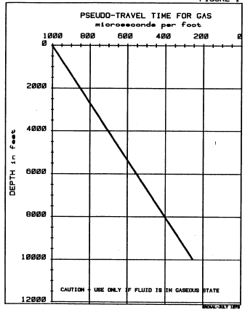
An additional term must be included in equation 3 to determine the travel time, (and hence seismic velocity) in a vugular rock. Due to the fact that the acoustic travel time measured by a sonic log is the shortest time path, the travel time will be lower than that which includes travel path segments through large vugs.

Figure 1: Pseudo travel time for gas for use as DTChyd in equation 3.
We can define the porosity term in equation 4 to include a vuggy porosity fraction:
5: PHIe = PHIint + PHIvug
Where:
PHIint = intercrystalline porosity
PHIvug = vugular porosity
The porosity formed by vugs, and not “seen” by the sonic logs can be found by log analysis if a full suite of logs is available. For log analysis purposes this porosity is defined as:
6: PHIvug = PHIxnd – PHIsc
Where:
PHIxnd = porosity from neutron density crossplot method
PHIsc = porosity from sonic log method
The effective porosity can also be found from core analysis, which will “see” vuggy porosity as long as it is connected to other pores. The vuggy porosity described above is often called “secondary” porosity but this may be a misleading term to some.
Equation 3 thus provides us the opportunity to compute the sonic travel time (and the seismic velocity) of any hypothetical formation by describing the quantity of rock matrix, shale, water and hydrocarbon, as well as the sonic properties of these elements. Conversely, given a full suite of well logs, we can compute the quantities of these same elements in a given reservoir. In either case, the seismic response to these quantities can be computed by convolving the reflection coefficients, derived from the acoustic data with a suitable wavelet. The methods for determining values for each of the terms in equation 4 are covered in reference 2 (or any other log analysis manual).
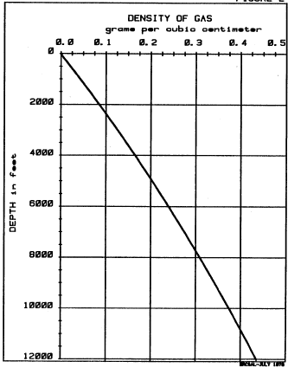
THEORETICAL BACKGROUND – DENSITY
It is more desirable to derive the seismic response from acoustic impedance instead of acoustic velocity. Since acoustic impedance contains a density term, an equation similar to equation 3 is required to predict the density component of the impedance:
7: DENSlog = PHIe * DENSwater * Swater + PHIe * DENShyd * Shyd
+ (1 - PHIe - Vshale) * DENSmatrix + DENSshale * Vshale
This equation is rigorous and can be used with real hydrocarbon densities based on the temperature, pressure and phase relationship of the fluid in question.
Corrections for the fact that density logs respond to electron density, and not bulk density, can be made (see ref. 16), and may be necessary especially in the case of coal or salt beds. We usually do not make these corrections, again because the accuracy needed for computing seismic response does not warrant the effort.

A chart showing approximate gas density versus depth is shown in Figure 2, based on average pressure and temperature data for the Western Canadian basin.
Figure 2: Density of gas for use in equation 7

MODELING METHODS
Seismic modeling is a loosely defined term. We take it to include any or all of the following:
- Compute seismic response from a postulated rock sequence, given velocity and density values for successive layers of equal or unequal thickness.
- Compute seismic response from existing unedited well logs (sonic or density or both).
- Modify edited log data values to reflect real or hypothetical fluid, porosity, shale or matrix rock quantities or types, and compute the seismic response.
For the balance of the paper, we will consider only models of the third type. We do not feel that either of the first two methods is adequate – for the reasons that few can predict velocity and density accurately enough without a well log suite to work from (or without a great deal of pre-computation), and that unedited or unmodeled log data can predict significantly different seismic response than is actually seen on seismic data. An excellent review of the uses and qualifications of modeling techniques is available in reference 17.
Even in the third type, we do not normally permit direct entry of velocity and density data over the modeled interval. Instead we describe the rock/fluid composite in terms of its volume of shale amount and type of porosity, rock matrix type, and hydrocarbon content and type. A velocity and density are computed from this description using equations 4 and 7 respectively, and the seismic response computed from that. The edited sonic and density logs are used as input data for the balance of the well, where we presume that the logs (after editing) indicate the true state of nature. Thus we can inject new layers, delete existing layers, replace existing layers with new ones, change the fluid content from water to gas or oil (or vice versa), as well as correct logs for things which they could not record, such as vuggy porosity or gas effect. Another variant of this modeling method is to replace data, or add data to the bottom of one well, using log data from another well which more closely represents the interpreted rock sequence.
EDITING OF LOG DATA
No model or seismic response computation will be adequate unless the well logs are edited properly. This subject is covered extremely well in reference 18 and will not be repeated here.
We do have the following observations on the subject. Most geophysicists and petrophysicists underestimate the severity of the editing problem. Density data is very often affected by large or rough hole, and it is far better to inject a straight line density log with a single reasonable value than to live with the spurious values which are a function of the amount of mud between the logging tool and the formation. It is a difficult task to discriminate coal and salt beds from rough hole effects (they often go together) so recourse must be made to other logs or sample descriptions. Needless to say, no two analysts will do exactly the same job of editing.
Sonic data is also affected in large holes, but less often than density data. In addition shale alteration may occur, giving a consistent bias to the sonic log data. Use of check shot (seismic reference survey) data should be used with extreme care. Our own experience has shown that time breaks and first break times are often difficult to pick and adjusting the log to such data is sometimes worthless. This problem is complicated further in deviated holes.
When in doubt, we feel that the more severe editing should be done first, and adjustments towards leniency be made after the first few response computations have been reviewed.
Integrated time discrepancies are the most obvious clues to over-edited or under-edited data, and usually the offending zone can be identified readily, when compared to seismic section character.
EXAMPLES
We have prepared two examples using the Log/Mate evaluation system to illustrate the techniques described above. The Log/Mate system was designed to allow rapid well log evaluations and is described in more detail in reference 19. For seismic purposes Log/Mate offers the following features:
- Log analysis to obtain porosity, water saturation and shale volume results, if these are needed for modeling purposes.
- Time integration of the acoustic velocity log.
- Computation of velocity, density and reflection coefficient versus depth and integrated time.
- Printer output of all data.
- Depth or time plots in 4 colours of all data.
- Selective modeling using the methods described above.
- Wavelet generation and convolution with reflection coefficients.
- Synthetic section plotting in 4 colours.
- Interactive user operation.
- Stand-alone package system.
The first example is illustrated in Figure 3. This is a Swan Hills reef section in the Rosevear area of Alberta with significant gas-filled porosity. The graph contains the log analysis results and seismic results (acoustic impedance and reflection coefficients) on a highly compressed depth scale. Formation tops are shown and the modeled interval is marked.
The model merely replaced the mud filtrate seen by the logs with a mixture of gas and formation water.
The model results, along with the original data, are shown on Figure 4. The shaded area on the acoustic impedance curve shows the difference between log recorded values and the modeled values. Reflection coefficients and peak amplitude on the synthetic are about 40% higher after modeling. We believe the modeled values more closely represent the formation as seen by the seismic impulse.
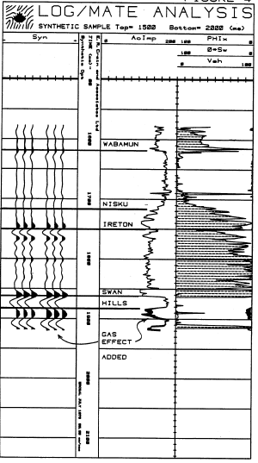
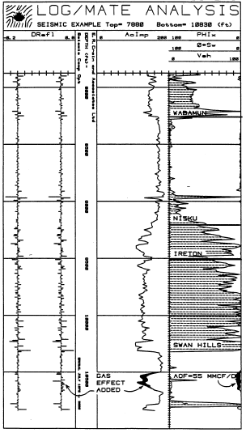
Figure 3: Log Analysis Results Swan Hills Reef Figure 4: Seismic Response Fluid Replacement
The second example illustrated a synthetic seismic section derived from a single well in the Arctic Islands. The well contains gas in a thick porous sandstone. The object of the model section was to determine if water bearing sands could be distinguished from gas sands, and what critical sand thickness was required before the interpreter could be sure that the sand was present.
Since the geology of the area, as well as log character, suggest that the sand is eroded from the top at an unconformity, we selectively removed 10 feet at a time from the top of the sand and made a synthetic trace for each case. Both a water and a gas model were used. The sand was originally 80 feet thick. Results for the water and gas models are shown in Figure 5.
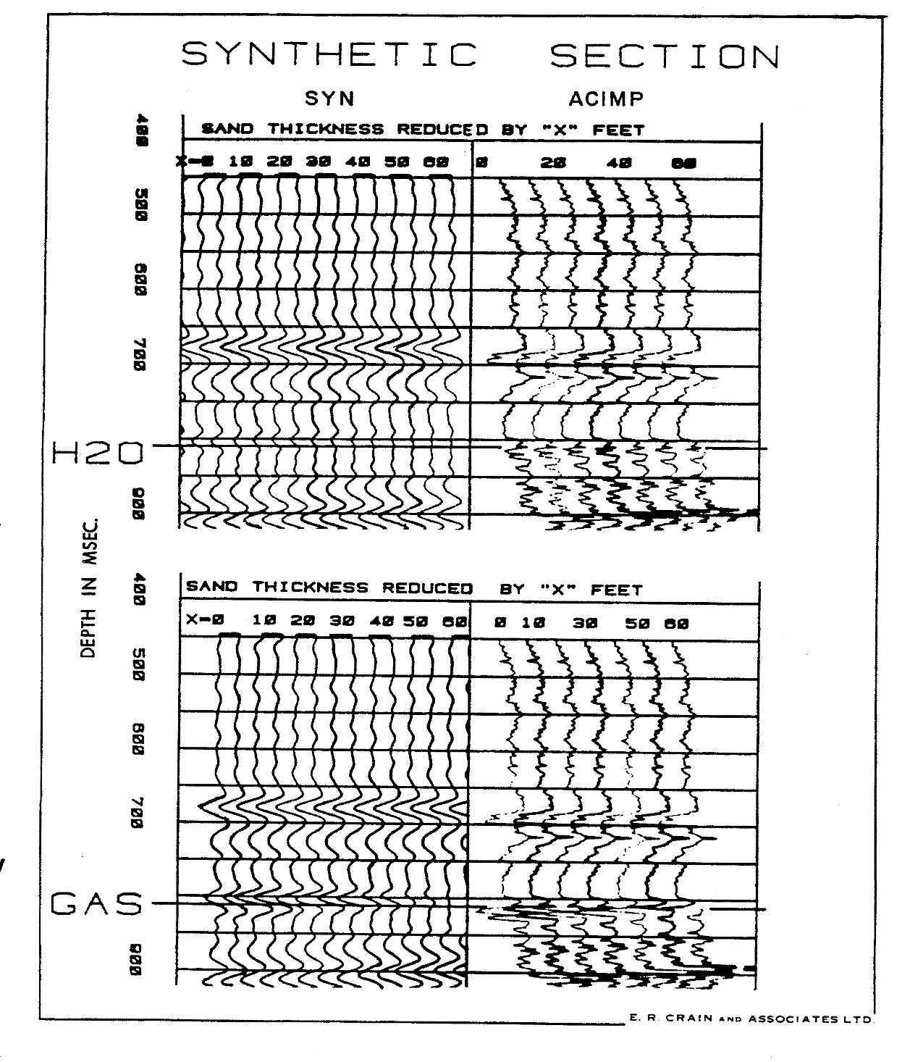

Figure5: Fluid Replacement - Seismic Response in Water and Gas zones of varying thickness.
The sand being modeled is between 810 and 830 milliseconds. It is evident from these plots that a gas sand 30 feet thick gives rise to about the same seismic response as an 80 foot water sand, and that no seismic event can be expected if the sand is wet and less than 60 feet thick, or gas bearing and less than 40 feet thick. These results are corroborated by the seismic data and other wells in the area, including 3 dry holes drilled on “bright spots” that turned out to be thick wet sands, not gas wells as predicted..
Many more models could be made, and often are made, during the course of a project. Various wavelets at varying frequencies are often needed to narrow down the possible choices before modeling is even attempted. The model parameters or wavelet may have to be adjusted to obtain a better match, and since this is a modeling problem, there may be more than one model which will adequately match the seismic data.
ECONOMIC CONSIDERATIONS
The cost for such models is modest. The first example took about four hours on the LOG/MATE system, which includes digitizing, plotting, and computation. With the professional time included this amounts to about $400 - $500. The synthetic section of the second example took about seven hours for a cost of about $800. The turn-around time in each case was “same-day” service.
This is a function of competing work load, so same-day turnaround is not always possible. The cost for this type of modeling on other systems should be comparable, and turnaround on a terminal oriented system should be “same-day”. A batch system will probably not allow same-day output unless special high priorities are involved.

CONCLUSIONS
Seismic modeling is one of the least exact scientific endeavors known. There are many conflicting factors and a wealth of unknowns. Results can be spectacularly good or dismally poor, with a fair supply of modest successes. We believe that careful use of the methods described here on an interactive computer system will provide useful information to aid in the stratigraphic interpretation of the seismic sections.

REFERENCES
- Elastic Wave Velocities in Heterogeneous and Porous Media
M.R.J. Wyllie, A.R. Gregory, L.W. Gardner
Geophysics – 1956
- Log Interpretation Volume I – Principles
Schlumberger Well Services Corporation, 1972
- Effect of Brine-Gas Mixture on Velocity in an Unconsolidated Sand Reservoir
S.N. Domenico
The Log Analyst – 1977
- An Experimental Investigation of Factors Affecting Elastic Wave Velocities in Porous Media
M.R.J. Wyllie, A.R. Gregory, G.F.H. Gardner
Geophysics – 1958
- Effect of Pore Fluids on the Elastic Properties of Sandstone
R.L. Mann, I. Fatt
Geophysics – 1960
- Some Aspects of Elastic Wave Propagation in Fluid–Saturated Porous Solids
J. Geertsma, D.C. Smit
Geophysics – 1961
- Effect of Porosity, Grain Contacts, and Cement on Compressional Wave Velocity Through Synthetic Sandstones
- Viknsne, J.W. Berg, K.L. Cook
Geophysics – 1961
- Studies of Elastic Wave Attenuation in Porous Media
M.R.J. Wyllie, G.H.F. Gardner, A.R. Gregory
Geophysics – 1962
- Effects of Pressure and Fluid Saturation on the Attenuation of Elastic Waves in Sands
M.R.J. Wyllie, G.H.F. Gardner, D.M Droschak
Journal of Petroleum Technology – 1963
- Wave Velocities in Rocks as a Function of Changes in Over-Burden Pressure and Pore Fluid Saturants
M.S. King
Geophysics – 1966
- Theory of Propagation of Elastic Waves in a Fluid-Saturated Porous Solid
M.A. Biot
Journal of Acoustic Society of America – 1956
- Elastic Waves Through a Packing of Spheres.
F. Gassmann
Geophysics – 1951
- Velocity Measurements in Near-Surface Formations
J.E. White, R.L. Sengbush
Geophysics – 1952
- Causes of Reflection Amplitude Variances
R.W. Mossman, S.W. Schoellhorn
Dallas Geological and Geophysical Societies – 1973
- A Study of the Acoustic and Density Changes Associated with High-Amplitude Events on Seismic Data
W.R. Laws, C.A.M. Edwards, P.A. Wichmann
SPWLA – 1974
- Log Interpretation Volume I – Principles Chapter 8, pages 45, 46, 47
Schlumberger Well Services Corporation – 1972
- Modern Seismic Methods – an Aid for the Petroleum Engineers
B.E. Ausburn, A.K. Nath, T.R. Wittick
JPT, 1978
- Well Log Editing in Support of Detailed Seismic Studies
B.E. Ausburn, J.R. Butler
SPWLA, 1977
- The Log/Mate Evaluation System
E.R. Crain and D.W. Curwen
CWLS, 1979

