THE CWLS LOG ANALYSIS EXAMPLE BOOK
– A PREVIEW
E. R. Crain, P.Eng
CWLS Publications Chairman
Presented at the 8th Formation Evaluation Symposium of the Canadian Well Logging Society, Calgary, 27 – 30 September 1981. Published in CWLS Journal Vol. 11 No 1 Dec 1982. This electronic version created Jan 2021.

The CWLS Log Analysis Example Book is an ambitious project by the CWLS to provide examples of high quality log analysis for use by the oil and gas industry in Canada. The Handbook is intended to illustrate modern log evaluation methods, using computers and hand calculators, along with core, drill stem test, hydrocarbon mud log and production data. We hope that such examples will demonstrate the utility of log analysis in general, the wide range of methods available, and the accuracy of volumetric predictions made from log data. The project will be funded by the Corporate members fees and their contributions to date are sincerely appreciated.
The examples contained here are meant to illustrate the format of the book, and to encourage CWLS members to contribute worked examples for inclusion in the Handbook. Blank forms are available from the author, who is Chairman of the Handbook Sub-committee.
To date, some 25 examples have been completely or partially prepared. However, many more examples are needed as those created to date rely heavily on the authors own methodology. We would hope for a better balanced set of examples than this.
Publication of this Handbook was meant to coincide, both in timing and content with a companion volume of Oil and Gas Fields of Canada, to be created by the Canadian Society of Petroleum Geologists. Neither our Handbook nor the CSPG volume are on schedule, so we have elected to proceed separately until sufficient material is available for both projects to warrant further co-operation. We believe that ultimately the two companion volumes will be an ongoing effort, with new material and updates being provided by both societies at regular intervals.
The expected publication date for the first 50 examples, in a loose leaf binder is the fall of 1983. Please consider contributing some examples from your own stock of interesting wells.
Three examples are included below.

CWLS LOG ANALYSIS HANDBOOK
LOCATION:  WELL NAME: |  |  |  |  | POOL(S):  FIELD:  PROVINCE:
LOGS AVAILABLE |  |  |  |  | CORE AVAILABLE
 | Type |  | Interval |  | Interval |  | Recovery
1 | Borehole Comp. Sonic |  | 345-3244
2 | Induction Electric |  | 345-3244
3
4
5
6
LOG INTERPRETATION CONSTANTS
Depth | 3070-3230 |  |  |  | Depth
Rw @ 25ºC | 0.500 | RHOma | 2.65 |  | Rw @ 25ºC |  | RHOma
Rw @ FT | 0.397 | DELTma | 55.00 |  | Rw @ FT |  | DELTma
Rsh @ FT | 8.0 | RHOw | 1.00 |  | Rsh @ FT |  | RHOw
Rwb @ FT | 2.0 | DELTw | 188 |  | Rwb @ FT |  | DELTw
A | .620 | PHINsh | 30 |  | a |  | PHINsh
M | 2.150 | PHIDsh | 0 |  | M |  | PHIDsh
N | 2.000 | DELTsh | 95 |  | N |  | DELTsh
FT | 97.8 | Cp | 100 |  | FT |  | Cp
DST INFORMATION
UNITS: | - ENGLISH |  | - METRIC |  | UNITS: | - ENGLISH | - METRIC
DST # |  | None |  |  | DST #
Interval |  |  |  |  | Interval
IHP |  |  |  |  | IHP
Preflow |  | ( min) |  |  | Preflow |  | ( min)
ISIP |  | ( min) |  |  | ISIP |  | ( min)
VO |  | ( min) |  |  | VO |  | ( min)
FSIP |  | ( min) |  |  | FSIP |  | ( min)
FHP |  |  |  |  | FHP
Recovery: |  |  |  |  | Recovery:
Comments:
PRODUCTION TEST RESULTS
PERF #1: 3121-3127
3 shots per foot
Frac.

RESULTS OF THE STUDY

Formation Name | # Zones | Avg Net  Pay-Meters
Belly River | 1 | 8.5
Bad Heart | 15 | 2.0
Cardium | 35
Dunvegan | 22
Shaftesbury | 1
Paddy/Cadotte | 35
Spirit River | 30
Bluesky/Gething | 31
Cadomin | 17
Nikanassin | 7
Rock Creek/Nordegg | 6
Total | 200
Average Per Well | 4.9 | 58.8

CONCLUSIONS

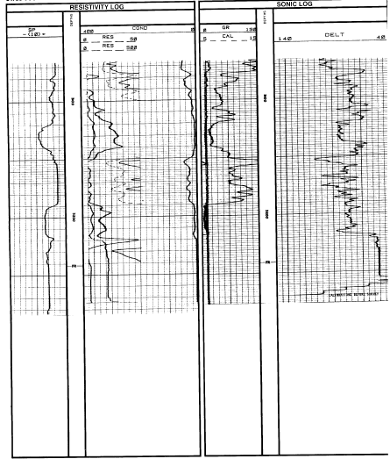

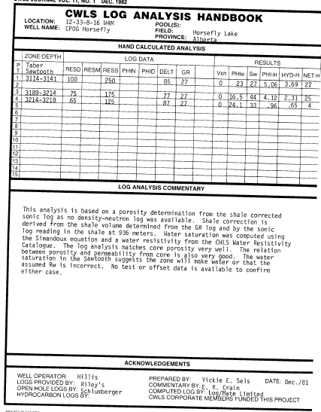

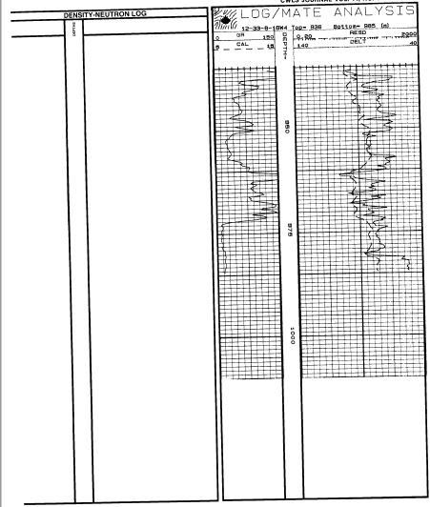

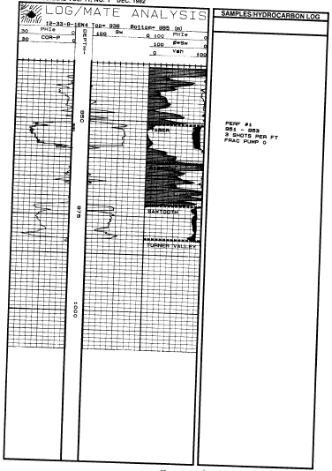

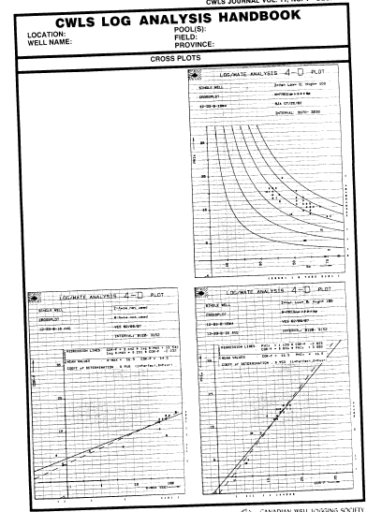

CWLS LOG ANALYSIS HANDBOOK
LOCATION: Dome Total Goodfare  WELL NAME: 10-7-72-11W6 |  |  |  |  | POOL(S): Paddy Cadotte  FIELD: Goodfare  PROVINCE: Alberta
LOGS AVAILABLE |  |  |  |  | CORE AVAILABLE
 | Type |  | Interval |  | Interval |  | Recovery
1 | DIL/SFL |  | 230-2037 |  | 1851-1867.3 |  | 16.3m
2 | BHCS-GR |  | “
3 | CNL/FDC-GR |  | “
4
5
6
LOG INTERPRETATION CONSTANTS
Depth | 1640-1710 |  |  |  | Depth n/a
Rw @ 25ºC | -- | RHOma | 1690 |  | Rw @ 25ºC |  | RHOma
Rw @ FT | 0.197 | DELTma | 180 |  | Rw @ FT |  | DELTma
Rsh @ FT | 20 | RHOw | 1000 |  | Rsh @ FT |  | RHOw
Rwb @ FT | -- | DELTw | 616 |  | Rwb @ FT |  | DELTw
A | 0.62 | PHINsh | 27 |  | a |  | PHINsh
M | 2.15 | PHIDsh | 2 |  | M |  | PHIDsh
N | 2.00 | DELTsh | 252 |  | N |  | DELTsh
FT | 62 | Cp | 1.0 |  | FT |  | Cp
DST INFORMATION
UNITS: | - ENGLISH |  | X METRIC |  | UNITS: | - ENGLISH | - METRIC
DST # | 2 |  |  |  | DST # | n/a
Interval | 1651.0 – 1667.3 |  |  |  | Interval
IHP |  |  |  |  | IHP
Preflow |  | ( min) |  |  | Preflow |  | ( min)
ISIP |  | ( min) |  |  | ISIP |  | ( min)
VO |  | ( min) |  |  | VO |  | ( min)
FSIP |  | ( min) |  |  | FSIP |  | ( min)
FHP |  |  |  |  | FHP
Recovery: | CST 1.5 Min@ 308, 228 m3/dlm condensate |  |  |  | Recovery:
Comments:
PRODUCTION TEST RESULTS
GAS WELL

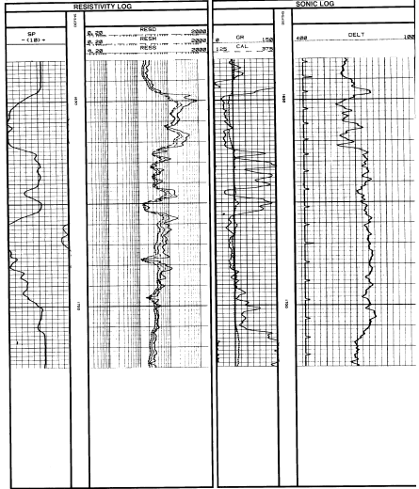

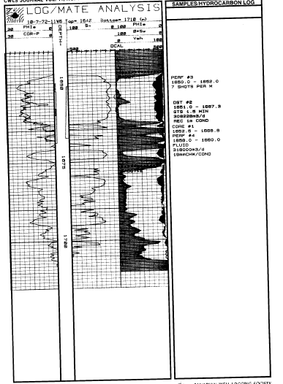

CWLS LOG ANALYSIS HANDBOOK
LOCATION:  WELL NAME: | POOL(S):  FIELD:  PROVINCE:
HAND CALCULATED ANALYSIS

 | ZONE/ DEPTH | LOG DATA |  |  |  |  |  |  | RESULTS
PT | Paddy/ Cadotte | RESD | RESM | RESS | PHIN | PHID | DELT | GR | VSH | PHIe | Sw | PHI-H | HYD-H | NET-H
1 | 1649-1653 | 175 | 200 | 400 | 11 | 24 | 280 | 22 | 0 | 19 | 18 | .76 | .62 | 4
2 | 1653-1656 | 150 | 150 | 300 | 15 | 18 | 280 | 30 | 6 | 16 | 23 | .48 | .37 | 3
3 | 1656-1663 | 175 | 225 | 400 | 12 | 20 | 280 | 25 | 2 | 16 | 21 | .96 | .76 | 6
4
5 | 1672-1674 | 80 | 120 | 260 | 10 | 17 | 240 | 29 | 5 | 13 | 38 | .26 | .16 | 2
6
7 | 1680-1683 | 45 | 65 | 100 | 9 | 19 | 220 | 32 | 7 | 14 | 47 | .42 | .22 | 3
8
9 | 1685-1688 | 33 | 43 | 60 | 12 | 8 | 215 | 38 | 12 | 8.3 | 94 | .36 | .02 | 0
10
11 | 1693-1694 | 40 | 48 | 60 | 11 | 16 | 228 | 45 | 18 | 12.0 | 58 | .18 | .08 | 1
12
13 | Net Pay Calculated using 0 = 9 SW = 60
14
15
LOG ANALYSIS COMMENTARY
The interval is typical of the best Paddy/Cadotte intervals in the Deep Basin area of Alberta. Density-Neutron log crossover due to gas is present, and rough hole conditions invalidate the density log in a few places. The Gamma Ray and Density-Neutron separation are good shale indicators, as in the SP except for the rounded derived from the density-neutron crossplot, and matches core if the density log is offset by a matrix value of 2690 Kg/m3 instead of the more usual 2650 value used in most sands. This is true for many sands in the deeper and older Cretaceous section including the Basal Quartz further south in Alberta. Water saturation can be calculated from the Simandoux or Dual Water method with fair reliability, using a water resistivity of 0.20 at formation temperature (this is an “area average” for the zone. The higher saturations in the Cadotte reflect the finer grained, higher clay content of the sand.

ACKNOWLEDGEMENTS
WELL OPERATOR: Dome Petroleum Ltd. PREPARED BY: E.R. Crain / V. Sels Date: 15/09/82
LOGS PROVIDED BY: Riley’s Data Share COMMENTARY BY: E.R. Crain
OPEN HOLE LOGS BY : Schlumberger COMPUTED LOG BY: Log/Mate Limited
HYDROCARBON LOGS BY: n/a CWLS CORPORATE MEMBERS FUNDED THIS PROJECT

