History of Well Logging in Canada

E. R. (Ross) Crain, P.Eng.
Log/Mate Limited
Calgary, Alberta, Canada
First published in Journal Canadian Petroleum Technology, February 1982
Reprinted Canadian Well Logging Society Journal, December 1982
Reprinted Canadian Well Logging Society Insite, Sept 2003

The history of well logging in Canada begins in 1937, a mere 10 years after the very first electric log was run in the Pechelbronn oilfield in France on September 5, 1927. A quote from the official Schlumberger history tells the story: “In another part of the country, a young engineer named Bill Gillingham was attempting to raise some interest in electric logging in the Bradford, Pennsylvania area. The response was not immediately tremendous. A trainee under Gillingham, R.R. Rieke, was told to head west by northwest, to Mt. Pleasant, Michigan, embarking on one of the strangest Schlumberger journeys you’ve heard of.”
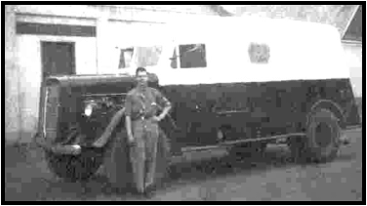
“You see, they ended up in Canada, not looking for oil, but for gold. The preliminary work had been conducted by Andre Allegret and, as a result of surface exploration, a contract had been let. When we arrived” Rieke said. ”Trouble was afoot. They had found gold alright, but not where the survey had said. When they drilled there – nothing. We left rather quickly.”
Two years, later, “electric logs” were introduced to the Canadian oil patch in 1939 by the forerunner of today’s Halliburton Services Ltd.

FIGURE 1: Early Halliburton Logging Truck c. 1946
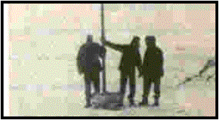

FIGURE 2: Showing Off at 55 Below Zero c. 1957
The first Halliburton unit was operated out of Black Diamond, Alberta by Jack Pettinger, who remained active until 1979. Jack and another pioneer, Stan Nelner, currently with Halliburton in London, England, recalled that trips of hundreds of miles to such far-flung wildcat sites as Kamsack, Saskatchewan, Pouce Coupe, B.C. and Lloydminster were not uncommon.
During the war years, equipment was also stationed at Norman Wells on the Canol Project and at Vermilion, Alberta.
The logger of those days had to be versatile because he was often called upon to operate cementing and acidizing equipment, or run drill-stem tests, in addition to the standard electrical survey (ES). With increased demands after the Leduc discovery in 1949, more modern survey equipment was added. Also, the “FM” (frequency modulated) system of transmitting sub-surface data via a single conductor cable was adopted by Halliburton. This technique remained a unique feature of the Halliburton-Welex wireline equipment for many years.
The approximate dates of first availability of modern logging methods, as recalled by Gerry Obermeyer, a manager of operations for Halliburton, were Focused Resistivity 1952, Radioactive 1954, Induction 1954, and Acoustic 1958. A shift in the development of Canadian operations also occurred in 1957 when the parent company purchased WELEX Incorporated. A combined WELEX-Halliburton Electrical Well Section operated in Canada as a separate company for some time. The perforating service, which had also been introduced to Canada by Halliburton in 1940, was expanded. Later, that group was adsorbed as an operating division of Halliburton Services Ltd.

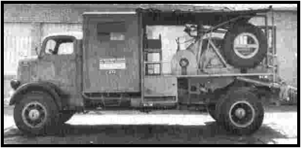
Schlumberger arrived permanently in Canada in 1946 by opening a location at Lloydminster, manned by such notables as Ed Burge, Hugh Gough, and Arne Thorson.
FIGURE 3: Early Schlumberger Truck c. 1949

Truck numbers were in the 200 series. One of the older units in Canada about that time required that the crew jack up the rear end and install a chain from the rear axle to the winch drive. Services offered were ES, six-shot sidewall core guns and bullet perforating.

By 1949, there were offices in Calgary and Edmonton, and Neil Collins was at the helm in booming Redwater. Barry McVicar had joined the forces as well. By 1951, tools available were ES, gamma ray, dipmeter, directional, cores, microlog, laterolog, limestone device, temperature, perforating and caliper.

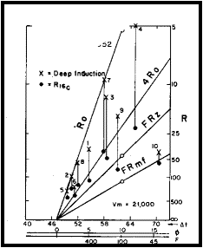
FIGURE 4: Wellsite Log Interpretation c. 1962

The year 1951 also saw the introduction of revolutionary armoured steel cable to replace the one inch diameter fabric-covered line known as the “ragline”.
A job report of that year mentions a trip to a well near Fort Vermillion that commenced the 26th of April and ended June 29th, with most of the intervening time spent attempting to get to the well by building bridges and barges, waiting for ferries, and sinking into mud. Ten years later (1961) saw the first logs to be run in Canada’s Arctic Islands at Winter Harbour on Melville Island.
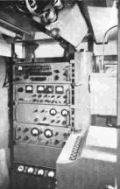
FIGURE 5: Inside an SLB logging truck c. 1962
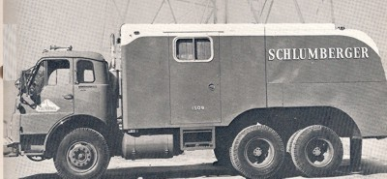
FIGURE 6: Truck #1509, brother to my first truck #1508
Since that epic event, operations have taken place in all the frontier areas from the misty Queen Charlottes to Hudson’s Bay, the East Coast offshore, the Beaufort Sea, and High Arctic on land and from ice-pads over the Arctic Ocean.
Lane-Wells established their first office in Edmonton on the Cooking Lake Trail in 1947, offering the usual GR log. They quickly opened stations in Stettler, Virden, Swift Current, Estevan, Drayton Valley, Red Deer, Swan Hills and Fort St. John, the hot spots of the time. The early managers were Bill Ludwig, Lee Lobdell and Glenn Robinson.
Perforating Guns of Canada Limited opened their first office in Edmonton and Calgary Trail in 1949. Walt Minor and Bill McKay were the people in charge. In the early 1950’s radiation logging for cased and open hole was one of the primary services available, out of the usual towns such as Lloydminster, Kindersley, Stettler, Estevan and Drayton Valley. In 1965, the name was changed to Pan Geo Atlas Canada Limited and open-hole logging services were introduced in the following year.
In July of 1968, PGAC and Lane-Wells merged into one larger operation under the auspices of Dresser Atlas Inc. The combined companies offered a full line of services from various Canadian locations thereafter.
McCullough Wireline Services were around in the early 50s and offered services mainly in the cased-hole field. Mart Kernahan, one of the early managers, became better known for his contribution to the early days of computed log analysis at Computrex Computer Services Limited in the early 60s. Mart recognized the potential of the scintillometer, developed at the University of Manitoba, and offered it in place of the less efficient Geiger-Muller GR counter – now nearly all GR logs are run with scintillation counters.
The late 50s and most of the 1960s saw a number of independent wireline operators appear on the scene. This trend continues today, with one of the notable successes being the acquisition of an interest in Wireline Electronics (1976) Limited by Perfco Services Limited in 1976. Later in the year, the management of Perfco and Wireline joined with Gearhart-Owen Inc. of Fort Worth, Texas, to offer the Gearhart direct digital logging system in Canada for open-hole logging under the name of Computalog Services Limited. Perfco, Wireline and Computalog operated somewhat independently until 1979 when they were amalgamated to form Computalog-Gearhart Limited.
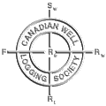
While the logging tools got better and more expensive, and the number of services grew, the interpretation of well logs remained at a relatively primitive state until 1951 when the first technical paper directly relating to interpretation of logs in Canada was published in The Canadian Mining and Metallurgical Bulletin in September of the year. The title of the paper was “Application of Electrical Logging in Canada” by M.P. Tixier and R.L. Forsythe. It was presented at the Annual General Meeting of CIM in Quebec City in April 1951. The paper dealt with the Leduc-Woodbend-Redwater discoveries and long-range correlations between the Nisku pools. Since that time, large numbers of technical papers have been presented at CIM meetings and more recently at the Canadian Well Logging Society meetings.
This section was updated July 2022.
The Canadian Well Logging Society was formed in 1954 after a group of people in the major oil companies and service companies in Canada perceived the need for the exchange of ideas and technical information. This was the first technical society in the world to exclusively promote the science of petrophysics. The pioneers of the CWLS were Al Brown, Ed Burge, Nick Ediger, Barry McVicar and Gerry Shaw. Barry claims to have provided the beer and Gerry the sandwiches at the organizational meeting in the 400 Club cardroom. At least we know from this what their priorities were.
Other important names involved in the early years of the CWLS were A.G.T. Weaver, A.A. Perebinossof, Leo Vladicka, Ted Connolly, Trev Cutmore, Don Tough, Bob Labelle, Percy Cole, Doug Morrison, and Mart Kernahan. Some important names may have been left from this list, and I hope that response from readers will generate a more complete history of the early years of the Society.
The Society was even brave enough to open a chapter in Regina, which was active between 1957 and 1961. Don Tough was one of the prime movers in this venture.
Although lunch and evening meetings were held for a number of years, there is no formal printed record of the topics or papers presented until 1968 with the appearance of CWLS Journal, Volume 1 and almost simultaneously the Transactions of the 2nd Formation Evaluation Symposium. Symposia had been held roughly every second year, and are now held jointly with the CSEG and CSPG. The Journal ceased publication briefly with Volume 10 in 1977 but was revitalized in 1982 by E. R. Crain, and it continued regularly until it was replaced by the CWLS InSite magazine in 2002.
An important function of the Society is the maintenance of the Water Resistivity Catalogue of Canada, with the most recent revision occurring in 2003.
The Society membership has grown from the initial complement of about 12 to something approaching 500 members. In addition, approximately 80 corporate members assist in financing the operations of the Society. Although this history is concerned mainly with well logging in Canada, it is important to note that the CWLS has a large list of members and officers from other disciplines related to formation evaluation, such as drill-stem testing, hydrocarbon logging, core analysis, and geological, geophysical, and reservoir engineering specialties.
The CWLS maintains direct liaison with the Society of Professional Well Log Analysts in the United States and with The Petroleum Society of CIM in Canada. These close relationships help to maintain the cross fertilization of ideas so necessary in a multidisciplinary function such as the petrophysical evaluation of well logs.
CWLS members developed the Log ASCII Standard (LAS) digital data file format for interchange of well log data. This is now the de-facto world standard for log data.

