The Evolution of Log Analysis Methods
E. R. Crain, P.Eng.
C. I. (Ganz) Caldwell
Log/Mate Limited
Calgary Alberta Canada
Invited article published in Offshore Resources Magazine in three installments in May, July, and September 1984. Reprinted in CWLS Journal February 1985. Published as Chapter One of “The Log Analysis Handbook”, Pennwell 1986. This electronic version created February 2001.
Author’s Note: An updated version that takes us into the new millennium appears in Chapter Two of Crain’s Petrophysical Handbook. ERC Jan 2021.
Introduction
The evolution of log analysis methods over the past seventy years is a fascinating and illuminating subject. Obsolete but traditional definitions, abbreviations, symbols, and methods still pervade the industry. Newcomers often wonder why these old-fashioned ideas persist. In many cases, methods were developed which required better logging tools or more powerful computational methods than were available at the time. Such methods fell into disuse, to be resurrected years later when the appropriate tools were developed. An appreciation of the history of logging and the development sequence of analytical methods will help any geologist, geophysicist, or engineer in his/her career.
Well logging is a relatively young science, but initial work in the field dates back over 130 years. As early as 1869, about the same time as Drake made the first discovery of oil in the USA, Lord Kelvin in Britain was making interpretations of heat flow in shallow well bores by measuring temperature versus depth.
Later, surface measurements of electrical resistance of rocks by Conrad Schlumberger in 1912 led him and his brother Marcel to consider similar measurements in boreholes. In 1927, they convinced the Pechlebronn Oil Company, drilling in Alsace, France, to try such electrical measurements as an aid to understanding the rock layers. The first such log in the USA was run on 17 August 1929 for Shell Oil Company in Kern County, California. The first well logs in Canada were run in 1937 for a gold exploration project in Ontario, and in 1939 for oil in Alberta. After the Great Depression, well logging was common worldwide.
The Early Years (1929 - 1949)
The first recognizable technical paper on log interpretation, by the Schlumberger brothers and E.G. Leonardon, describing the electrical resistivity log, was published in 1934. Log analysis using these new tools involved curve-shape recognition - still a valid and commonly used qualitative approach to interpretation. Log curve shapes are determined visually from the appearance of the recorded data when plotted versus depth. These curve shapes were related to rock sample and core description data to determine general rules-of-thumb for separating permeable, porous, oil bearing beds from non-productive zones.
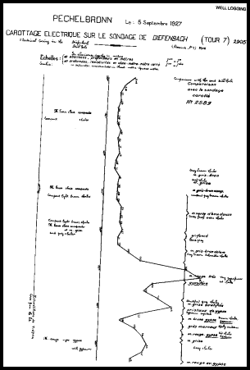
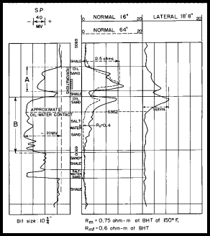
FIG 1: First Schlumberger Log 1927 FIG 1.02: Curve Shape Analysis 1950
The early success of curve shape interpretation was quite accidental. It depended on the fact that the formation water in the first wells logged was quite conductive due to dissolved salt. Had these logs been run in west Texas at the beginning of the twenties, the fresh water sands may have given such confused interpretations that well logging might never have become popular.
Seven years after the original Schlumberger paper, in 1941, G. E. Archie developed the empirical data behind the concept of "formation factor" - a term used to relate the porosity, the resistivity log reading, and the water saturation in the zone. This revolutionized log analysis, as the subject was now quantitative rather than only qualitative. In practice, however, the errors due to borehole effects on the measurements and uncertainty about other items relating formation factor to porosity, prevented really accurate results.
W. O. Winsauer, with others, modified the Archie equation slightly in 1952. This formula is used today but is commonly known as the Archie equation. M. P. Tixier of Schlumberger published the details of the so-called Rocky Mountain or resistivity ratio method in 1949. It was based on Archie's water saturation equation, but avoided the need to know porosity by using the ratio of deep and shallow resistivity readings.
Studies of invasion profiles and water chemistry reactions were thus common during this period.
From its earliest beginnings, the spontaneous potential log was interpreted by its curve shape. Since an SP voltage was developed across sandstones, and not along shale beds, it was relatively easy to identify sandstone from shale by the shape of the SP curve. Between 1943 and 1949, much work was done on the theory behind the spontaneous potential. Interpretation from this curve is still popular because it gives approximate values for formation water resistivity in clean (non-shaly) sandstone formations, or the shaliness of the formation in shaly sandstones.
Shale content calculations were enhanced by the appearance of the gamma ray log in 1934 because shale emitted natural gamma rays and clean sandstone and limestone did not. The log was calibrated to present a curve similar in shape to the spontaneous potential log. Although the gamma ray log has existed for seventy years, its appearance has not changed much. However, its resolution and accuracy have improved greatly due to more efficient and smaller gamma ray detectors.
The electrical, SP, and gamma ray logs all measured the average value of rock properties over eighteen inches to five feet of rock thickness. Beds thinner than this could not be detected or evaluated. The microlog was introduced in 1948 and allowed resistivity in beds as thin as two or three inches to be measured at a correspondingly shallow depth of investigation into the rock.
The curve shape approach to analysis was commonly used for microlog data, although laboratory derived charts allowed quantitative interpretation of formation factor, and as a result, porosity. The curve shape analysis for micrologs provided rapid visual identification of zones which were invaded by drilling fluid, and were thus permeable to some small degree. The log is still used today for this purpose.
The structural dip of rock formations is an important piece of knowledge for geologists. The first dipmeter log using three simultaneous spontaneous potential measurements spaced equally around the perimeter of the borehole, was run in 1942. It was superseded in 1947 by three simultaneous resistivity measurements. The theory of interpretation was simple. Slight offsets in the depth of the bed boundaries recorded by each of the three curves, plus the tool geometry, hole diameter, and tool orientation in space, could be reduced to give the dip of the bed boundary. Initially this was done by hand comparison, later in manually operated optical comparators and now by computer cross-correlation. The work was tedious and fraught with difficult decisions when the curves wiggled too much or not enough.
The modern dipmeter tool, first used in 1969, records four or more simultaneous resistivity curves, which provides considerable redundancy, and hence improved quality in the results. Data is often so good as to allow interpretation of stratigraphic features, such as crossbedding in sandstone deposits, as well as the much larger structural features of the rock layers detected by earlier tools.
The section gauge (or caliper log) also appeared in 1942 and made the application of borehole size corrections to all kinds of resistivity logs possible. The use of laboratory derived departure curves for this purpose, (between 1949 and 1955), was a common event in a log analyst's life. The corrections were seldom satisfying and may have been "gilding the lily" somewhat. Modern resistivity logs need little borehole correction if run in a well-designed mud system in a reasonably good hole.
Additional logging tools have existed for a long time, and are used as aids to interpretation of other logs. One is the formation tester, which measures the formation pressure and obtains a fluid sample, usually of the invaded zone. It was first run in 1957. Refinements with digital recording techniques proved very helpful in sorting out reservoir fluid content and reservoir continuity. The log made by the formation tester is of pressure versus time instead of a depth dependent log. Many such tests taken at different depths can provide a formation pressure versus depth log for analysis of pressure gradients.
The sidewall core gun (sample taker) was first used in 1942. It used a large hollow bullet, tied to the tool by wires, to retrieve a small plug of rock from the well bore. Anywhere from a few to forty eight bullets could be shot sequentially in one trip into the well. Other than an SP or GR correlation log taken for depth control, no real log is recorded by the sample taker. Other types of core retriever have been used with limited success.
The temperature log, used to detect entry of gas into the well bore, was made available about 1936. It was also used to determine formation temperature and temperature gradient.
Much evolution was going on behind the scenes that the log analyst never really appreciated, but the logging engineer did. The rag-line logging cable gave way in 1947 to steel armoured multiconductor cable, which was far stronger and more reliable. Today, fiber optic cables are sometimes used. The tools evolved from purely electrical devices with ammeters and voltmeters, to vacuum tubes in the late forties, to transistors in the early sixties and finally integrated circuits and computers in the seventies and eighties.
Trucks changed radically from short wheel base, open cab flat decks with equipment bolted to the floor and shaded from the elements by an umbrella, to canvas covered vans in the early forties. Bread wagon style panel vans appeared in the late forties, to be superseded by the six and ten wheel "corn binders" of the fifties and sixties. The air conditioned behemoths of today, that look ever so much like space age garbage trucks, are the result of the computer revolution.
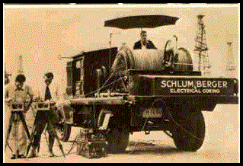

Figure 2: Very early logging truck c. 1930s
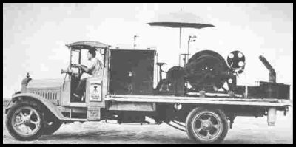

Figure 3: Very early logging truck c. 1930s
Service availability, both in the number of trucks and the number of locations where they were available, increased dramatically. The far flung network was held together by the professionalism and integrity of the early pioneers. Today it is big business – multi-national and vertically integrated.
Trucks were moved offshore by barge and boat in the forties, and finally in 1947 when you couldn't see land from the rig anymore, genuine offshore skid units were built and placed on the rigs. Wave compensation devices and corrosion engineering solved many initial problems by the late fifties.
In sum, the early years were a period of invention and ingenuity - solving problems as they arose, and surviving the Great Depression and World War II by sheer determination.
The Middle Years (1949 - 1969)
All the logs mentioned so far, except the caliper, needed a conductive fluid in the borehole in order to operate. The induction log was introduced in 1949 to overcome this requirement in holes drilled with air or oil based drilling mud. The log was calibrated to read rock conductivity by inducing currents with electromagnetic coils. Prior to this invention, logging tools impressed currents into the formation by means of direct application of voltages from the logging tool electrodes. Over the next ten years, the induction log also became popular in wells drilled with fresh mud.
Interpretation of water saturation became more reliable because of reduced borehole effect on the resistivity measurements, compared to conventional electrical resistivity logs. To some degree, bed boundary effects were more predictable and compensated for electronically. The induction log has evolved considerably over its fifty year life and is the most common log run today.
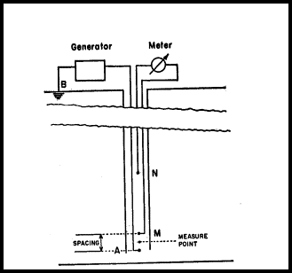
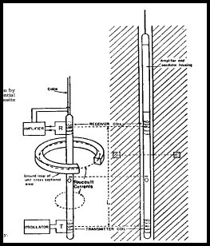
FIGURE 4: Comparison of Electrical Survey (ES) and Induction Log (IL)
The laterolog was also introduced in 1948 - 1949. It was a multi-electrode electrical log designed to minimize borehole effects in salty drilling mud. Again, improved resistivity values led to better water saturation and porosity determinations, still using the Archie method.
The microlaterolog, to replace the microlog in salt mud, was first seen in 1952. Curve-shape analysis was not easy, but standard Archie methods worked well with this data. Other similar tools, such as the proximity log, and the micro-spherically focused log, are variations of the microlaterolog designed to improve shallow resistivity measurements in a variety of borehole conditions.
Neutron logs first appeared in 1938, but were not common until 1946, when better sources of neutron radiation became more readily available. Neutrons emitted by the source, are absorbed by hydrogen atoms, which are common in water and petroleum. Qualitative interpretation of porosity (which contains water or oil) was possible by detecting the number of neutrons which were not absorbed but were scattered back to the detector. In some tools, the capture gamma rays created by the neutron bombardment were counted instead of the neutrons.
This was the first independent source of porosity information that did not rely on Archie's formation factor concept and the resistivity log data. The tool had, and has, its faults, but modern neutron logs are useful quantitative interpretation aids. Again, better detectors have increased the resolution and accuracy of the measurements. The modern version of the neutron log compensates for borehole size and a number of environment factors automatically.
The two-receiver acoustic travel time (sonic) log showed up in 1957. Laboratory work had demonstrated that the travel time of sound in a rock, after adjustments for fluid and matrix rock travel time values, was capable of estimating porosity. Thus, another independent source of porosity data was born.
M. J. Wyllie published an interpretation method for apparent porosity from the sonic log using the time average equation in 1956. It is one of the most common analysis methods in use. The laboratory work and relationships between porosity and sound velocity (or travel time) was exhaustively studied between 1940 and 1965. Much of the work was aimed at solving problems in seismic survey interpretations. Strangely enough, the Wyllie formula, for all its success over forty years of use in log interpretation, can be shown to be physically incorrect in the laboratory and in theory for many situations, especially those involving compressible fluids such as gas.
The sonic-resistivity crossplot was invented shortly after the sonic log. It allowed visual as well as quantitative presentation of porosity and water saturation results on one piece of paper without the use of additional charts, nomographs, or slide rules (hand calculators had not yet been invented). It was tedious work, but thousands of crossplots were made during the sixties, and a few less progressive analysts still use them today.
Quick look methods to differentiate hydrocarbon zones from water zones also followed the introduction of the sonic log. One such technique, the "Rwa Method", is still very popular. The principle used was to quickly calculate, from the Archie water saturation equation and the sonic log porosity value, the apparent water resistivity which would make the zone 100% water saturated.
If a particular value of water resistivity was considerably higher than the trend of many other values from above and below it in the borehole, then hydrocarbon could be suspected in the anomalous zone. No shale corrections were made, so shaly sands often showed poorly in this analysis.

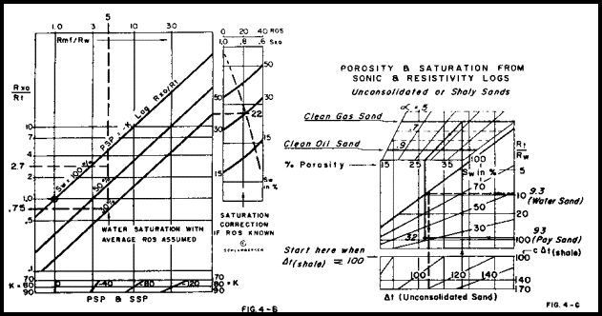
FIGURE 5: Sonic-Resistivity Crossplot Interpretation for Porosity and Water Saturation
Another quick look method is called the overlay method. The simplest approach was to overlay the resistivity log and the sonic log in such a way as to have the two curves fall on top of each other in the obvious water zones. Zones in which the resistivity log fell to the right of the sonic log were either potential pay zones or tight (non-porous).
The overlay method was improved by generating compatible scale logs so that scaling differences did not cause false shows. The compatibility could be created by transforming the resistivity and sonic curves to apparent porosity or to apparent formation factor. This was done at the wellsite by appropriate function formers in the surface electronics, or back in the office by use of computer processing.
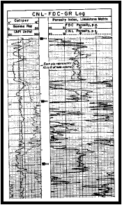
The invention of the logarithmic presentation for resistivity data, when the dual induction log was introduced in 1962, made quick look overlay methods even more popular and practical at the well site.
Many modern logs are designed to give good visual impressions of lithology, porosity, or hydrocarbon by means of compatible scale overlays. The density-neutron combination log is the most common example. The latest versions of computerized logging trucks even shade-in the separation between compatible scaled logs to emphasize the apparent prospective zones.
FIGURE 6: dual-spacing Neutron log, (CNL), and compensated formation density log, (FDC) combination.
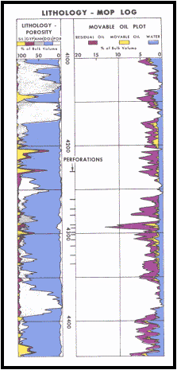
The density log was introduced in 1959. It was another independent source of porosity data. With three sources of apparent porosity, (sonic, neutron and density), in addition to the resistivity methods, it was now possible to account for more variables. This led to crossplot or chartbook methods which compared the apparent porosity values from two sources, to help identify lithology (shale content or limestone - dolomite ratio, for example).
The sonic-density crossplot was common in the early sixties, with the density-neutron crossplot becoming more common in the late sixties, as the neutron logs became better calibrated and scaled in porosity units.
Since a crossplot is merely the solution to three simultaneous equations in three unknowns, the use of computers to solve these equations was a popular subject in the early sixties. Extensions of this concept to four, five or six simultaneous equations demanded a computer since graphical methods could not cope with the multi-dimensional aspect of the job.

FIGURE 7: Early Computed Log c. 1966
The desired results from such methods are porosity and the percent of each matrix rock type present. Usually one extra component can be found for each additional independent logging tool measurement used in the simultaneous equations. The method suffered if the list of unknowns in the equations did not match the real rock sequence. This can be mitigated, at least in part, by allowing the computer program to search for the best lithologic model.
Linear programming (simultaneous equations with constraints) was tried. It was not very successful, because knowledge of rock properties, the so-called known data, was not really very well known. As well, tool response to rock mixtures was not well defined.
The late fifties and early sixties also saw a great deal of work in atomic physics and both the pulsed neutron (or atomic activation) log and natural gamma ray spectroscopy log were described. However, suitable tools did not become available until 1968, and were not common until 1971.
The pulsed neutron log provides another apparent porosity evaluation, as well as an independent assessment of water saturation. The logs are also called thermal decay time logs, chlorine logs, carbon/oxygen logs or spectral gamma ray logs (note the lack of the word "natural" in this case) depending on the details of the source-detector systems and the rock properties derived from the data. They are usually run in cased holes.
The natural gamma ray spectrolog allows interpretation of uranium, thorium and potassium content in a formation. This is used to help segregate shale from other naturally radioactive rocks, such as uranium bearing dolomites or potassium rich sandstones. In conjunction with other log data, it can help define the types of clay minerals present in the shales.
The nuclear-magnetic resonance log was described in 1956. The theory suggested that effective porosity and permeability could be determined from the measurements. Good examples of this are still rare even after nearly forty years of refinement - but Year 2000 versions of the tools will probably succeed.
Other methods for interpreting permeability, based on empirical relationships between porosity and water saturation had been presented prior to 1960 and are still used today. Some examples are the Timur, Wyllie-Rose, and Coates-Dumanoir methods.
Prediction of abnormally pressured zones, and potential drilling or blowout problems, were developed from the various porosity estimating logs, beginning in 1956. This was based on depth-trend line analysis of the sonic log primarily, although most logs, including density, neutron, and resistivity logs can be used.
The log types and interpretation methods discussed so far are all used in open-hole conditions, that is, after the well is drilled but before it is cased with pipe and cement, and finally completed to flow oil or gas (or heaven forbid, water). All the radioactive logs (gamma ray, spectral gamma ray, neutron, pulsed neutron) except density logs can be run in cased holes, and interpreted with approximate corrections for casing size and thickness.
Resistivity and older style sonic logs cannot be run in casing to obtain information about the rocks, although the sonic log is used to evaluate the cement behind the casing. Sonic wavetrain logs run through the casing are sometimes useful in evaluation of the rocks, but are most frequently used for cement evaluation. Recent versions of sonic logs use computer processing of the wavetrains to determine compressional, shear, and Stoneley wave travel times in both open and cased hole situations. Resistivity logging through casing is also being developed.
Other logs, such as temperature, flow-meter (spinner surveys), gradiomanometer (a fancy name for fluid density meter), and noise logs are used to assist in interpretation of the location, amount, and type of fluid flow in producing or injecting wells. The tools and techniques have evolved gradually since 1952, when the first serious effort was made to evaluate well performance with logging tools.
While the early years were clearly a period of invention of hardware and techniques, the middle years could be termed the period of understanding. Although significant new tools were developed, such as the sonic and density logs, the interpretation process required more formidable effort. Customers wanted more reliable answers along with the more reliable logging tools.
The Recent Years (1969 - 1985)
A major effort was made in the mid-sixties to perfect water saturation interpretation in shaly sands. Archie's equation was not designed for this situation. Many competing methods were proposed, but the fallout left the Simandoux equation (about 1965) with the Waxman-Smits method (1968) holding sway for a zealous few. Most of the methods, including Simandoux, suffer from lack of rigour or have a physically unsatisfying model. The Waxman-Smits method is theoretically acceptable but some of the data needed for the equations (such as cation exchange capacity of the rock) cannot be obtained from logs reliably. It is difficult and expensive to get from measurements on cores of real rocks, especially if there are no cores to be found from the zone in question.
Another approach is called the dual-water model (or bulk volume water method), published by various authors between 1968 and 197l. It segregates the total amount of water in a formation into two parts - that bound to the shale (bound-water) and that in the pore space (pore water). The method is currently popularized in most service company programs, both in the office and on the computerized logging trucks at the wellsite.
Controversy still rages over the best water saturation method and the ultimate water saturation equation has yet to be presented.
Water saturation interpretation in shaly sands and porosity determination were both being studied in the late sixties. With several independent sources of data, and with more unknowns than measurements, a new style of interpretation was proposed. Instead of solving a fixed set of simultaneous equations, various iterative solutions were used to minimize the change in one or several computed results.
The primary goal was to correct for shale, light hydrocarbon effect, heavy mineral effect, and to solve for porosity and lithology at the same time. Success depended greatly on log data quality and on how well the calculation model actually fit the real geology. Much work is still being done in this area and new approaches appear in journals yearly.
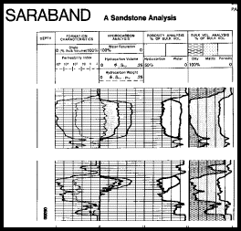
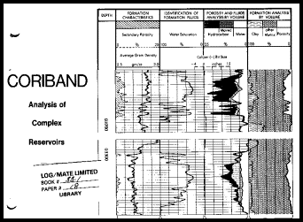
FIG 8: SARABAND Computed Log FIG 9: CORIBAND Computed Log c.1971
These models absolutely depended on high powered computers, digital data recording (first achieved in 1965) and great patience, since results did not appear quickly. Weeks or months might be needed to get results for even a small group of related wells. This situation has improved markedly since 1985.
More advanced computer programs for carbonate rocks appeared in 197l to provide a similar service as was available for the shaly sand situation. The goal in this program was automatic hydrocarbon correction and mineral identification.
The best known examples of these programs are Schlumberger's SARABAND (superseded by VOLAN and ELAN), CORIBAND, and Dresser Atlas' EPILOG products. All these methods are iterative refinements of the crossplot or simultaneous equation solutions.
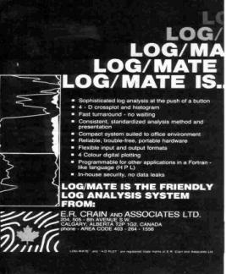
During the seventies and early eighties, these methods were programmed on low cost sophisticated hand calculators. If large volumes of data are required, desktop computers with digitizers, plotters and printers could be obtained from several sources. Today, the ubiquitous personal computer does the work at a fraction of the cost and time.
FIGURE 10: LOG/MATE, the first commercial desktop log analysis software package (1976)
The first truly portable stand-alone desktop system that did not require connection to a large mainframe computer was LOG/MATE, developed by the author and D. W. Curwen in 1976. This was 5 years before IBM "invented" the PC. It has since been mimicked and improved upon by many others, so that a wide range of such systems are available.
Timeshare systems using computer terminals to larger mainframes or mini-computers were first seen in 1965, and are still used. Both batch and interactive time share systems can be found in many oil companies, service companies, and consulting firms. The phrase "time sharing" has disappeared from computer lingo but the concept persists with local area networks, UNIX servers, and distributed computing.
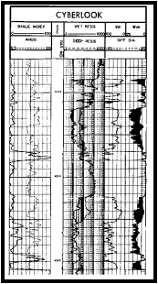
Log analysis methods vary from crude to complex and the quality of results varies with the knowledge and experience of the analyst. The quality and age of input data is always a problem to consider. Simpler systems, with a good analyst at the controls, often provide better results, because of the personal input and knowledge of the analyst. More complex programs tend to do unexpected things and are not easy to control, even by expert log analysts.
Moving the analysis from the office to the wellsite, to speed up decision making, has always been a driving force in interpretation techniques. Of course, all the manual methods described above could be performed at the wellsite, using charts and slide rules, and later with electronic calculators.
In 1963, attempts were made to interpret porosity and water saturation automatically by recording the so-called moveable oil plot. This involved analog processing of log curves to obtain the appropriate data. How many readers actually know what an analog computer is?

FIGURE 11: CYBERLOOK Computed Log Analysis c. 1976
While digital recording of well logs began in 1965, early trials of digital computation at the wellsite did not begin until 1972. After this date, the major service companies have almost completely replaced all their older analog logging units. This provided both log interpretation and calibration control by computer. The best known interpretation examples are Schlumberger's CYBERLOOK and Dresser's PROLOG products.
A number of new tools, revised uses of older tools, and significant advances in computer processing of log data have been introduced in the 1980's, and are gaining rapid acceptance by well operators.
Satellite transmission of log data from the wellsite to service company computer centers superseded the Telecopier and FAX machine in many areas, allowing faster decision making at the head office, somewhat to the detriment of local autonomy and egos.
The lithodensity log is an improved density log with reduced statistical variations on the density measurement, and a new curve - the photo electric capture cross-section curve, better known as the PE curve. Its' value depends on the rock lithology and is relatively unaffected by porosity and pore fluid type. Therefore, it can be used to assist in lithology identification in simultaneous equation solutions.
The natural gamma ray spectrolog, mentioned earlier, is now also widely used to resolve lithology problems, such as radioactive dolomite or granite wash formations, or to help define clay types in shale. It provides three primary curves - the potassium, thorium and uranium curves, which when summed, give the total gamma ray curve. These three curves, plus the three porosity curves (density, sonic and neutron), and the PE curve provide seven independent measurements of formation properties, which should allow a total of eight lithologic properties to be calculated from the data.
The three usual resistivity curves, the caliper curve(s), and data from the electromagnetic propagation log, which is presently being used to determine flushed zone water saturation, can be added to the list, for a total of 12 or more independent curves. It is clear that the solution mechanism is beyond chartbook and calculator capabilities. Most popular computer programs have been updated to provide specific hard-coded solutions for specific combinations of these tools and individual lithologic models. For example, Dresser lists eight different open hole and five cased hole programs to adapt to the changing times.
When one considers adding multiple passes of the thermal decay time log (pulsed neutron log) for each year of a well's life, the data explosion becomes increasingly difficult to cope with.
One product, called FACIOLOG, by Schlumberger, was an attempt to reduce this data overload to a minimum. It provides a detailed electro-facies log which, when calibrated to rock sample and core data, can be very useful in understanding depositional environments and well to well correlations. It can also be presented on a seismic time scale to assist in correlating normal seismic data, or vertical seismic profiles taken in the same well. Its’ visual appearance mimics the type of shading used by geologists while drawing their geological sample logs. Unfortunately, such interpretive log displays have not received wide acceptance.
Single well studies as described above lead directly to field and pool studies, seismic modelling, mapping, contouring, reservoir modelling and simulations which are topics not normally associated with well log analysis. Such studies are becoming commonplace, and are far more successful when the log data has been properly processed for the specific end-use, and integrated with all other geoscience disciplines.
A second approach by Schlumberger has been to create a universal log interpretation program, in which the log data suite, the lithologic model, and the log-rock response equations are provided by the user, instead of being hard coded. This product is called GLOBAL and can be classed as a linear programming solution. It has additional features which make it unique, such as a complete set of detailed environmental corrections, and a statistical evaluation section which attempts to minimize the inconsistency between input data sources and assumptions, and the interpretation model being used. The uncertainty in each input data value is also considered by the program. This approach is independent of the log interpretation model used which could be VOLAN or CORIBAND or any other model supplied by the user. Similar software is available now from several sources.
Another area of advance is in dipmeter interpretation, as more sophisticated computer programs provide more coherent data for evaluation of detailed stratigraphy and permeability direction. This is especially practical when combined with a product like FACIOLOG.
The nuclear magnetic log (sometimes called the unclear magnetic log because so few people understand how it really works) is also being pursued again for its ability to predict permeability, fluid viscosity, clay bound water, and irreducible water saturation.
These complex and expensive logging tools plus interpretation procedures have one thing in common - the capacity to improve oil and gas production if used properly. In order to reduce dependency on imported oil in Europe, USA, and Canada, it is necessary to exert this maximum effort on many wells. A minimum well evaluation effort is no longer considered a cost saving, but is instead an expensive loss of potential reserves.
The recent years in well logging can be termed the era of digital data, giving tool designers and analysts the power of the computer to bring to the surface more data of higher quality than ever before.
Log Interpretation in the Future
The future? It will probably involve artificial intelligence - the darling of the academic world in the 1980’s. Computer based expert systems will learn from experts in the field of log analysis, and will subsequently advise and consult with less expert users. As the expert system is increasingly used, its cleverness will heighten, until it is more intelligent than any single expert. Such hardware and software already exists, albeit for much simpler situations than log analysis. However, it is known that major service companies, oil companies, and consulting firms have embarked on research in this field, emphasizing log interpretation.
The success of a log analysis is judged by how well the analysis predicts the future performance of the completed zone. Many analysts and their managers are unaware whether their results were good or bad. Artificial intelligence with a learning data base, should provide the kind of "perfect memory" and the unbiased question/answer sequence needed to keep track of success and failure.
Hopefully we will learn how to do better work as time goes on, by studying the background to each success or failure, monitored automatically by the expert system.
The future holds the promise of a long sought goal in well logging - an automatic, universal interpretation program that never fails and adapts to change. Of course, this is just a dream, right?
Author’s Note: Thirty Five years have passed since the above was written and neither prediction seems any closer to fruition. What happened to all that research effort and all those prototype systems? See “The Future of Petrophysics in Reservoir Description” (Crain, 2000) for an update to this paper. ERC Jan 2021.

