UNICORNS IN THE GARDEN OF GOOD AND EVIL
PART 1 – Total Organic CARBON (TOC)
E. R. (Ross) Crain, P.Eng.
Spectrum 2000 Mindware Ltd
Published in CSPG Reservoir, Nov 2010.
Unicorns are beautiful, mythical beasts, much sought after by us mere mortals. The same is true for petrophysical models for unconventional reservoirs. This is the first in a series of review articles outlining the simple beauty of some practical methods for log analysis of the unusual.
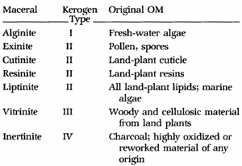
Total Organic CARBON (TOC) BASICS
Organic carbon or Kerogen content is usually associated with shales or silty shales, and is an indicator of potential hydrocarbon source rocks. Organic material can be subdivided into a number of types representing the source of the material.
Figure 1: Correlation between kerogen type, its source, and its maceral name. Macerals are organic matter names, somewhat akin to mineral names in the non-organic world
Organic content in gas shales is usually Type II, as opposed to coals, which contain mostly Type III. There is usually a strong correlation between TOC and adsorbed gas in gas shales. TOC correlations with gas content are sometimes used to predict specific gas content (Gc) instead of using detailed calculations with sorption curves.
High resistivity with some apparent porosity on a log analysis is a good indicator of organic content.
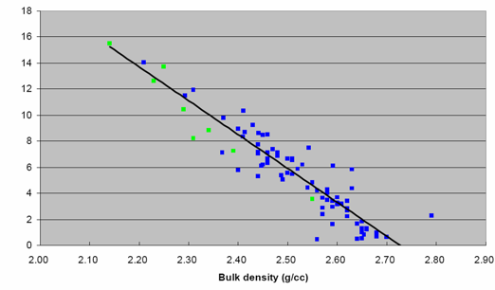
Correlation of core TOC values to log data leads to useful relationships for specific reservoirs. The one shown below is for the Barnett shale. A strong correlation exists in some shales with Uranium content from the spectral gamma ray log. In other cases, the relationship is made with density, resistivity, sonic, gamma ray, or combinations of these curves.
Figure 2: Typical correlation of TOC with density in Barnett Shale. Similar crossplots of sonic or neutron data can be used for specific reservoirs where TOC data is available from core.

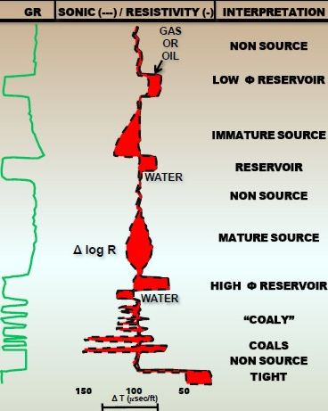
VISUAL ANALYSIS OF TOC FROM LOGS
Visual analysis for organic content is based on the porosity - resistivity overlay technique, widely used to locate possible hydrocarbon shows in conventional log analysis. By extending the method to radioactive zones instead of relatively clean zones, organic rich shales (potential source rocks, gas shales, oil shales) can be identified. Usually the sonic log is used as the porosity indicator but the neutron or density log would work as well.
The trick here is to align the sonic log on top of the logarithmic scale resistivity log so that the sonic curve lies on top of the resistivity curve in the low resistivity shales. Low resistivity shales are considered to be non-source rocks and are unlikely to be gas shales. Shales or silts with source rock potential will show considerable crossover between the sonic and resistivity curves (shaded red in the schematic example).
Figure 3: Schematic log showing sonic resistivity overlay in a variety of situations
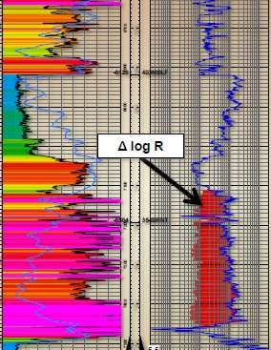

The absolute value of the sonic and resistivity in the low resistivity shale are called base-lines, and these base-lines will vary with depth of burial and geologic age.

Figure 4: Sonic resistivity overlay showing crossover in Barnett Shale, Texas
Crossplots of porosity and logarithm of resistivity can also be used to define and segregate source rocks from non-source rocks. See "Identification of Source Rocks on Wireline Logs by Density-Resistivity and Sonic-Resistivity Crossplots”, by B. L. Meyer and M. H. Nederlof, AAPG Bulletin, V. 68, P 121-129, 1984..The best description of the method is posted on the online magazine Search and Discovery, in "Direct Method for Determining Organic Shale Potential from Porosity and Resistivity Logs to Identify Possible Resource Plays” by Thomas Bowman, Article #110128, posted June 14, 2010. (Figures 3 through 6 are from this reference).
These crossplots usually show a non-source rock trend line (Figure 5) on the southwest edge of the data (similar to the water line on a Pickett plot) and a cluster of source rock data to the right of the non-source line, as shown in the image of Figure 5. The slope and intercept of the non-source line is used to calculate a pseudo-sonic log, DtR, from the resistivity log, which can then be plotted on the same scale as the original sonic log.
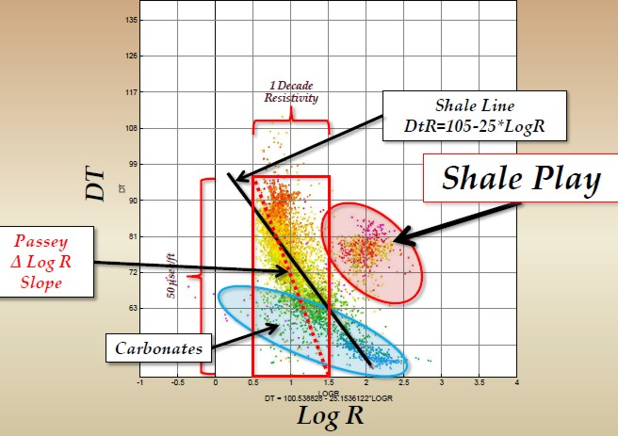

Figure 5: Sonic versus logarithm of resistivity (DlogR) Crossplot showing non-source rock trendline and source rock cluster of data. The equation of the non-source rock line is DtR = 105 - 25 log(RESD) for this Barnett Shale example.
As for the manual overlay technique described above, crossover indicates source rock potential, shale gas, or an oil shale, or if the zone is clean, a potential conventional hydrocarbon pay zone.

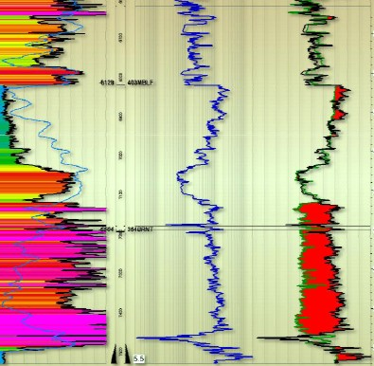

Figure 6: An example of a DtR log. Original sonic log (black curve) and calculated DtR curve (shaded red) showing potential source rock or, as in this case, gas shale (Barnett)

PASSEY'S "DlogR" METHOD
Various methods for quantifying organic content from well logs have been published. The most common method is based on sonic versus resistivity. The method has been revised and modified by others. It is also known as the "D log R" method (with or without spaces and hyphens between the characters). The "D" was originally the Greek letter Delta (ΔlogR). See "A Practical Model for Organic Richness from Porosity and Resistivity Logs" by Q. R. Passey, S. Creaney, J. B. Kulla, F. J. Moretti, and J. D. Stroud, AAPG Bulletin, V. 74, P 1777-1794, 1990. The basic equations of the Passey model are:
1: DlogR = log (RESD / RESDbase) + 0.02 * (DTC – DTCbase)
2: Wtoc = DLogR * 10^(0.297 – 0.1688 * LOM)
3: WT%toc = 100 * Wtoc
Where:
RESD = deep resistivity in any zone (ohm-m)
RESDbase = deep resistivity baseline in non-source rock (ohm-m)
DTC = compressional; sonic log reading in any zone (usec/ft)
DTCbase = Sonic baseline in non-source rock (usec/ft)
DlogR = Passey’s number (fractional)
LOM = level of organic maturity (unitless)
Wtoc = total organic carbon (weight fraction)
WT%toc = total organic carbon (weight percent)
Divide metric DTC values by 3.281 to get usec/ft. DTC and DTCbase can be replaced with DENS (g/cc) and PHIN (fractional) values, with a corresponding change in the constant (+0.02) to -2.5 for DENS and +4.0 for PHIN. Density of TOC is about 0.94 to 0.98 g/cc.
Numerical Example:
RESD | RESDbase | DTC | DTCbase | LOM | DENS | DENSbase | PHIN | PHINbase
25 | 4 | 100 | 62 | 8.5 | 2.35 | 2.65 | 0.34 | 0.15

DTC DENS PHIN
DlogR = 1.556 1.546 1.556
Wtoc = 0.113 0.113 0.113 weight fraction

In practice, it is rare to have both TOC laboratory measurements and reliable organic maturity data to assist in calibration. Chose a value for LOM that will result in a match with available TOC data. Vitrinite reflectance (Ro) values may be available and are converted to LOM with the graph in Figure 7. LOM is typically in the range of 6 to 12 but could be as low as 4.
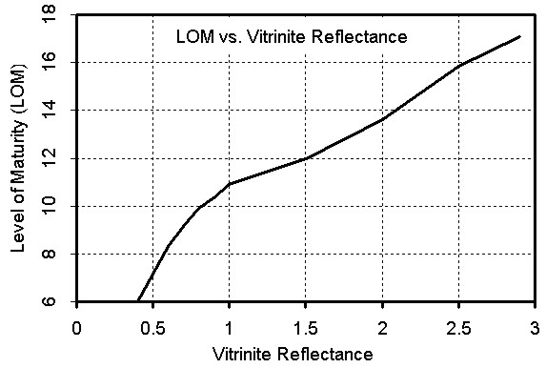
Figure 7: Graph for finding Level of Organic Maturity from Vitrinite Reflectance. Higher LOM reduces calculated TOC. Some petrophysicists do not believe this chart, and use regression techniques on measured TOC to estimate LOM - see Figure 11 for an example.
ISSLER'S METHOD
Dale Issler published a model specifically tuned to Western Canada in "Organic Carbon Content Determined from Well Logs: Examples from Cretaceous Sediments of Western Canada" by Dale Issler, Kezhen Hu, John Bloch, and John Katsube, GSC Open File 4362. It is based on density vs resistivity and sonic vs resistivity crossplots (other methods are also described in the above paper).
The crossplots were redrafted in Excel, as shown in Figures 8 and 9, and a drop-through code developed to generate TOC, based on the lines on the graphs. No doubt there is a simpler way to code this, but I didn't have time to sort it out. A spreadsheet is available free from my website at www.spec2000.net that will do the math for you. An example from Issler’s paper of the sonic resistivity method and Passey’s Dlog R method are shown in Figure 11.
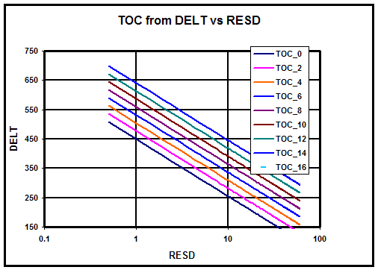 Figure 8 : DTC vs RESD
Figure 9 : DENS vs RESD 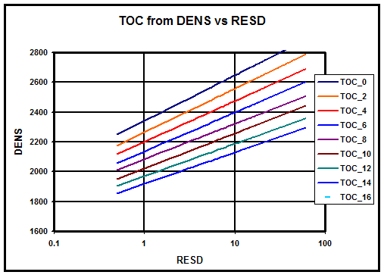

TOC calculated from DTC vs RESD crossplot is most easily done by a series of IF statements. This can be coded into a spreadsheet or software package that allows user defined equations. Note that sonic and density data are in Metric units. You can download a spreadsheet from my website at www.spec2000.net/00-downloads.htm
Numerical Example:
RESD DTC DENS
English 25 100 2.35
Metric 25 328 2350
Wtoc (RESD-DTC crossplot) = 0.11 weight fraction
Wtoc (RESD-DENS crossplot) = 0.10 weight fraction

TOC ANALYSIS EXAMPLES
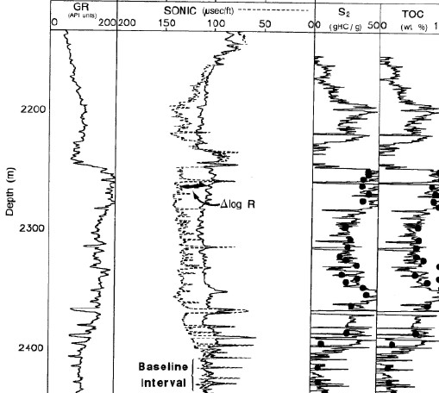
Figure 10: TOC calculated from Passey DlogR Method. The sonic resistivity overlay is shown in Track 2. Sonic is a dashed line, resistivity is solid line on a scale of 0.01 to 100 ohm-m. TOC is from Passey equation. There are numerous published examples with much worse correlations between calculated and measured TOC, usually attributed to varying proportions of Type I, II, and III kerogen or mineral variations (calcite, dolomite, pyrite, and quartz) in the shale. (Halliburton example)
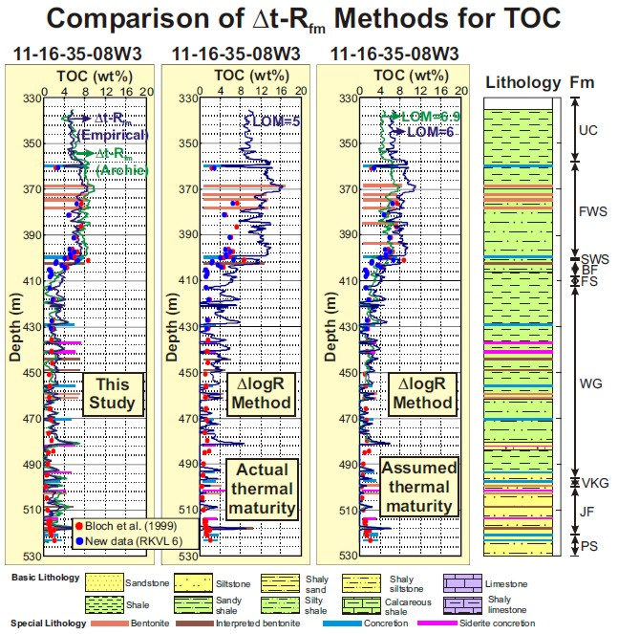
Figure 11: A comparison of the DlogR method with the Issler model. Both methods use sonic and resistivity logs to calculate the depth variation in TOC. Red dots represent measured TOC analyzed on ore samples using a Rock-Eval 2 instrument; blue dots represent re-analyses of the same samples using a Rock-Eval 6 instrument. For the Issler model, results are presented for both empirical (blue) and Archie (green) resistivity porosity methods. The DlogR method gives poor results for this well when observed thermal maturity is used (LOM = 5.0) An LOM value of 6.9 provides a good fit to the data but it is not representative of the true LOM (see right hand log track). Illustration from Issler’s paper.

