POTASH REDUX
E. R. (Ross) Crain, P.Eng.
Spectrum 2000 Mindware Ltd
Published in CWLS InSite, Dec 2010.
INTRODUCTION
Potash was a hot topic in the early 1960’s when I was a young logging engineer assigned at Lanigan, SK with one operator and a bread wagon (equivalent to today’s “cube-van”). We dripped oil-base mud into the motel and all along the Yellowhead from Saskatoon to Yorkton. Recent potash price peaks have encouraged a renewed interest in potash, and numerous email inquiries based on my 1964 work to calibrate gamma ray log response to potash ore grade, co-written with Bill Anderson. For those who are unfamiliar with potash, and those who are tired of the ordinary grind, looking for romantic adventure, this story may be a useful escape from the four walls of today’s more mundane petrophysical models.

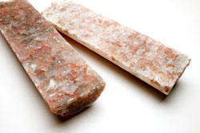
POTASH basicS
Potash refers to potassium compounds and potassium-bearing minerals, the most common being potassium chloride. The term "potash" comes from the old method of making potassium carbonate by leaching wood ashes and evaporating the solution in large iron pots, leaving a white residue called "pot ash".
Figure 1: Potash salt core, slabbed and ready for inspection
Later, "potash" became the term widely applied to naturally occurring potassium salts and the commercial product derived from them. The main potash salts are sylvite, carnalite, langbeinite, and polyhalite, mixed in varying concentrations with halite (rock salt). The main use of potash is as fertilizer.
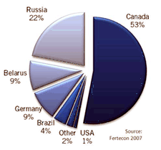
Sylvinite is the most important ore for the production of potash in North America. It is a mechanical mixture of sylvite (KCl, or potassium chloride) and halite (NaCl, or sodium chloride). Most Canadian operations mine sylvinite with proportions of about 31% KCl and 66% NaCl with the balance being insoluble clays, anhydrite, and in some locations carnallite. Sylvinite ores are beneficiated by flotation, dissolution-recrystallization, "heavies" separations, or combinations of these processes.
Figure 2: Potash production statistics 2010
The major source of potash in the world is from the Devonian Prairie Evaporite Formation in Saskatchewan, which provides 11 million tons per year. Russia is second at 6.9 million and the USA (mostly from New Mexico) at 1.2 million tons per year. A dozen other countries in Europe, Middle East, and South America produce potash from evaporite deposits.
Potash can be mined mechanically by underground machinery or by solution mining using ambient or warmed water. Halite (salt) for human use or road de-icing can be mined the same ways. Potash ores contain halite as well, so the by-product of potash extraction is road salt. In earlier times, salt was more valuable per ounce than gold, as it was essential to human life. A person "worth his salt" was one who contributed his fair share to the community.
The word potash is used in several different contexts in the literature. Here are some variations:

Table 1 Common Name | Chemical Name | Formula
Potash fertilizer | potassium oxide | K₂O
Caustic potash or potash lye | potassium hydroxide | KOH
Carbonate of potash, salts of tartar, or pearlash | potassium carbonate | K₂CO₃
Chlorate of potash | potassium chlorate | KClO₃
Muriate of potash (MOP) | potassium chloride | KCl
Nitrate of potash or saltpeter | potassium nitrate | KNO₃
Permanganate of potash | potassium permanganate | KMnO₄

PETROPHYSICAL PROPERTIES OF POTASH
Potassium is radioactive so the gamma ray log is used to identify potash bearing zones. Potash minerals have distinctive physical properties on other logs, so conventional multi-mineral models can be used to determine the mineral mixture, just as we do in carbonates in the oil and gas environment.

For consistency, potash ore and fertilizer concentrations are rated by their equivalent K2O content. Some literature can be confusing because they rate the ore by its potassium content (K) or potassium chloride content (KCl), The table below lists the physical properties of potash minerals, including K and K2O values. The GR (API units) entry in the table do not seem to match any known correlation, so some caution is urged.

Table 2 POTASH MINERAL PROPERTIES
Mineral Halite Sylvite Carnallite Insolubles Langbeinite Polyhalite Units
Formula NaCl KCl KMgCl₃●6H₂O Clay K₂SO₄Mg₂(SO₄)₂ K₂SO₄Mg(SO₄)(Ca(SO₄))₂●2H₂O
Potassium (K) Content 0.00 0.524 0.141 0.08 - 0.10 0.188 0.130 weight fraction
Gamma Ray 0 747 200 120 - 150 268 185 API Units (linear tool)
Apparent K2O Content 0.00 0.63 0.17 0.10 - 0.15 0.225 0.156 weight fraction
Hydrogen Index 0.00 - 0.02 0.60 0.30 - 0.40 - 0.01 0.25 fractional
Sonic Travel Time 67.0 74.0 78.0 90.0 - 120.0 52.0 57.0 microseconds per foot
Density (log) 2.03 1.86 1.57 2.35 - 2.65 2.82 2.78 gram/cc
Density (true) 2.16 1.98 1.61 2.35 - 2.65 2.83 2.79 gram/cc
Photoelectric 4.72 8.76 4.29 1.45 - 3.50 3.56 4.32 capture units

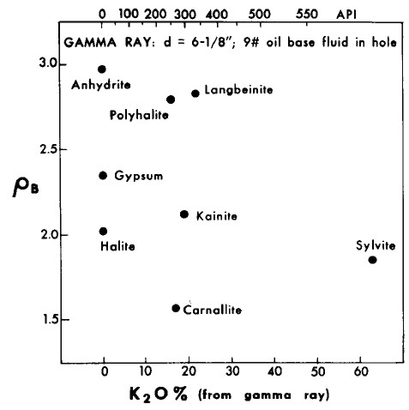
Figure 3: Gamma ray versus density crossplot of evaporite minerals used for mineral identification.

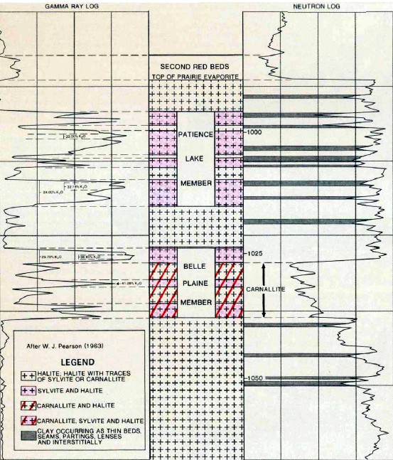
Figure 4: Example gamma ray and neutron log from Saskatchewan showing halite, sylvite, carnallite, and clay responses. In the exploration heyday in Saskatchewan in the 1960's, we presented the gamma ray across 3 tracks of the log, giving a scale of 0 to 450 API units (or 0 to 600) across 7.5 inches of paper. This was sufficient resolution for accurate evaluation and eliminated the need for GR backup curves cramped into Track 1.

POTASH ANALYSIS CONCEPTS – OLDER LOGS
Since potassium is radioactive, the K2O content can be derived from gamma ray logs, and this technique has been used since the 1960's. In 1964, I was stationed in Lanigan, Saskatchewan to run logs in potash exploration wells. While there, I scrounged a personal tour of the Esterhazy potash mine, then only two years old. This was the first and only time I have seen geological structure and stratigraphy from the "inside" of the rock. Truly amazing!

No direct calibration between GR and K2O had been developed up to that time, so I convinced a client to let me see his core assay data. After adjusting for hole size, mud weight, and bed thickness, a reasonable relationship was found, and was published as "Quantitative Log Evaluation of the Prairie Evaporite Formation of Saskatchewan" by E. R. Crain and W. B. Anderson, Journal of Canadian Petroleum Technology, Quebec City and Edmonton, July-September, 1966.

The work was subsequently reprinted in five other papers by various authors, some included updates as tool technology evolved. The original GR correlation was unchanged, widely distributed, and was the standard for potash analysis from oilfield style logs run prior to the era of digital logs in the 1980's. Most analog oil field GR logs were non-linear above about 300 API units due to dead time in the counting circuit. These older logs are still available in the well files and were recently used by Saskatchewan Industry and Resources to update their potash isopach and ore grade maps.

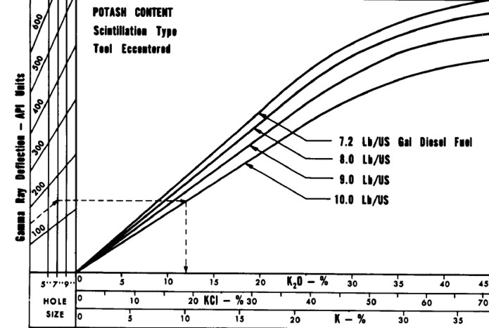Figure 5: K2O versus Gamma Ray relationship for analog Schlumberger tools circa 1960 - 1980, run in open hole with oil based mud. Tools from other service companies may differ. Correlation between log and core assay data for specific cases is strongly recommended.

GAMMA RAY BOREHOLE CORRECTIONS
The hole size and mud weight corrections derived from the data, and embedded in the above chart, were:
1. GRh = GR * (1.0 +.0.05 * (HS - 6.0)) + (320 * (HS - 6.0)) / (GR + 100.0)
2. GRc = GRh * (1.0 + 0.10 * (WM - 7.2))

Where:
GR = gamma ray log reading (API)
GRc = GR corrected for hole size and mud weight (API)
GRh = GR corrected for hole size (API)
HS = hole size (inches)
WM = mud weight (lb/gal)

POTASH ORE GRADE FROM GAMMA RAY
K2O from GRc
GR API | K20
0 | 0.0
45 | 2.5
90 | 5.0
135 | 7.5
175 | 10.0
220 | 12.5
265 | 15.0
310 | 17.5
355 | 20.0
400 | 22.5
435 | 25.0
470 | 27.5
505 | 30.0
530 | 32.5
550 | 35.0
565 | 37.5
580 | 40.0
590 | 42.5
600 | 45.0
605 | 47.5
K2O content was derived from GRc using the lookup table shown at the right. It is linear up to 400 API units and exponential thereafter. Values in the table represent a 6 inch borehole filled with diesel at 7.2 lb/gal. The linear portion of the lookup table is represented by:
3: IF GRc <= 400
4: THEN K2O = 0.05625 * GRc
5: OTHERWISE Use Lookup Table

The slope in the above equation can be determined by correlation to core assay data for other hole sizes or other tool types.

The non-linear relationship must be honoured while analyzing these older logs for potash. The effect is negligible for conventional oil field applications. Modern digital tools are linear up to about 1000 API units so the discussion in this Section does not apply.

A 1967 paper showed a linear GR relationship up to 650 API units for the McCullough tool, but its use was not widespread in Canada. That graph showed 600 API units was equivalent to 45% K2O, identical to my original data, but the slope of the line at lower GR readings was different. No mud weight correction was implied but a bed thickness correction similar to mine was presented.

In the analog era, GR logs were calibrated to a secondary standard based on the API GR test pit in Houston which contained an artificial radioactive formation defined as 200 API units in an 8 inch borehole filled with 10 lb/gal mud.

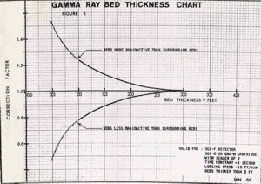
However, there were no published borehole size or mud weight correction charts for the GR log. These effects are large enough to seriously compromise the correlation.
BED THICKNESS ISSUES
Bed thickness corrections are also needed for beds less than 3 feet thick (1 meter). This is true even for modern logs. The chart shown at the right illustrates the importance of normalizing the GR log for these factors. Unfortunately, my original data plots for this work were lost in the bowels of a Schlumberger shredder many years ago - it would have been nice to recalibrate the work with the power of non-linear regression in a good statistics package.
Figure 6: Empirical bed thickness correction chart for older GR logs
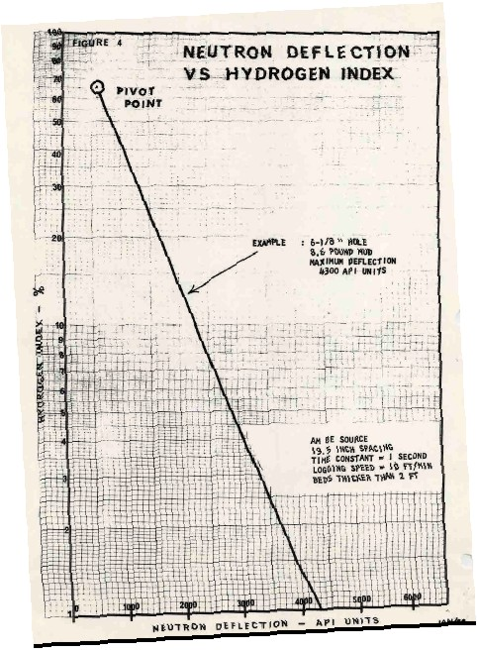
NON-OILFIELD GAMMA RAY TOOLS
Many potash exploration wells in the USA and elsewhere were logged with slim hole GR tools intended for uranium work. While they may have been more linear, they were not usually calibrated to any standard, suffered from larger borehole effects, and were recorded in counts per second (cps). Specific correlations to core assay data on a well by well basis are required for these wells. More on this later.

USING ANCIENT NEUTRON LOGS
Due to the water of hydration associated with carnallite, the neutron log is very useful for distinguishing between carnallite and sylvite. High neutron count rates mean low hydrogen index, thus sylvite and not carnallite.
Figure 7: Empirical neutron porosity chart for older neutron logs
To quantify the relative amounts of carnallite and sylvite, the neutron response must be converted to porosity from count rates using the standard semi-logarithmic relationship. A typical transform for a 1960's era Schlumberger tool is shown at the right. Charts for other tools can be found in ancient service company chart books. With the advent of the sidewall neutron log in 1969 and later the compensated neutron log, this transform was no longer required.
USING SONIC AND DENSITY LOGS
Some wells were logged with sonic and/or density logs which also could be used quantitatively with the GR and neutron to provide a potash assay. This was important where core was lost or for regional exploration when core data, but not the logs, were proprietary. The logic behind these models is shown below. A later section of this article deals with the use of more modern logs.
POTASH ANALYSIS ModelS – OLDER LOGS
My original computer program for potash analysis was written for the IBM 1620 in Regina in 1964. The model was based on four simultaneous equations that define the response of the available logs. Although this seems like a long time ago, nothing has changed except the improved tool accuracy. If you want to analyze the older log suites, here's how to do it.
The minerals sought are halite (rock salt), sylvite, carnallite, and insolubles or clay. The only logs available on old wells are resistivity, sonic, neutron, and total gamma ray. The resistivity is not a helpful discriminator, except as a shale bed indicator, so it is not used in the simultaneous solution. These evaporite beds contain potassium and ore grade is measured in units of potassium oxide (K2O). K20 is obtained from a gamma ray log, corrected for borehole size and mud weight, using a non-linear transform derived from core assay data. In middle aged wells, the density log is also helpful, and in modern wells the PE curve can be added. Further, the gamma ray response is linear on modern wells so the transform to K2O is not as difficult to obtain.
The equations are:
1.00 = Vsalt + Vsylv + Vcarn + Vclay
K20 = 0.00 * Vsalt + 0.63 * Vsylv + 0.17 * Vcarn + 0.05 * Vclay
PHIN = 0.00 * Vsalt + 0.00 * Vsylv + 0.65 * Vcarn + 0.30 * Vclay
DELT = 67 * Vsalt + 74 * Vsylv + 78 * Vcarn + 120 * Vclay
K2O is obtained, after borehole correcting the GR, from the equations and lookup table shown earlier, or from a fresh correlation based on specific data from the wells under study. Note that the chart and table given earlier are in percent K2O and this set of equations expects fractional units for K2O, neutron porosity, and all output volumes. Parameters in the sonic equation are in μsec/ft.
When solved by algebraic means, these equations become:
1: Vclay = 0.0207 * DELT - 0.23 * K20 - 0.29 * PHIN - 1.3891
2: Vcarn = 1.54 * PHIN - 0.46 * Z
3: Vsylv = 1.59 * K20 - 0.41 * PHIN + 0.04 * Z
4: Vsalt = 1.00 - Vclay - Vsylv - Vcarn
These equations were derived with DELT in μsec/ft. All constants will be different if DELT is in us/m.
To convert from mineral fraction to K2O equivalent (K2O equivalent is the way potash ores are rated), the final analysis follows:
5: K2Osylv = 0.63 * Vsylv
6: K2Ocarn = 0.17 * Vcarn
7: K2Ototal = K2Osylv + K2Ocarn
EFFECT OF OCCLUDED WATER
If occluded water (V) is added to the desired results, the equations become:
1.00 = Vwtr + Vsalt + Vsylv + Vcarn + Vclay
K20 = 0.00 * Vsalt + 0.63 * Vsylv + 0.17 * Vcarn + 0.05 * Vclay
PHIN = 1.00 * Vwtr + 0.00 * Vsalt + 0.00 * Vsylv + 0.65 * Vcarn + 0.30 * Vclay
DELT = C + 67 * Vsalt + 74 * Vsylv + 78 * Vcarn + 120 * Vclay
Where:
Vwtr = PHIN value in pure salt above the zone of interest.
C = DELT in salt minus 67 μsec/ft.
Reduction of these equations results in:
8: Vclay = 0.0207 * (DELT - C) - 2.23 * K20 - 0.29 * (PHIN - V) - 1.3891
9: Vcarn = 1.54 * (PHIN - V) - 0.64 * Z
10: Vsylv = 1.59 * K20 - 0.41 * (PHIN - V) - 0.04 * Z
11: Vsalt = 1.00 - Vsylv - Vcarn - Vclay - Vwtr
These equations show the use of constraints (Vwtr and C) on the otherwise underdetermined linear simultaneous equations. The first set of equations is exactly determined, and the second set are underdetermined until Vwtr and C are defined. If the density or PE equation were added, then the set would be exactly determined and the strategy of finding Vwtr and C in the pure salt bed would not be needed. This work was done in Saskatchewan before density logs were common, so the density equation was not used at that time.
POTASH MASS (WEIGHT) FRACTION
Conversion to K20 equivalent remains the same as before. Note that mineral fractions are in volume fractions. To convert to weight fraction, one more step is needed. By using the density of each mineral times the volume fraction, summing these to get the total rock weight, then dividing each individual weight by the rock weight, we get weight fraction of each. This allows comparison to core assay data which are reported in weight fraction or percent. The same math is used in tar sands and coal analysis to allow comparison to lab data:
12: WTclay = Vclay * 2.35
13: WTcarn = Vcarn * 1.61
14: WTsylv = Vsylv * 1.98
15: WTsalt = Vsalt * 2.16
16: WTwtr = Vwtr * 1.10
17: WTrock = WTclay + WTcarn + WTsylv + WTsalt + WTwtr
Mass fraction or weight percent values are obtained by dividing individual weights by WTrock. for example:
18: Wsylv = WTsylv / WTrock
19: Wcarn = WTcarn / WTrock
20: WT%sylv = 100 * Wsylv
21: WT%carn = 100 * Wcarn
Where:
Vxxx = volume fraction of a component
WTxxx = weight of a component (grams)
Wxxx = mass fraction of a component
WT%xxx = weight percent of a component

POTASH ANALYSIS MODELS – MODERN LOGS
With a modern suite of calibrated logs, we can use conventional multi-mineral models to calculate a potash assay. With GR, neutron, sonic, density, and PE, we can solve for halite, sylvite, carnallite, clay (insolubles or shale stringers), and water (occluded in many salts as isolated pores). The potassium curve from a spectra gamma ray log might also prove useful, if the detector system is linear and does not saturate.

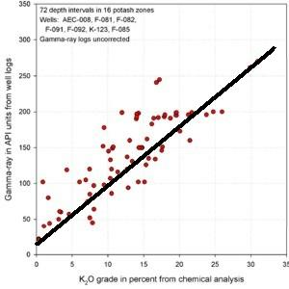
The mathematical methods are similar to those shown above, except that more log curves can be added to the simultaneous equation set, and constraints for occluded water can be replaced by specific numerical solutions.

Figure 8: K2O vs GR correlation for a modern GR log

If other potash minerals are present, such as polyhalite, these can be added to the equation set if enough log curves are available to maintain an exactly- or over-determined solution. Matrix rock properties for the minerals were shown earlier in this article. Water is treated as a "mineral" so that it can be segregated from the water of hydration in carnallite.

The first step is to correct the gamma ray for borehole and mud weight effects, using the appropriate service company correction charts. The other logs seldom need much correction as the potash is not especially deep or hot. However, if a water based mud was used, it will have a high salinity, so a salinity correction for the neutron log may be required.

The second step is to confirm the GR to K2O correlation using any available potash core assay data. Since modern GR logs are more linear than older tools, the relationship should be a relatively straight line and can be extended beyond the available core data, as shown in Figure 8.

SPECIAL CASES
There are numerous situations which require special treatment and some imaginative work-arounds by the petrophysicist.

Incomplete Logging Suite
Here we must include fewer minerals in the model. Isolated water is easy to ignore, and insoluble clay comes next, although it is an important economic factor in the extraction process. In the worst case, we might need to settle for K2O from the gamma ray and a sylvite / carnalite discriminator based on the neutron log. This situation occurs most often when potash geologists are using logs in wells drilled originally for oil or gas, in which potash evaluation was not considered as a priority.

Through Casing Logs
The most obvious problem will be to correct the gamma ray log for casing size and weight, cement sheath thickness, and borehole fluid weight using service company correction charts. Where core assay data is available from the well or from reasonably close offsets, the GR to K2O relationship can be confirmed. The second problem is usually an incomplete logging suite, as described above. If a through casing neutron log is available, scaled or not, a carnallite flag can be created.

Thin Bed Problems
This issue affects all logs used for all purposes, but can seriously affect potash evaluation in areas where thin beds predominate. An approach was shown earlier using a bed thickness correction chart. Another approach is to correlate K2O times thickness to GR times thickness instead of a direct GR to K2O transform. This is best suited to hand-picked data, as thickness is not so easily determined automatically in most log analysis software. The US Geological Survey published an example, originally developed by Jim Lewis of Intrepid Mining for a New Mexico case study. The pertinent crossplots from his work are shown below. The regression has much less scatter on the GR times thickness plots. This method was originally suggested in a 1967 paper describing the use of McCullough GR logs for potash evaluation.

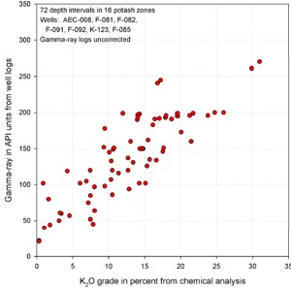 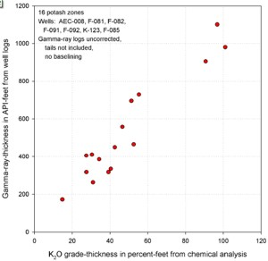
Figures 9A and 9B: /GR in API units vs K20 (left) shows poor correlation due to thin bed effects.
GR-thickness vs K2O-thickness products (right) correlate much better (regression lines not shown).
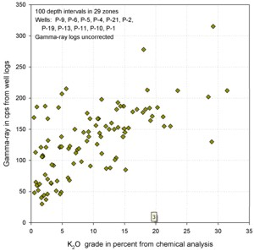 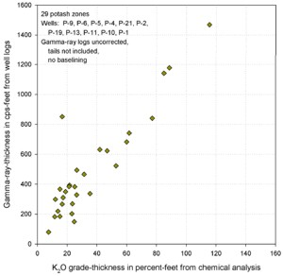
Figures 10A and 10B: Similar graphs for some USGS GR data in cps show that the GR-thickness product is a better predictor of potash content than GR by itself in thinly bedded potash zones..

GR in Counts per Second
Many potash wells are drilled as stratigraphic test wells and are not intended to be completed. They are often drilled as slim holes and slim hole GR logs must be run. Some of these logs may be calibrated to the API GR standard; many are not. In any case the GR to K2O correlation must be established for each tool type and adjusted if mud weight or borehole size varies between wells. Bear in mind that the core retrieved from a slim hole is volumetrically much smaller than full size cores. Variations between log and core data is expected to be somewhat larger in slim holes.
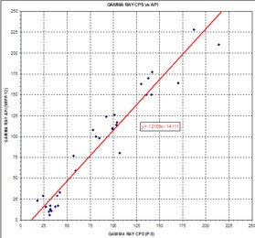
Combinations of the Above
It would be unusual if there were no problems to solve. Logs run in different areas by a variety of service companies need to be normalized to some single standard. Borehole and casing effects need to be handled first. Then normalizing oilfield and strat hole gamma ray logs can be done by correlating potash beds between near offset wells. It would be nice if both wells also had core assay data but this is seldom the case.
Figure 11: Comparison of USGS log picks over 29 potash intervals showing the regression against the API units for the same zones in the nearest oilfield well.
The equation of the line can be used to convert all USGS logs to API units in this particular project area.
POTASH ANALYSIS EXAMPLES – OLDER LOGS
A sample of computed results from this log analysis model compared to core data is shown below. The GR was borehole corrected but no bed thickness corrections were applied.
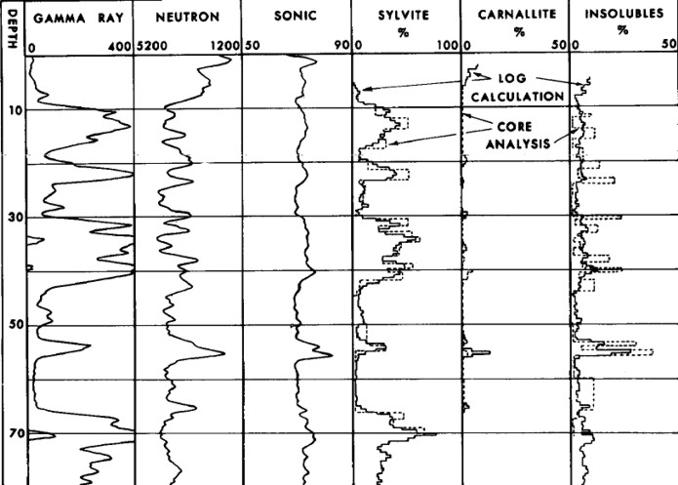Figure 12: Example log analysis showing excellent match to core data (Crain and Anderson, 1964). Raw data is shown but note the scales are opposite polarity to normal oilfield presentations.
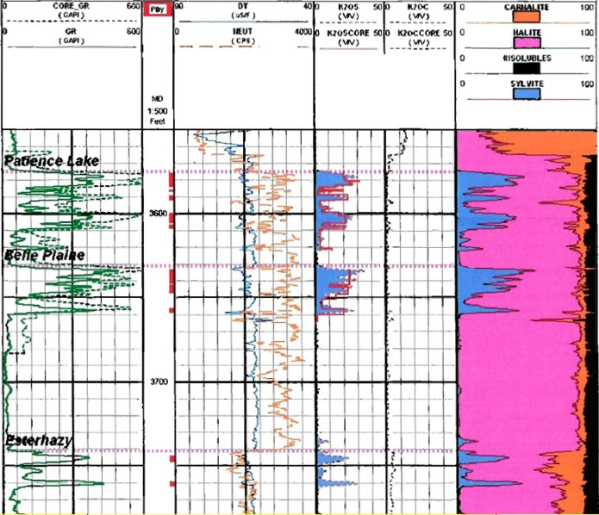Figure 13: Potash evaluation of 1960's logs with a modern log analysis program using Crain and Anderson’s original algorithms, calibrated to core data (see data in K2OS and K2OC tracks).
(Example log analysis courtesy Encanto Potash, analysis performed by Chapman Petroleum Consultants)
BIBLIOGRAPHY
1. Quantitative Log Evaluation of the Prairie Evaporite Formation of Saskatchewan
E. R. Crain and W. B. Anderson
Journal of Canadian Petroleum Technology, Quebec City and Edmonton, July-September, 1966
2. Defining Evaporite Deposits with Electrical Well Logs
R. P. Alger and E. R. Crain
Trans Northern Ohio Geological Society - Second Symposium on Salt, Cleveland, 1966
3. Some Fundamentals of Potash Geology As A Guide to Exploration
L. H. Goldsmith
SPWLA Transactions, 1966

4. Nuclear Log Evaluation of Potash Deposits
J. M. Edwards, N. H. Ottinger, and R. E. Haskell
SPWLA Transactions, 1967

5. Logging the Prairie Evaporite Formation in Saskatchewan
J. T. Costello and I. P. Norquay
CANADIAN CENTENNIAL CONFERENCE ON MINING AND GROUNDWATER GEOPHYSICS, 1969

6. Log Evaluation of Non-Metallic Mineral Deposits
M. P. Tixier and R. P. Alger
GEOPHYSICS, VOL 35, No 1, FEBRUARY 1970)

7. Potential Uses for Borehole Logs in Mineral Exploration
W. B. Anderson.
Annual Western Meeting of the CIM. Saskatoon, December 1972

8. Analysis of Borehole Geophysical Data in an Evaporite Sequence at Salt Valley, Utah
J. J. Daniels, J. H. Scott, and R. J. Hite
SPWLA Transactions, 1979
9. Schlumberger Log Interpretation Principles Vol 2- Applications, 1972
10 Evaluation of Potash Grade with Gamma-ray Logs
P. H. Nelson
USGS, Open-File Report 2007-1292

