Petrophysics in the green economy
Part 10: METALLIC MINERALS – Logging methods
E. R. Crain, P.Eng. Accessible Petrophysics Ltd.
Sandra Bleue, Petrophysics Outsource Inc.
Published in CSPG Reservoir Jan – Feb 2024
Introduction
This article reviews conventional borehole logs that are useful in the mining sector, followed by a more detailed discussion of some less familiar special-purpose logs with specific application to metallic mineral exploration. Both have a significant part to play in the evolving quest for greener energy solutions and in finding essential commodities.
There is much common ground in the geoscience of mineral and petroleum exploration and development, but also some fundamental differences. For example, mining operators rely on drill-cores more than borehole logs. Mine integrity and the safety of underground workers is part of the reason. Also pertinent is that miners need to know the mineral composition of an ore body with more precision than logging tools could offer. Regardless, logs and cores are used in both industries, so we will explain the differences and overlaps in these two communities.
Decarbonizing by electrifying the world is a monumental task. Reports suggest that metallic mineral outputs may not keep pace with demand for wind turbine construction. ^{(1, 2, 3)} Deeper new mines and expansion of older mines are urgently needed; leading to increased demand for geoscientists and engineers capable of locating, detailing, and operating them. Failure to match mineral supply to expected demand will mean failure of any plan for a “net-zero” future.
We hope you will be inspired to consider new ways to improve our mineral outputs and meet the tough challenges ahead.
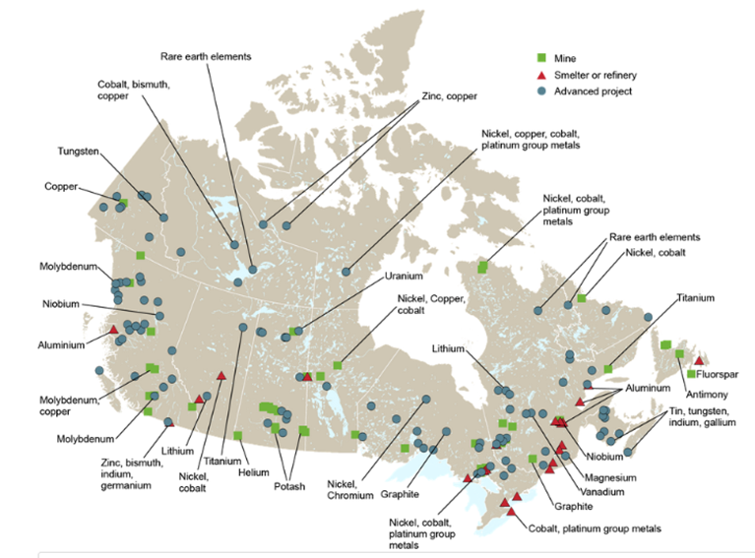
Figure 1. Location of Mineral Deposits in Canada, including Rare Earth Elements ⁽⁴⁾
borehole logging IN the Mining ENVIRONMENT
For clarity, we will refer to logs run for the mining industry as “borehole logs” and those for the oil and gas industry as “oilfield logs” or “well logs”, even though the guiding physical principles are the same for both.
It is difficult to make direct comparisons between oilfield logging tools and borehole tools. Many contractors developed their own tools and probes are often customized to suit a particular exploration challenge. The result is less standardization. Some contractors offer a complete range of services from data acquisition to mapping, while others specialize in smaller projects, by supplying tool rentals. Happily, many of the borehole log names are well-known to the oilfield log analyst, as the measurement principles are the same. Acoustic, gamma ray, spectral gamma ray, density, neutron and electrical logs are common to both industries.
In general, borehole tools are smaller and have reduced temperature and pressure ratings (eg., 20 mPa and 80 degC) compared to oilfield tools (100 mPa and 150 degC). However, many standard oilfield tools are available in slim-hole versions and are quite suitable for mineral borehole logging. A typical slim-hole gamma ray tool is just 42.9 mm (1-13/16 in) in diameter and approximately a meter long, compared to a mineral service contractor’s GR tool at 38 mm diameter and length of 0.63 meters.
There is a striking difference in scale between borehole logging operations for mining, and that for petroleum. Mining drill-rigs are typically portable (even heli-portable), and boreholes are drilled to recover core or, in the case of reverse circulation (RC) drilling, to recover samples. Boreholes can be blasted or drilled, with logging equipment typically consisting of 3 components: a data acquisition system to collect data from the downhole probe, a winch to deploy the probe into the borehole, and the downhole probe itself, which might be standalone or stackable.
borehole logging and coring Programs
The primary logging measurements would be one or more of the following: electrical conductivity (or resistivity), magnetic susceptibility, natural gamma radiation (total and spectral), acoustic velocity (or travel time), bulk density, and more recently, induced gamma ray spectroscopy to identify particular metallic elements in the host rock.
Specialty logs such as magnetic susceptibility, induced polarization, or high resolution temperature logs may be used as well.
Terraplus in Canada offers auxiliary equipment such as video inspection systems, borehole geophones, and hydrophone arrays, plus ground penetrating radar antennas for single hole investigation and cross-hole tomography. In the USA, Century Geophysical, among others, provides a wide variety of tools for the mining industry. The service providers are usually local contractors or the mining company itself.
Geological Survey of Canada and the US Geological Survey have also developed their own logging tools, mostly used in mineral reconnaissance surveys.
The mining industry relies heavily on coring, core description, and lab work for its geotechnical and geomechanical logs. Very detailed lithology, stratigraphy, and structure are annotated on these logs, as well as detailed notes on grain size, texture, and rock fabric. This information is entered into 3-D modeling software. Rock strength, discontinuities, faults, and fractures are carefully mapped into the model. Borehole logs and core photos are added to complete the 3-D display.
The model is constantly updated throughout the feasibility, design, development, operational, and expansion phases of a mines long lifetime. The integrity of the mine and the safety of the workers depend on the accuracy of this model. No shortcuts allowed!
The coring and logging procedures described above are also used to study geomechanical properties for dams, tunnels, highways, foundations, and many other large construction projects.
SPECIALIZED BOREHOLE Logging TOOLs FOR MINING APPLICATIONS
This section describes some of the specialized borehole logging tools used in mineral exploration and development, including some new or experimental tools that may solve some problems that conventional tools cannot. With the exception of induced gamma ray spectroscopy and limited use of induced polarization, these tools are not used in oilfield situations.
INDUCTION / Electromagnetic Susceptibility Logs
Electromagnetic methods are familiar to the oil and gas sector as induction logs. They were developed due to the popularity of oil-based mud and air-drilling systems. There was early recognition that having control data from a borehole instrument would verify the interpretation of surface magnetometer studies. ⁽⁵⁾
In the mining sector, a probe consisting of a transmitter and receiver induces current flow in the formation creating a primary magnetic field. This causes eddy currents to flow in a continuous circular distribution centered around the borehole axis. These eddy currents are proportional to the formation conductivity, and they in turn generate a secondary magnetic field, which induces an alternating voltage in the receiver coil. In the resulting voltage vector, the magnitude and phase are a function of the conductivity of the formation. Phase sensitive detectors separate the signal into its resistive (from conductivity) and reactive (from magnetism) components so that the electrical conductivity and magnetic susceptibility are recorded independently and simultaneously.
The log displays magnetic susceptibility, (χ (chi)), either in cgs^10⁶ or SI units, and conductivity in mmho/m (mS/m). Chi relates a material’s magnetization M, to the strength of an applied magnetic field H, using the equation M = Chi * H.
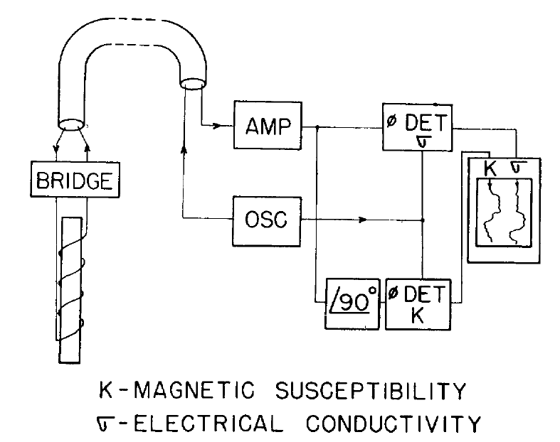
Figure 2. Simplified diagram of Electromagnetic tool showing phase shift between conductivity and susceptibility. ⁽⁵⁾

Magnetic anomalies may be caused by primary igneous or sedimentary processes, or by secondary alterations where magnetic material is either added or removed. Conductivity measurements can be used to detect and correlate conductive sulphides. Magnetic susceptibility can directly detect iron ore and be used to characterize and correlate sulphide units. Main benefits of borehole electromagnetic methods are their indifference to borehole rugosity and their ability to make measurements through PVC casing.

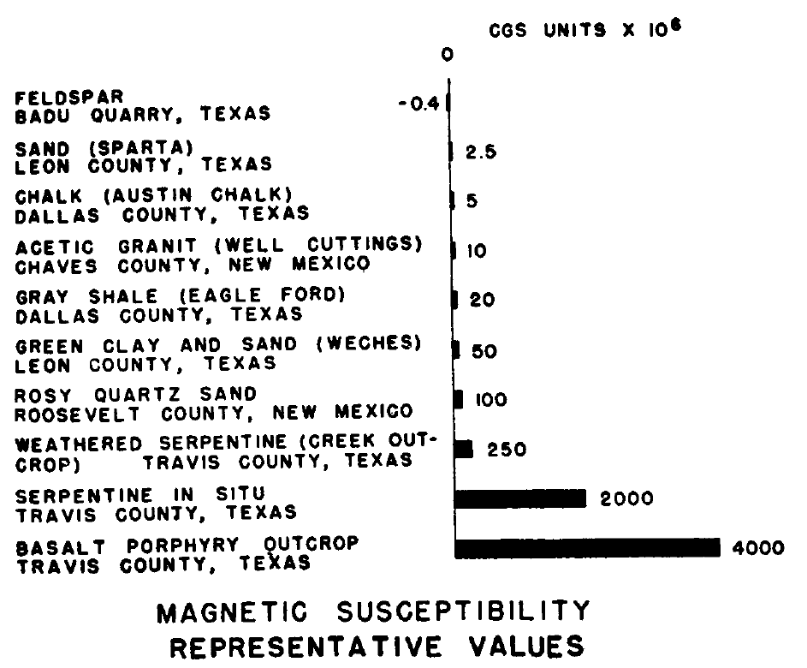
Figure 3. Values of Magnetic Susceptibility in various formations, in cgs ^ 10⁶ units. ⁽⁵⁾

In 2011, the Geological Survey of Canada sponsored development of a new triple sensor probe (TSP), which combined an electromagnetic component to measure magnetic susceptibility, alongside a capacitive resistivity sensor and high-resolution temperature device. The TSP allowed three measurements to be taken concurrently in a single logging run. The resistivity component was re-designed to use a capacitor array formed from parallel rods instead of galvanic contact electrodes which are useless in PVC cased or air-filled holes. An oscillator drives the capacitor array to produce the electrical field. This tool combination has found success in delineating base metals such as Cu-Pb-Zn massive sulphides and nickel-sulphide deposits. ⁽⁶⁾

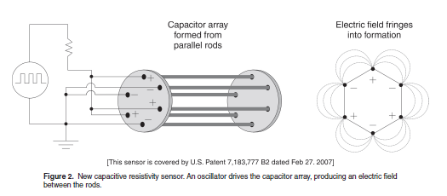
Figure 4: Diagram of Capacitor Array for TSP logging tool ⁽⁶⁾

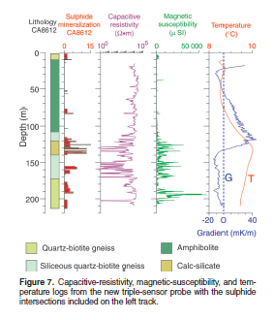
Figure 5: Results from a TSP log showing a lithology track, sulphide occurrences, resistivity, susceptibility and temperature. ⁽⁶⁾
Induced Polarization Logs
Induced polarization is a method to image the conductivity and chargeability of porous rocks. It is most commonly used to delineate disseminated sulphides within a host rock. When a charging current is turned off, voltage decays over a finite time (discharging) back to zero. When the current is turned on, voltage builds up over a finite time to a maximum applied value. The current is for a time stored in the ground (capacitance), causing some material to become polarized. This phenomenon is called induced polarization. ⁽⁷⁾
Century Geophysical has a multi-parameter Series Induced Polarization logging tool for hard rock mining and uranium exploration. It records SP, a single point resistance, and induced polarization, with optional natural gamma ray. The tool features a 16 and 64 array electrode spacing, passing an alternating current through the formation, resulting in a measurement of chargeability. This lightweight tool is 51 mm. OD and ~2 m. long.
Material Type  1 % Sample Concentration | Chargeability (msec)
Pyrite | 13.4
Chalcocite | 13.2
Copper | 12.3
Graphite | 11.2
Chalcopyrite | 9.4
Galena | 3.7
Magnetite | 2.2
Malachite | 0.2
Hematite | 0
Figure 6: Chargeability times for various rocks and minerals. ⁽⁷⁾
In 1986, a Canadian study ran IP logs along with temperature, resistivity, and SP logs to evaluate IP’s usefulness in finding gold associated with pyrite within a volcanic host rock. The combined logs were very good at defining a marker bed of graphite-schist but proved more ambiguous for the gold. The study showed the benefits of multiparameter logging acquisitions for delineating highly altered rocks, but a statistical approach to the
complex dataset needed further development. ⁽⁸⁾

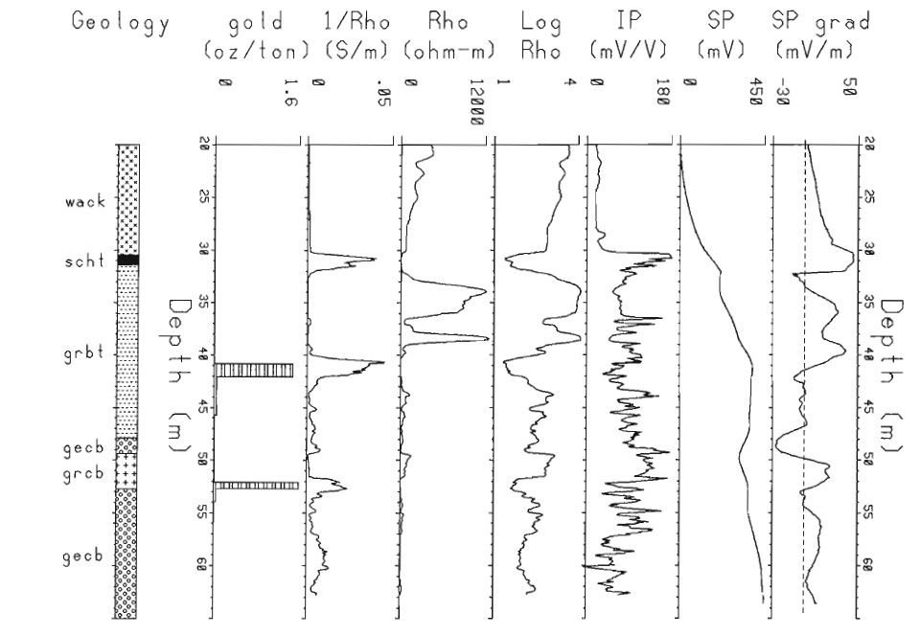
Figure 7: Comparison of Gold Assay, track 1 with IP response, track 5. ⁽⁸⁾
Induced Gamma Ray Spectroscopy
Induced gamma ray spectroscopy logs, sometimes called activation logs, measure the concentration of specific elements in the rock. In oilfield use, the elemental yields are transformed into minerals using a least squares algorithm to create a lithology log presentation. Capture cross section (Sigma) and neutron porosity (TPHI) are the other primary measurements, carried forward from the earliest days of the pulsed neutron log. These two measurements allow us to calculate porosity and water saturation in cased holes.
In mining exploration, this technology has lagged behind resistivity and gamma ray methods, mainly due to mining’s reluctance to handle radioactive sources in the field. This is not surprising when the logging unit could be the back of a geologist’s truck, plus developing such a specialized tool could be prohibitively expensive.
Pulsed neutron methods were being used in mining in 1972, initially to detect copper. The development of a delayed-fission neutron system, by Century Geophysical Corp. was found to be superior for uranium prospecting. ⁽⁹⁾
More recently, CSIRO in Australia has developed a Prompt Gamma Neutron Activation Analysis (PGNAA) ⁽¹⁰⁾, a spectrometric nuclear logging tool which results in a real-time downhole assay of elements in the rock. Similar in principle to the LithoScanner and
Pulsar tools from the petroleum industry, the PGNAA bombards the formation with fast neutrons and measures the gamma ray spectra generated by the nuclear reaction. The gamma rays’ intensity and energy create unique photopeak signatures, proportional to the elemental composition of the rock. The tool samples the surrounding rock to a depth of ~50 cm, generating in situ rock mass density and estimates of elemental composition. A main advantage over the core assay method is continuous depth coverage (no lost core!) plus deeper depth of investigation. The tool is calibrated to the expected mix of mineralogy and source/detector configuration is designed specifically for that expected lithology.
The PGNAA tool may feature either chemical or pulsed neutron sources and uses either BGO (NaI(T1) or CsI detectors. The measurement range is slightly larger than oilfield tools at 0.5 to 11 MeV. The tool has several shields, to protect the detector from fast and thermal neutrons escaping from the sample, and from the primary gamma rays generated by the source. A biological shield is built-in to minimize radiation risk to logging personnel.
The tool quantifies elements such as Si, Fe in iron ore, Mn in manganese ore, Cu, Ni, Ti, Cl, and many more. A benefit is that the large range of discoverable elements makes it possible to quantify “penalty” elements, which lower the grade of ore, cause smelting problems, or introduce unwanted attributes in the finished product, such as brittleness to steel.
In contrast, oilfield tools such as Schlumberger’s open-hole LithoScanner or cased-hole Pulsar use a pulsed neutron generator. LithoScanner focuses on the element sets common to petroleum environments (silicates, carbonates, unconventional), with just 4 metals of interest to mining: Cu, Gd, Ni and Ti. Although the PGNAA’s element sets are geared to hard rock environments, the tools have 15 elemental outputs in common, as shown in figure 9.
The Pulsar log is a slim-hole 42.7 mm (1-11/16 in), 5.5 m long alternative to LithoScanner. Pulsar provides a similar suite of elemental logs (with additional elements on request) and an accurate measure of TOC. Its main advantage is the fast neutron cross section (FNXS), a measurement that, being independent from resistivity-based calculations, is a fool proof gas indicator. The results are very helpful in monitoring CO2 storage, CO2 miscible floods, and helium reservoirs. In mining boreholes, it may provide information suitable for correlation and quantification of massive sulphides.
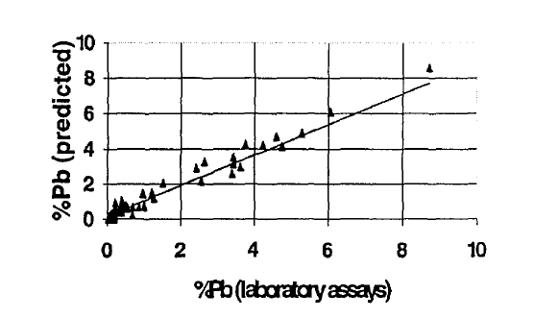
Figure 8: Comparison of laboratory assays with SirologTM PGNAA values for lead. ⁽¹⁰⁾
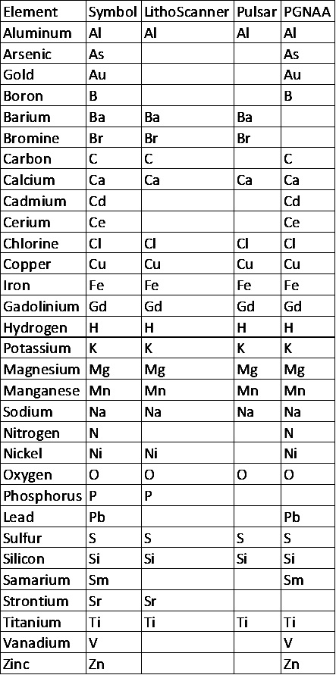
Figure 9: Comparison of elements “seen” by various tools.
High Resolution Temperature Logs
In the 1980s, the Borehole Geophysics Group of the Geological Survey of Canada developed a sensor to quantify borehole temperature to a resolution of 0.001 degree Celsius. ⁽⁶⁾ Roke Oil Enterprises in Calgary developed a tool with the same resolution about the same time and offered the service commercially. The resolution of most tools is 0.01C.
Temperature gradients can change by formation and results can be used to map thermal conductivity contrasts, plus detect massive sulphides. Other applications include predicting proximity to old mine workings, where the heat dissipates from the warmer underground openings, finding the base of permafrost, understanding groundwater flow patterns, and locating gas flows through “worm-holes” in the cement behind casing.
CONCLUDING REMARKS
The traditional role of integrated petrophysics has been successful in the petroleum sector for many years. We hope that the technical achievements of the energy industry, so applicable to mining, do not get overlooked in the change of direction to a greener economy. Both sectors should be pooling their considerable knowledge to achieve the complex goals needed to reduce the impact of climate change.
This is the last of a 10-part series on non-petroleum uses of petrophysics and well logs. The series began in the July-August 2022 issue of the CSPG Reservoir Magazine, tracing a trip through the back-roads to visit the diverse applications of the science of petrophysics. If you missed an episode, go to the magazines archives at cspg.org.
REFERENCES
- Exner-Pirot, H. “Drop in mining derails drive for Net Zero”. The National Post. https://epaper.nationalpost.com/article/281895892585033 (accessed May 11, 2023)
- “Action Plan 2020: Introducing the Pan-Canadian Initiatives”. The Canadian Minerals and Metals Plan. https://www.resourcedata.org/dataset/23794a95-1cae-47fd-bbca-da003845fa1d/resource/c4f58523-3a23-4f3f-b393-f63b1efa8f70/download/f6.pdf, (page 18) (accessed May 11, 2023)
- Government of Canada, “Government of Canada to develop guidance for best-in-class new oil and gas projects and net-zero emissions requirements by 2050”. https://www.canada.ca/en/environment-climate-change/news/2022/04/government-of-canada-to-develop-guidance-for-best-in-class-new-oil-and-gas-projects-and-net-zero-emissions-requirements-by-2050.html (accessed May 11, 2023)
- Government of Canada, “Critical minerals: an opportunity for Canada”. https://www.canada.ca/en/campaign/critical-minerals-in-canada/critical-minerals-an-opportunity-for-canada.html (accessed May 11, 2023)
- Broding, R.A. et al. “Magnetic Well Logging”. Geophysics, Volume XVII, Number 1, (January 1952)
- Bristow, Q. and Mwenifumbo, C.J., “A new temperature, capacitive-resistivity, and magnetic-susceptibility borehole probe for mineral exploration, groundwater, and environmental applications”. Geological Survey of Canada, Technical Note 3, (2011)
- University of British Columbia, “Introduction to induced polarization surveying”. https://www.eoas.ubc.ca/courses/eosc350/content/methods/meth_2/ip.pdf (accessed May 11, 2023)
- Urbancic, T.I. and Mwenifumbo, C.J., “Multiparameter Logging Techniques applied to Gold Exploration”, from Borehole Geophysics for Mining and Geotechnical Applications, ed. P.G. Killeen, Geological Survey of Canada, https://ftp.maps.canada.ca/pub/nrcan_rncan/publications/STPublications_PublicationsST/123/123596/pa 85_27.pdf Paper 85-27, p. 13-28, 1986.
- Hallenburg, J.K., “Nonhydrocarbon Logging”. The Log Analyst, (May-June 1992)
- Borsaru, M. and Charbucinski, J., “Nuclear Borehole logging techniques developed by CSIRO_EXPLORATION and MINING for in situ evaluation of coal and mineral deposits”. https://inis.iaea.org/collection/NCLCollectionStore/_Public/29/057/29057219.pdf
(accessed May 08, 2023)

