PETROPHYSICS IN THE GREEN ECONOMY
PART 5 – HYDROGEN: natural and manufactured
E.R. Crain, P.Eng.
Published in CSPG Reservoir Mar – Apr 2023

INTRODUCTION
HOW H2 FUEL CELLS WORK
Through an electrochemical reaction, fuel cells produce electricity and heat as long as fuel is supplied. A fuel cell consists of a negative electrode (anode) and a positive electrode (cathode) sandwiched around an electrolyte. The hydrogen fuel is fed to the anode, and air is fed to the cathode. A platinum catalyst at the anode separates hydrogen molecules into protons and electrons. The electrons go through an external circuit to the cathode, creating a flow of electricity. The protons migrate through the electrolyte to the cathode, where they unite with oxygen and the electrons to produce water and heat.
Anode reaction: 2H₂ + 2O₂⁻ → 2H₂O + 4e. Cathode reaction: O₂ + 4e⁻ → 2O. Overall cell reaction: 2H₂ + O₂ → 2H₂O.
Hydrogen is the smallest and lightest element. At standard conditions hydrogen is a diatomic gas (H₂). It is colorless, odourless, tasteless, non-toxic, and highly combustible, creating water (H₂O) when burned. Hydrogen can be separated from water by electrolysis and from methane by pyrolysis or steam reforming.
There is one known example, in Mali, of naturally occurring hydrogen in a geologic setting. It is a small accumulation but is revolutionizing geological thought on possible sources of natural hydrogen. Dozens of hydrogen seeps are known around the World – some of these may prove to be more than just curiosities.
Most of the hydrogen on Earth exists in water and organic compounds, and in hydrides inside the Earth.
Known occurrences of natural hydrogen are rare, partly because we haven’t looked very carefully, due to preconceived opinions that are now known to be incorrect.
Major uses of hydrogen are making ammonia, upgrading bitumen and heavy oil, and removal of sulphur from liquid petroleum, industrial and agricultural chemicals, as well as food processing.
A new era of hydrogen powered aircraft, railway locomotives, ships, and ground transport is being led by
innovative entrepreneurs and both large and small business ventures. So far, very tiny steps forward on a very, very long road to the “Hydrogen Economy” – think year 2050 or beyond. The virtue of such a fuel is that the exhaust is water (and maybe some NOx), instead of CO₂, which contributes to climate change. There are many unresolved technical and practical issues, not the least of which is what to do with all that water in cold weather. Hydrogen has the potential to assist the global race for decarbonization. Stay tuned!
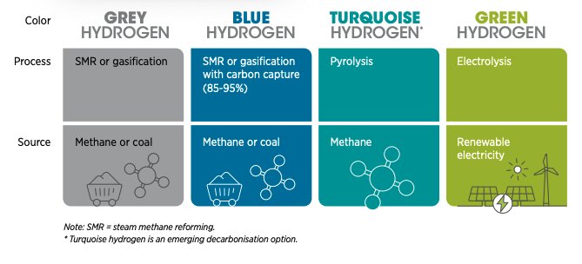FIGURE 1: The Colours of Hydrogen: green if produced from 100% renewables; black, brown, or grey if coal or methane is used; blue if CCS is added, gold or white if source is naturally occurring. (Image from World Economic Forum, from 2022 talk by Emanuele Taibi)

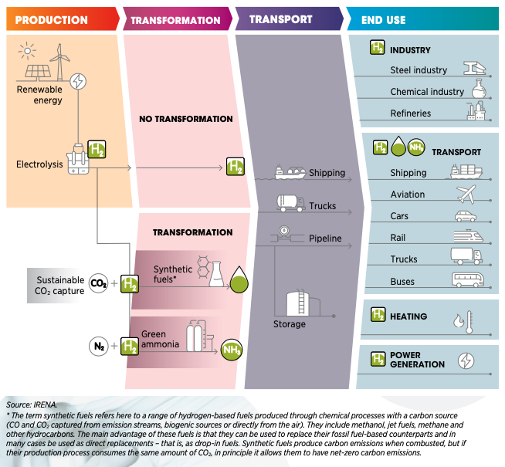
FIGURE 2: The Green Hydrogen Transition (Image courtesy International Renewable Energy Agency)
To produce enough Green Hydrogen to displace fossil fuels, we need to increase renewable electrical energy output by a factor of 1000, probably much more. And drill and complete unknown thousands of deep water wells, plus build a desalinization plant for each electrolysis plant. Why? Because most of the fresh water needed for electrolysis is already allocated for human and agricultural use.
It might be better to electrify transport and use heat pumps for HVAC and avoid the H₂ middleman. This leaves about 40% of current carbon emissions to be fixed – the carbon-heavy industrial heartland to decarbonize with Green Hydrogen. As hydrogen technology improves, the timing might just work out for all those year 2050 targets that governments have made.
Petrophysical analysis in Hydrogen bearing rocks
Petrophysical analysis in a hydrogen accumulation is truly difficult, unconventional, and still open to improvement.
Natural hydrogen gas accumulations do not behave on well logs in the same way as methane gas reservoirs. Hydrogen gas does not exhibit high resistivity like a methane gas zone. This phenomenon is not fully understood but may be related to ionization of H2 in the water in the rock.
When a hydrogen atom dissolves in aqueous solution, it ionizes into H+ (a proton) and H- (an electron). Protons cannot live in isolation and immediately hook up to a water molecule, creating the ion H3O+, called hydronium. As the protons are used up, more hydrogen can be dissolved and more hydronium is created. H3O+ ions are conductive, similar to other Group 1 elements, such as sodium (Na+) and potassium (K+). As a result, conventional water saturation equations make hydrogen zones look like water zones.
Hydrogen does not produce density neutron crossover (gas effect). Instead, H2 shows up as if the zone were shale or heavy minerals – high neutron porosity from higher hydrogen index (HI) with slightly high density porosity, giving density neutron separation instead of crossover. The gamma ray can usually distinguish if it is shale or non-shale rock.
When methane co-exists with hydrogen, open hole logs behave more like they would in conventional gas zones.
Detailed sample descriptions are critical in determining the actual mineralogy, since standard 2- and 3-mineral models are unlikely to behave well in an H2 zone. Multi-mineral models might work, but the petrophysical properties of H3O+ are as yet unknown.
Hydrogen can be seen on the mud log C1 gas curve and as a temperature log anomaly which shows the hydrogen accumulation as a gas cooling effect compared to geothermal trends.
Fracture intensity, formation dip, and depositional environment can be determined from resistivity image logs.
Reservoir seal integrity is critical due to the small size of the H2 molecule, which can leak through almost any trap that would contain CH4, CO2, N2, or He. The best possible seals are lava flows and evaporites. You still need a stratigraphic or structural trap, otherwise the H2 will “just keep on a-movin’ ”.
New and evolving technology may help. One possibility is the fast neutron cross section measurement (FNSX). Low density CH4 and CO2 have very low FNXS values, as well as low SIGMA values, compared to water, heavier hydrocarbons, and rock minerals. A direct calculation of gas saturation might be possible in these cases. The FNXS and SIGMA values for H2 and H3O+ in an accumulation setting are currently unknown, so we will wait and see what develops.
Elemental yields from a slim hole induced gamma ray spectroscopy log (e.g. Schlumberger Pulsar log) might resolve the presence of hydrogen or hydronium-ions. It should be possible to tune the element to mineral transform to include H2 and H3O+ in the allowed “mineral” list.
It has also been observed in ROKE Quad Neutron logging that the borehole resistivity measurement correlates with the Mudlog H2 signal. One pass with this slim hole logging tool is all that is needed to identify a hydrogen gas accumulation.
Natural Hydrogen From GEOLOGIC ACCUMULATIONS
Conventional literature says that hydrogen gas does not occur naturally in convenient accumulations like oil and natural gas reservoirs, because the small molecules could escape too easily. This is not the case, as a hydrogen accumulation is being exploited in the region of Bourakebougou in Mali, producing electricity for the local village.
Tested in 2012 from a capped wellbore machine-drilled for water in 1987, natural hydrogen flowed from below the plastic casing cemented to the bottom of the wellbore. Analysis of this shallow GazBougou1 discovery well confirmed H₂ gas at a concentration of 98% purity, with traces of methane, and nitrogen. This is the purest naturally occurring hydrogen ever discovered.
Further exploratory wells were drilled long after the first two stratigraphic holes F1 and F2 had their cores studied to begin defining the regional geological model for H₂.
Mali’s natural hydrogen is gathered in 5 rock layers, trapped by subsurface lava flows. Deep, medium, and shallow sources are believed to be at work to periodically refresh the accumulations of geologic hydrogen. There are at least 7 possible mechanisms for the generation of hydrogen discussed in the reference paper. There are many challenges in defining hydrogen system logic, so there are still many unknowns.
This is where petrophysics comes to the rescue. Take a peek under the rug and see what might be waiting below all those volcanics you drilled through over the last 70 years. No, it won’t be easy, as you probably will need faults to the basement and fractures, where well logs can help there too.
It’s time for a paradigm shift for hydrogen!
Some scientists believe geologic hydrogen gas produced in Mali will continue for thousands of years, sustainably decarbonising the local community (even though they did not have much of a carbon footprint to begin with). This is highly speculative as it may have taken millions of years for the gas to accumulate.

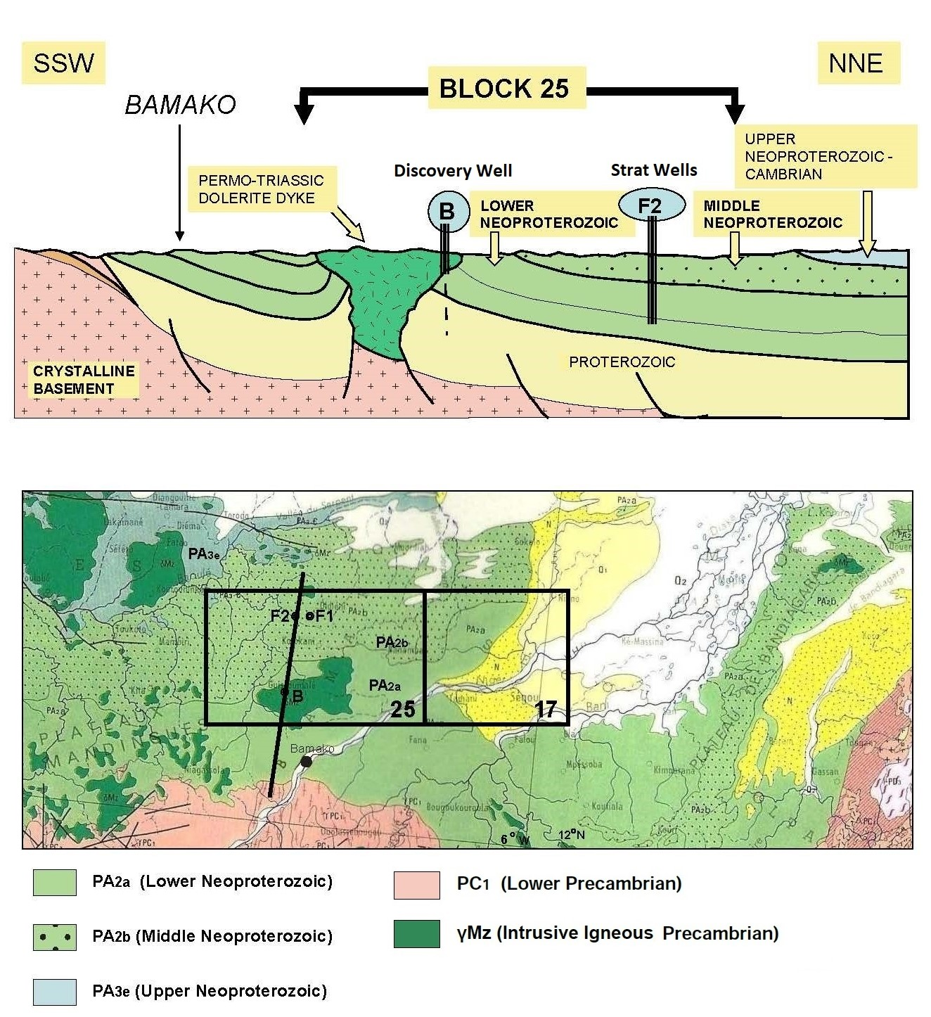FIGURE 3: Stratigraphic sequence of Mali natural hydrogen discovery (Ref 1)
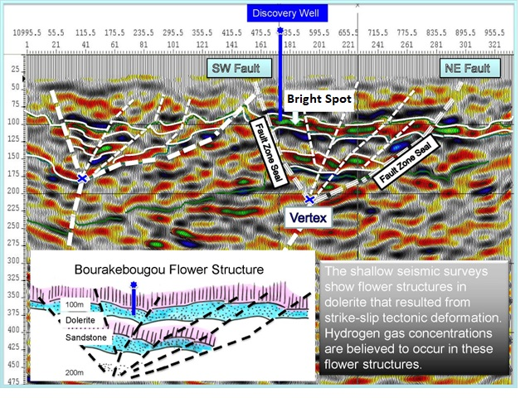
FIGURE 4: Seismic cross-section of Mali natural hydrogen discovery showing “flower structure” (Ref 1)
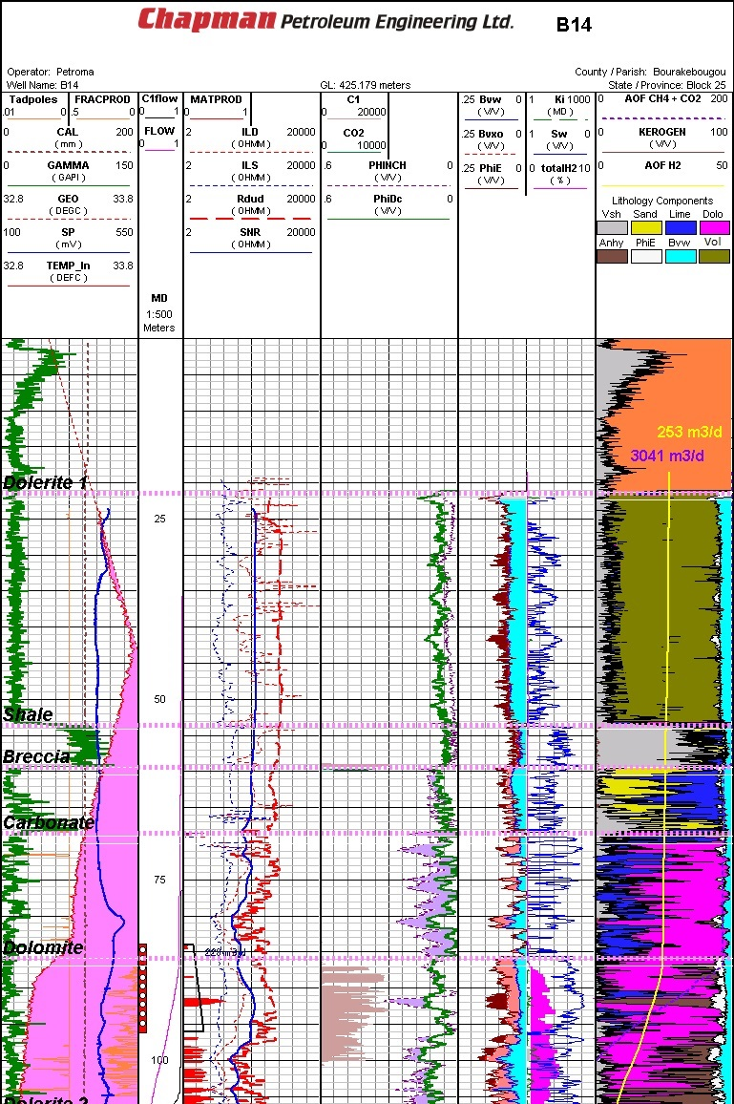
FIGURE 5: Well log from typical Mali natural hydrogen discovery area (Ref 1)
MANUFACTURED HYDROGEN
There are over 200 chemical reactions that can produce hydrogen, some dating back 150 years or so. None could be considered “Green”. About 48% of commercial bulk hydrogen is produced by the Steam Reforming Method (SRM), using natural gas as a feedstock, with CO₂ released to the atmosphere, or with carbon capture and storage (CCS) to mitigate greenhouse gas (GHG) emissions.
Other sources of H₂ are from by-products of the manufacture of ammonia, methanol, and other industrial chemicals, plus electrolysis of water or pyrolysis of methane.
HYDROGEN PRODUCTION FROM METHANE USING STEAM REFORMING
The most common method is reacting water, in the form of super-heated steam (700 – 1100 C), with methane to form carbon monoxide, which in turn causes the removal of hydrogen from the methane. The water vapor is then reacted with the carbon monoxide to oxidize it to carbon dioxide, turning the water into hydrogen. The process is called Steam Reforming, also known as the Bosch process. The chemistry is:
1: CH₄ + H₂O → CO + 3 H₂
2: CO + H₂O → CO₂ + H₂
This reaction is favoured at low pressures but is usually conducted at high pressures (2.0 MPa). This is because high pressure H₂ is the most marketable product, and pressure swing adsorption (PSA) purification systems work better at higher pressures. The product mixture is known as "synthesis gas" because it is often used directly for the production of methanol and related compounds.
HYDROGEN PRODUCTION FROM ELECTROLYSIS OF WATER
When a direct current is run through water, oxygen forms at the anode (+) while hydrogen forms at the cathode (-). Typically the cathode is made from platinum or another inert metal. While this is a proven technology, it supplies only 5% of the World’s demand for hydrogen.
The method presumes that an adequate supply of unallocated fresh water, (or desalinated sea water or medium depth oilfield brine) and a source of unallocated electricity can be found. In many areas, fresh water is already in short supply and additional draws on surface or near surface water may be impossible. Deeper sources may also be restricted. See “Water Well Analysis” in Chapter 18, Green Economy Petrophysics, to learn how to locate potential underground sources of water.
The chemistry for electrolysis is pretty simple:
3: 2 H₂O + electricity → 2 H₂ + O₂ + heat
Theoretical efficiency (electricity used vs. energetic value of hydrogen produced) is between 88 to 94% with no impurities in the water, much less if desalinization is needed. Energy costs of compression, storage, and transportation to market are also not included.
HYDROGEN PRODUCTION FROM METHANE PYROLYSIS
Natural gas (methane) pyrolysis is a one-step process that produces no greenhouse gases. Developing volume production using this method is the key to enabling faster carbon reduction by using hydrogen in industrial processes, fuel cell electric heavy truck transportation, and in gas turbine electric power generation.
Pyrolysis is achieved by having methane (CH₄) bubbled up through a molten metal catalyst containing dissolved nickel at 1,070 C. This causes the methane to break down into hydrogen gas and solid carbon, with no other by-products (except those from maintaining the reactor at the high temperature required).
The chemistry is deceptively simple, but implementation is tricky.
4: CH₄ + heat + catalyst → C + 2 H₂
The industrial-quality solid carbon may be sold as manufacturing feedstock or permanently landfilled; it is not released into the atmosphere and there is no ground water pollution in the landfill.
Methane pyrolysis is in development and considered suitable for commercial bulk hydrogen production, assuming low-cost methane is available as both feedstock and heat source. Further research continues in several laboratories and at least one pilot project.
Native Hydrogen From Serpentinization ReactionS
The hydrogen in the Mali example may have come from a deep source from mantle degassing, a moderate depth source from rock crushing in faults, or a shallow source from chemical serpentinization.
Serpentinization is a form of low temperature metamorphism driven largely by hydration and oxidation of olivine and pyroxene, creating serpentine minerals brucite, and magnetite. Under the unusual chemical conditions accompanying serpentinization, water is the oxidizing agent, and is itself reduced to hydrogen. This leads to further reactions that produce rare iron group native element minerals, such as awaruite and native iron, methane, and other hydrocarbon compounds, and hydrogen sulphide.
During serpentinization, large amounts of water are absorbed into the rock perhaps during intense rainy seasons, increasing the volume, reducing the density and destroying the original rock structure. The density changes from 3.3 to 2.5 gm/cc with a concurrent volume increase on the order of 30 to 40%. The reaction is highly exothermic and rock temperatures can be raised by about 260°C, providing an energy source for the formation of non-volcanic hydrothermal vents.
Hydrogen is produced during the process of serpentinization. In this process, water protons (H+) are reduced by ferrous (Fe₂+) ions provided by fayalite (Fe₂SiO₄). The reaction forms magnetite (Fe₃O₄), quartz (SiO₂), and hydrogen (H₂).
5: 3 Fe₂SiO₄ + 2 H₂O → 2 Fe₃O₄ + 3 SiO₂ + 3 H₂ + heat
fayalite + water → magnetite + quartz + hydrogen
Laboratory studies of serpentinization at high temperature and pressure show how methane could be produced, lending some credence to deep-seated gas and oil generation and migration.
6: 18 Mg₂SiO₄ + 6 Fe₂SiO₄ + 26 H₂O + CO₂ → 12 Mg₃Si₂O₅(OH)₄ +4 Fe₃O₄ + CH₄
forsterite + fayalite + water + carbon dioxide → serpentine + magnetite + methane
My grade 9 chemistry class didn’t get much past 2H₂ + O₂ → 2 H₂O, but equation 6 looks OK to me.
Ocean seeps show both hydrogen and methane emissions. We just have to find them on land, complete with a hydrogen accumulation, as in the Mali example. There are more than 100 published reports of natural hydrogen seeps on land in a dozen countries, treated as curiosities across many years. Maybe they will lead to a new industry, just as the oil seeps of antiquity did. (Reference: Wikipedia)
ACKNOWLEDGEMENT
Thanks to Denis Briere of Chapman Petroleum Engineering Ltd for contributing information and suggestions for this article, including illustrations in Figures 3, 4, and 5.

REFERENCES
1. On generating a geological model for hydrogen gas in the southern Taoudeni
Megabasin, Bourakebougou area, Mali, ACS Letters, 12 June 2016
Denis Briere and Tomasz Jerzykiewicz,
https://doi.org/10.1190/ice2016-6312821.1
2. Hydrogen and Hydronium, Chem-Libre, 2022
https://chem.libretexts.org/Bookshelves/General_Chemistry/Book%3A_ChemPRIME_(Moore_et_al.)/11%3A_Reactions_in_Aqueous_Solutions/11.05%3A_Hydrogen_and_Hydroxide_Ions
3. Hydrogen Technical Data, Production Methods, Serpentinization
Various Wikipedia pages

