Petrophysics in the green economy
Part 9: METALLIC MINERALS – SUBSURFACE METHODS
E. R. Crain, P.Eng. Accessible Petrophysics Ltd.
Sandra Bleue, Petrophysics Outsource Inc.
Published in CSPG Reservoir Nov – Dec 2023
Introduction
For this article, we are expanding the definition of petrophysics to include the exploration methods performed on or near the surface to locate potential ore bodies, using all the physical principles we remember from our oil field well logging experience. The next article, the last in our Green Economy Series, covers borehole logging in the mining environment.
But first, a little background to set the stage. A 2023 International Energy Agency (IEA), stated that “to reach net-zero emissions by 2050, we need to be producing SIX times the current global output of minerals just to build the turbines, transmission lines, batteries, and other items essential for low-carbon energy infrastructure.⁽¹⁾ Instead, we are mining less than we did in 2019. A reading of the Pan-Canadian Geoscience Strategy (PGS), outlined in Natural Resources Canada’s report: “The Canadian Minerals and Metals Action Plan 2020 (CMMP)” might hold some clues. By 2017, it was posited that a strategy was needed “to develop next generation geoscience knowledge and tools to efficiently target higher-grade or deeper deposits”, with the ultimate goal being a mine of the future that produces zero waste. ⁽²⁾
Zero waste may be a bit of a stretch. Regardless, new mines are urgently needed and we already have the tools, and the petrophysical skills to use them. There are a surprizing number of tools and analysis techniques available. No single one is a “magic-bullet, although some combinations may come close.
The first Secret to Success is to choose the appropriate tools and integrate the results to gain the best possible understanding of the potential ore body. The second is to combine the talents of both mining and petroleum geoscientists to encourage collaborative and innovative solutions to the search for critical minerals.
Seismic acquisition for mining applications
While the petroleum industry used seismic as its primary exploration tool for a hundred years, it wasn’t until 1993 that Geological Survey of Canada began applying acoustic technology to mineral exploration. Seismic had been viewed as too expensive, the terrain too challenging, and the coupling of the receivers to hard ground too uncertain to merit serious consideration. However, with the depletion of near surface ore bodies, these objections needed re-evaluation. The burning question was, is the acoustic impedance between ore body and host rock large enough to generate a reflection?
Data was collected in various mining locales, including mineral samples from various deposits for lab analysis, followed by the acquisition of well logs, offset VSP surveys and eventually 2D multi-channel seismic surveys. Special care was taken to adjust for pressure differences between lab and subsurface, and to determine if the high frequency, short propagation paths characteristic of logging data could match the lower frequencies in a seismic survey. The results were promising, and acoustic data is now used to map lithologies, detect ore bodies, and find permeable zones (such as sulphide mineralization controlled by fluid flow through faults), using full waveform acoustic logs to help interpret seismic reflections.
Vertical seismic profiles should also be considered as they “see” below the bottom of the borehole and a considerable distance beside the hole. A density log is also recommended to allow more accurate calculation of acoustic impedance for seismic modeling and tomography.
POTENTIAL FIELD METHODS
Surface seismic surveys rely on acoustic impedance (density times seismic velocity) contrasts across a geologic boundary. Other surface methods are employed which exploit changes in rock density or naturally occurring geomagnetic waves. These methods tend to cover large areas and have poor resolution; despite these downsides, they are most effective when used in conjunction with seismic. While seismic detects near-horizontal rock boundaries, gravity and magnetics are better for steep discontinuities such as faults. ⁽³⁾
Gravity Field Mapping and DATA Processing
These surveys, which locate anomalous rock density, can be acquired on land or water and tend to be popular in frontier areas. The main purpose of a gravity survey is to define lithology, structure, and potential ore bodies. These methods have benefitted from the widespread use of GPS; GPS antenna can be placed on receivers and transmitters in airborne systems. Gravity surveys have been used with magneto-telluric (MT) surveys and magnetics to map basalt covered sediments ⁽⁴⁾.
Corrections for station elevation, surrounding terrain elevation (using digital surface maps and digital Hammer Charts, and Bouguer Anomaly are required. Subtraction of 3rd order regional surface from corrected data set will give contour map of the Bouguer gravity anomaly, which can be used to plan next steps in the exploration program. ⁽⁵⁾

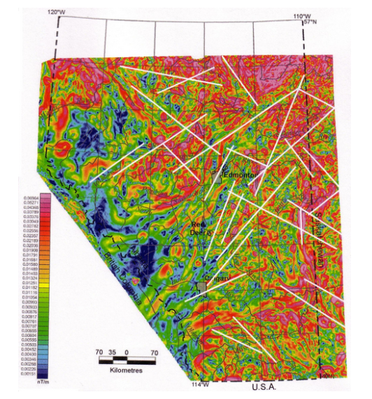
Figure 1: Horizontal-gradient magnetic map of Alberta showing lineaments (white lines). after Lyatsky et al., 2005. ⁽³⁾

Magneto-tellurics (MT)
This passive geophysical method measures the naturally occurring electromagnetic waves generated by solar wind and lightning above the earth to image the subsurface in terms of resistivity. MT is used in remote areas as a lower cost alternative to seismic.
Surface receivers record horizontally and mutually orthogonal 2 components of electric and 3 components of the magnetic fields. The variation and amplitude of the signals are interpreted using the magneto telluric impedance, Z. This method has been used since the 1950s. In recent time it is being used to explore for and monitor geothermal fields. In 2018, the US began to compile an open-source repository of these data. ⁽⁶⁾⁽⁷⁾
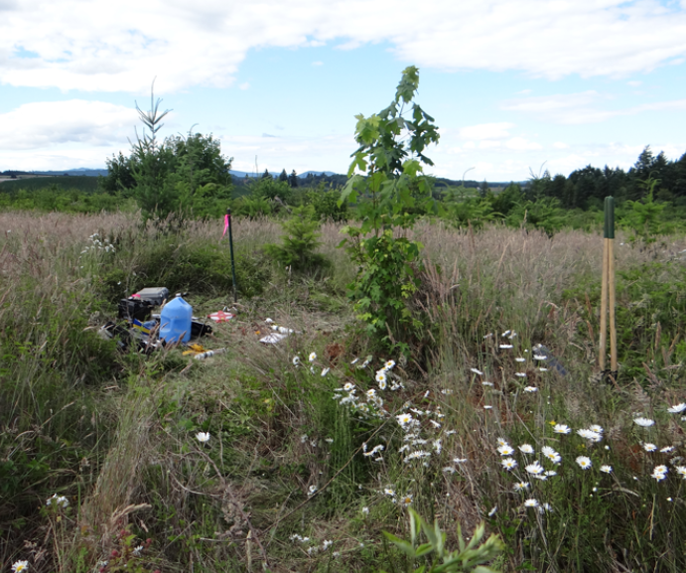
Figure 2: Magneto-telluric site in Oregon a magneto-telluric system is connected to a magnetometer and two sets of electrodes to collect magnetic and electric field data. ⁽⁶⁾

applied CURRENT METHODS
These methods have direct comparisons to well logging tools.
Subsurface Resistivity Mapping
Subsurface resistivity measurements are made using electrodes planted in the ground and a power source. Different electrode arrays vary, with a dozen or so well documented arrangements. Electrode arrays were developed in order to make field measurements more efficient and data interpretation easier.
Schlumberger Array
This subsurface geophysical exploration method using induced electrical current was developed by Conrad Schlumberger in the early 1900s. He used direct current (DC), but the polarity was reversed at a rate that prevented charge buildup in the earth. Two current electrodes were driven into the ground some 50 to 200 meters apart. Two measure electrodes were placed symmetrically between and inline with the current electrodes, some distance away from the current electrodes to prevent “edge effects”. The voltage measured was inversely proportional to the resistivity of the ground between the measure electrodes. The depth of penetration of the measurement increased with increased electrode spacing, so multiple spacings were run to obtain a “3-D” image of the resistivity.

In sediments, low values could mean aquifers or clay/shale beds; higher values suggested hydrocarbons or tight rock. In hard-rock country, low resistivity suggested massive sulphides or metallic minerals. Other uses include clay alteration around hydrothermal zones, lithology and structural controls on mineralization. Successful interpretation was not guaranteed. Awareness of this uncertainty led to more recent work where ERT (Electrical Resistivity Tomography) is acquired with IP survey data to successfully image galena veins within a granitic host rock, beneath a sedimentary cover layer. ⁽⁸⁾

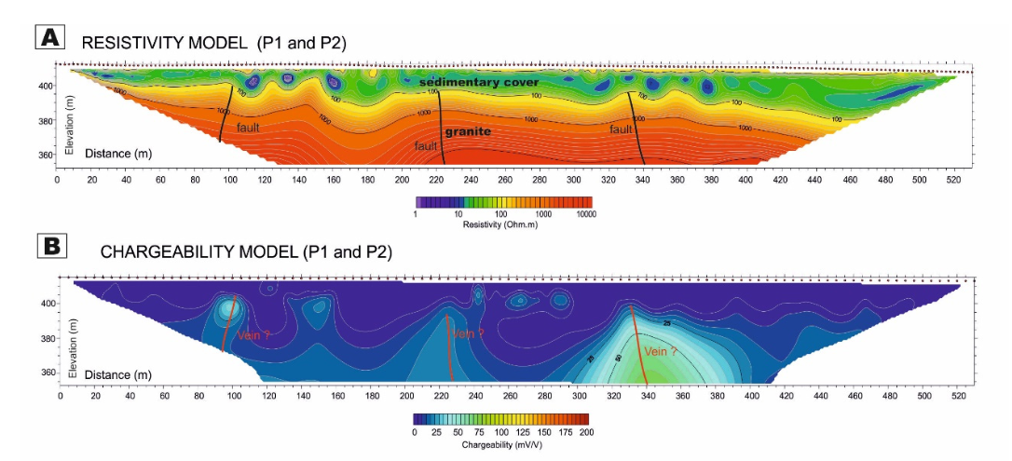
Figure 3: Combined data from ERT survey (A) and IP model (B) to detect narrow galena veins in granite. Model A clearly distinguishes the sedimentary cover from the granite; IP anomalies show the veins. ⁽⁸⁾

Mise-a-la-Masse Array (MALM)
Loosely translated from French, Mise-a-la-Masse means “charged body”. This method was very popular in the 1920s and 1930s for searching out ore bodies. This technique is unique to mining; its purpose is to demarcate highly conductive masses such as sulphides and contaminant plumes.
This method is still in use today. Mise-a-la-Masse is unique because the conductive mass being examined is itself used as one current electrode, with a second current electrode placed 5-10 times distant from the size of the conductive volume being investigated. Current is injected across the current electrodes and the potential voltage distribution radiating outwards from the injection borehole gives an idea of the shape and volume of the mass. ⁽⁹⁾
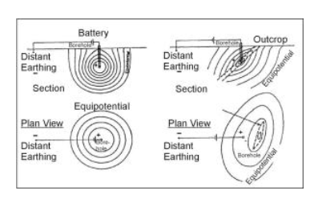
Figure 4: The left side of the diagram shows current potential lines in a homogeneous material; to the right, equipotential lines are distorted by a conductive ore body, which pushes the lines away, roughly delineating the ore mass. ⁽⁹⁾

Induced Polarization Methods (IP)
Induced polarization (IP), is an electromagnetic method in widespread use in the mining industry. It is a method to image the conductivity and chargeability of porous rocks. It is most commonly used to delineate disseminated and massive sulphides within a host rock.
For a 2 or 3D output, a Wenner-Schlumberger configuration selects combinations of electrodes in groups of four (two current electrodes and a pair of non-polarizable potential electrodes) applied on the ground. Apparent chargeability and resistivity are recorded by each electrode and the measurement assigned to a geometric depth in the ground. ⁽¹⁰⁾

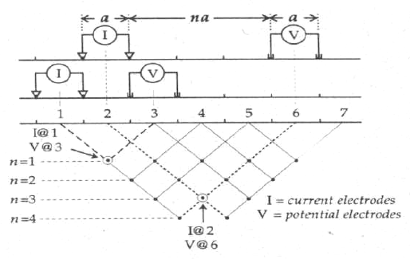
Figure 5: Simplified acquisition scheme for apparent chargeability and resistivity. ⁽¹⁰⁾

When a charging current is turned off, the voltage decays over a finite time (discharging) back to zero. When the current is turned on, voltage builds up over a finite time to a maximum applied value. The current is, for a time, stored in the ground (capacitance), causing some material to become polarized. This phenomenon is called induced polarization. Chargeability is affected by grain size, mineral type, mobility of ions in pore fluid, interactions between solid surfaces and fluids (such as clay particles in the fluid), and surface area of the material. For example, illite, a clay, which has a much greater surface area than sandstone, tends to hold a charge, whereas the latter (a possible host rock) does not. IP surveys are useful in hydrogeology, to isolate saline water from clay, which both have low resistivity.
Chargeability can be measured in the time domain, calculated as the normalized area underneath the decay curve indicated in figure 6d below. The data are inverted, resulting in a resistivity model which quantifies the rock above the deposit and a chargeability model which images the deposit itself. Chargeability can be measured in both frequency and phase domains. ⁽¹¹⁾ In the latter, the data is solved for MF, or metal factor, in Siemens per meter (S/m). ⁽¹⁰⁾

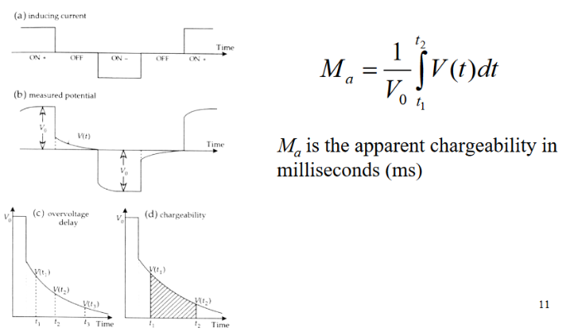
Figure 6: Induced Polarization in time domain showing a) on/off time increments of inducing current, b) measured potential, c) overvoltage delay and d) calculation of apparent chargeability. ⁽¹⁰⁾

Multiple logs must be run for a definitive result. For example, disseminated sulphides, which gold deposits could be associated with, can be resistive or conductive, plus resistivity can appear lower due to either the presence of clays or ore minerals. There is a large range in chargeability between different materials, from 0 msec for groundwater, up to 30 msec in a Precambrian Gneiss. For specific minerals, chargeability is dependent on the concentration within the host rock. There is a large spread of possible values, ranging from 13.4 msec in a 1% sample concentration of pyrite, down to 2.2 msec in a similar concentration of magnetite.
This anomalously high chargeability of pyrite has sparked a novel use for IP in hydrocarbon exploration. Minor amounts of hydrocarbon leaking through the top seal of a deeper hydrocarbon trap can form a pyrite rich alteration zone. These halo-shaped zones can be identified as anomalies with an IP survey, helping to reduce drilling costs. ⁽¹²⁾

aeromagnetic Methods (EM, TEM)
These surveys can be acquired by aircraft flying a track or grid pattern at relatively low altitude, or on the ground. They measure spatial variations in Earth’s magnetic field over the surveyed area, which are usually related to mineralogy. The main objective of an aeromag survey is direct detection of iron ore, subsurface lithology, and structure, as well as the extent of permissive terranes (areas that can contain a certain type of mineral occurrence or ore deposit). It can be used to identify hazardous material from nickel/copper or asbestos in serpentine. Like IP, TEM has been used to map geochemical anomalies and oil-water contacts in shallow hydrocarbon reservoirs - a lot of this investigation has been done in Russia. ⁽⁴⁾
Like IP, the data can be represented in the time domain (TEM: Transient Electromagnetic), or the frequency domain (EM). In the frequency domain, a current is transmitted continuously as a single frequency, which works well for shallow targets.
For helicopter conveyed TEM, the transmitter coil is fixed to a rigid frame suspended beneath a helicopter, with a receiver positioned centrally within the frame. A DC current is run through the transmitter, then rapidly switched off, generating a square wave. This in turn generates a time-varying magnetic field in the subsurface which instigates eddy currents. These currents cause the onset of a secondary magnetic field. The receiver coil measures this secondary field’s strength and temporal response, and data is displayed as time/magnitude decay curves. The resultant time amplitude data is inverted to arrive at a resistivity image of the subsurface.
When deployed by a fixed wing airplane, the receiver, or bird, is towed behind in an offset configuration. A ground-based system has a similar transmitter/receiver arrangement as the helicopter, providing information about the ground directly beneath the loops.
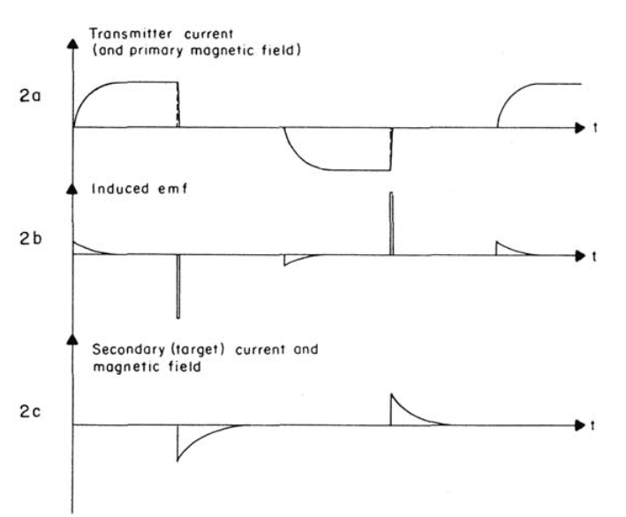
Figure 7: TEM system waveforms: 2a) transmitter current, 2b) the induced electromotive force, 2c) the secondary current and magnetic field. ⁽¹³⁾

Aeromag requires data corrections for flight altitude and flight track closure errors (pre-GOS only). Subtraction of 3rd order regional surface from corrected data set will give contour map of the magnetic anomaly. An optimized borehole drilling and coring program is derived from this map. ⁽⁵⁾
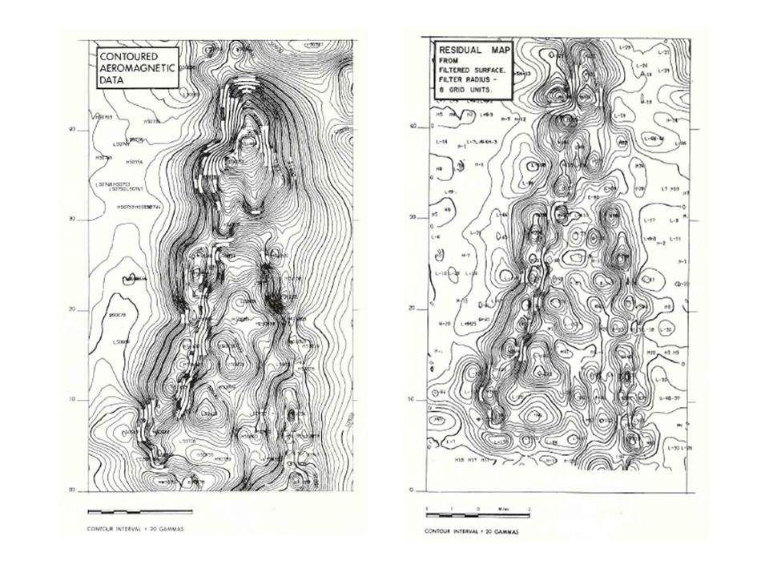
Figure 8: Contoured Aeromagnetic data (left), post-processed 3rd order residual map of same dataset (right).

Unsurprisingly, electromagnetic measurements can be complicated by the IP effect. This occurs where the earth is neither acting as a resistive nor conductive body but instead acts as a capacitor. In cases where this is known to be a problem, the data can be inverted using a special model which inverts not just for resistivity but also for IP effects. A description of this workflow can be found in reference 14.
Current trends in TEM involve complex forward modeling of massive sulphides, with a focus on recognizing various possible morphologies. ⁽¹⁵⁾
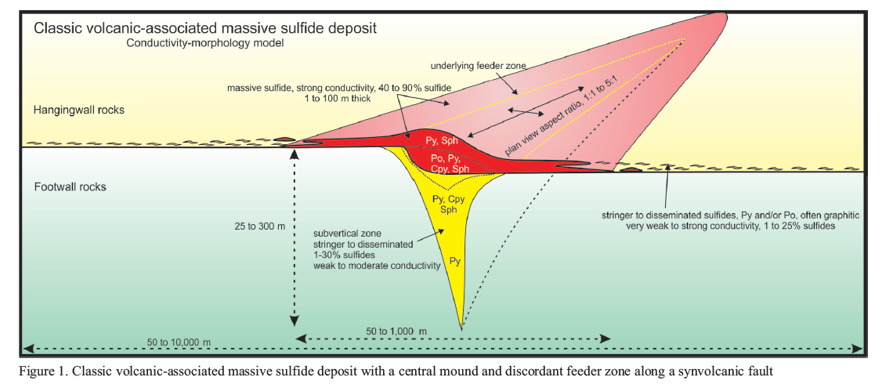
Figure 9: Model morphology of classic volcanic-associated massive sulphide deposit with central mound and discordant feeder along a synvolcanic fault.
Radiometric Field Mapping and data processing
These surveys can be acquired by aircraft or on land surface. They measure natural occurring radiation from potassium, thorium, and uranium. Also known a gamma-ray spectrometry, their main purpose is direct detection of uranium prospects.
Thorium increases in felsic rocks, indicating alkalinity, which in turn provides an indication of oxidation of sulphides, leading to faster uranium mobilization. Potassium alteration associated with hydrothermal ore deposits can also be detected. Other uses include heat flow studies and environmental mapping.
Recorded data requires corrections for flight altitude and flight track closure errors (pre-GPS only). Subtraction of 3rd order regional surface from corrected data set will give contour map of the radiometric anomaly. It is interesting to note that combined airborne magnetic and radiometric surveys, being the most cost-effective geophysical survey method, have become a means to “stimulating mineral exploration” worldwide. ⁽¹⁶⁾

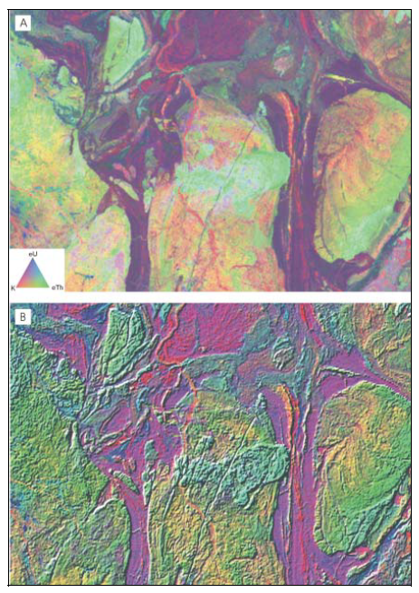
Figure 10: A: Ternary radioelement map showing abundance K (red), Th (green), U (blue). B: IHS composite image.
ElectromagNETIC Spectrum Remote Sensing
These surveys record infra-red (IR), visible, and ultra-violet (UV) light emanating from the earth’s surface, usually acquired from air photos or satellite images from instruments with appropriate filters fit for the survey’s purpose. Recent developments include surveying via drone, which provides a compromise between ground-based soil and rock sampling, and large-scale airborne surveys. This is important, given today’s eco-conscious attitude against mining. Hyperspectral (the continuous spectrum of reflected sunlight in the visible and near infra-red regions) imaging is being used to map rare-earth-element prone regions in Namibia. ⁽¹⁷⁾
Often used to locate anomalous vegetation which may indicate minerals in soil, EMS remote sensing is also used to identify chemical spills, tailings, pond leakage, other environmental damage, or to demonstrate successful environmental restoration.

Conclusions
The examples shown in this article illustrate the possibilities for integration of diverse data sets that can reduce the risk of misinterpretation and help to meet the objectives of an eco-friendlier industry. The multiple and overlapping usages of surface exploration methods provide real solutions to real exploration issues.
The “Petro” in Petrophysics means “rock”, not “petroleum”! The right kind of rock is what mining engineers, management, and shareholders are looking for. It is time to integrate all our petrophysical / geoscience skills to find those deeper prospects we know must be out there. Our World depends on our success.
REFERENCES
- Exner-Pirot, H. “Drop in mining deratils drive for Net Zero”. The National Post. https://epaper.nationalpost.com/article/281895892585033 (accessed May 11, 2023)
- The Canadian Minerals and Metals Plan. “Action Plan 2020: Introducing the Pan-Canadian Initiatives”. https://www.resourcedata.org/dataset/23794a95-1cae-47fd-bbca-da003845fa1d/resource/c4f58523-3a23-4f3f-b393-f63b1efa8f70/download/f6.pdf, (page 18) (accessed May 11, 2023)
- Schulte, B.W., “Methods of fault detection with geophysical data and surface geology”, https://csegrecorder.com/assets/pdfs/2019/2019-09-RECORDER-Methods_of_fault_detection.pdf (accessed June 28, 2023).
- Meju, M.A., “Geoelectromagnetic exploration for natural resources: Models, case studies and challenges.” Surveys in Geophysics, 23: 133-205 (2002)
- Crain, E.R., Pratt, David, Bogehold, R., “Review of Gravity and Magnetic Data Processing Systems, CSEG Journal Vol 8 No 1 Dec 1972
- Gupta, H., Roy, S., “Geothermal Energy”, 2007
- Kelbert, A. et al, Ec Newsletter, https://eos.org/science-updates/taking-magnetotelluric-data-out-of-the-drawer 27 December 2018
- Martinez, J, Rey, J., Sandoval, S., Hidalgo, M.C., Mendoza, R. “Geophysical prospecting using ERT and IP techniques to locate galena veins.” www.mdpi.com/jornal/remotesensing. Remote Sens. 2019, 11, 2923; doi:10.3390/rs11242923
- EPA Web Archive, Environmental Geophysics, “Equipotential and Mise-a-la-Masse Methods”, https://archive.epa.gov/esd/archive-geophysics/web/html/equipotential_and_mise-a-la-messe_methods.html (accessed June 12, 2023)
- Marescot, L., “Electrical Surveying, Part II: Induced polarization method”, Swiss Federal Institute of Technology, Zurich, (accessed March 20, 2023)
- University of British Columbia, “Introduction to induced polarization surveying” https://www.eoas.ubc.ca/courses/eosc350/content/methods/meth_2/ip.pdf (accessed May 10, 2023)
- SEG, “A review of some experience with the induced-polarization/resistivity method for hydrocarbon surveys: Successes and limitations” https://library.seg.org/doi/10.1190/1.1442963
- McNeill, J.D., “Applications of Transient Electromagnetic Techniques”. http://www.geonics.com/pdfs/technicalnotes/tn7.pdf Oct 1980 (accessed June 12, 2023)
- Grombacher, D., et al, “Induced polarization effects in airborne transient electromagnetic data collected in the McMurdo Dry Valleys, Antarctica”. Geophysical Journal International, 2021, pg. 1574-1583.
- Prikhodko, A., Mumin, H., “Electromagnetic responses to massive sulphide ore systems of various morphologies and conductivities. CIM Journal Vol. 9, No. 4, 2018.
- IAEA, Vienna“Guidelines for radioelement mapping using gamma ray spectrometry data”, , https://www-pub.iaea.org/mtcd/publications/pdf/te_1363_web.pdf, 2003, page 97 (accessed June 28, 2023).
- Jackisch, R. Drone-based surveys of mineral deposits. Nat Rev Earth Environ 1, 187 (2020). https://doi.org/10.1038/s43017-020-0042-1

