DEFINING EVAPORITE DEPOSITS WITH ELECTRICAL WELL LOGS
R.P. Alger, Houston, Texas
E.R. Crain, Calgary, Alberta
Schlumberger Well Surveying Corp.
Presented by R.P. Alger at 2nd Salt Symposium, Northern Ohio Geological Society, Cleveland Ohio, 1966. Published in Symposium Transactions. This electronic version created Feb 2021.
ABSTRACT
Many evaporite deposits can be located and defined through use of electrical logging tools developed for oil exploration. These logging tools, run into drilled holes at the end of electrically insulated cables, provide continuous recordings of various formation properties. Among the formation characteristics that may be recorded are electrical resistivity, density, natural radioactivity (Gamma Ray log), response to neutron irradiation (Neutron log), and acoustic transit time (Sonic log).
In oilfield applications of the logs, interest is primarily directed to the definition of the amount and type of fluids in the formations. These determinations require that matrix effects be defined and accounted for through appropriate combinations of logging measurements. In evaporite exploration the primary interest is in the identification and definition of the matrix minerals.
Because most evaporite minerals are extremely resistive, electrical resistivity measurements are frequently used in a first reconnaissance. The less resistive beds of shale, sand, and carbonate may be illuminated from further study.
Formation density measurements are used in most evaporite studies. Some minerals are directly identified by density measurement, but usually density must be complemented by other data. Comparisons of density and acoustic transit time identify salt, trona, anhydrite, and other evaporites. Because the neutron log is sensitive to the amount of water of crystallization in an evaporite formation, it provides information necessary to define such hydrous materials as gypsum, polyhalite, kyanite, carnallite, and trona. The Gamma Ray measurements are used to determine potassium content and thus help distinguish between various potassium salts.
INTRODUCTION
Electrical well logs, so useful in oil exploration, accurately locate and identify evaporite beds. This paper will show how certain logs define the type of evaporite. Furthermore, data from log combinations permit estimation of percentages of minerals and mixtures.
The process for making logs in boreholes involves the following: a sonde or exploring device, usually electronically operated, is lowered into the borehole at the end of an armored cable. This cable contains insulated conductors for signal transmission and provides accurate measurements of the position of the sonde below the surface. The cable is spooled on a powered winch drum. As this cable is lowered or raised, signals from the sonde are processed through surface equipment, then photographically recorded on a moving film which is synchronized with the rate of cable movement. This photographic record is called an electrical well log.
IMPORTANT PROPERTIES MEASURED
For oilfield use electrical logs provide a means for defining the amount and type of fluids contained within porous formations. Also, the type of lithology is often determined if suitable logs are available. The accumulated understanding of these lithologic matrix effects can easily be extended into the realm of evaporite logging. Pertinent formation properties, measurable by borehole devices are as follows:
- Electrical Resistivity (R_{T}). This is the property of the formation to oppose the flow of electrical current. Resistivity is expressed in ohm-meters (a simplification of ohm-m²/m).
- Bulk density (ρ_{B}). This is numerically equivalent to specific gravity and denotes the average density of a formation expressed in gm/cc. Measurement involves the Compton scattering of Gamma Rays which emanate from a constant radiation source on the tool. The amount of Compton scattering which takes place is a function of the average electron density of the formation. For some minerals (such as NaCl) electron density is not quite proportional to specific gravity (Wahl and Tittman, 1964). Therefore, such minerals require use of an apparent ρB for interpretation purpose. Comparisons of actual densities with log values of ρB in Table 1 illustrate these differences.
- Acoustic interval transit time (_{t}). This represents the time in microseconds required for a Sonic compressional wave to move one foot in the formation. This parameter is well known for many materials (see Table 1).
- Neutron porosity index (φ_{n)}. The Neutron Log is a measurement resulting from neutron irradiation of the formations. The response is primarily a function of the hydrogen concentration, whether from water or from hydrogen or from water (or oil) in the pore space. Additionally, some minerals produce a small matrix effect, so that φ_{n} refers to a neutron curve deflection equivalent to that obtained in a water-filled limestone of that porosity. Such matrix effects vary slightly for different types of Neutron tools.
- Natural Gamma Ray (GR). This is a measurement of the naturally occurring radioactivities of the formations expressed in API Units. The Gamma Ray response is a function of potassium concentration in potash minerals. In shales, the magnitude of curve deflection is a function of potassium, thorium, and uranium content. The level of radiation is high in potash beds and, to a lesser extent, in shales; in other formations the level is low.
A supplemental log of considerable usefulness is the hole caliper. Increases in hole diameter can be caused by caving or, in the case of some evaporite beds, solution.
USE OF RESISTIVITY MEASUREMENTS
Bedded evaporite minerals are essentially nonporous or are electrically nonconductive. Thus, they should appear infinitely resistive to the standard resistivity logging devices. However, the conductive borehole acts as a shunt for the logging current. As a result, in nonfocused logging, the maximum resistivity is much less than Infinity. Characteristic curve shapes, depending on the geometry of the electrode system and formation, identify these infinitely resistant beds. Figures 1 and 2 are typical cases. 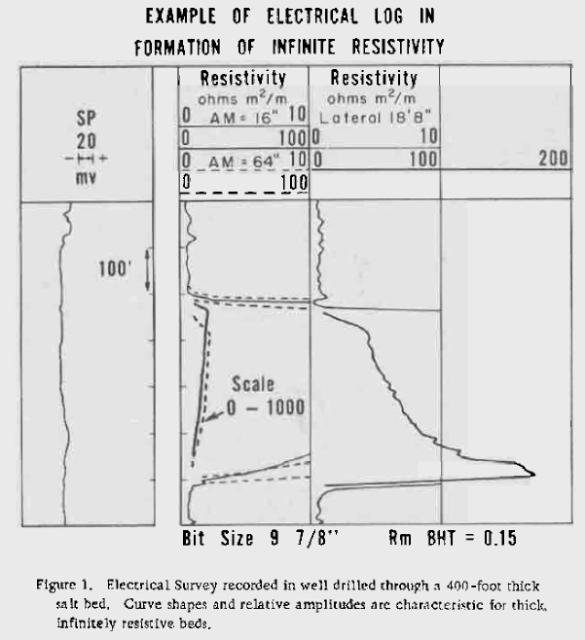
Figure 1: Electrical Survey through thick salt bed.

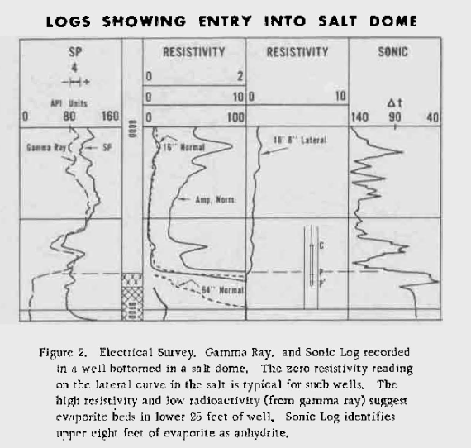
Figure 2: Electrical Survey, gamma ray, and sonic logs run into a salt dome.
Modern resistivity logging systems, such as the Laterlog, produce very high resistivities opposite evaporite beds, unless the borehole is greatly enlarged. Thus, in favourable conditions, evaporites are easily delineated where the resistivity approaches Infinity. Another system, one which does not require a conductive borehole fluid, is the inductive device (IL). Figure 3 illustrates an Induction Log opposite an evaporite section (B and C), in a hole drilled with an oil base mud.
A special electrode system, called the limestone lateral (Tixier, 1951), can be used to measure the average diameter of the borehole in nonconductive formations. This is demonstrated by Figure 4. The response chart is derived from a standard resistivity departure curves (Schlumberger, 1955) for a 32 inch lateral device. For investigation of larger holes, the spacing can be increased. For example, if the spacing were doubled, the hole diameter scale would be doubled. The accompanying log shows application of this chart and a comparison with a mechanically actuated caliper (Section Gauge). As long as the formation is nonconductive, like salt or anhydrite, the limestone lateral curve provides an excellent caliper.
Since evaporite beds are more resistive than surrounding sedimentary beds, they are easily located by resistivity logs. However, definition of the mineral content requires additional logs.
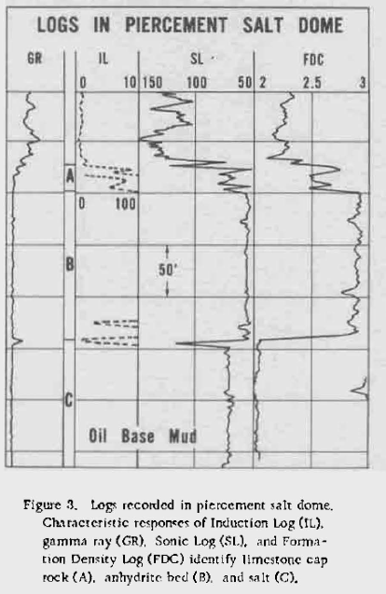
Figure 3: Induction log in nonconductive mud.

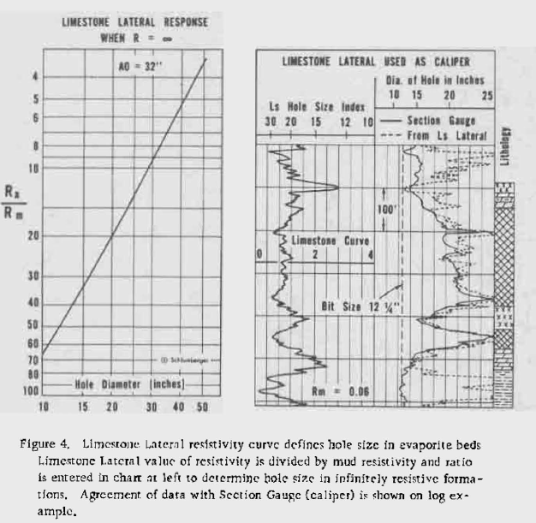
Figure 4: Limestone Lateral Curve
USE OF ONE POROSITY LOG
Sonic, density, and neutron logs are used both singly and jointly for determination of formation porosity. Thus, in the petroleum industry and throughout this paper, these logs are referred to as porosity logs. However, while each of the three reflect variations in porosity, each also responds to variations of the matrix mineral. In evaporite exploration there is little interest in porosity evaluation – most evaporites have little or no porosity. Here, the primary interest is identifying the evaporite through characteristic responses on one or more of the porosity logs.
When nonporous evaporite deposits occur in isolated beds of a single mineral, identification is often simple. Identification is achieved by comparing the log values to the data shown in Table 1. To illustrate, the three different porosity logs are shown, each being the actual recording over an evaporite interval from a Permian basin well.
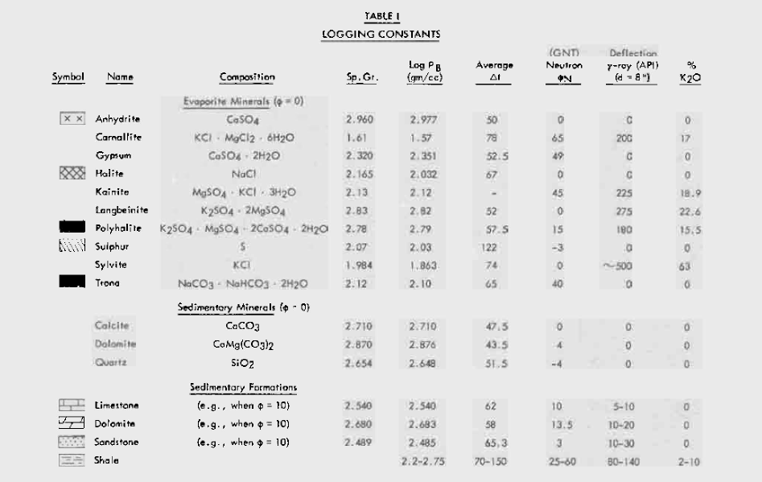
Table 1: Physical properties of Evaporite Minerals.
Figure 5 shows the Gamma Ray-Neutron log, for many years the standard correlation log in this region. The gamma ray deflections to the right indicates shale streaks. Shale also affects the neutron log, producing deflections to the left. Besides shale, both halite and anhydrite are present, but cannot be distinguished from each other.
Figure 6 shows the Gamma Ray, caliper, and bulk density curves. Hole enlargements caused by solution of the halite show on the caliper curve. But these salt zones are much more clearly identified by the value of bulk density, which should be 2.03 for pure halite. Beds in which bulk density approaches 2.98 are evidently anhydrite. Values of approximately 2.4 generally correspond to shale, as is verified by the Gamma Ray.
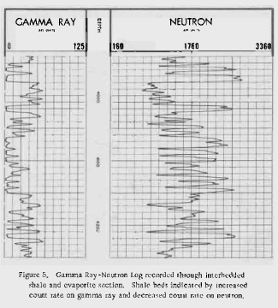
Figure 5: Gamma ray and neutron logs in halite and anhydrite, with shale beds
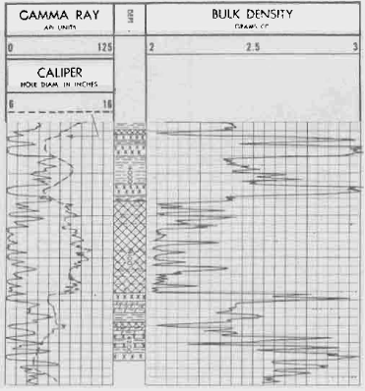
Figure 6: Formation density log with gamma ray and caliper recorded through shale and evaporite section (same intervals as in Figure 5).
Halite beds identified by density of 2.03 and by enlarged hole on caliper. Anhydrite beds characterized by high bulk density, approaching 2.98.

Figure 7 presents a BHC sonic log, which also includes gamma ray and caliper curves recorded simultaneously. The BHC (Kokesh, Schwartz, Wall, and Morris, 1965) tool compensates for a changing borehole diameter, a problem with older Sonic logs. The interval transit times ( t) shown in Table 1 for halite and anhydrite are 67 and 50, respectively. These beds are thus easily identified by this log. Shale streaks give higher t values, between 75 and 85 sec/foot.
For the interval just studied, the BHC sonic and gamma ray seemed to give the clearest identification of this evaporite sequence.
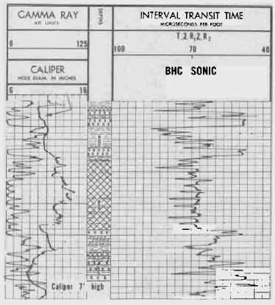
Figure 7: BHC sonic log with gamma ray and caliper recorded through shale and evaporite section (interval same as in figure 5 and 6). Interval transit time is 67 microseconds per foot for halite; 50 for anhydrite.
USE OF SEVERAL POROSITY LOGS
When evaporite beds contain mixtures of minerals, when they are in intercalated with sedimentary rocks, or when appreciable pore space is present, several porosity logs are required for mineral identification. A recent paper (Raymer and Biggs, 1963) showed that cross plots of data from pairs of porosity-sensitive tools often identify the lithology. Figures 8, 9 and 10 are from this paper, with some small modifications and additions. The zero indications represent the respective readings for the pure minerals, as listed in Table 1. Extensions to the upper right show how the presence of porosity affects the log values for specified minerals. These charts can serve several functions: one, cross-plotting data from unknown lithologies can often provide rock identification and the amount of porosity present; two, if the formation contains two known minerals the plotted point also permits estimation of the proportions of these minerals; three, if the formation contains two known minerals, a glance at the series of charts enables one to pre-select the pair of logs which will provide optimum resolution.
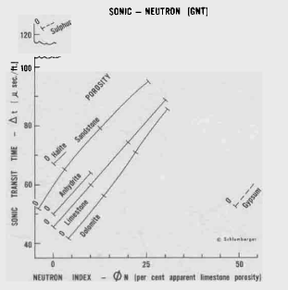 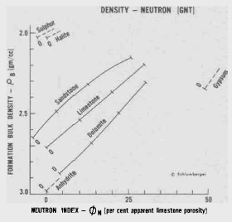
Figure 8 and 9: Sonic-Neutron (left) and Density-Neutron (right) crossplot charts for determination of lithology and porosity.
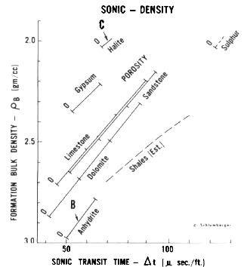
Figure 10: Sonic-Density crossplot chart for determination of lithology and porosity.
If a third mineral is involved, additional data is required. Evaluation becomes more difficult and usually requires complex graphical solutions or, even better, processing by machine computation (Savre, 1965).
Halite-Anhydrite Example
The logs shown on Figure 3 serve to illustrated the use of the crossplot technique. The log data are as follows:
Zone | Sonic Logs (SL) _{t} | Density (FDC) ρ_{B}
B | 56 | 2.88
C | 70 | 2.02

These values are entered in Figure 10 (Sonic- Density Chart). Zone B plots on the anhydrite line and indicates about 4% porosity is present. Zone C plots on the halite line and suggests about 2% porosity is present. The contact between Zones B and C appears to be a solution interface.
Here water is dissolving the halite and freeing the disseminated anhydrite crystals, which become concentrated and subsequently are recrystallized above the salt mass (Landes, 1962, p. 8) . Zone A is predominantly of limestone containing considerable porosity. Such a zone, when well developed, is favorable for deposition of native crystalline sulphur.
Sulfur Example
An example (Fig. 11) of sulphur location and evaluation is used to present another method of mineral analysis. Sulphur is usually deposited in vugs or caverns in the limestone cap rock. Some water-filled voids still exist. The set of logs must be able to resolve the percentages of water, sulphur and limestone. The recently developed density tool (FDC) and sidewall epithermal neutron (E-N) are most suitable for this purpose. These logs can be scaled in linear porosity, assuming a limestone matrix. With this scaling the Neutron Log primarily reflects variations in the amount of water in the formation, and the density curve indicates the combined effect of variations in amounts of water and sulphur. Figure 11 shows application of the method. A neutron deflection to the left of the zero porosity line gives the percentage of bulk volume occupied by water. The density curve gives that occupied by water plus sulphur. These guides are then useful for interpretation:
- When the curves agree, only limestone and water are present.
- When the density curve is to the left of the neutron curve, sulphur is indicated.
- If no other minerals are present in the sulphur-bearing limestone (such as anhydrite, gypsum, salt, pyrite), the percentage of sulphur can be found as follows; (φ Density- φ Neutron) / 40 = fraction of sulphur. Actually, this is true only if sulphur produces no matrix effect on the neutron measurement. Probably some effect does exist, but it is usually of little importance.
- When the density curve is to the right of the zero porosity line for limestone, anhydrite is usually present.
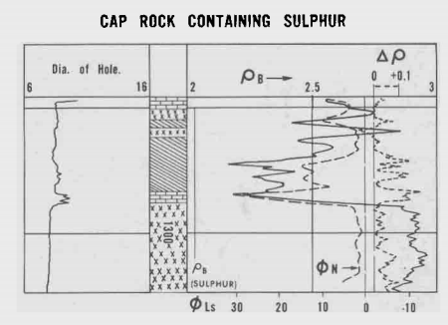
Figure 11: Density and Neutron data identify sulphur-bearing cap rock. Sulphur present in beds identified by diagonal cross-hatching.
Trona Example
The Green River formation, Sweetwater County, Wyoming, contains beds of trona (Na₂CO₃ NaHCO₃ 2H₂0). The properties of this mineral are sufficiently different from the surrounding marl formation that electrical logs clearly locate the trona beds. Figure 12 illustrates this application. A lithology log based on core description is shown on the figure. The beds of trona are indicated by solid black. Log characteristics for trona are as follows:
- Gamma Ray indicates low radioactivity (curve to left).
- Caliper shows hole enlargement (due to solubility of trona).
- Sonic shows low t (this could also be due to limy streaks).
- Neutron shows high φ N, due to water of hydration. (This eliminates the limy streaks)
The density log is potentially useful, since the bulk density of trona is very low (approximately 2.10 gm/cc). However, the wall rugosity noted would limit the value of the log. If a well is drilled with oil-base mud, or with air, the hole size should remain more to gauge and the density log would be more useful and reliable.
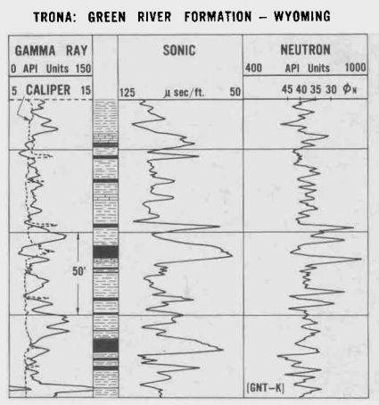
Figure 12: Beds of Trona identified by logs.

SYLVITE, HALITE, CARNALLITE EXAMPLE
An example of quantitative use of the density and neutron logs to evaluate potash-bearing evaporites in Saskatchewan was shown in a previously cited paper (Raymer and Biggs, 1963, p. X-19). Figure 13 shows the logs and Fig. 14 the interpretation chart. The positions of the plotted levels indicate the relative abundance of the minerals present. The results are in good agreement with the geologist’s description of cores taken in this well.
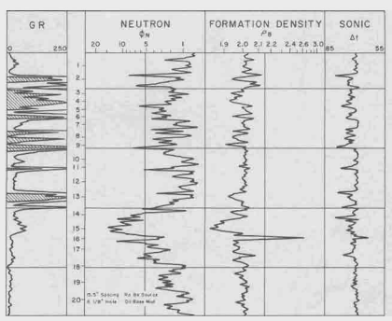
Figure 13: Logs recorded through potash-bearing evaporite beds.

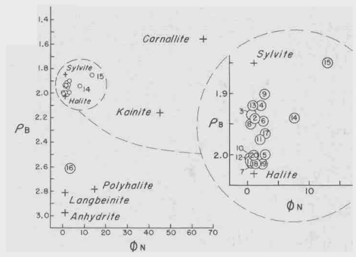
Figure 14: Cross-plot of density vs. neutron identifies evaporite minerals (data from logs in Figure 13).

When the evaporite salts contain potassium, the presences of the radioactive isotope K⁴⁰ (constituting about 0.012% of the naturally-occurring potassium) can be detected by a gamma ray log. From empirical studies – involving assayed values of K₂0, hole diameter, type of borehole fluid, and type of sonde – curves relating gamma ray deflection to K₂0 have been developed (Fig. 15 Crain and Anderson, 1966). Another means is thus available for mineral identification, since for potassium minerals the gamma ray response for the pure mineral can be calculated from the K₂0 content (see Table 1). Figure 13 shows that high gamma ray deflections occur at many levels.

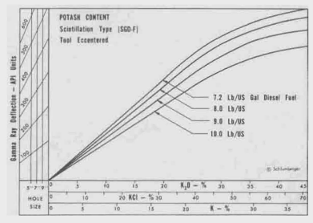
Figure 15: Empirical Chart relating gamma ray deflection to potassium content.
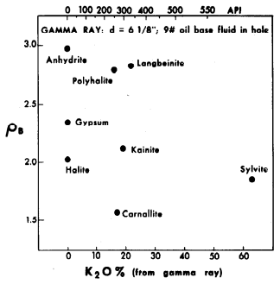
Figure 16: Plot of gamma ray vs. bulk density defines potash minerals (data from logs in Figure 13).

Figure 16 is a plot of gamma ray (also calibrated in terms of K₂0) versus bulk density, . Coordinates are located for pure halite, anhydrite, polyhalite, langbeinite, sylvite, and carnallite. The plotted levels indicate mixtures of halite with either sylvite or carnallite. Level16 is an anhydrite-halite mixture. This plot confirms the mineral concentrations indicated by the density vs. neutron cross plot (Fig. 14).
POLYHALITE EXAMPLE
Figure 17 shows four sections taken from logs run in a well located in the Permian Basin. These contain mostly halite (cross-hatched intervals); an anhydrite bed appears at the bottom of the example. The four sections of interest are characterized by five logs as follows:
- Gamma Ray – sharp, rather high radioactivity, suggesting a potash mineral.
- Caliper – indicates solubility less than for halite.
- Sonic – t less than for halite.
- Neutron – higher porosity index than for halite, suggesting a hydrated mineral.
- Density – much higher than for halite.
Two cross-plots are shown; one, density vs. gamma ray (Fig. 18), the other, sonic vs. epithermal neutron (Fig. 19). Both cross-plots indicated these four zones are primarily polyhalite with some halite also present. Possibly some kainite is also present, as evidenced by the plotted position to the right of the halite-polyhalite line.
Three other thin beds appear and are labeled X. The mineral involved evidently contains little or no potassium, is hydrated, has long transit time, and has about the same density as halite. Mineral identification of these beds is uncertain.

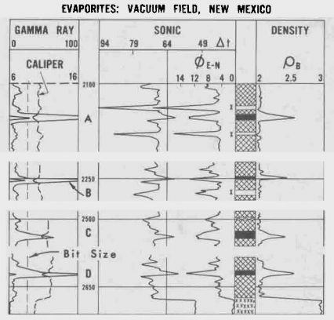
Figure 17: Logs identify beds of polyhalite.
QUANTITATIVE POTASH EVALUATION
From foregoing discussions it is apparent that logs offer a method of quantitatively determining relative fractions of potash minerals in evaporite formations. The greater the number of different minerals, however, the more difficult the problem becomes – and the greater is the number of logs required for a solution.

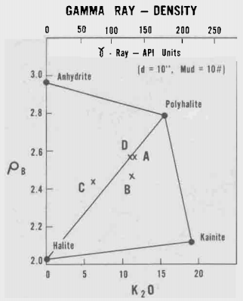
Figure 18. Plot of gamma ray vs. bulk density data from logs in Figure 16.

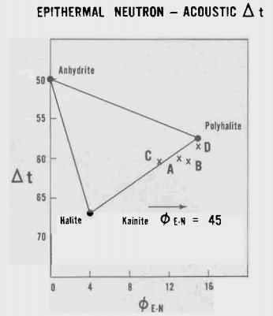
Figure 19. Plot of sonic vs. epithermal neutron data from logs in Figure 16.

In some areas the types of potash minerals likely to be encountered are well known. Thus, methods appropriate for the particular area can be developed. One such area is the development of the Prairie Evaporite Formation in Saskatchewan, Canada. There, the ore zones are made up chiefly of sylvite, carnallite, and halite. Small fractions of insolubles, mostly clay, are also present. Other minerals rarely exceed one percent of the formation and are therefore ignored.
An empirical method of interpretation for this Prairie evaporite section was developed by comparing log data with 28 core assay reports. This method uses sonic, neutron, and gamma ray data, and provides the relative fractions of sylvite, carnallite, halite, and insolubles in the formation.
Sonic and Gamma Ray measurements are used to determine the small, but significant, fractions of insolubles. Neutron data provide the control required for determination of the fraction of carnallite. With these two constituents determined, gamma ray data are used to define the sylvite fraction. Ultimately, the halite fraction is assumed to comprise the remainder of the formation volume. Results with this method have agreed closely with assay reports on subsequent wells.
Logs from one of the Prairie evaporite wells are shown in Fig. 20. As in drilling all of these development wells, oil base mud was used to prevent hole enlargement through the soluble evaporites. The logs are recorded on an expanded depth scale for maximum resolution of the often thin ore beds. In addition, the logs are recorded at a slower logging speed than normal to insure maximum detail.
In addition to the recorded gamma ray, neutron and sonic curves, the results of the analysis are shown. These results are plotted to indicate the relative proportions of sylvite, halite, carnallite, and clay at each level. The computed percent of sylvite closely agrees with the assay of cores.
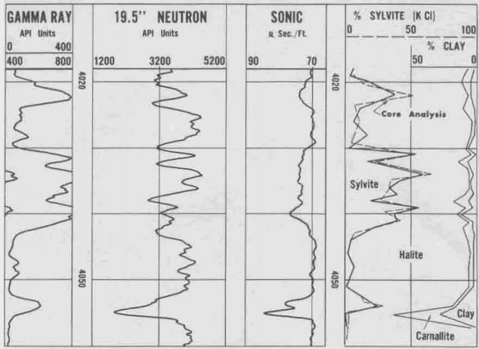
Figure 20: Logs recorded through Prairie evaporite section with computed mineral analysis and core assay.

CONCLUSIONS
Electrical resistivity logs in bedded evaporites generally give characteristic curve shapes and values, depending on the type of measuring system and the geometry of the bed. From such logs the evaporites can be distinguished from the less resistive sedimentary formations. However, resistivity curves do not indicate the kind of evaporite present. Mineral identification is based on knowledge of pertinent logging parameters. When two minerals occur together, their relative abundance can be obtained if two properly selected porosity devices are run. Additional logs are useful for confirmation or when other minerals are expected. The gamma ray gives added information for identifying potash salts. When the mineral suite is generally known, logging programs yield quantitative data equivalent to assays of the formations.
ACKNOWLEDGMENTS
Appreciation is extended to the several companies who furnished logs or other information used in this discussion. Special recognition is due Mr. H. V. W. Donohoo of the Texas Gulf Sulphur Company.

REFERENCES
Kokesh, F. P., Schwartz. R.J., Wall, W. B., and Morris, R. L., 1965, "A New Approach to Sonic Logging and Other Acoustic Measurements": Journal of Petroleum Technology. vol. 27. no. 3. p. 282.
Landes, K. K . 1962. "Origin of Salt Deposits": Symposium on Salt, Northern Ohio Geological Society, p. 8.
Raymer, L. L., and Biggs, W. P., 1963, "Matrix Characteristics Defined by Porosity Computations": in Transactions of Soc. of Prof. Well Log Analysts Meeting, 1963, p. X-12 to X-20.
Savre, W. C., 1963. "Determination of a More Accurate Porosity and Matrix Composition in Complex Lithologies with the Use of the Sonic, Neutron. and Density Surveys": Journal of Petroleum Technology. vol. 15. no. 9. p. 945.
Schlumberger Well Surveying Corporation. 1955. "Resistivity Departure Curves -- Document 7": Schlumberger Well Surveying Corporation. p. 19.
Tittman. J., and Wahl, J.S., 1965. "The Physical Foundations of Formation Density Logging (gamma-gamma)": Geophysics. vol. 30. no. 2. pp. 284-294.
Tixier. M. P., 1951, "Porosity Index in Limestone from Electrical Logs": Oil and Gas Journal, vol. 50. no. 28. p. 140 and vol. 50, no. 29. p. 53.
Wahl, J. S., Tittman, J., Johnstone, C. W., and Alger. R. P., 1964, "The Dual Spacing Formation Density Log": Journal of Petroleum Technology. vol. 16. no. 12. p. 1411.
Crain, E. R. and Anderson, W. B., 1966, “Quantitative Log Evaluation of the Prairie Evaporite Formation in Saskatchewan,“ Jour. Canadian Pet. Tech. (July-Sept., 1966).

