DIGITAL PROCESSING OF SPARKER SEISMIC DATA
E. R. Crain, P. Eng.
Digital Technology Pty. Ltd.
Published as Digitechnical Bulletin #1 April 1970

USING SPARKER DATA
Exploration management selects sparker surveys in order to get accurate seismic reconnaissance information at a low cost. Digitech, recognizing the value of such a service to the industry, installed the only facility in Australia for processing sparker data recorded on Ampex digital tape. We have since processed more than 1,000 miles of single channel sparker data – including private surveys as well as portions of the B.M.R. regional survey.

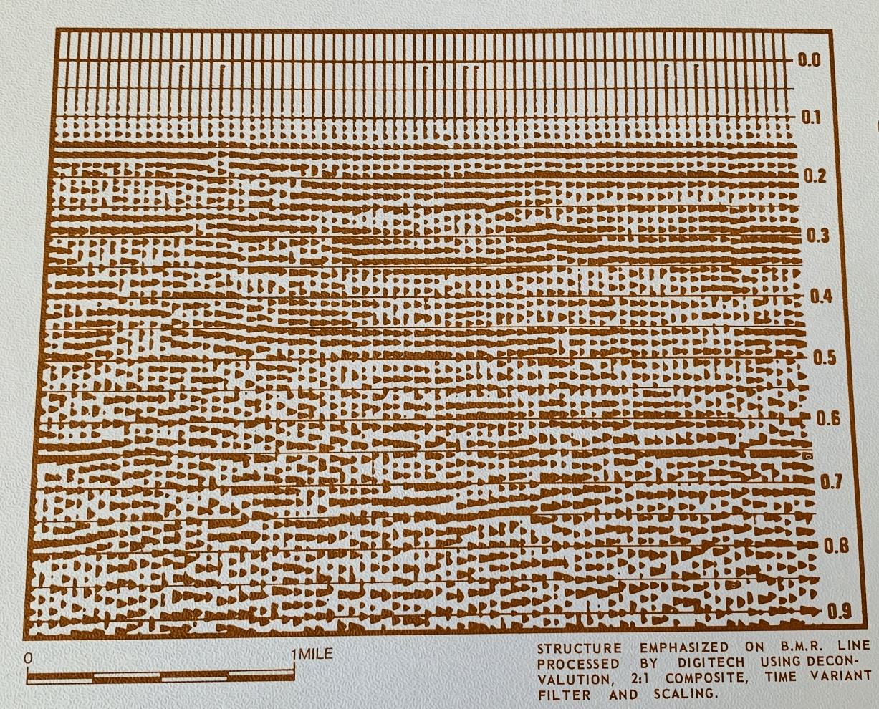
Figure 1:Structure emphasized on B.M.R. line processed by using deconvolution, 2:1 composite time variant filter, and scaling.
Experience in potential field corrections and interpretive methods using the digital computer shows benefits in the integration of magnetic and gravity data. Exploration companies looking for prospective farm-in acreage also find this data valuable in assessing regional trends and local anomalies in new areas.
Likewise, large scale marine seismic surveys, created by the sparker method, provide another dimension to assist regional and local structural interpretations. Digital seismic data processing of the sparker survey can enhance vertical resolution and reflection continuity, making interpretations less ambiguous and more accurate.

IMPROVING SPARKER DATA QUALITY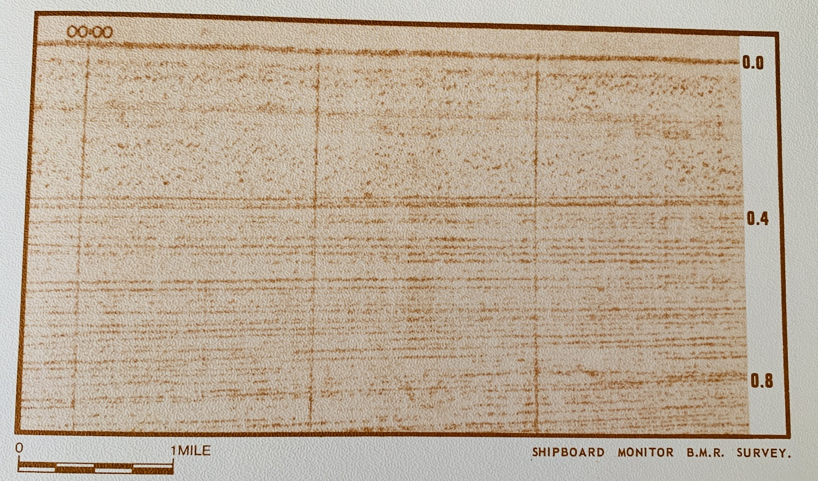
Figure 2: This section is an example of a shipboard monitor section from the Australian Bureau of Mineral Resources (B.M.R.) survey (single channel sparker), offshore NW Shelf, WA. Although these sections are of good quality, and are helpful in doing a quick interpretation, they do not give the geophysicist enough information. Ringing, which obscures structure, can only be attenuated by digital processing, which allows extraction of the maximum information from the sparker data.

ADVANTAGES OF DIGITALLY PROCESSED SPARKER DATA
- Optical presentation and scale uniformity: The client has his choice of display made and scale. Time scale changes, sometimes present on shipboard monitor sections, are eliminated.

- Predictive deconvolution: Water bottom ringing, which makes interpretation difficult, is attenuated.
- Trace compositing: Signal to noise ratio of deep reflections may be enhanced by compositing adjacent groups of traces.
- Time variant filtering: Reflection quality may be enhanced by the use of digital filters.
- Time variant scaling: Deep data and low amplitude zones may be brought out by the use of data dependent scaling programs.

PROCESSING COSTS
Very large surveys, such as the B.M.R. North-West Shelf program, could be processed for a group of clients. Processed sections, along with an interpretation, could be provided to each participant for a very low cost. Systematic processing and interpretation of a large project like this should be of great value to exploration companies on Australia’s Contintental shelf.

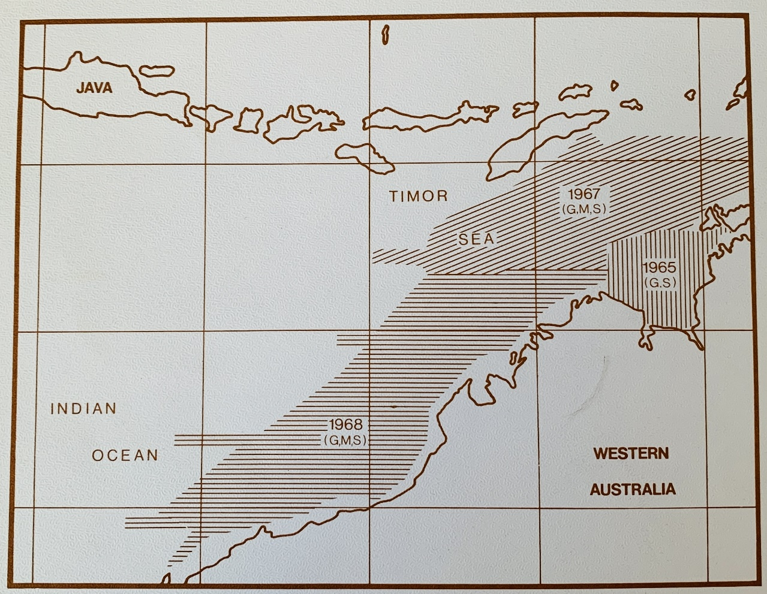
Figure 3: B.M.R. location map of northwest Australia gas play.
A sparker survey can be processed for a fraction of the cost of a common depth point recording. Most data can be processed for less than $A20.00 per mile (c.1970).

ACKNOWLEDGEMENT
The sparker data shown here is from the B.M.R. 1968 survey. The map is also drawn from the B.M.R.report.

