LOG INTERPRETATION IN THE HIGH ARCTIC
E.R. Crain, P.Eng
E.R. Crain and Associates Ltd.
Calgary, Alberta

Presented at the 6th Formation Evaluation Symposium of the Canadian Well Logging Society in Calgary, 24 – 26 October 1977. Published in 1977 Symposium Transactions.

ABSTRACT
Interpretation of well logs in the Canadian Arctic Islands is still a developing art. This paper presents the data and techniques acquired to date and itemizes the areas in which more work is needed. Methods of interpretation are demonstrated with numerous examples. Exotic minerals and other log interpretation problems are illustrated where possible.
INTRODUCTION
Due to the large and remote areas being explored, logs are probably used to a greater extent for exploration and reservoir calculations than in more heavily drilled areas. Well logs are not merely a record of where we have been, but clues as to where to go next. This leads to a greater effort, both in terms of quantity and quality of effort in the field and in the evaluation in the office.
Experimentation and subsequent re-computation of conventional Saraband and Coriband presentations has resulted in consistent and coherent reservoir descriptions from well to well within fields, and between fields. These data, supplemented by core DST, and sample data, form the basis of the reserves calculations for the Arctic Islands and for development of new exploration prospects.
GEOLOGIC SETTING
The majority of drilling has taken place in the Sverdrup Basin and in the Franklinian Basin south of the Sverdrup. The Sverdrup Basin ridge borders the Sverdrup Basin on the north and separates it from the Arctic (or Canada) Basin, which has not as yet been drilled. An area map and a typical cross section are shown in Figures 1a and 1b.
The rocks of the Franklinian Basin are a typical Paleozoic sequence, with carbonates and shales predominating. Evaporites are present, as are reefs of various ages. The upper portion of the Devonian is of a more continental type deposition, indicative of the terminal phase of deposition in this Basin. The stratigraphic sequence is shown in Figure 2.
The Sverdrup Basin is younger, with rocks ranging in age from Tertiary to Mississippian. Most rocks are clastics, with limestones and evaporites occurring only in Permo-Pennsylvanian. This sequence is shown in Figure 3.
Significant hydrocarbons (mostly gas) have been found in several zones in the Sverdrup Basin, including the Schei Point-Bjorne (Lower Triassic), Borden Island-Heiberg-King Christian (Lower Jurassic-Upper Triassic), and Mould Bay (Upper Jurassic).
In the Franklinian Basin, the only significant show has been an oil discovery in the Blue Fiord carbonate (Middle Devonian) at Benthorn on Cameron Island. Log evaluation examples from these major reservoirs will be described later in this paper.
LOGGING PROGRAM
The logging suite is fairly comprehensive, since a great deal of subsequent computation is done on the logs. The basic suite consists of:
- Dual Induction-Laterolog 8, with SP, Rxo/Rt and Gamma Ray.
- Borehole Compensated Sonic, with Gamma Ray (run in combination with the DIL).
- Compensated Neutron Log run in combination with Formation Density Compensated Log, with Gamma Ray and Caliper.
- High Resolution Gyro-Oriented Dipmeter.
- All logs tape recorded.
No caliper is recorded on the DIL/BHC combination due to a history of unreliable operations. Two inch scale films are made in the office from tape playbacks for the DIL and BHC logs. The CNL/FDC is recorded on porosity scales for the 5 inch film and neutron porosity/formation density scales on the 2 inch film. Scales are sandstone porosity in sand-shale sequences and limestone porosity in carbonate sequences. This allows simple field and office quick-look interpretations.
Optional logs include:
- DIL/BHC-GR only in surface hole.
- Long ES (20 ft. normal) for permafrost detection.
- Long Sonde Sonic Log for seismic velocity control in shallow sections.
- Dual Laterolog-Microspherically Focused Log for salt mud or moved hydrocarbon calculation.
- Sonic Amplitude-Variable Density Log for cement top detection, and in carbonates in open hole for fracture location.
- Sidewall cores for paleontological studies.
All log scales are standardized, except the caliper, so that fewer errors are made by inexperienced users. Other scales or detailed logs are made from tape playbacks. If necessary.
Due to transport and handling problems in cold weather, a spare set of tools is kept at the main camp at Rea Point. Lost time statistics are given later in this report.
LOG EVALUATION PROCEDURES
A complete log analyses is performed in the field, using a programmable calculator (HP-25), which solves for formation temperature, apparent formation water salinity, effective porosity from density-neutron crossplot, shale content from gamma ray or crossplot, and water saturation corrected for shale. Results of typical analyses are shown in the discussion of the examples which follow. Logs are sent to Calgary from the base camp at Rea Point by telecopier (if very short) or by digital data transmission (DART) via Panarctic’s satellite telephone hookup. Further testing or abandonment programs can be radioed to the rig with minimum delay. Hardcopy logs are sent south on the first available aircraft. To our knowledge, this is the only DART system using the satellite in North America. There have been no data transmission failures to date.
An experiment using HF radio from the rig site to the satellite phone circuit, failed due to the low passband of the HF sets. When the Panarctic VHF network is completed, this form of transmission will become a reality, reducing further the lag time between logging and decision making.
Office evaluation consists of computing the dipmeter results, and computing a Saraband in sand/shale sequences or Coriband (in carbonate sequences), or both. Numerous experiments have been run to determine suitable and consistent interpretation parameters for the programs. Parameter selection is closely controlled and results are “pushed” to agree with samples, cores, tests, gas detection logs and offset wells (if available).
Rank wildcats suffer from lower quality of such input, but are recomputed later if new data comes to light.
On one well (Chads Creek B-64), we have run 45 experimental Sarabands on the one zone to learn the quantitative effect of some of the parameters. In addition, this well has 10 normal computer runs of Saraband and one of Coriband, to assist in evaluating difficult sections. This necessitated the design of a new log heading to eliminate the confusion of 56 different computed logs in the well file.
Computer listings are consolidated in one folder and permanently marked to correspond to the “Computed Run Number” on the computed log. Four to six computed runs are not unusual for a productive well. The new heading also has a breakdown by zone of the key shale parameters and water resistivity data, which is often missing on normal Sarabands.
Since we run a large number of jobs of many types through the computer at the same time, we have developed a computed log status report to keep track of them.
Saraband and Coriband displays are standard, with two exceptions:
- The Vsh curve is displayed in track four as well as track one on Sarabands; the difference between Vcl and Vsh being the silt content of the zone. (see Figure 6, 7, and 8).
- The apparent “hydrocarbon” computed in porous permafrost is coded differently from normal hydrocarbon. Igneous sills are also coded differently where they can be identified.
An aid to parameter selection, and now a standard display format for all wells, is the Porosity Playback Log. It consists of the sonic, density, neutron and deep resistivity curves on a compatible porosity scale in tracks 2 and 3, with hole size corrected gamma ray, caliper, and apparent grain density (crossplot) in track 1 for correlation. See figures 6, 7, and 8.
This log is used for normalization of log data from well to well and is the only record of the editing done to the logs. Gas effect, shale character changes, hole size effects and exotic minerals can be readily identified.
The logging and evaluation procedures described above are summarized in Figure 4.
LOG QUALITY CONTROL
Quality control of logs is accomplished by a simple form - a log feature is either “OK” or “not OK”; There are no grades of good-poor-terrible. Quality has been generally high; the major problem being noisy or nonexistent SP, and curves missing due to equipment malfunction. A number of induction and density logs have shown unexplained shifts or separation but, being unacceptable logs, were re-run at the time. This shows up as lost time due to equipment failure but not as a low quality log.
LOG EVALUATION EXAMPLE – Borden Island and Lower Wilkie Point
The main gas reservoir in the Drake and Hecla gas fields is the Borden island zone. The reservoir is contained in widespread laterally continuous bar sands in the Jurassic, Borden Island Formation and the overlying Wilkie Point Formation.
The average net pay thickness at Drake field is 83 feet; the wellbore pay thickness vary from 34 feet on the southern flank of the field to 115 feet at Drake Point F-16 on the crest of the structure. The overall trend is a northward improvement in reservoir thickness and quality. The reservoir is one of excellent quality and average effective porosity of 18%, and average Saraband permeability index of 550 mD.
The Borden Island gas zone contains about 5.0 Tcf of gas in place in the Drake and East Drake pools.
At Hecla the maximum measured net pay is 103 feet in the northwest Hecla M-25 well, and the reservoir section thins toward the southern wells to less than 40 feet. The average effective porosity is near 20% with permeability averaging close to one Darcy.
The Borden Island zone at Hecla contains about 3.5 Tcf of gas in place.
At the base of the Borden Island formation at Hecla and Drake, an irregularly distributed conglomeratic iron mudstone infills topography on the surface of the unconformity between the Jurassic and the Triassic. The conglomerate is rich in iron with formation density exceeding 3.5 gm/cc in some cases, and is more radioactive than any other shale in the well. It also exhibits an unusually high neutron log response of about 60% apparent porosity.
The conglomerate is overlain by marine pro-delta shale followed by a barfoot and finally a bar facies which becomes coarser in the upward direction. In most of the wells a repeat of the cycle of barfoot and bar facies is found. The lowermost cycle has been designated as Unit 1 and the uppermost as Unit 2.
Bar sands, particularly those in Unit 2, contain the main reservoir for the field. The sand is clean, rather friable, light brown quartz sand consisting of subangular grains ranging from fine at the base to medium toward the top of each bar cycle. A few thin carbonaceous partings are present and minor amounts of calcite and silica occur as cement. There are some grains of kaolinite and some interstitial kaolinite as well. The barfoot facies consists of silt, very argillaceous sand and shale, and contains considerably less effective reservoir. The conglomeratic basal unit consists of pebbles up to 5 mm in diameter; of chert, clay, goethite nodules and other iron oxides, quartz and siderite embedded in a red clay matrix. Although the conglomerate has some apparent porosity, permeability is extremely low and no effective reservoir is present.
The Borden Island formation is unconformably overlain by fine grained, silty,
glauconitic sand and argillaceous conglomerate in the lower Wilkie Point Formation. Significantly less effective reservoir is present due to the argillaceous, glauconitic nature of the sands, but where it has been tested it appears to form a common reservoir with the Borden Island Formation.
The logs for a typical Borden Island/Lower Wilkie Point section are shown in Figure 5 for the Drake E-78 well. These are true vertical depth logs made from the original tape, so the Rxo/Rt curve is missing. The major items of note are the clear indication of gas exhibited by the density-neutron crossover in the clean sand, the gas (and lack of cementation) effect on the sonic, and the SP drift (due either to the high resistivity of the zone, or fluid flow into or out of the borehole). The cleaner and coarser upward trends of the two sand units is evident.
The low resistivity, high density, high radioactivity, and high neutron porosity of the basal conglomerate is a unique characteristic of this Borden Island unit.
It is likely, from the DST results, that production can be expected from the Lower Wilkie Point (which is quite shaly) and from the lower shaly portions of each sand unit.
Figure 6 illustrates the computed results for Drake E-78 (TVD). The porosity Playback Log shows the gas effect on all three porosity logs, and the separation between PHIrt and the other porosity curves, indicating hydrocarbons. The Saraband shale parameters conform closely to actual log values, although they were chosen from averages of many crossplots.
The Saraban shows porosity in the mid-twenties permeability of about 1 Darcy, and the effect of the light hydrocarbons.
The dipmeter is of poor quality in the rough hole, but the erosional tops are clear and crossbedding in the sands show up. This is one of the least definitive dipmeters available in the area and other examples in this report illustrate better results.
Figure 7 shows the computed results from Hecla P-62. Notice the similarity to Drake E-78 with shale values above the Borden Island; the curve-shapes in the sands and in the basal conglomerate are very similar even though this well is some 60 miles West of Drake E-78. The gamma ray log suffers from a zero shift (a tool malfunction) but otherwise data is similar to all other Drake and Hecla wells.
The dipmeter is of considerably better quality due to better hole conditions and recent improvements in the dipmeter computation program. The erosional tops, direction of transport, crossbedding, and stratigraphic patterns are very clear. Each individual lithographic unit has its own distinctive dipmeter pattern, indicating the transgressive and regressive phases of the sand and the shale deposition.
The Borden Island Sand Unit 1 (the lower sand) appears from the dipmeter to be divided into two distinct parts, namely 2760-2783 and 2783-2800. The indicated current directions are from the southeast for the upper, and from the northwest for the lower.
The interval 2783-2800 appears to have been under the same current direction influences as Unit 2 (the upper sand). It may be expected then that thickening or thinning of Unit 1 could occur due to either of the two depositional trends which contact at 2783, in addition to erosion at 2760 feet.
Well site log analysis with the HP 25 programmable calculator gave the following comparison with the final Saraband (Table 1):

TABLE 1 – BORDEN ISLAND LOG INTERPRETATION
(HECLA P-62)
 | Field Interpretation | Saraband | Field Interpretation | Saraband
Depth | 2746-2756 |  | 2761-2798
Effective Porosity | 11 | 10-12 | 26 | 25
Water Saturation | 61 | 45-65 | 11 | 12
Shale Content | 60 | 50-60 | 5 | 7
Water Resistivity | 0.08@77ºF | 0.08@77ºF | 0.08@77ºF | 0.08@77ºF
Tested | Not Tested |  | 5.7 MMcf/d
Constants | a=0.62  m=2.15  n=2.00
Agreement is usually good between field evaluations and Saraband when Rw is known. Since no Drake or Hecla well has a gas/water contact, water resistivity must be inferred from off-structure wells. These wells have a definite salinity gradient with depth and is an open question whether this gradient also occurs within the gas zone. It is possible that the salinity in the gas zone is constant or, at worst, is entirely unrelated to the water below the spill point, which may be more recent water. In any event, several computed runs have been made on each well, and the current version utilizes a variable salinity for each field. A further discussion of water resistivity appears later in this report.
There is no mistaking a wet well, as seen in Figure 8 (Chads Creek B-64). All three porosity curves track each other as well as the PHIrt curve. Being off-structure, the top of the sand is not eroded down as far and shows some finding upward. Other off-structure wells exhibit the same curve-shape. The “iron mudstone” basal conglomerate is still present. Bad hole conditions give apparent shale parameters considerably different from the average for the area, and would have given erroneous Saraband results if they had not been used. No dipmeter is available for the portion of the well.
A set of typical crossplots for the Borden Island are shown in Figures 9 through 11. Figure 9 shows the density-neutron crossplot for the lower sand (Unit 1), which is very shaly, and the basal conglomerate. The high density, high neutron, high gamma ray points are ignored when attempting to pick shale parameters since these belong to the conglomerate. The data fits our standard model of the Borden Island closely with:
PHImax = 28%
PHInso = 27%
PHIncl = 48% (40% if SNP)
PHIdcl = 2%
Figure 10 shows the same plot for the upper sand (Unit 2) and the Wilkie Point combined. This shows the gas effect, but there is insufficient shale to pick a true clay point.
Figure 11 covers the shales above the Lower Wilkie Point and confirms the standard shale line fairly well. Since logs are normalized by use of the Porosity Playback Log, the standard values have been very successful in interpreting the Borden Island. This is not true in some of the other zones in the Arctic due either to insufficient data or burial depth differences.
The three crossplots described are normally combined as one plot, but were broken out here to illustrate their component features.
LOG EVALUATION EXAMPLE – Mould Bay Formation
These rocks include a series of offshore bar and channel sands interbedded with tongues of marine shale. Gross sand intervals exceed 300 feet as a rule, but only two thin sands contain any significant quantities of gas (less than 50 Bcf of recoverable gas) in the Hecla area.
The Mould Bay sands present several difficult log interpretation problems. The formation water is fresh, many sands are shaly and also contain heavy minerals, and individual sands may not be continuous from well to well.
It is necessary to use two adjacent wells to illustrate these problems. The Hecla N-52 well tested gas with little water, and the P-62 well, some 2000 feet northwest tested water with little gas in the same (apparently) sand. The computed results are shown in Figure 12 (Hecla N-52) and Figure 13 (Hecla P-62). Structurally this result is entirely possible but at first glance the logs would not give the impression that one zone is wet and the other is gas bearing.
The raw logs for N-52 and P-62 are show in Figure 14. Note the excessive separation of the density-neutron in even the clean lower sand. This is due to limestone and dolomite fragments within the sand, which itself is not well cemented. The neutron log reads too high and the density log porosity reads too low due to these lithologic effects. Fortunately, the crossplot porosity ends up being nearly correct. This separation is accentuated in the upper, slightly shaly sand, and no gas effect is generated. The wells are drilled with sea water so the SP and induction log separation are virtually non-existent in these sands. Sonic logs in both zones skip badly. The major difference is that Rt is 20 ohm-m in N-52 and 13 ohm-m in P-62. This gives the N-52 well a relative water saturation of 81% if the porosity of both is the same - hardly a distinguishing characteristic. It is thus difficult to distinguish a gas sand from the fresh water sands using any of the normal criteria. Field evaluation and Saraband calculations are shown in Table 2.
TABLE 2 – LOG INTERPRETATION – MOULD BAY
 |  | Hecla N-52  Saraband |  |  | Hecla P-62  Saraband
 | Field | #1 | #2 | Field | #1 | #2
Depth | 1698-1728 |  |  | 1724-1750
Effective Porosity | 23 | 26 | 26 | 22 | 26 | 27
Water Saturation | 50 | 55 | 77 | 53 | 64 | 85
Shale Content | 10 | 12 | 12 | 10 | 8 | 0
Water Resistivity @FT (40ºF) | 0.40 | 0.48 | 0.80 | 0.32 | 0.48 | 0.80
Tested | 1.5 MMcf/d gas 130’ water 13.5 Mcf/d gas 1220’ water
DST Salinity | 28,000 ppm NaCl 17,600 ppm NaCl
Constants: | a = 0.62 m = 2.15, n = 2.00
The DST data supports an Rw of 0.480 ohm-m for N-52 and 0.80 ohm-m for P-62. This conclusion is difficult to accept, since the wells are only 2000 feet apart, unless we assume that the formation water above the spillpoint is different from that below. Otherwise, we must conclude that the DST’s do not reflect the true nature of the reservoir water.
The effect of a lower gas saturation on the hydrocarbon correction can be seen on the porosity and on the shale content calculated by Saraband in the P-62 well. It is obvious that gas zones in such an environment are not readily detected even by sophisticated computations, so a good mud log is essential. However, both these wells had significant shows on the mud log, so the DST was the final arbiter.
A typical density-neutron crossplot for the Mould Bay is shown in Figure 15. The clay points are higher than in the Borden Island, and it is apparent that the gamma ray is a good silt/shale indicator, as seen in the “contourable” Z-values on the plot. The Rwa-GR crossplot for the same interval is shown in Figure 16. The sand and shale gamma ray parameters are chosen here and the Rw value on the low side can be picked. Because of the salinity gradient with depth, and possible variations due to flushing below the spillpoint, this plot has a very wide spread of values.
Referring back to Figures 12 and 13, the Coriband results are interesting for two reasons. The Saraband Vsh curve has been added to track four, to give a silt presentation, and the grain density curves of the Coriband illustrates the high matrix density of the sands. Matrix density of 2.70 to 2.75 gm/cc is not uncommon in these sands. The value is highly variable within each sand, but the average value corresponded approximately between wells.
The effect of different approaches to hydrocarbon and shale corrections (and the assumed grain density difference) gives porosity and saturation differences between Saraband and Coriband, which are evident on these examples.
From the dipmeter, regional dip (if any) is west to northwest, as evidenced by the reasonably consistent trends in that direction through most of the shaly interval. The direction of sediment transport from the southeast is a reasonable interpretation. A minor scour surface is suggested at 1832 with potential thickening of the sand unit above to the northeast. The lack of high-angle foresets in the cleaner sands place the environment as low energy, deep water.
LOG EVALUATION EXAMPLE – Schei Point / Bjorne Formations
The Schei Point / Bjorne sand is productive in two wells to date, with reserves approaching 500 Bcf of recoverable gas. These occur at Drake L-67 and Hecla P-62.

The dual laterlog-microspherically focused log was run to help sort out movable from non-movable hydrocarbon. The logs are show in Figure 17 and the computed results in Figure 18.
Dipmeter quality is excellent, with each sand, shale, and silt bed having a distinctive pattern. The repeat log over the interval is extremely good (except for a small depth shift).
The structural dip at 3300 is northwest at 2º. The increase in average dip magnitude with depth down to 3430 indicates either of two things:
- Deposition was contemporaneous with northwest tilt. In this situation cross bedding orientation is influenced by the slope of the depositional surface.

OR
- The sediment from 3300 to 3430 was deposited in a broad channel which deepened to the northwest. The cut surface would be at 3430.
Below 3430 structural dip inference is subtle but likely between west and north. Foreset and slope patters both suggest deposition from the south to southeast, probably on a gentle slope in that direction.
Water resistivity data from the water zone gives good results in the gas and oil bearing sands. So far, we have no reason to assume that the water associated with the gas is different from the water below. The salinity is considerably lower than the Borden Island zone above, contrary to the normally observed increase of salinity with depth. Many tests and log calculations confirm this, so it is not just a localized occurrence.
Crossplots are show in Figures 19 through 21. The sallinity is lower than expected, due to compaction of the shales. Gas effect is evident. The complimentary nature of Figures 19 and 20 illustrate the effective use of the SP for a change. Most wells have negligible SP or SP problems, and the SP is not used in Saraband in these cases. Both GR and SP Z-values are contourable, although not as smoothly ad the Mould Bay examples discussed earlier.
The Rwa-GR crossplot of Figure 21 shows a more definitive pattern than did the Mould Bay example. The gas, water and shale values stand out well.
The comparison of field evaluation and Saraband results follow in Table 3.
TABLE 3 – LOG INTERPRETATION – SCHEI POINT / BJORNE
Depth | 3398 – 3244 | (gas)
Effective Porosity | 21 | 20 – 22
Water Saturation | 16 | 16 – 20
Shale Content | 6 | 5 – 8
Depth | 3504 – 3518 | (gas and oil)
Effective Porosity | 29 | 25 – 30
Water Saturation | 27 | 32 – 40
Shale Content | 0 | 0
Depth | 3766 - 3778 | (transition to water)
Effective Porosity | 12 | 10 – 15
Water Saturation | 77 | 65 – 70
Shale Content | 8 | 17
Constants: a = 0.62, m = 2.15, n = 2.00

Interpretation with a good log suite, a contiguous water zone, and a good Rw value is obviously a straightforward process.
LOG EVALUATION EXAMPLE – King Christian – HeIberg Sand
All the productive sands found to date in the King Christina – Heiberg Sands are clustered around the southwest coast of Ellef Ringes Island. The sand is similar in age to the Borden Island, but is much thicker (up to 2000 feet) and traps are related to large anticlinal structures with high relief. Often a field is defined by only one well. About 5.0 Tcf of gas in place has been found so far. Each gas well has a water zone at the base, so log analysis is relatively simple. The water resistivity is different in each well to date, and is not a function of the present depth of burial.
Pay zones range in thickness from about 60 feet in Thor P-38 to a maximum of 583 feet of net pay in Jackson G-16A. As at Drake and Hecla, the offshore portions of the field are more significant than the portions on land. The reservoirs are not filled to the spillpoint.
The Porosity Playback Log and resulting Saraband for King Christian N-06 is shown in Figure 22, along with the computed production log. Because of the water zone, the choice of a suitable Rw for the gas zone is easily made. Some wells exhibit two different apparent Rw values in the water zone. The Rw from logs is different than DST values, so “a” and “m” are definitely not equal to the standard values of 0.80 and 2.00 used in Saraband.
Depth of burial of the pay zone in each well is different, so a “standard” set of clay and shale values is only partly possible for the Ellef Ringnes area.
In Figure 22, the gas effect is clearly seen, and the transition zone is almost non-existent, testifying to the excellent permeability of the sands.
The production log shows a standing fluid column at 2268 feet, well above the base of the gas. With the well flowing at 30 mmcf/d, the fluid holdup is 44 feet which would infer some gas production through the fluid.
There is a definite problem in the top half of the two long perforated intervals. Little production is evident on the production log from these two zones, yet the sands appear of similar quality compared to the others, which produce the majority of the gas. The perforating and subsequent well clean-up may be below par.
The computed data for Thor H-28 (Figure 23), another King Christian Sand gas well, is similar to the King Christian N-06 well in all respects. The dipmeter shows many small stratigraphic features within the sand. This well has a thick transition zone, due probably to lower permeability in the area of the gas/water contact (which is also unusually radioactive). The production log shows the same effect of fluid holdup, and lack of continuity of production through the perforated interval, as the King Christian N-06 well, (Note that depths on the Porosity Playback log and Saraband are TVD and on the Dipmeter and Production Log are measured depth).
The Thor P-38 well (Figure 24) actually tested light oil (or condensate) with a very small amount of gas. The water resistivity in the two wells is nearly the same. Computed data is shown in Figure 27. There is no significant gas effect on the porosity logs and the light hydrocarbon content computed by Saraband is low. A thick transition zone is evident and permeability is lower than average.
Porosity in these wells is in part a function of depth, with averages near 24% at 2000 feet, 20% at 4000 feet and correspondingly lower in deeper wells (10-16% at 6000 feet in Jackson G-16A) and nearly zero at 10,000 feet in Dumbbells E-49.
LOG EVALUATION EXAMPLE – Blue Fiord Formation
Data from Benthorn oil pool in the Blue Fiord carbonate on Cameron Island is still held confidential. Log analysis methods for this zone are quite unique and will be the subject of a new paper sometime in the future.

RESULTS OF EXPERIMENTS AND RESEARCH
Experimental work has been aimed at improving log analysis computations (primarily Saraband) and at better definition of mineral content, formation factor exponents, fracture porosity, and reservoir volume.
Saraband Investigations and Computer Re-Runs
Since Saraband is so important to our reserves estimates, we decided to investigate the internal workings of Saraband in more detail. The understanding thus gained assisted us in choosing the proper options and input parameters.
A second major investigation undertaken by us was to determine the quantitative effects of changes in key interpretation parameters. Since there are several iterative routines and optional logic which depend on actual data values, it was found easier to run several experiments with identical data sets (except for the parameter being studied) than to attempt to solve for the result analytically.
The items considered were:
- Shale model (Quasi or Quasip)
- Shale indicators allowed to influence the result (SP, GR, PHIN, PHID, RESD)
- Shale parameters (GR, SP, PHINcl, PHIDcl, PHINso, Rcl, Rsh)
- Saturation modifier for shale
- Corrections for light hydrocarbon effect
- Corrections for bad hole and “unlikely” data
- Statistical shale parameters found by Saraband
Most experimental runs were made on two wells, Chads Creek B-64 (wet) and Drake B-44 (gas), which helped to define the results to be expected from normal crossplot and gas effect logic. All the shale parameters used previously on individual Borden Island zones were analysed as well, and a new “standard” set chosen. It was obvious that Sarabands computed with this new data would be significantly different from the originals and the amount of difference could be predicted, to some extent, by the results of the experimental work. The difference was large enough to justify the expense of recomputing all Drake, Hecla and Ellef Rignes pay zones. For this set of runs, all program options and most input parameters except Rw were held constant.
SARABAND Standard Options
The options we use as a standard are listed below (some may be changed for very special purposes):
Option
- Use regular GR
- Use Rt from ILD
- Use SP plus GR, to correct bad data in washouts
- Use QUASIP model (variable silt index, with data falling on elongated shale line (supports hard shale / soft shale model)
- Use partial sonic correction where PHIN reduced by a fraction of PHIS depending on value of PHIS
- Do not use SP for shale indicator
- Use GR from input values for shale indicator
- Do not use sonic as shale indicator
- Do not use Rt as shale indicator
- Use Rsh = Rcl
- Saturation model = modified Simandoux
- Use with Vsh = Vsh²
- Modify high and low Sw values to prevent statistical noise
- Use Timur equation for permeability with CPERM = 10,000
- Increase Sw in shale (WASAMP and JAS)

Final Parameter sELECTION
After choosing the appropriate options, and settling on a reasonable Rw for each well or field, the “standard” clay values were used to re-compute all pay zones.
The shale parameters for Drake and Hecla were defined as:
PHImax = 28%
PHIDcl = 2%
PHINso = 27%
PHINcl = 48% (for CNL)
PHINcl = 40% (for SNP)
Gamma Ray parameters were chosen as illustrated below
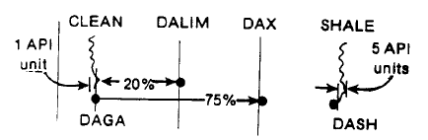

Other parameters were chosen from cross plots and other measurements. The key values used are:
Grain Density | DENSma | = 2.65 gm/cc
Sonic Matrix | DTDma | = 55.5 usc / ft
Neutron lithology shift | ZSPHIn | = 0.0
Surface temperature | SUFT | = 50ºF
Bottom hole temperature | BHT | = 95ºF @4500 feet
Dry clay density | DENSDC | = 2.84 gm / cc
Lithology constant | LIT | = 0.05
Clay resistivity | RCL | = 15 ohm-m
Shale resistivity | RSH | = 2.0 ohm-m
Sxo constant | CSS | = 0.2
Hydrocarbon density switch | SSHY | = 0.2
Cutoff porosity | PHILEV | = 0.001
Hydrocarbon density | DENSHY | = 0.03 gm / cc
Likely area switch | PUN | = 0.03
Sonic shale value | PHISSH | = 0.45

All other values are program defaults and do not effect the results, as they are not normally used in calculations on these wells.
For the Ellef Ringnes area the most reasonable values derived for deeper wells were:
PHImax | = | 26%
PHIDcl | = | 2%
PHINso | = | 26%
PHINcl | = | 48% (for CNL)
PHINcl | = | 42% (for SNP)

For the three shallow wells, King Christian N-06, King Christian D-18A and Sutherland 0-32, the values used were:
PHImax | = | 28%
PHIDcl | = | 8%
PHINso | = | 28%
PHINcl | = | 40% (for SNP)

The input parameter values for the Drake-Hecla “standard” model were chosen in early 1975, and seven new wells have corroborated the selection.
In wet sands the effective porosity was found to be most sensitive to the maximum clean porosity value (PHImax), and silt index (SI) was very sensitive to all shale parameters. Silt index therefore does not appear to be a very meaningful number since it varies a great deal from foot to foot within both clean and shaly sand, and with small changes in shale parameters.
In clean gas sands the effective porosity does not vary much with the maximum porosity (PHImax) parameter, due to the gas correction logic, but it is affected instead by the assumed (or computed) hydrocarbon density and the relationship between Sw and Sxo.
Core Comparisons
These factors, plus the possibility of miscalibrated or hole size affected logs, indicate the need for core analysis control. An example of core analysis results overlaid on Saraband calculation is shown in Figure 25. Core analysis porosity and permeability compares closely to Saraband data in the clean sands, but the core is usually higher in the shaly sections. This may be due to drying of the clay in the shaly sand prior to core analysis or to incorrect assumptions in the shaly sand calculation procedures in Saraband. The difference is not yet entirely understood, and is the subject of further study.
Analysis of Reservoir Parameters
All of the Saraband data from the lower Wilkie Point and Borden Island have been tabulated and analyzed statistically and a set of cumulative curves representing all of the data with no reservoir cutoff applied has been prepared to compare the reservoir quality of the gas wells. In each case the variable (porosity, permeability or water saturation) have been plotted against the percentage of hydrocarbon filled pore space in each class division. A smooth average curve was then drawn for each parameter.
The average cumulative curves (Figure 26) show that:
90% of the in-place hydrocarbons are contained in porosity greater than 13.5%
70% are contained in porosity greater than 20.5%
90% of the in-place hydrocarbons are contained in beds with permeability index greater than 4 mD.
70% are contained in beds with permeability index greater than 130 mD.
90% of the in-place hydrocarbons are contained in beds with water saturation less than 55%
70% are contained in beds with water saturation less than 28%

The illustrations amply demonstrate that most of the hydrocarbon filled pore space is in the best quality reservoir, i.e. the bar facies of the Borden Island Formation (unit 2).
Use of the SP
The choice of shale indicators usually precludes the use of SP since there are so few good SP logs. On Chads Creek B-64, the SP was used and is compared with the Gamma Ray result in Figure 27. Crossplot density-neutron values are also used where there is no gas effect. Both porosity and sand content are reduced (at least in this example) when the SP is used. This may be caused by the hyperbolic interpolation within Saraband used to convert SP differences to shale values. So far, the Gamma Ray has given results that compare more closely with core analysis so the SP has been ignored as a shale indicator.
Heavy Minerals
The separation between neutron and density porosity in the Mould Bay (and some other sands), discussed earlier, caused some serious concern for two years. This separation normally indicates shaliness, but only small amounts f clay are present in samples, and the Gamma Ray log looks clean. The separation was then ascribed to at least ten other effects, including the hole size, mud weight, tool problems, calibrating problems, sample description errors (i.e. shale not described) and differential pressure. There was no correlation between the separation and any of these factors, and the same tool would give “good” results in one well and “bad” results in another on the same day.
Our belief at the moment is that separation is due to mineral effects caused by fossiliferous detritus within the sands. Detailed sample descriptions indicate a large proportion of worm tubes and other fossil debris in the sands which exhibit the separation. Since the separation is larger than that possible from pure calcite, the separations must be due to some dolomitization of the carbonate material or from iron rich mineralization. This has yet to be proved in samples (see Mould Bay example, Figure 14). As it happens, the correct porosity is calculated anyway, since the crossplot porosity matches the few cores taken.
Shale Resistivity
Another experiment was run on Chada Creek B-64 to determine the shale resistivity value to keep hydrocarbon saturation within reason in the Borden Island shaly sands. Since Chads Creek was a wet well, and fairly shaly, it was easy to find the value that would completely eliminate all evidence of hydrocarbons. It appears that at least 15 ohm-m is needed, which is about double the value used for the earlier “go-round” of recomputations.
Cementation Exponent (Borden Island)
During the course of the Saraband re-runs over Drake, Hecla, and Ellef Ringnes, we discovered that the cementation exponents “a” and “m” in the porosity formation factor relationship should have been varied. We used an incorrect Rw with the incorrect “a” and “m” to achieve reasonable saturations. This is only an approximation however since the needed Rw would vary with porosity.
This false Rw can be compared with the actual DST Rw to find a more reasonable value of “a” or “m”.
The data for the Borden Island/King Christian Sand is shown below in Table 4:
TABLE 4
 |  |  |  |  |  |  | Calculated
Well |  | Log Salinity  kppm | Log Rw  @75ºF |  | DST Salinity  kppm | DST  Rw  @75ºF | “a”  with  “m” = 2.0 | “m”  with  “a” = 1.0  PHIe=0.20
W. Amund I-44 |  | 189 | 0.043 |  | 233 | 0.038 | 0.96 | 1.975
Chads B-64 |  | 124 | 0.063 |  | 79 | 0.093 | 0.55 | 1.629
Collingwood K-33 |  | 183 | 0.045 |  | 118 | 0.066 | 0.54 | 1.617
Drake P-40 |  | 60 | 0.117 |  | 52 | 0.134 | 0.68 | 1.764
Hecla C-05 |  | 80 | 0.092 |  | 48 | 0.145 | 0.51 | 1.582
Hecla J-60 |  | 60 | 0.199 |  | 51 | 0.137 | 0.70 | 1.778
K.C.I. N-06 |  | 198 | 0.042 |  | 231 | 0.036 | 0.94 | 1.962
Kristoffer B-06 |  | 155 | 0.052 |  | 123 | 0.063 | 0.66 | 1.742
Mocklin D-23 |  | 152 | 0.052 |  | 188 | 0.044 | 0.94 | 1.962
Noyce G-44 |  | 100 | 0.076 |  | 154 | 0.052 | 1.16 | 2.092
Pat Bay A-72 |  | 171 | 0.047 |  | 154 | 0.052 | 0.72 | 1.796
N. Sabine H-49 |  | 150 | 0.053 |  | 162 | 0.050 | 0.85 | 1.899
Thor H-28 |  | 161 | 0.050 |  | 129 | 0.061 | .65 | 1.732
Thor P-38 |  | 180 | 0.045 |  | 141 | 0.056 | 0.64 | 1.723

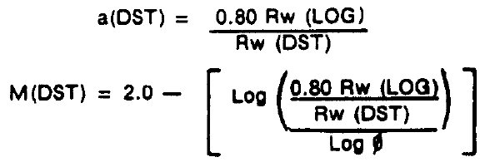
Assuming Rw (LOG) derived with a = 0.80, m = 2.00
Note than when Rw from DST and an Rw from logs are both known using any value of “a” and “m” (preferably 0.8 and 2.0 to make the arithmetic easy), then the “a” from DST defines “m” uniquely for any given porosity, but that “m” must vary with porosity.
If we draw a line through the actual data points from a F vs. PHI plot, and also through the value of “a” derived from DST Rw data (eg. as in Figure 28), we can determine a good average value of “m” which will be satisfactory over the range of porosity encountered in the clean sand. The low porosity shaly sands should b excluded at this stage. Results are listed below for the five wells with special core data, using an “a” of 0.60:

 | “m” | “n”
Drake D-73 | 1.94 | 1.92
Drake E-78 | 2.03 | 1.81
Hecla M-25 | 2.00 | 1.66
Hecla N-52 | 2.00 | 2.05
Average | 1.99 | 1.82
Because “m” varies with porosity (if “a” is held constant), the value thus determined should not be used where porosity is much different from the data used to derive “m”. The Saraband program accounts for this automatically by making “a” a function of shale volume (Vsh). Similar results can be obtained by varying “m” instead of “a”.
This means that porosity and formation factor are not linear relationships (on logarithmic paper) and are much more complex. However, the Vsh approximation used in Saraband works extremely well in our case.
The actual DST Rw values, the derived values of “a” and the estimated Rw for other wells are plotted in the map of Figure 29. From this map it is evident that “a” increases with the distance from the sediment source, which was in the southeast.
saturation exponent
The saturation exponent “n” from core analysis is in the range 1.66 to 2.05 with the preponderance of data near 1.80. Using this value decreases water saturation and helps to match log result to capillary pressure data. An example of a typical saturation exponent plot is shown in Figure 30 and a plot of porosity vs. saturation from both Saraband and special core analysis is shown in Figure 31.
Close agreement between Saraband and core values, after using the correct “a”, “m” and “n”, is evident even though the spread of the data is fairly large. This is caused by the heterogeneous nature of the rocks. The correspondence is amazingly poor if standard values of “a”, ”m”, and “n”, is evident even through the spread of the data is fairly large. This is caused by the heterogeneous nature of the rocks.
capillary pressure data
The capillary pressure data from the special core studies is a final check of the interpretation. These data indicate the minimum residual water saturation to expect in sands of various permeabilities. It can be used to determine the appropriate water resistivity in the Drake and Hecla gas sands, where no water leg is present in any gas well. Thus we can derive a water resistivity (or salinity) map for Drake and Hecla, which is significantly different from one based only on the wet wells and a salinity gradient with depth or distance from outcrop or subcrop. A typical set of capillary pressure curves for the Borden Island sand are shown in Figure 32. It is clear that water saturations as low as 10% can be expected in the good quality sand.
At no time did we attempt to force a match to the lowest saturations derived from capillary pressure data (especially mercury injection data, which is much lower than air-brine data in clean sands). In general we still accept Sw values quite a bit higher than the minimum found from core capillary pressure data. The result is an increase in gas-in place of about 5% compared to conventional log analysis methods.
Water Resistivity (Borden Island – King Christian Sand)
On earlier Sarabands, water resistivity was chose (for Drake and Hecla) from the wet wells and applied uniformly across each field. In the Ellef Ringnes area, each well has a water zone, so Rw was chosen in that zone. The cementation exponents used were “a” = 0.8 and “m” = 2.0 (fixed by the nature of the normal version of Saraband).
The Rw, “a”, “m”, and “n” values used for the final re-computation were described earlier.
Temperature is taken from the graph of Figure 33, which has data from every DST and logging run. The range in temperature data is fairly large, and is a function of the cooling caused by the mud in cases of higher than normal temperature. The choice of the proper formation temperature is critical, because gas reserves depend on temperature. Fortunately, a 10% error in temperature (ºF) is only a 3% error in reserves since ºR are used in the calculation. However, in a total reserve of say 12 Tcf recoverable gas, a 3% error is 360 Bcf, which is still a lot of gas.
More precise temperature measurements over a long time period in completed wells are needed.
In three wells at Ellef Ringnes an abrupt change in water resistivity occurs some distance below the spillpoint of the structures. This lower salinity is roughly contstant at 7500-8000 ppm NaCl and approximately equal to the salinity of several wet wells nearby.
Water Resistivity (Mould Bay and Isachsen)
The log derived water resistivity data for Mould Bay sands is shown in Figure 34. The Rwa values fall close to a line which is steeper than the temperature gradient for the area, so a definite salinity gradien with depth is present. As shown earlier, the Rwa values in gas sands do not stand out very well, and great care is needed at the wellsite to make sure a zone is not missed. This data is displayed in map form in Figure 35.
Water Resistivity (Schei Point and Bjorne)
Water Resistivity in Schei Point and Bjorne sands does not present a problem, except that it is fresher than the Borden Island sand which is above it. The is not doubt caused some flushing around the outcrop edge by meteoric water. Salinity contours are shown in Figure 36. The deeper parts of the basin exhibit the normal increase of salinity with depth, as does the Borden Island/King Christian sand. Log and DST water resistivities agree closely so the “a” and “m” problem does not seem to exist. Temperature is usually taken from Figure 33. Generalized salinity contours for the Borden Island and the Paleozoic section are shown in Figure 37 and 38 respectively, for comparison.

Water Analysis
All DST recoveries of water for non-confidential wells are listed in Appendix 1. Some results are probably filtrate and are so marked, but most are representative samples. With the known variation in cementation exponents, these salinities should be used with care in log analysis.
log Calibration and Normalization
Normalization of log data has so far been used only in the Borden Island – King Christian Sands. In the Drake and Hecla area, the logs are normalized in the bottom 100 feet of the Savik Shale, which is immediately above the Lower Wilkie Point reservoir. The density and neutron logs are shifted, if required, to conform to a model established by Drake F-16 and Hecla F-62 (both wells have extensive core data).
All Ellef Ringnes wells have water zones, so the shift is determined primarily by requiring logs to agree in clean wet sands, and secondarily by the Savik shale. In some cases the shale is behind the casing and in others, depth of burial or washed out hole makes this normalization procedure inappropriate.
A histogram of shifts for each log type is shown in Figure 39. The majority of the wells are not shifted.
A density-neutron crossplot for a typical well is show in Figure 40 and 41, illustrating the need for the shift to the density log. Both the shale point and the maximum porosity would be seriously different from the standard model if no shift is applied. Core analysis on 18 wells provided adequate control for normalization and verification of the standard model.

LOGGING ODDITIES AND PROBLEMS
Some interpretation problems have already been discussed, for example, the fresh water gas sands, the heavy minerals, the variable “a” and “m”, and the lack of a water zone for much of the Drake and Hecla fields. There are others, not the least of which is bad hole.
Figure 42 shows the log data and several computed logs over some very rough hole at Chads B-64, which has a number of prospective (but thin) gas sands. Interpretation is based almost solely on the Gamma Ray, and the porosity is only approximately known. It is interesting to note the large change in computed porosity caused by the change in computed hydrocarbon effect after changing the water resistivity. This is also a case where we forced Saraband to accept sonic data as a porosity log in lieu of the density, which is virtually useless in the rough large hole. We invented a “big arm” density tool that will open to 25 inches to help circumvent this problem, but pad pressure is sometimes insufficient. Better hole conditions are a prerequisite to adequate interpretation in these zones.
SALT MUD
The effect of a saturated salt mud system in very low porosity is quite drastic. Logs from Sabine Bay A-07, which was drilled through several thousand feet of clean salt are almost useless; the MSFL is the only log which corresponds to the apparent porosity/lithology logs. The DIL and DLL do not respond adequately to the formation. For some reason also the clean dolomite and limestone in this well caved or sloughed off, making for a very noisy density and neutron log. The sonic log is the only savior in this kind of hole. The explanation for the carbonates caving is not known, but fracturing either in situ or generated by stress relief after drilling is probable.
Conductive Graphite
A strange set of logs were taken in Bar Harbour E-76 (Figure 43). The porosity logs appear reasonable and very low in porosity, but the induction log did not recognize the tight zones. The conductive streaks resembled pyrite on logs but none was described in samples, although pyrobitumen (normally resistive) was described. Tool failure was suspected at this point so the ES was run. It also showed the conductive mineral; the log reading as low as 0.4 ohm-m in some places.
Lab analysis subsequently showed the “pyrobitumen” to be pure graphite, which is highly conductive. Graphite is the final phases of temperature pressure reduction of hydrocarbons.

Overpressure and Gas Hydrates
Slightly overpressured shales are a problem in the number of areas in the High Arctic. Data from Jackson G-16 in Figure 44 illustrates the departures from normal gradients on all logs in the overpressured zones. Drilling difficulties were encountered in the shaly sands at 1760 and 1965, where gas kicks were noticed. Several days were spent conditioning mud (mostly to cool it) as gas hydrates are possible at this depth. No hydrates are seen on the logs but this may be due to melting and subsequent invasion masking the effect of hydrates. We suspect hydrates have been present elsewhere and not seen for this reason. A full scale overpressure study of the entire Arctic using log data, is to be undertaken soon.

Gamma Ray Problems
In a number of holes we have found spurious Gamma Ray effects. These take the form of a zero shift, or a sensitivity change or an apparent time constant change between two runs in the same hole. These are attributed to tool problems within the combination tool system. The problem is unpredictable and is not removed by normal field calibration procedures.
Another spurious Gamma Ray anomaly occurs in any hole in which the CNL source has irradiated the formation for more than a few minutes. A large GR spike (about 6 feet thick) of 200 – 300 API units amplitude is seen, which fades away in an hour or so. They can be seen often at the bottom of the hole where calibrations were being run, or after being stuck in the hole. Repeat runs show greatly reduced or no anomaly.
Miscellaneous Identifiable Minerals
Many wells throughout the Arctic have coal beds (both clean and shaly), pyrobitumen, pyrite, lignite, siderite, kaolinite, glauconite, and traces of other exotic minerals. All these affect log response and interpretation of them is not always clear cut, especially coal and pyrobitumen in shaly zones. Carbonized wood occurs in a number of wells in the Banks Basin and can lead to abnormally high apparent porosity. So far they have always been found in frozen or water bearing zones and are well described in samples..

Permafrost
Permafrost is of major concern to the geophysicists for evaluation of velocity anomalies, to the engineers for casing, hole,, and cementing design, and to the geologist for possible gas hydrate zones.
The long spacing ES log with a 20 foot normal curve is run in addition to the normal suite of logs through permafrost zones. An example (rescaled and traced onto the DIL ) is shown in Figure 47. The DIL and long ES both show the frozen sands (high resistivity) between 817 and 928 feet, but the long ES shows the frozen shales above and below the sand as well. Permafrost depth would be picked at the base of the sand (928 feet) if only the DIL had been run, and at 990 feet from the long ES.
Most wells show a partially thawed transition zone due to melting caused by the warm drilling fluid. It looks like a long hydrocarbon transition on the DIL but is usually more sharply defined by the long ES. Numerous examples are found of unfrozen sands surrounded top and bottom by frozen rock.
Saraband computations in permafrost sands usually indicate, falsely, the presence of hydrocarbons, even if a very high water resistivity is used (10 ohm-m will not always eliminate the shows). Such Sarabands are now coded specially to alert the user to the permafrost effect.
The sonic log in this example (Figure 47) skips more in the permafrost than below it, but this is not always the case, and it is not a sufficient criteria to determine permafrost depth. The same is true of hole enlargement due to caving in permafrost. No significant density or neutron porosity anomaly is seen either.
Another source of permafrost depth is the Crystal Cable Survey, run in conjunction with the Seismic Reference (Velocity) Survey. The technique uses a cable with 12 geophones spaced 25 feet apart. The cable is moved as many times as needed to cover the entire permafrost zone. The travel time of a sound wave (usually dynamite) to each detector is recorded and plotted versus depth.
This time-distance plot define the acoustic velocity of the various layers and velocity interface is sometimes found at the bases of permafrost. This interface is not usually seen by the Sonic Log because the edge of the hole as been melted by the drilling mud. In shales the velocity change may be very small or absent.
A closely spaced SRS over the same interval will accomplish similar results if the Crystal Cable is not available.
There is some evidence that even Crystal Cable and SRS surveys see the thawed zone velocity on occasion. Deep thaw diameter and shot holes close to the well bore may account for this.
The Long Spaced Sonic log can be used as well to determined velocity changes caused by freezing. The short spaced (normal) BHC sonic usually gives the travel time of the thawed zone. The long spaced tool (transmitter-receiver spacing of 9 or 11 feet) is long enough to receive a refracted wave along the velocity interface between the thawed and unthawed zone, resulting in a measurement of the travel time in the frozen zone.
An example of both logs is shown in Figure 48 in a sand-shale sequence. The velocity contrast between frozen and unfrozen sand is about two to one, whereas there is no significant contrast between frozen and unfrozen shale in this case.
The long spaced tool could not be used without the long ES to find permafrost depth, unless the base of permafrost was in a thick sand section. Both long ES and long Sonic should be run soon after reaching 2000 to 2500 feet.
Further investigation of permafrost depth using the GSC temperature surveys* showed that open hole well logs almost always define a permafrost depth that is too shallow, by an average of 200 feet.
*Canadian Geothermal Data Collection – Northern Wells A.E. Taylor, A.S. Judge, Earth Physics Branch, EMR, Canada, 1975
A typical temperature graph is shown in Figure 49 and the corresponding computer printout in Figure 50. The transition zone (constant temperature) disappears with time. Permafrost depth is picked at the transition zone temperature on the most recent temperature log, which compensates for salinity variations and calibration errors.

LOGGING TIMES
A measure of the operational success that has been obtained in the High Arctic is reflected in the rig time per log and lost time per log statistics. The data is tabulated below:

TABLE 5 - LOGGING TIMES

Totals | Logging Trips | Logs Per Trip | Total Hours | Tool Failure Lost Time | Hole Reconditioning Lost Time
Aug 74 to Apr 75 | 29 | 6.3 | 833 | 117 | 113
Apr 75 to Oct 75 | 9 | 5.4 | 195 | 23 | 78
Oct 75 to May 76 | 21 | 5.3 | 396 | 53 | 203
May 76 to Mar 77 | 11 | 5.6 | 300 | 42 | 13

Averages | Hours/Survey | Tool Failure  Lost Time/Survey
Aug 74 to Apr 75 | 4.7 hours | 39.6 mins.
Apr 75 to Oct 75 | 4.2 hours | 28.7 mins
Oct 75 to May 76 | 3.6 hours | 28.7 mins
May 76 to Mar 77 | 4.9 hours | 40.8 mins

The August 1974 to April 1975 data shown above includes the SRS and Crystal Cable Surveys; more recent data excludes them. These figures reflect the improvement in logging times due to the increased use of combination logging tools. The lost time per survey appears to have hit a plateau of a little under 30 minutes per survey and then increased, primarily from an increase in unacceptable dipmeter surveys.
If no new tools or combinations are run, the lost time will improve, but new equipment always seems to have a breaking in period. We experienced this with the CNL/FDC combination in 1974 and the DIL/BHC in 1975, which was still causing problems into the spring of 1977.

CONCLUSIONS
Log analysis in the High Arctic is a steadily developing science. To gain the greatest amount of knowledge, a full suite of modern logs must be run. The lack of a key log (or core or DST) in older wells has created a number of irreconcilable anomalies. This must be avoided in the future.
The imaginative and detailed control of the input data and logic options of Saraband and Coriband (or equivalent) computer analysis is essential. Recognition of specific minerals, use of the silt display on Saraband, standard interpretation models, and the Porosity Playback Log are important elements in a reasonable interpretation of exploration prospects and hydrocarbon accumulations.
Special core studies are necessary for calibration of log interpretation constants. When this data is available, DST salinity, log derived water resistivity, and core derived irreducible water saturation can be match by the computed log analysis. Fractures, permafrost, salinity gradients, meteoric flushing beneath structures, and overpressure problems can also be resolved in sufficient data is collected. Hydrocarbon zones are seldom missed, but quantitative evaluation requires this extra data.
Low porosity carbonates require special attention, and compensation for rough hole or large caves is a problem. A few zones known to produce hydrocarbons cannot be evaluated properly due to bad hole conditions. Better hole conditions are a prerequisite to adequate evaluation.
Water resistivity is the single most variable factor in the Arctic. More DST’s in wet zones are needed to better define these changes.
Temperature data is also poorly recorded, adding to the problem. More special core analyses are needed in certain areas to allow reconciliation of DST and log derived water data where no special core data now exists (such as in the Ellef Ringes area).
The only available production logs show that a large fraction of the perforated intervals were not producing at the time the logs were run. This could indicate a very low well deliverability compared to that forecast from other data. A concerted effort should be made to run production logs on all wells, so that the remedial completions can be designed and implemented before any production is attempted. TDT base logs should be urn at the same time, so that production monitoring can be done at periodic intervals.
Reserves estimates based on log analysis data have been refined as far as practical. The reconciliation of all available data, and the use of new formation factor and saturation exponents, has increased gas-in-place at the wellbore by about 5%. This amounts to some 0.7 trillion cubic feet of gas reserves, which more than compensates for the cost of computer runs and log analysts.
The future holds some surprises, no doubt. Carefully constructed models will be overturned or at least modified. Improved logging tools will help resolve data in poor holes. The nuclear magnetic log may solve for hydrocarbon in permafrost. The downhole gravity meter may predict porosity in carbonates with more precision. An improved (larger depth of investigation) density log and borehole compensated gamma-ray tool would be most welcome.
Computer analysis requires a better method of determining porosity in rough hole. The sonic data is not used enough and it is laborious to zone each interval of rough hole to force the use of the sonic log. Compensation of the neutron log in oval hole is inadequate and should be modified in future programs.
This then is the state of the art of logging and evaluation in the High Arctic in mid-1977. Much remains to be done in the areas of tool improvement, in the computer program improvement, and in the gathering and analysis of log related data such as cores and DST’s. However, the directions to take in each area are now well defined, and results will be limited only by lack of concrete effort to improve tools and techniques.

ACKNOWLEDGEMENTS
A number of the interpretations reported here were done by others. Dipmeter interpretations were done by John Cox of Schlumberger. The original salinity maps (later updated by the author) were drawn by Werner Klug of Panarctic Oils, and now with SOQUIP. Formation factor data is drawn from reports by Core Laboratories Inc.
The assistance of Dave Curwen, Bob Everett, and Ray Chenosky of Schlumberger, who assisted in parameter selection, computer throughput, program modification and administration of the Saraband recomputations is gratefully acknowledged.
The support of Bob Meneley and Diego Hanao of Panarctic Oils Ltd., is sincerely appreciated. Without their encouragement, questions, and faith we would not have been successful in reducing this mass of well data to some semblance of order.
Thanks are also due to Vickie Baran, whose masterful touch on the I.B.M. Mag Card II an the further help of Diane Moore put this repot in useable form, and to Terry Wiswell and John Lauzon who drafted the figures.
I would also like to thank Panarctic Oils Ltd. for permission to publish this report, and for the technical and secretarial support provided.
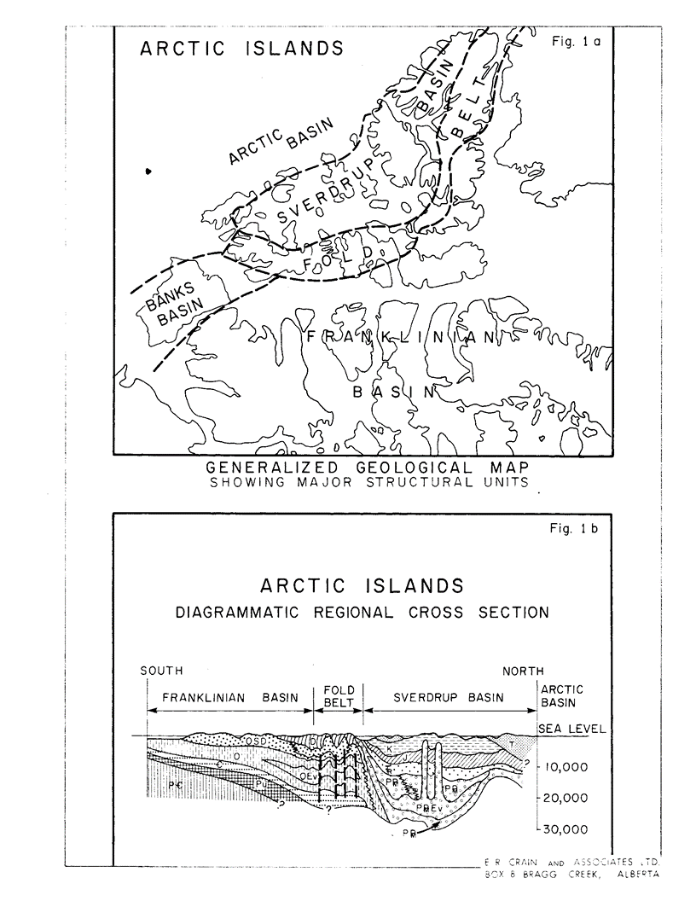
ILLUSTRATIONS
Figure 1a: Arctic Islands Map
Figure 1b: Arctic Islands Diagrammatic Regional Cross Section
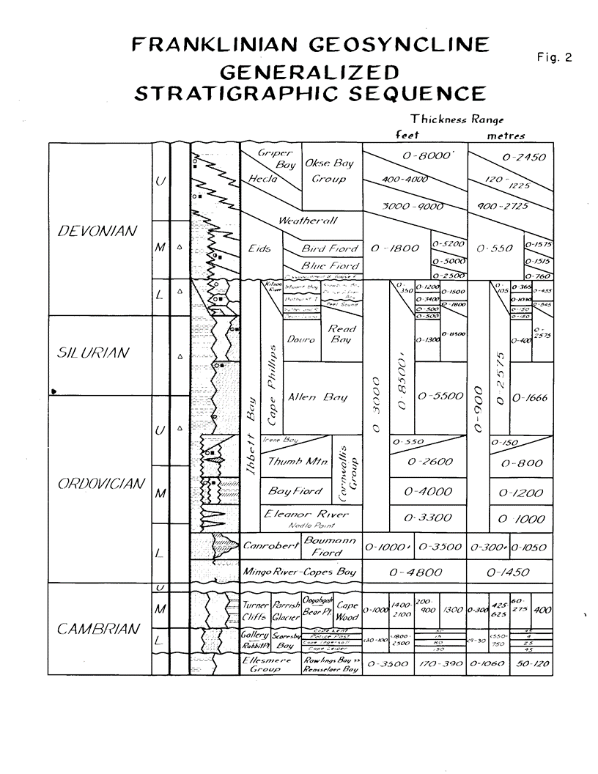
Figure 2: Franklinian Geosyncline, Generalized Stratigraphic Sequence
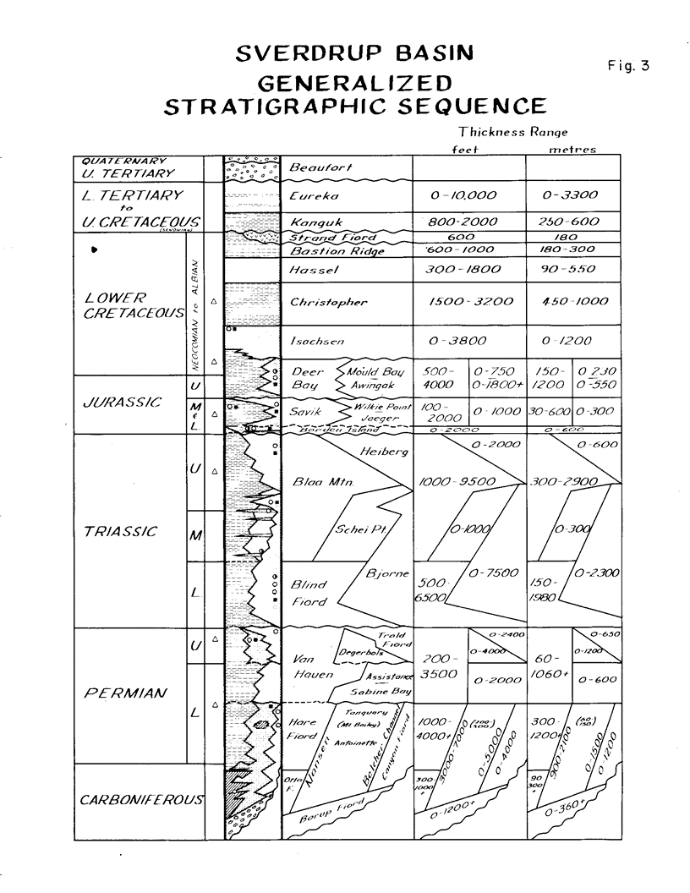
Figure 3: Sverdrup Basin, Generalized Stratigraphic Sequence
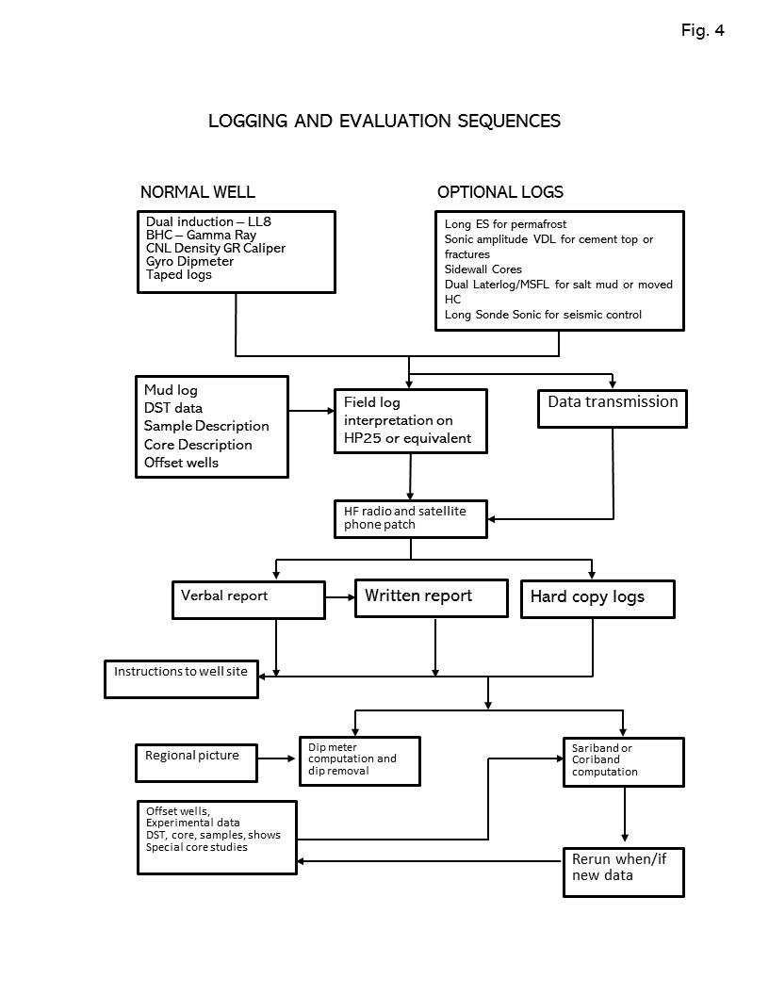
Figure 4: Logging and Evaluation Sequences
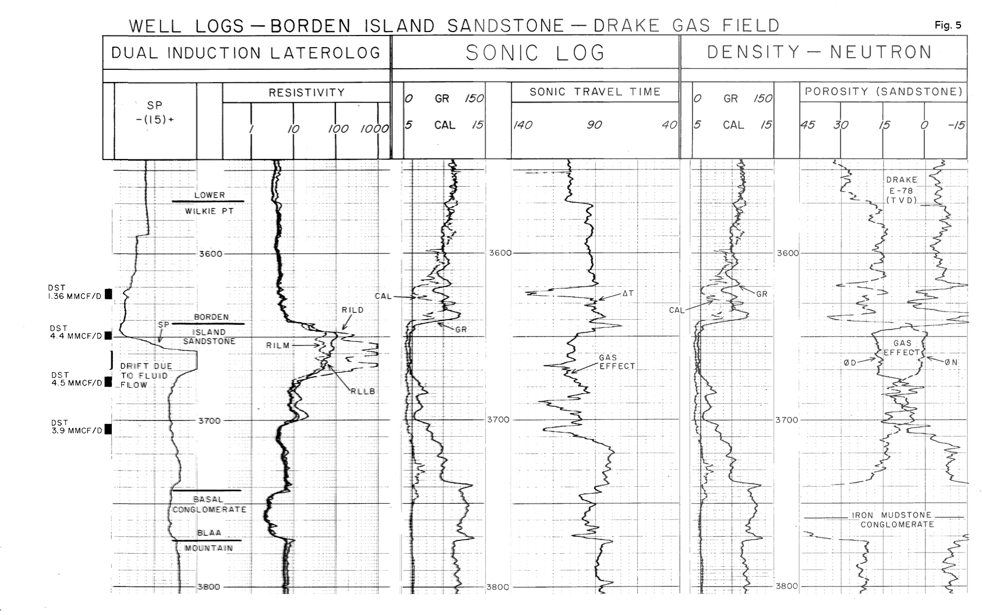
Figure 5: Well Logs, Borden Island Sandstone, Drake Gas Field
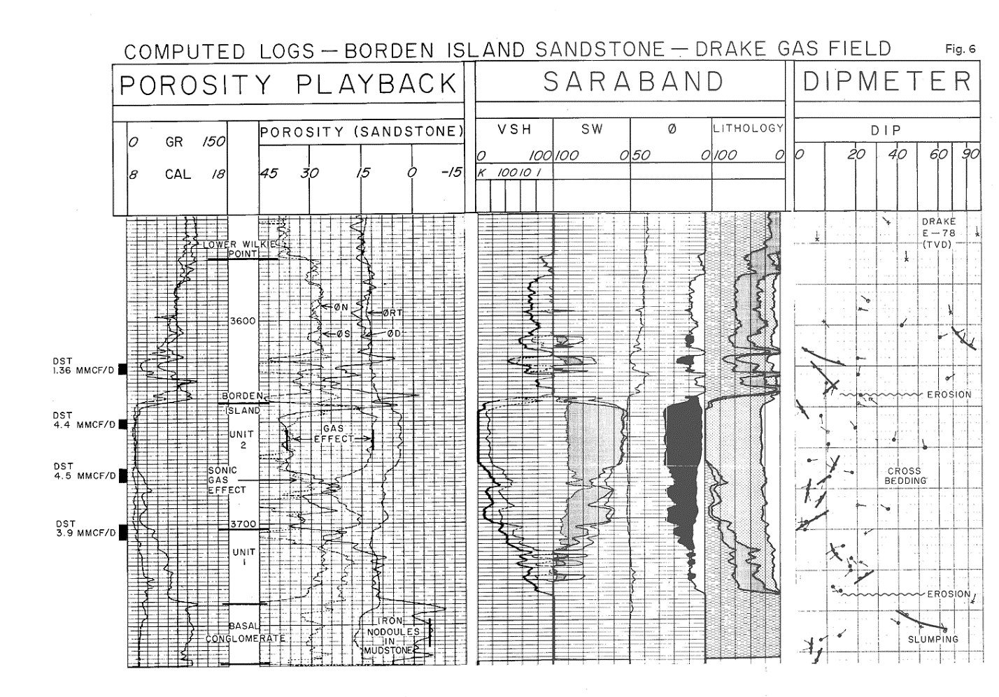
Figure 6: Computed Logs, Borden Island Sandstone, Drake Gas Field
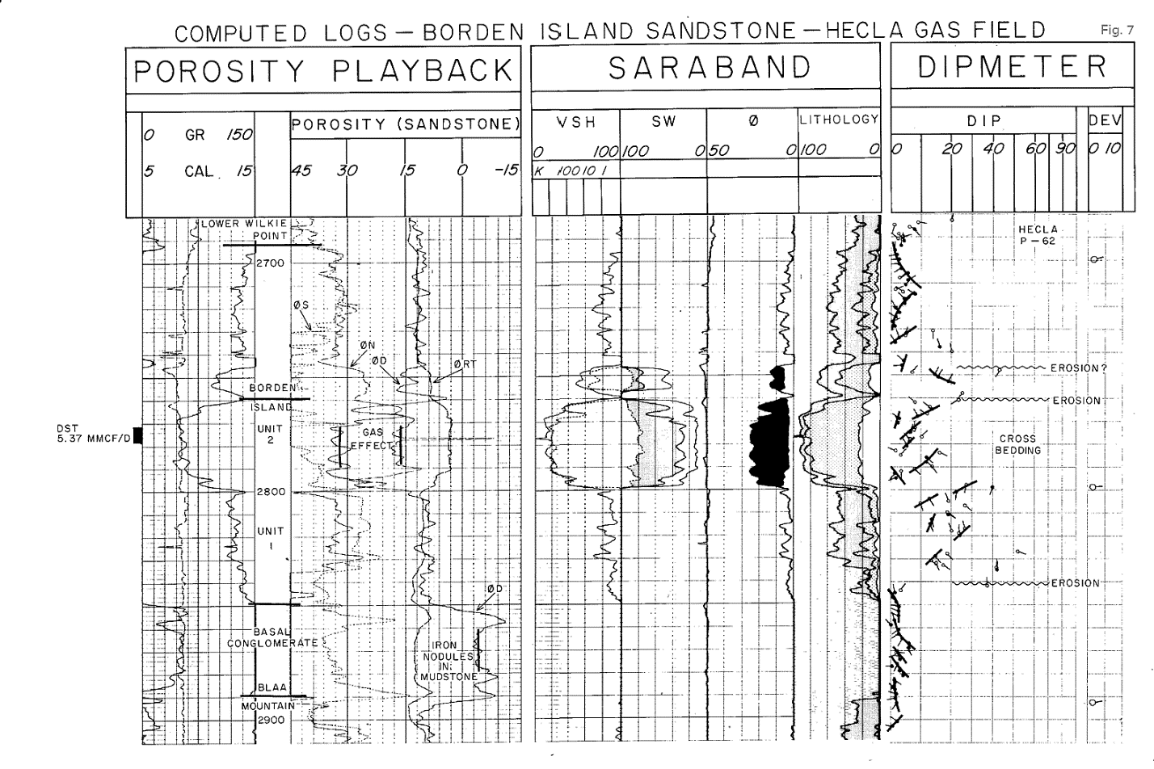
Figure 7: Well Logs, Borden Island Sandstone, Drake Gas Field
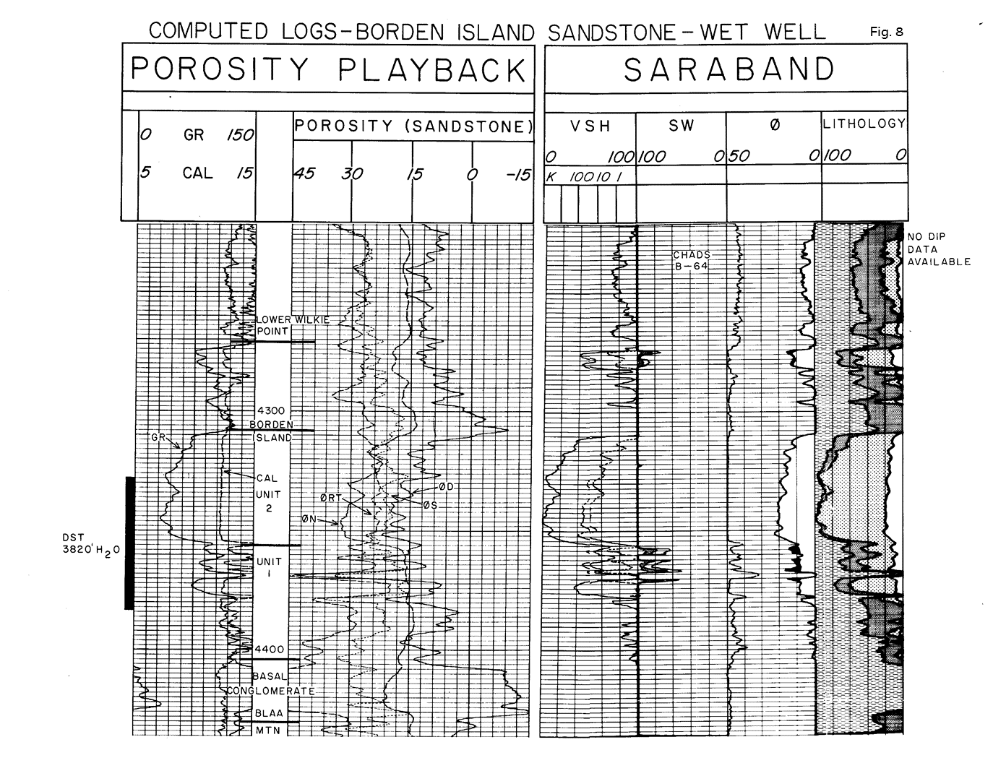
Figure 8: Computed Logs, Borden Island Sandstone, Wet Well
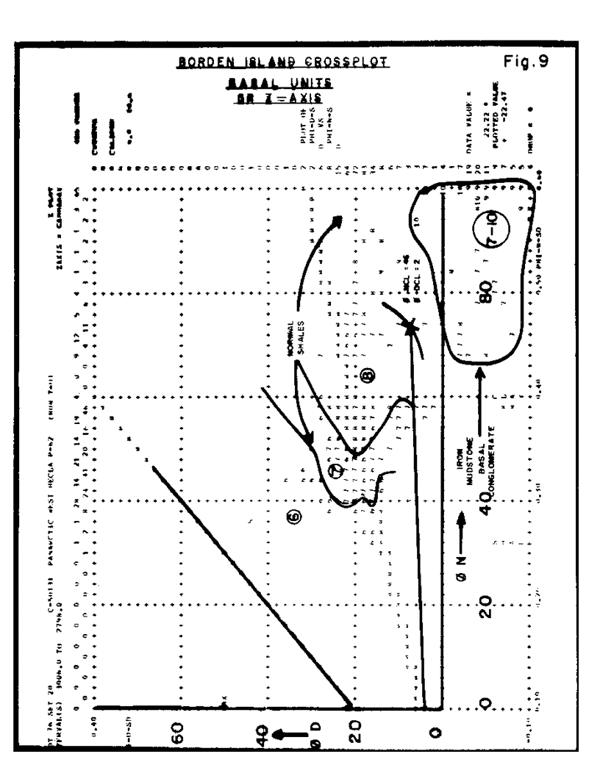
Figure 9: Borden Island Cross-plot, Basal Units, GR Z Axis
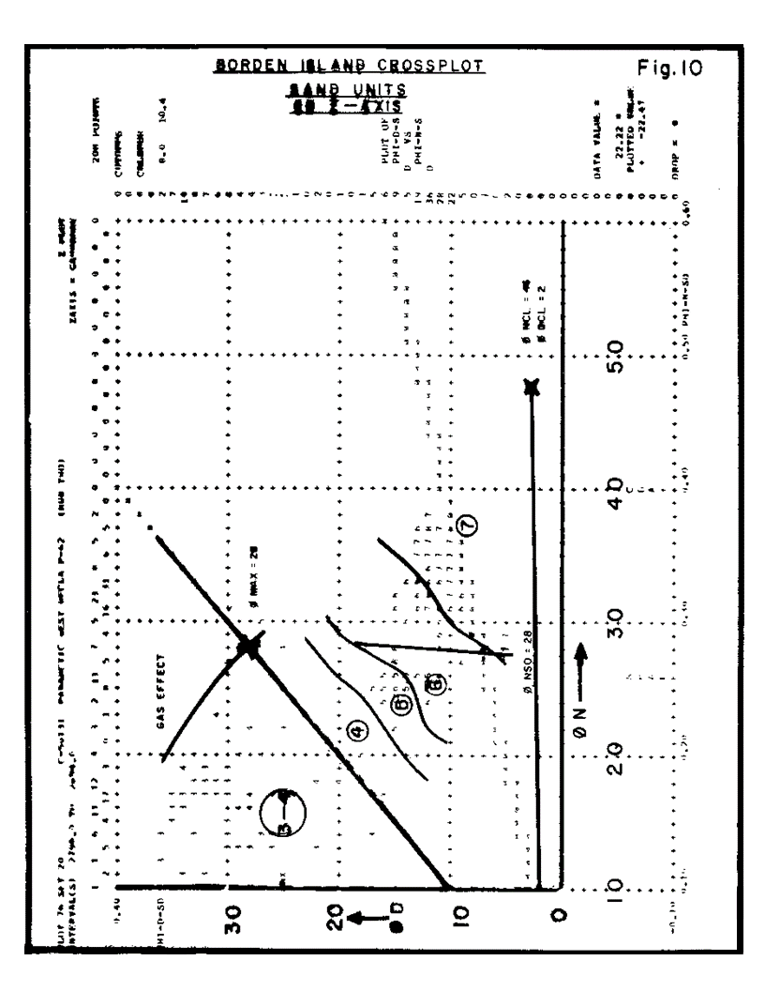
Figure 10: Borden Island Cross-plot, Sand Units, GR Z Axis
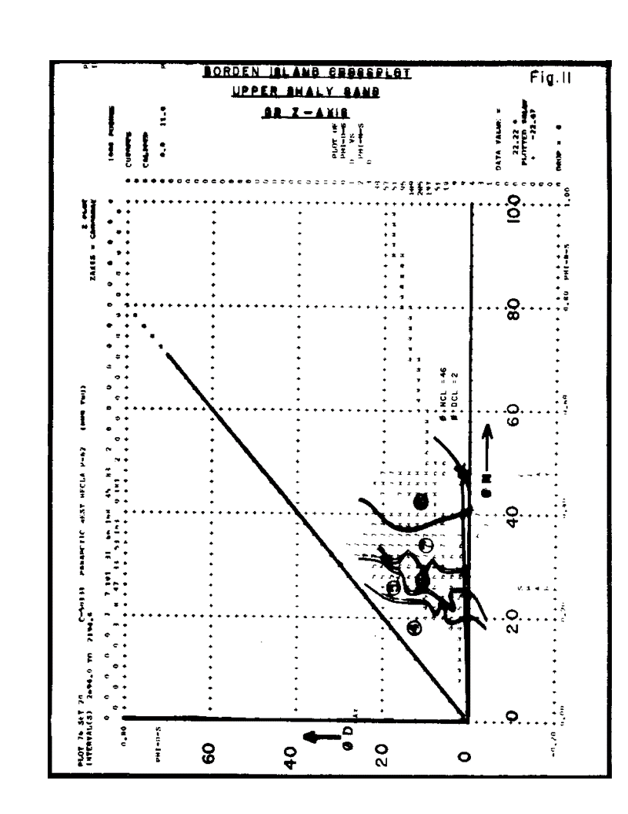
Figure 11: Borden Island Cross-plot, Upper Shaly Sand, GR Z Axis
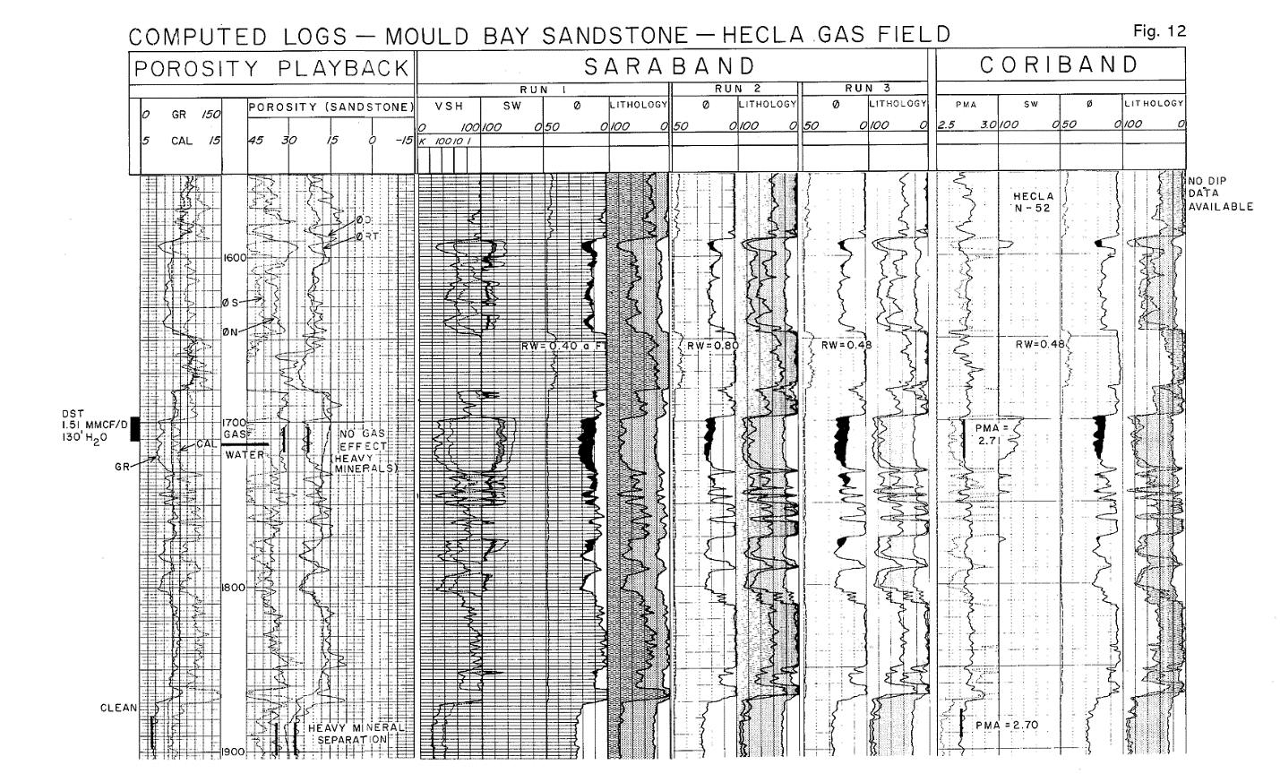
Figure 12: Computed Logs, Mould Bay Sandstone, Hecla Gas Field
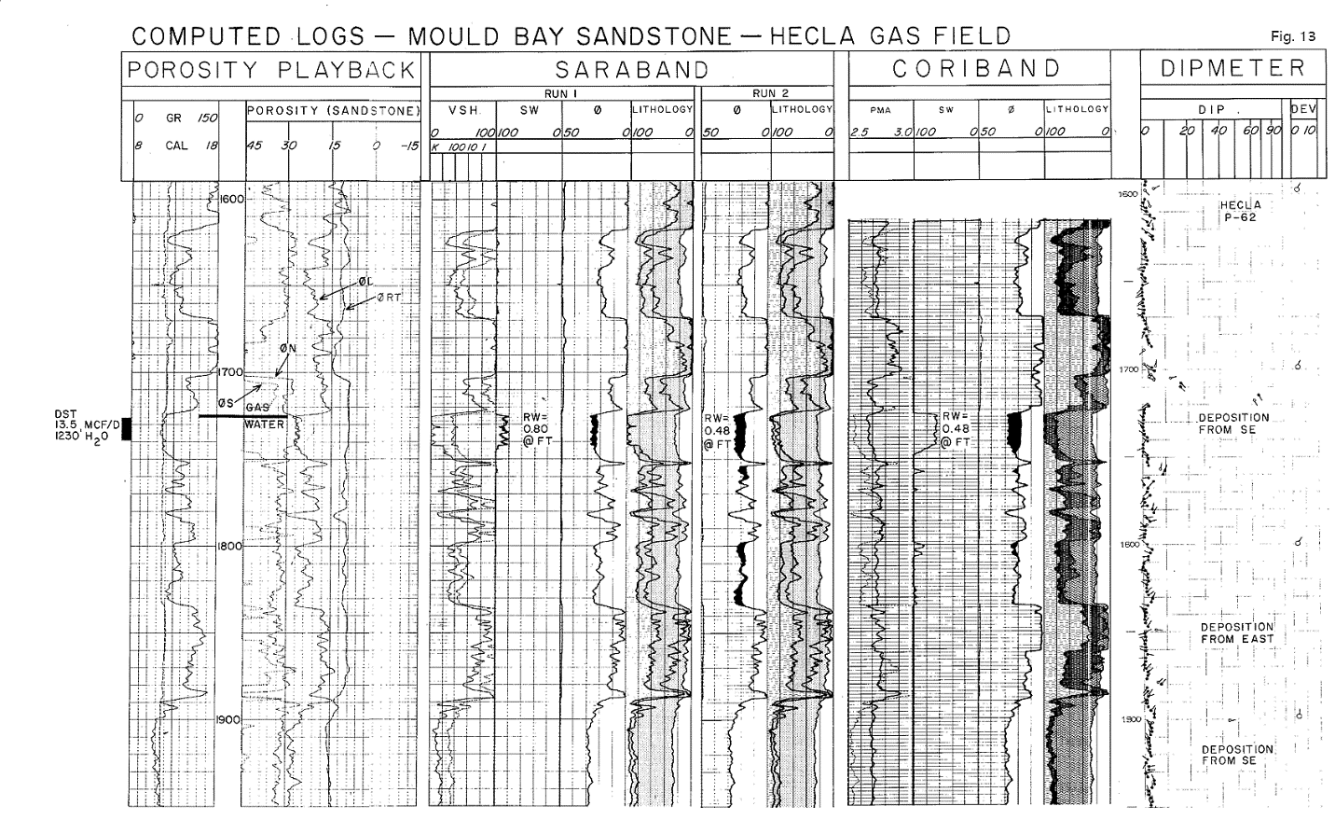
Figure 13: Computed Logs, Mould Bay Sandstone, Hecla Gas Field, with Dipmeter
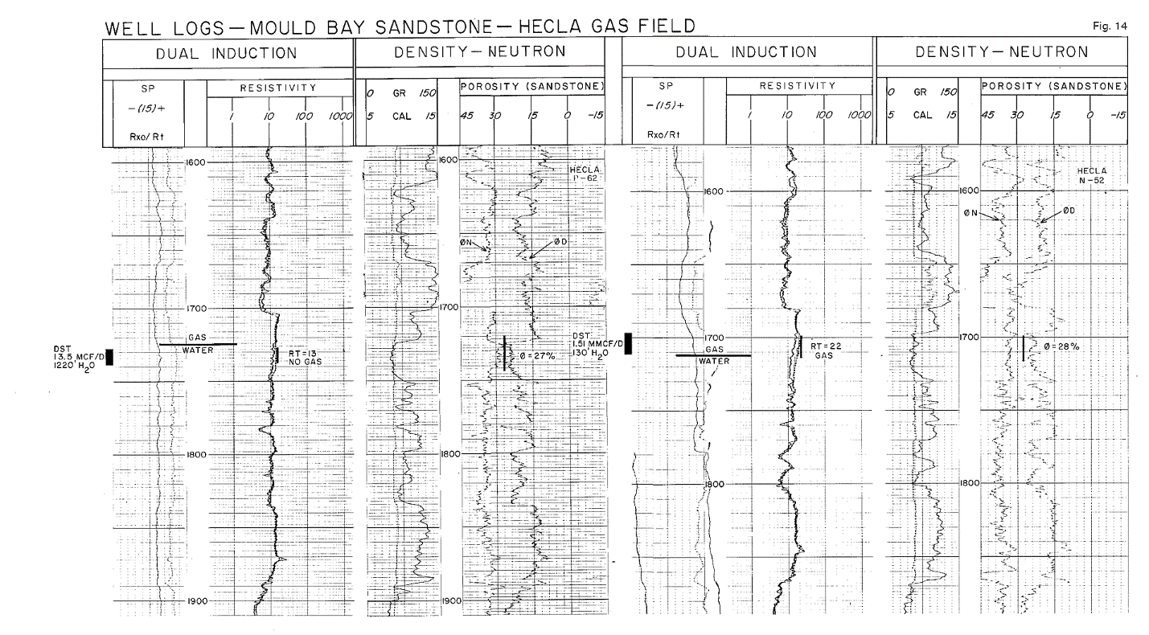
Figure 14: Well Logs, Mould Bay Sandstone, Hecla Gas Field
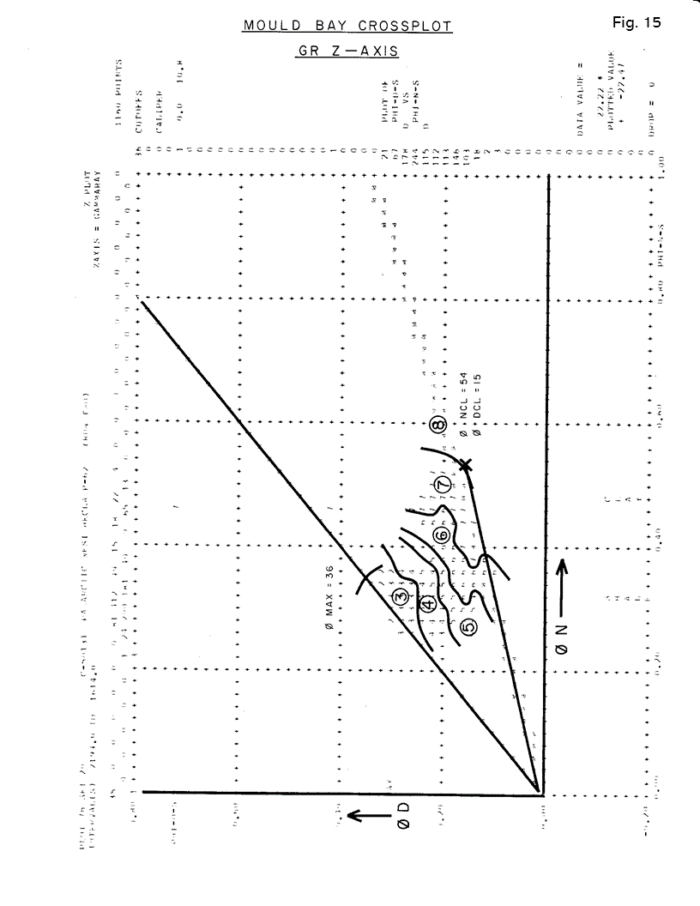
Figure 15: Mould Bay Cross-plot, GR Z Axis
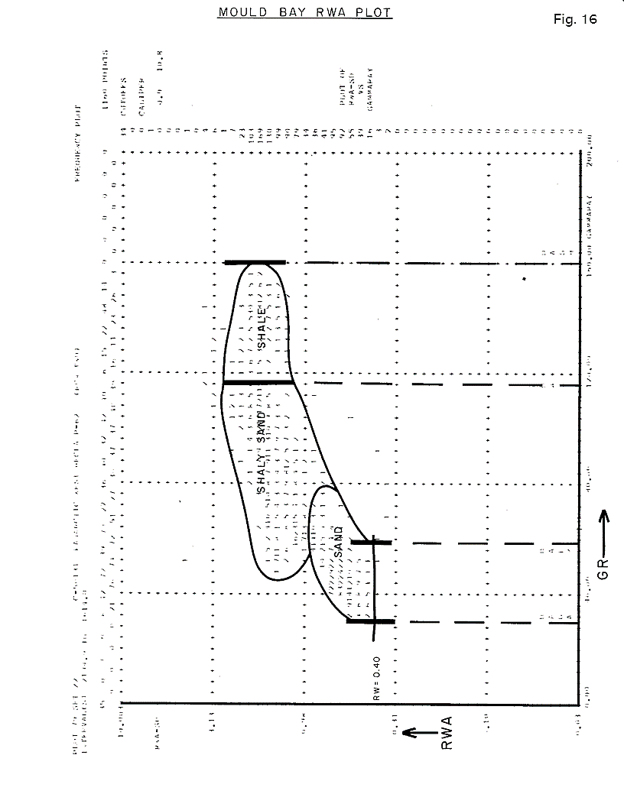
Figure 16: Mould Bay RWA Plot
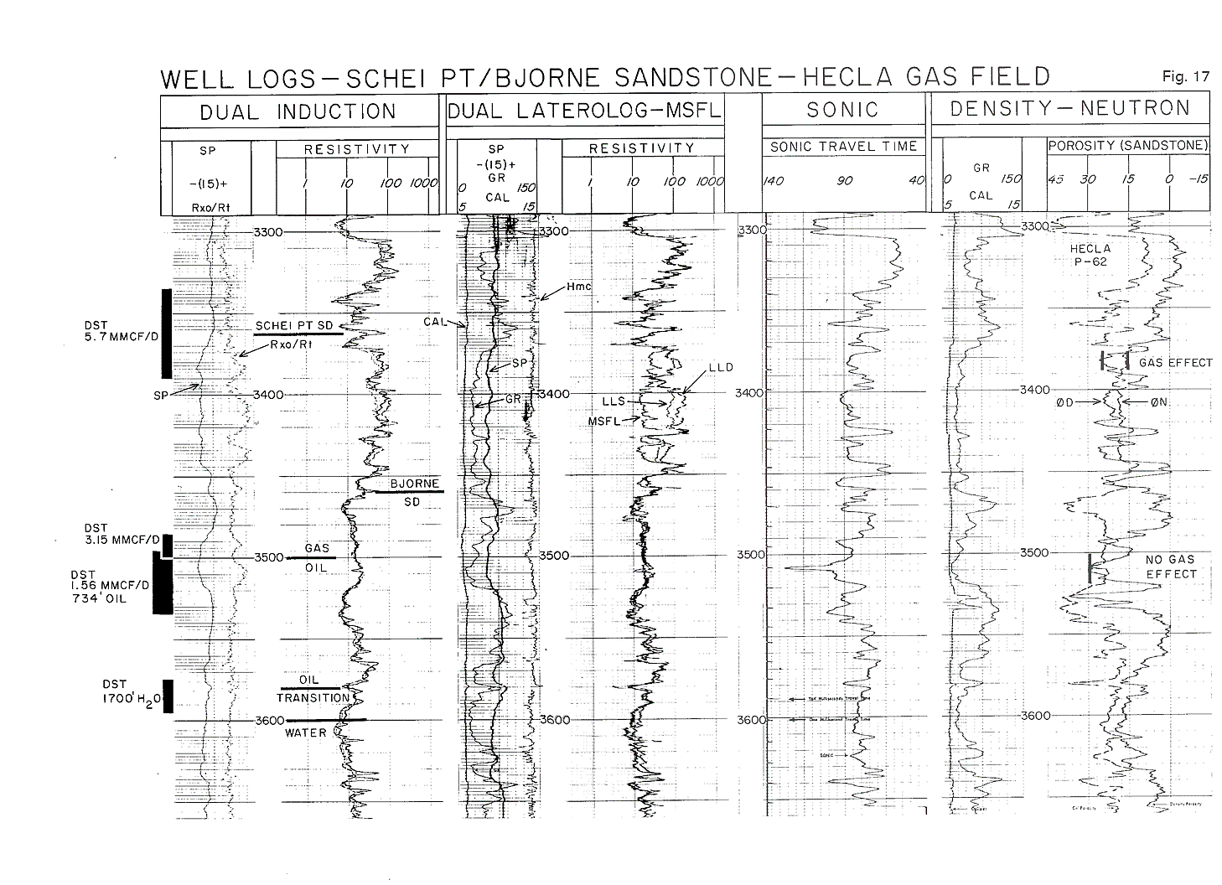
Figure 17: Well Logs, Schei Pt./Bjorne Sandstone, Hecla Gas Field
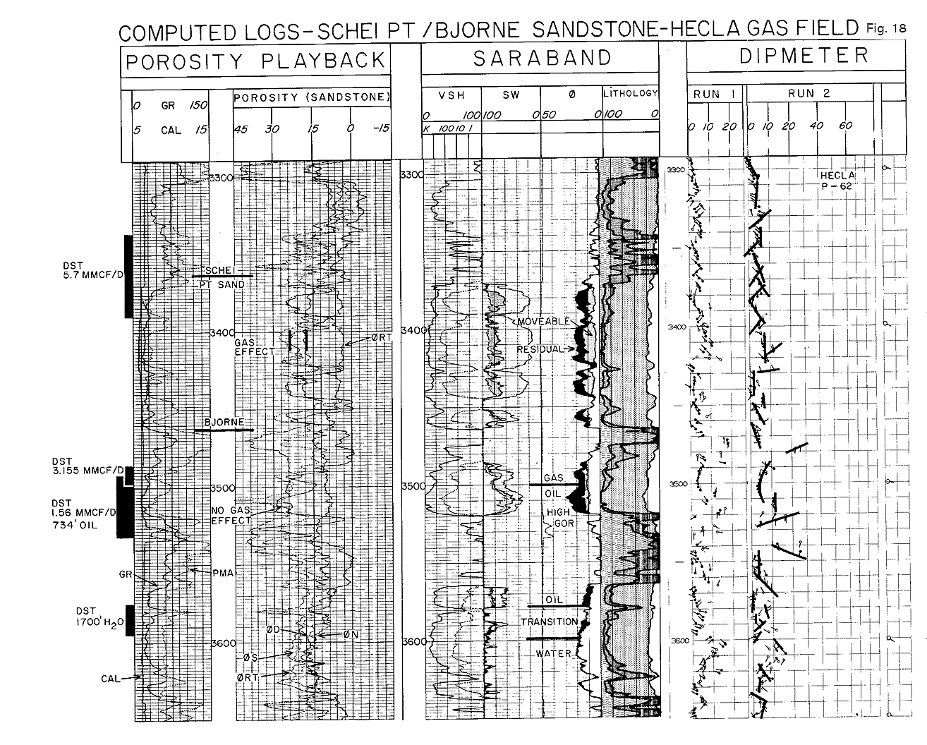
Figure 18: Computed Logs, Schei Pt/Bjorne Sandstone, Hecla Gas Field
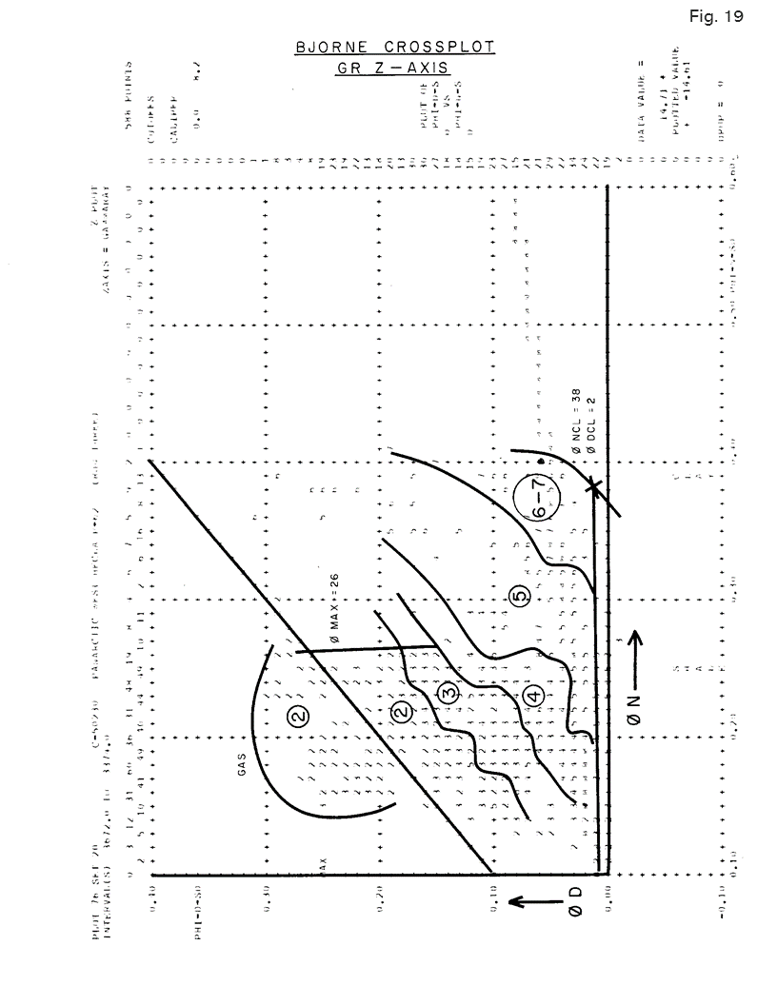
Figure 19: Bjorne Cross-plot, GR Z Axis
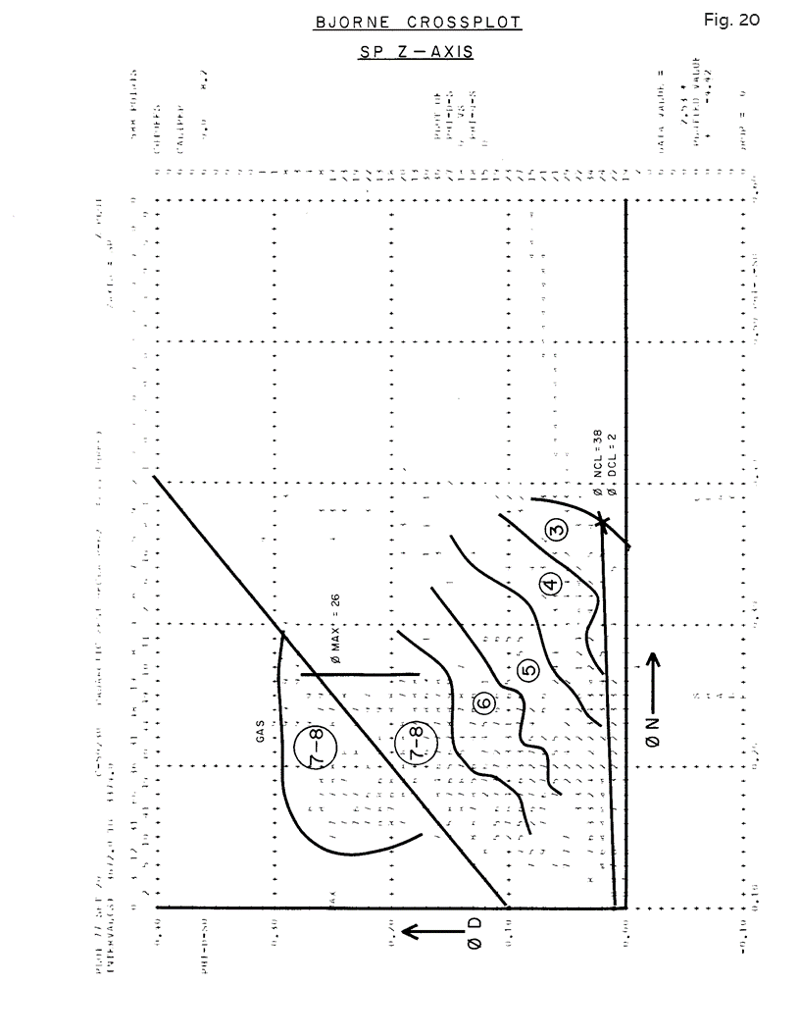
Figure 20: Bjorne Cross-plot, SP Z Axis
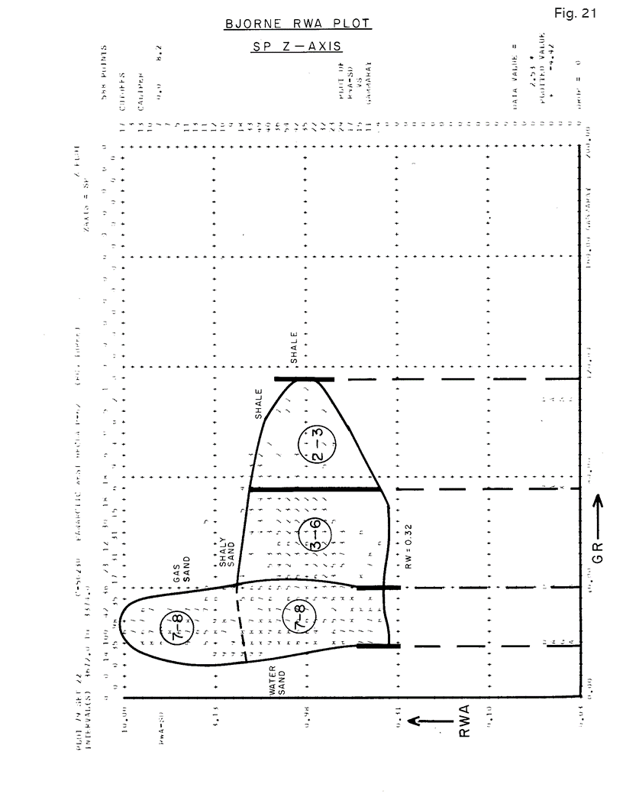
Figure 21: Bjorne RWA Plot, SP Z Axis
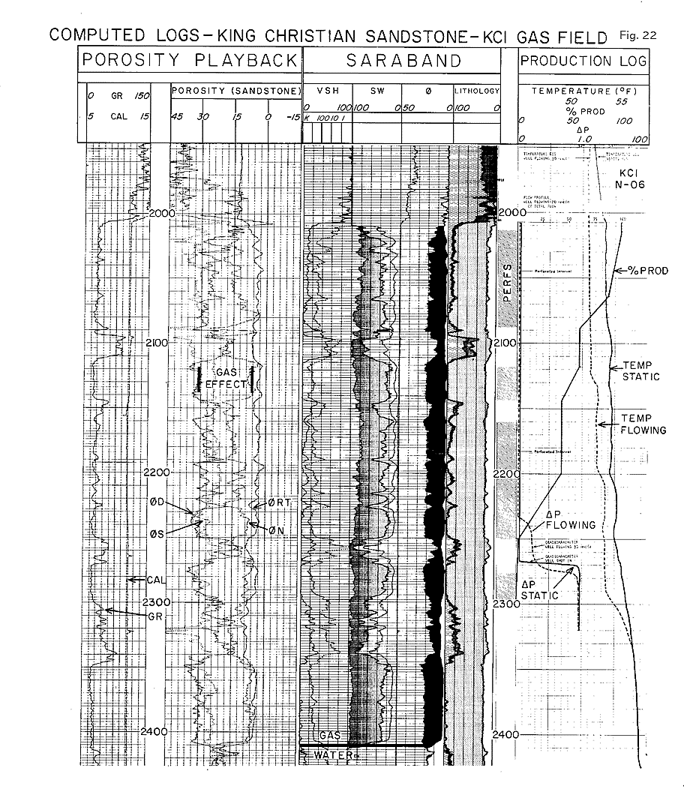
Figure 22: Computed Logs, King Christian Sandstone, KCl Gas Field
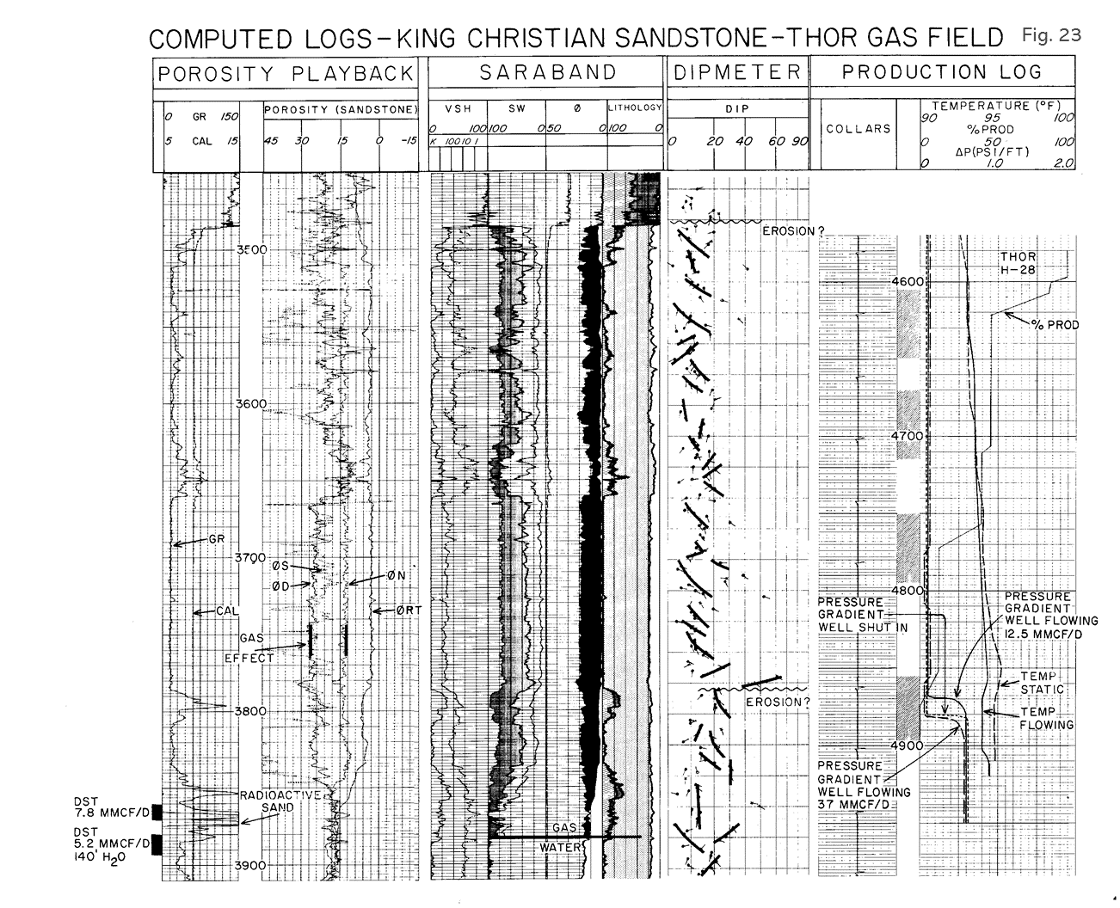
Figure 23: Computed Logs, King Christian Sandstone, Thor Gas Field
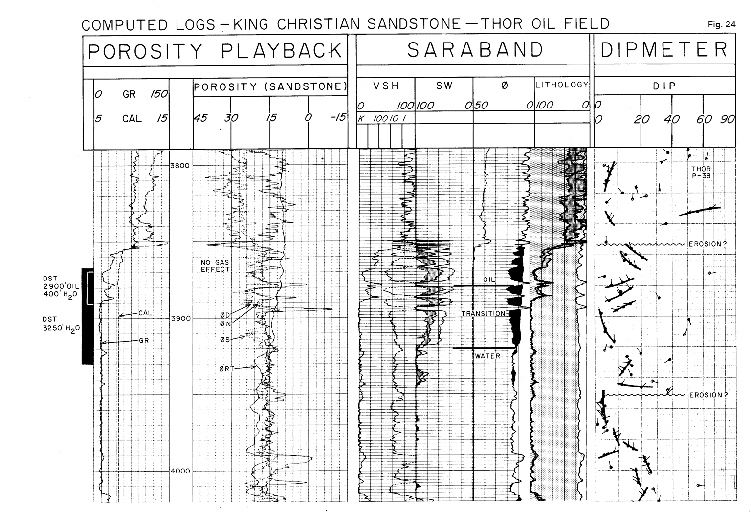
Figure 24: Computed Logs, King Christian Sandstone, Thor Oil Field
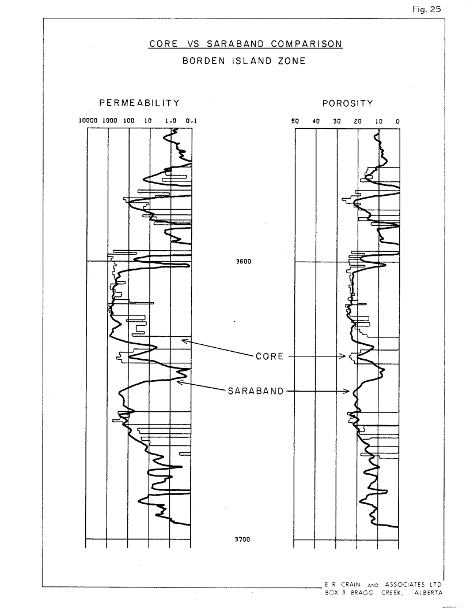
Figure 25: Core vs Saraband Comparison, Borden Island Zone
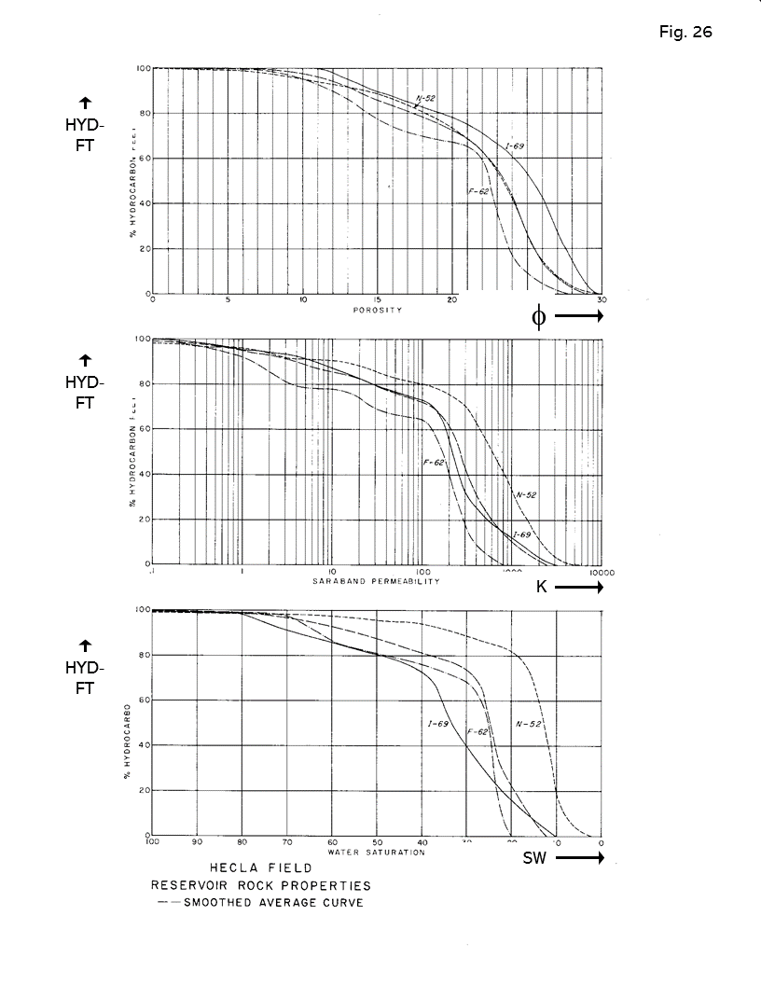
Figure 26: Hecla Field, Reservoir Rock Properties
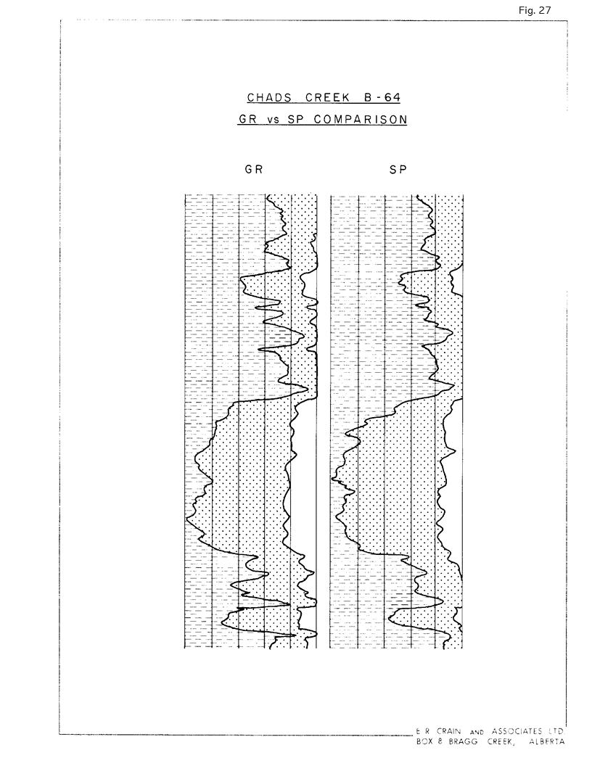
Figure 27: Chads Creek B-64, GR vs SP Comparison
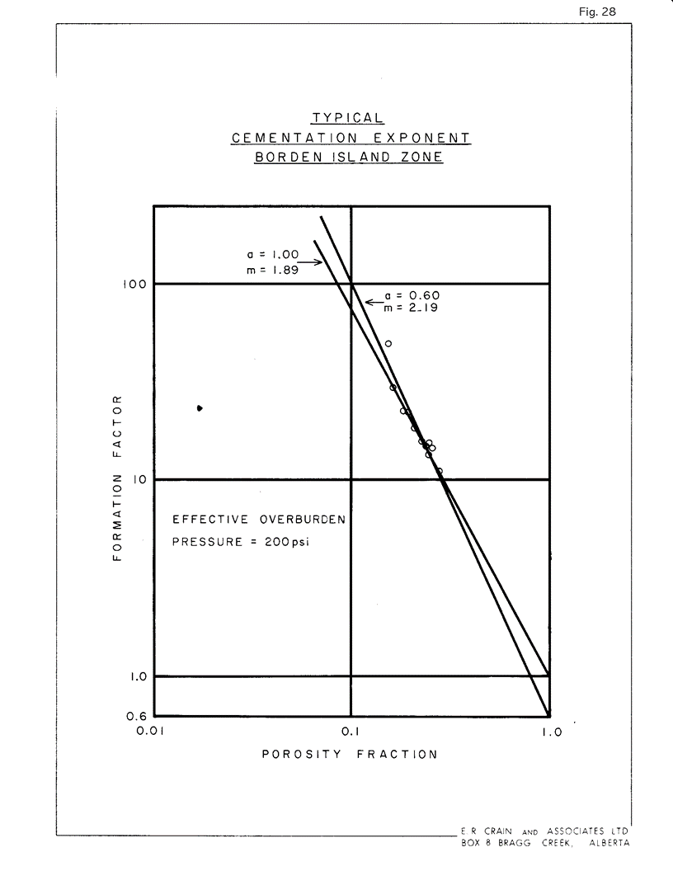
Figure 28: Typical Cementation Exponent, Borden Island Zone
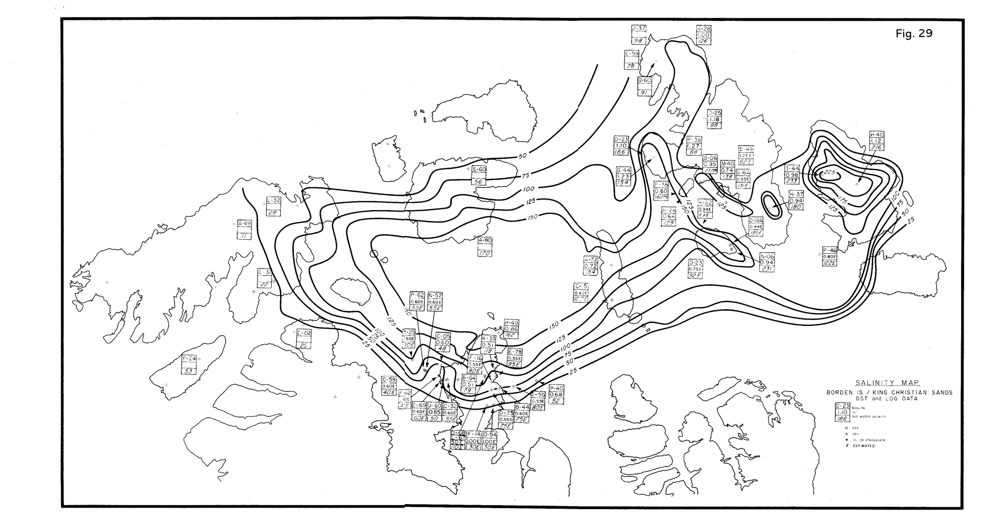
Figure 29: Salinity Map, Borden Island, King Christian Sands
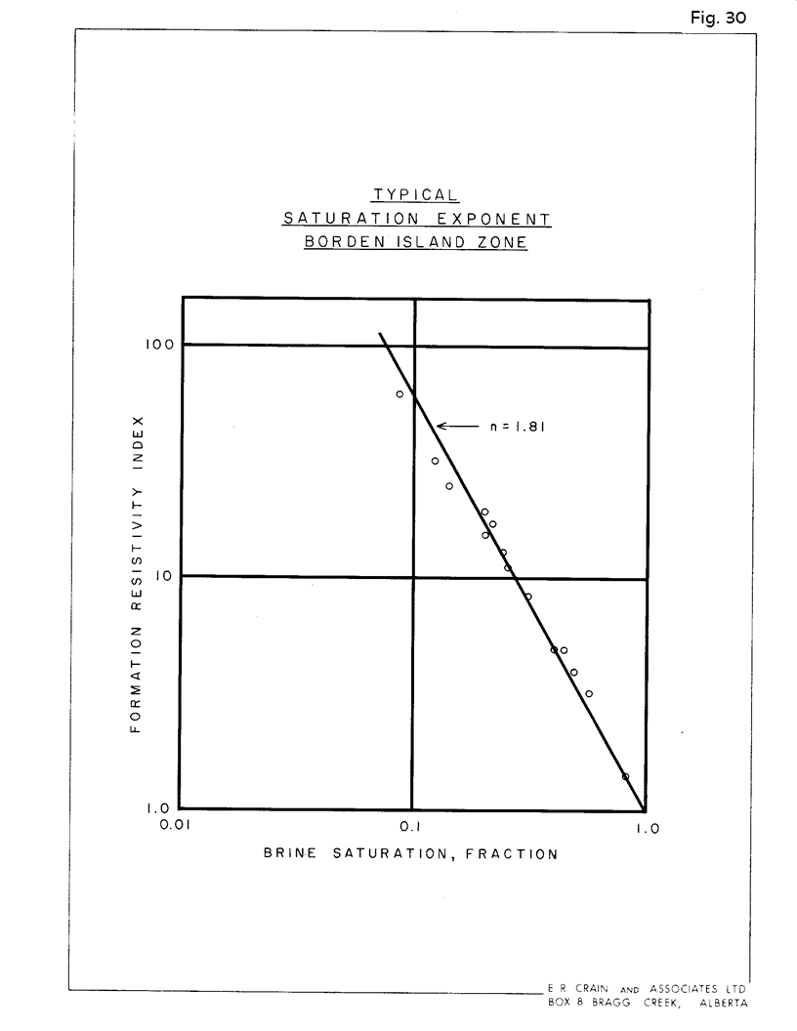
Figure 30: Typical Saturation Exponent, Borden Island Zone
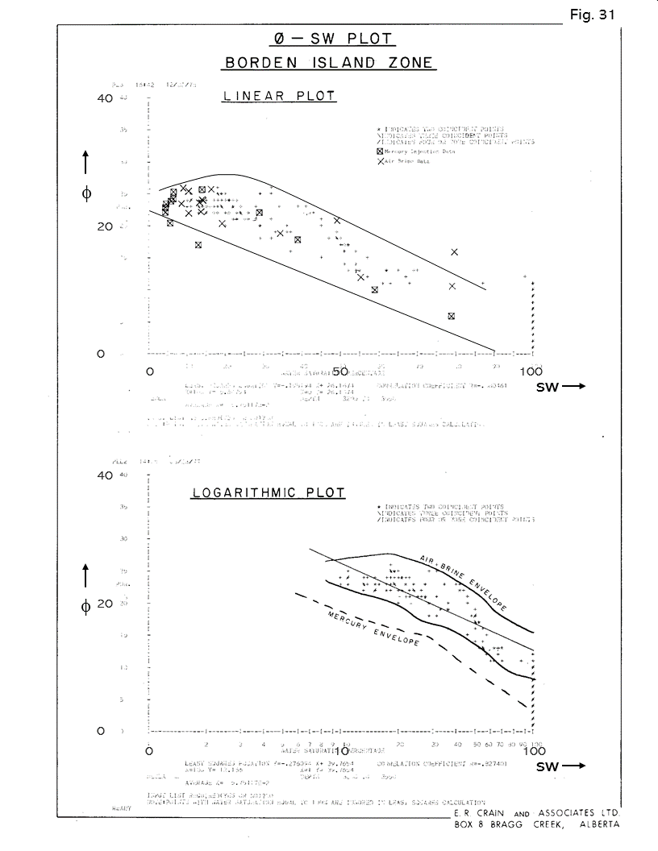
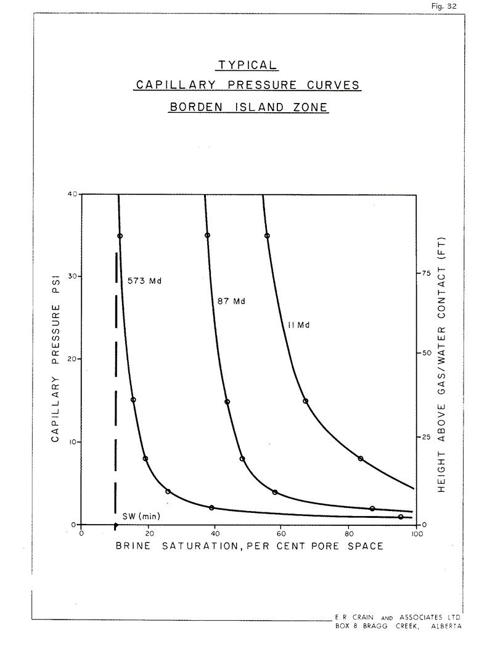
Figure 31: Porosity vs SW Plot, Borden Island Zone, Linear and Log Plots
Figure 32: Typical Capillary Pressure Curves, Borden Island Zone
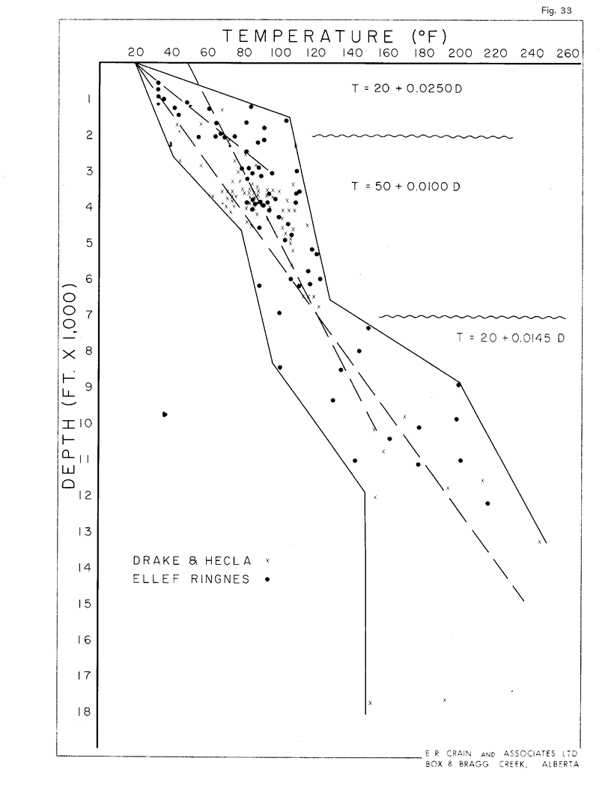
Figure 33: Temperature, Degrees F
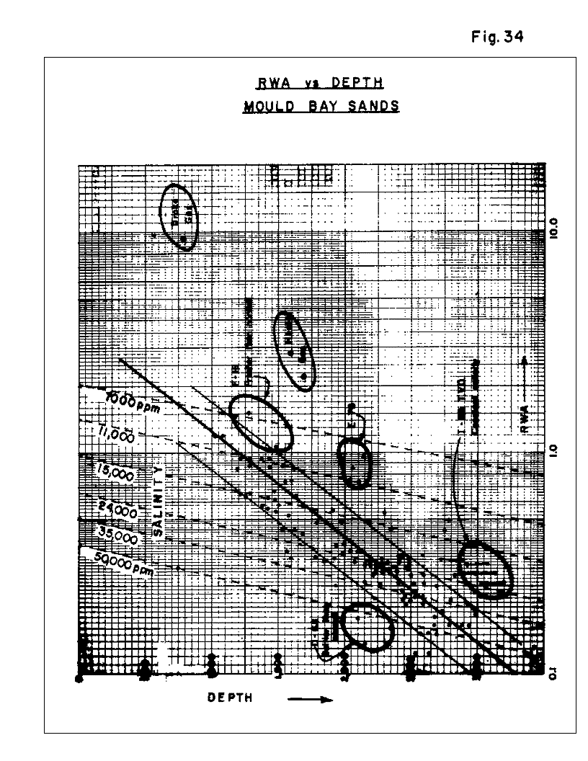
Figure 34: RWA vs Depth, Mould Bay Sands
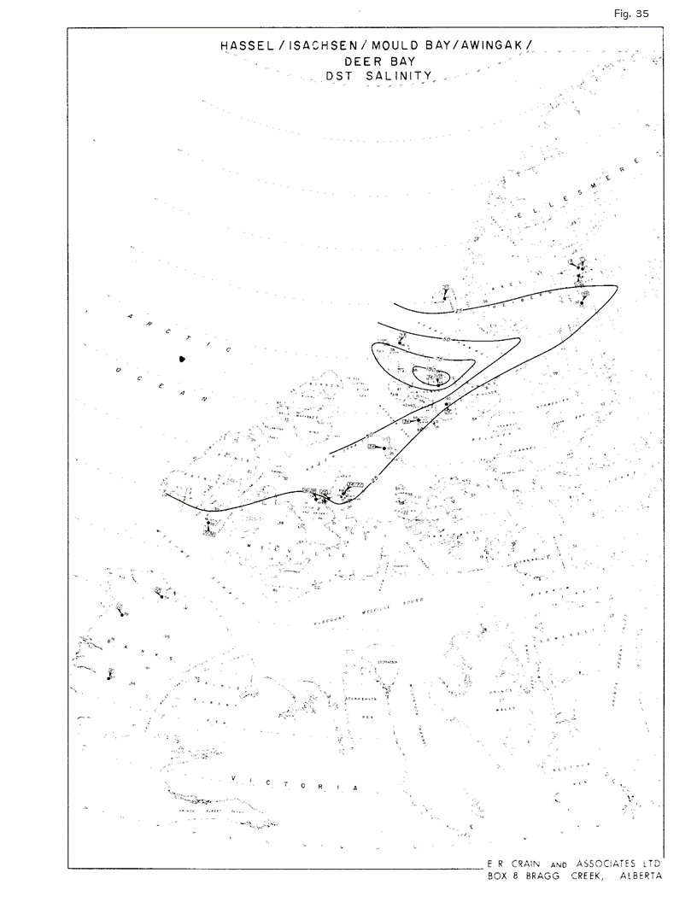
Figure 35: Hassel, Isachsen, Mould Bay, Awingak, Deer Bay, DST Salinity Map
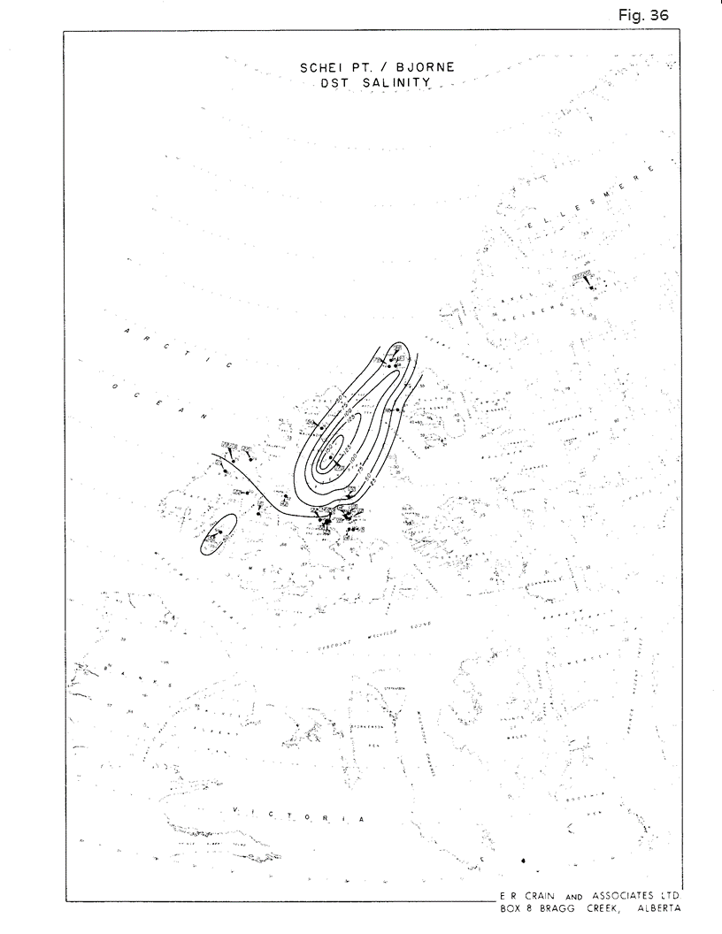
Figure 36: Schei Pt./Bjorne, DST Salinity Map
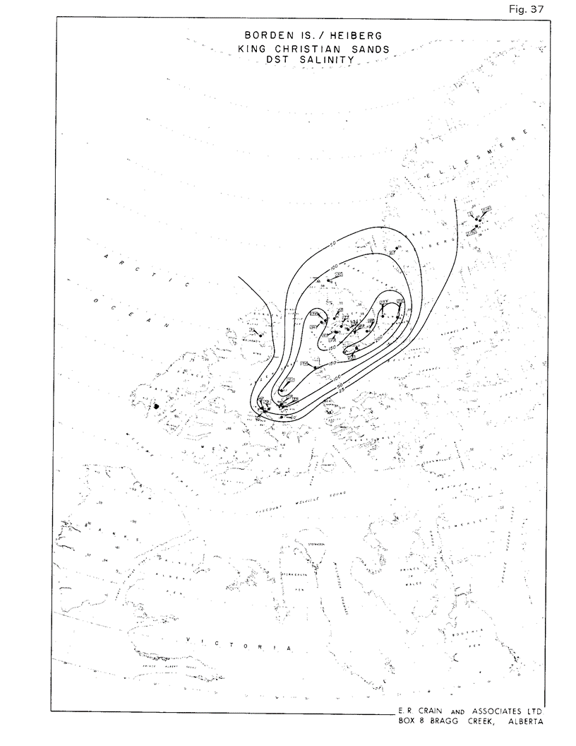
Figure 37: Borden Island, Heiberg, King Christian Sands, DST Salinity Map
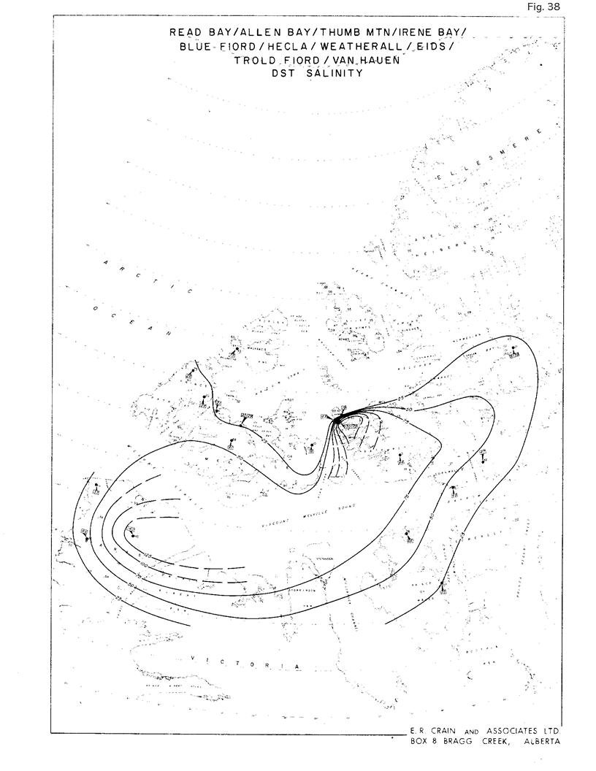
Figure 38: Read Bay, Allen Bay, Thumb Mtn., Irene Bay, Blue Fiord, Hecla, Weatherall, Eids, Trold Fiord, Van Hauen, DST Salinity Map
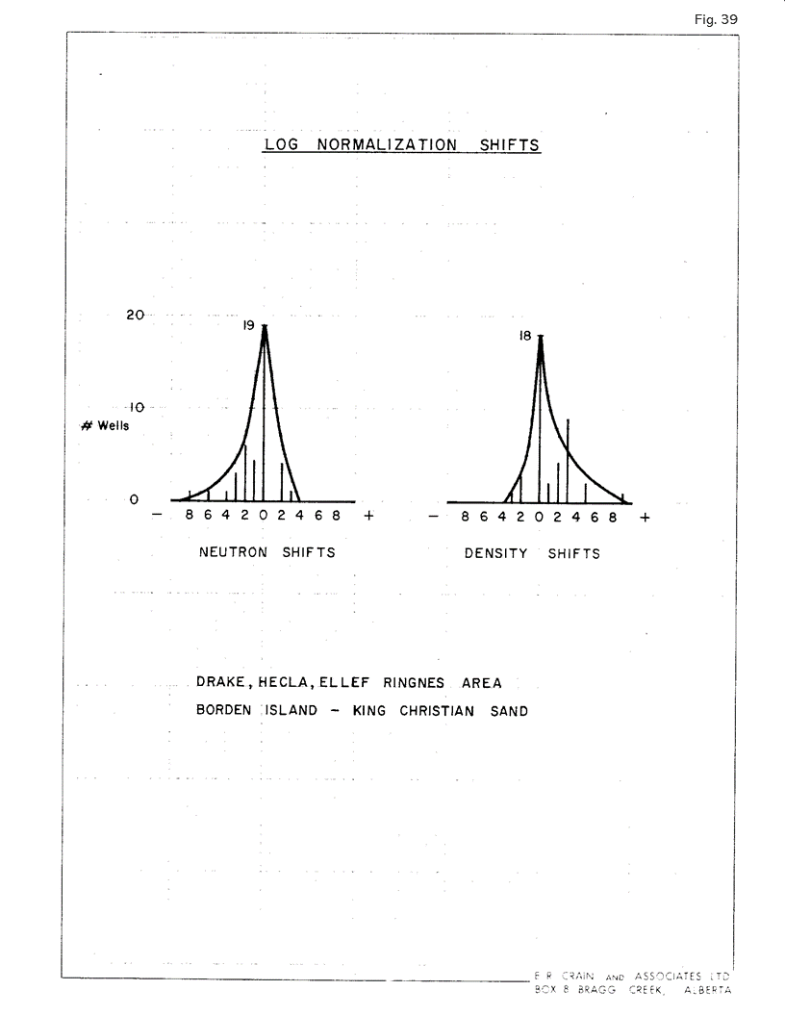
Figure 39: Log Normalization Shifts, Drake, Hecla, Ellef Ringnes Area, Borden Island, King Christian Sand
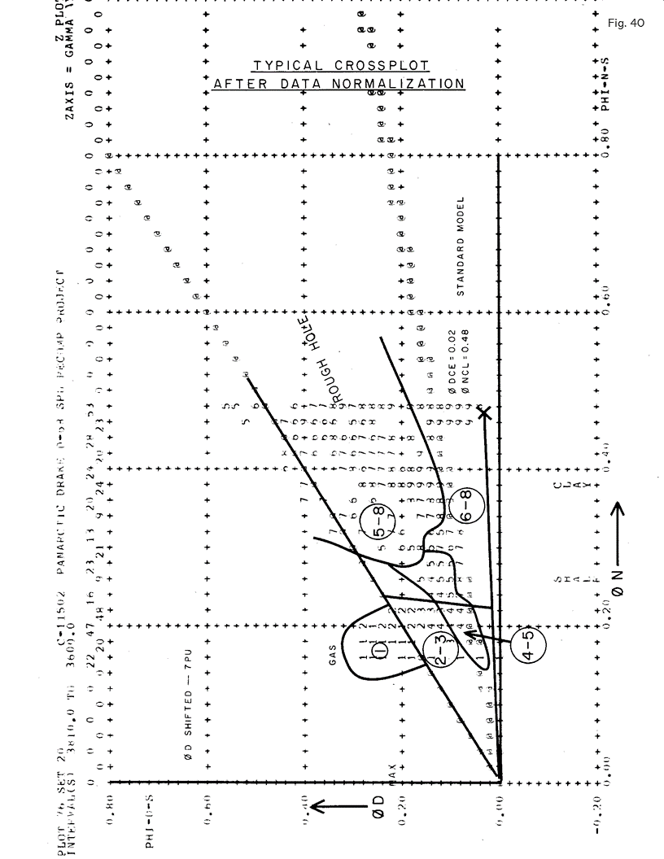
Figure 40: Typical Cross-plot after Data Normalization
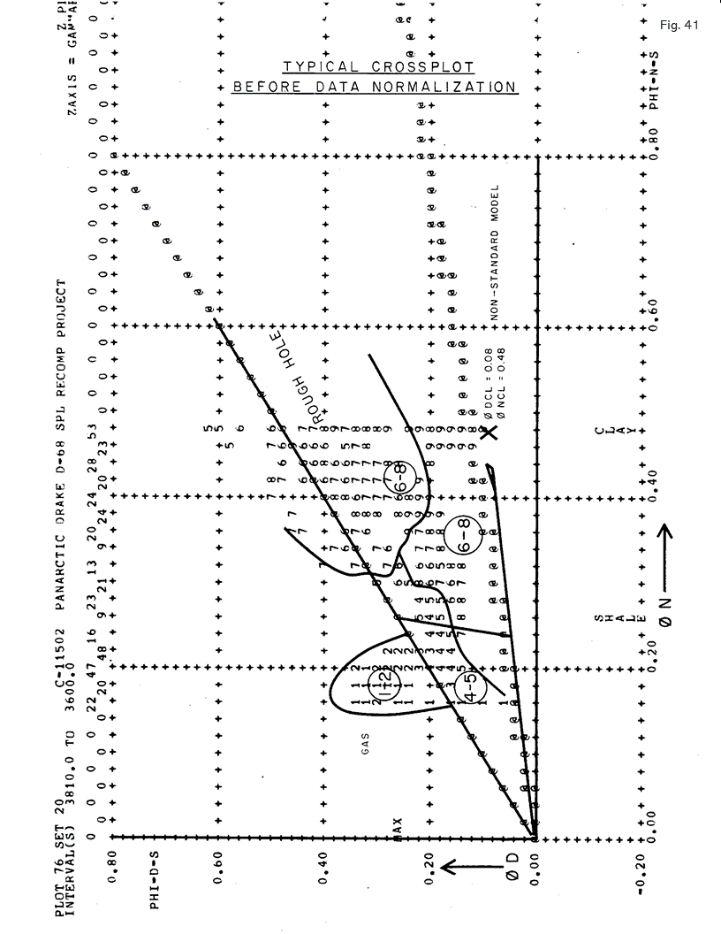
Figure 41: Typical Cross-plot before Data Normalization
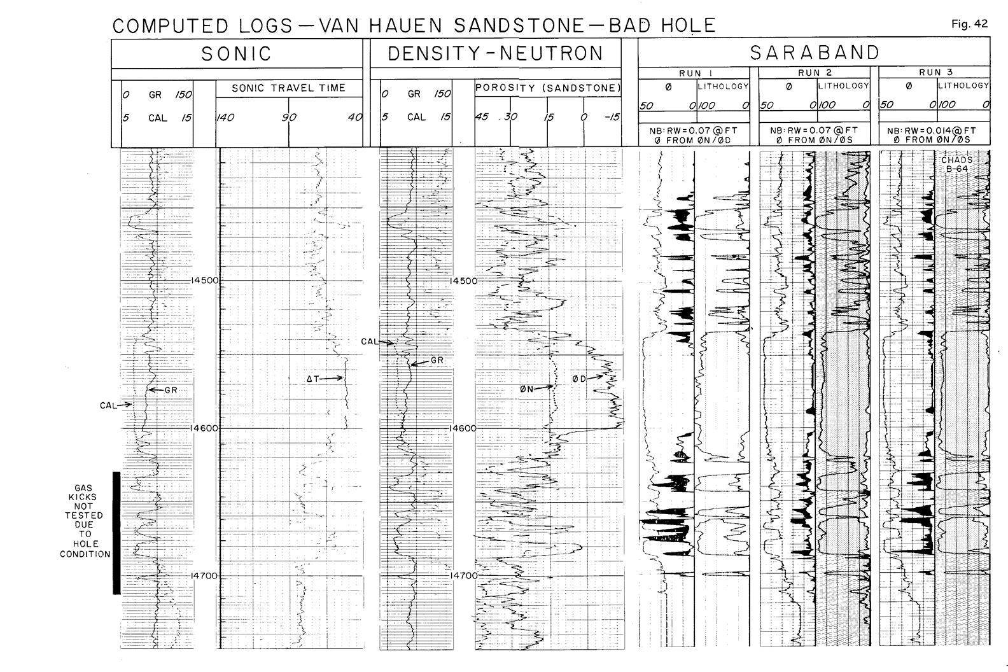
Figure 42: Computed Logs, Van Hauen Sandstone, Bad Hole
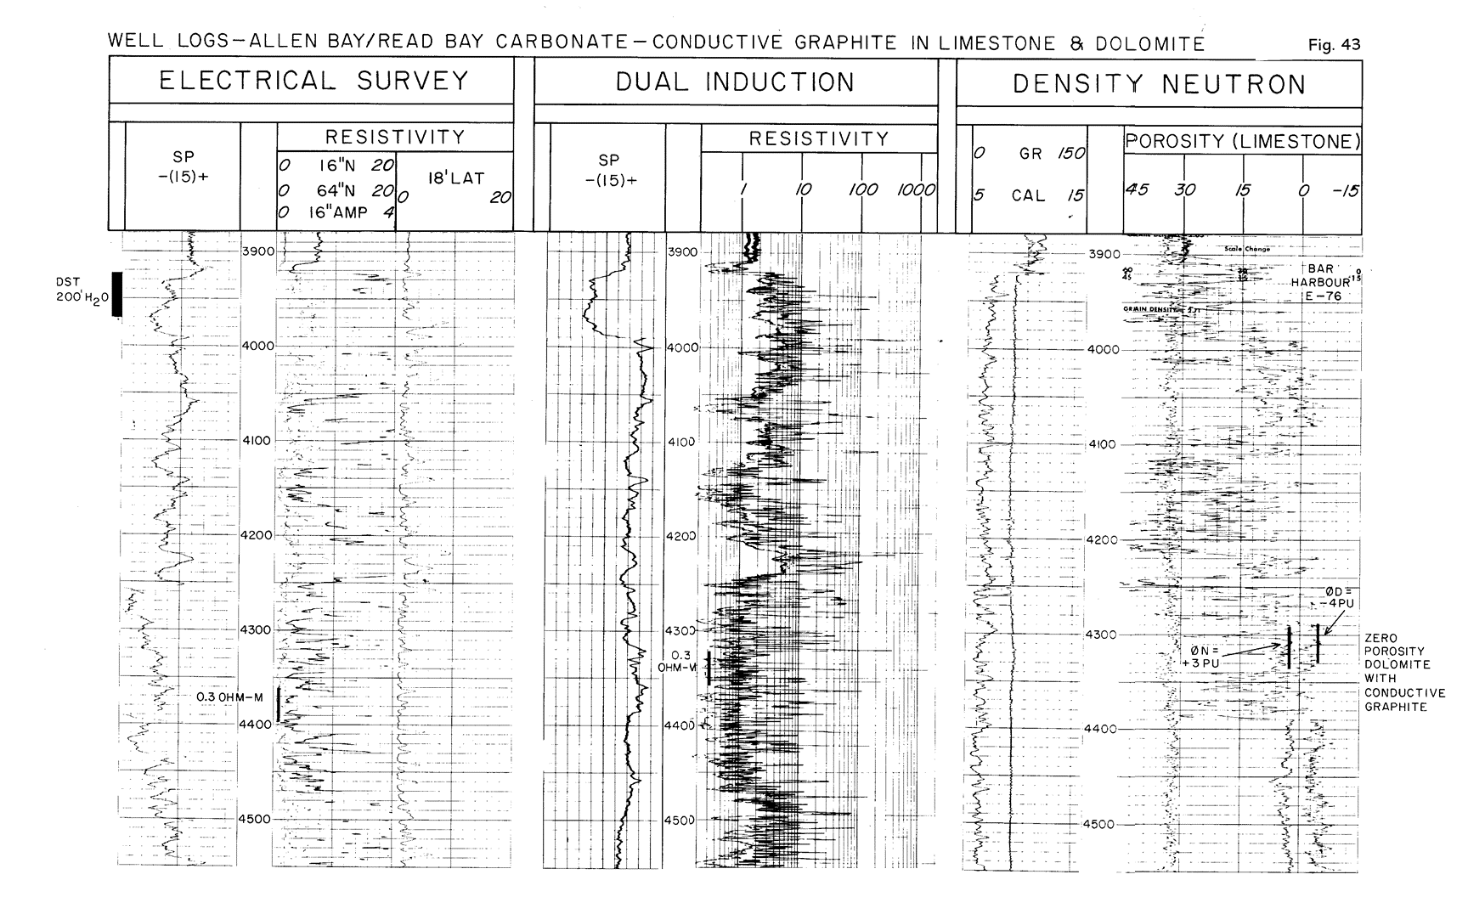
Figure 43: Well Logs: Allen Bay, Read Bay Carbonate, Conductive Graphite in Limestone and Dolomite
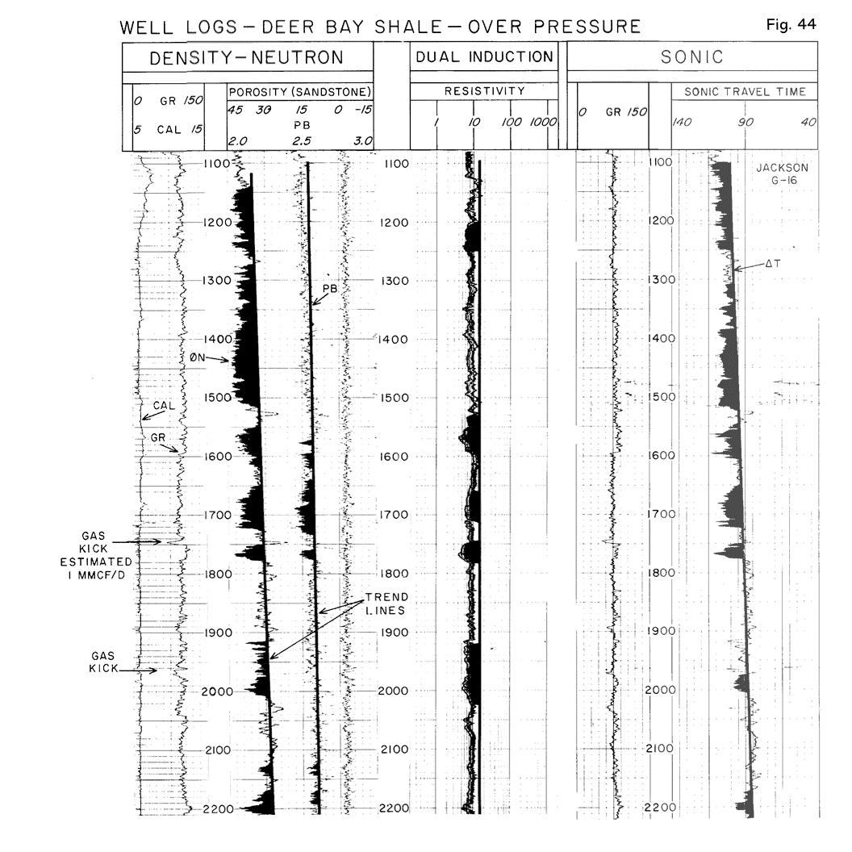
Figure 44: Deer Bay Shale: Overpressure
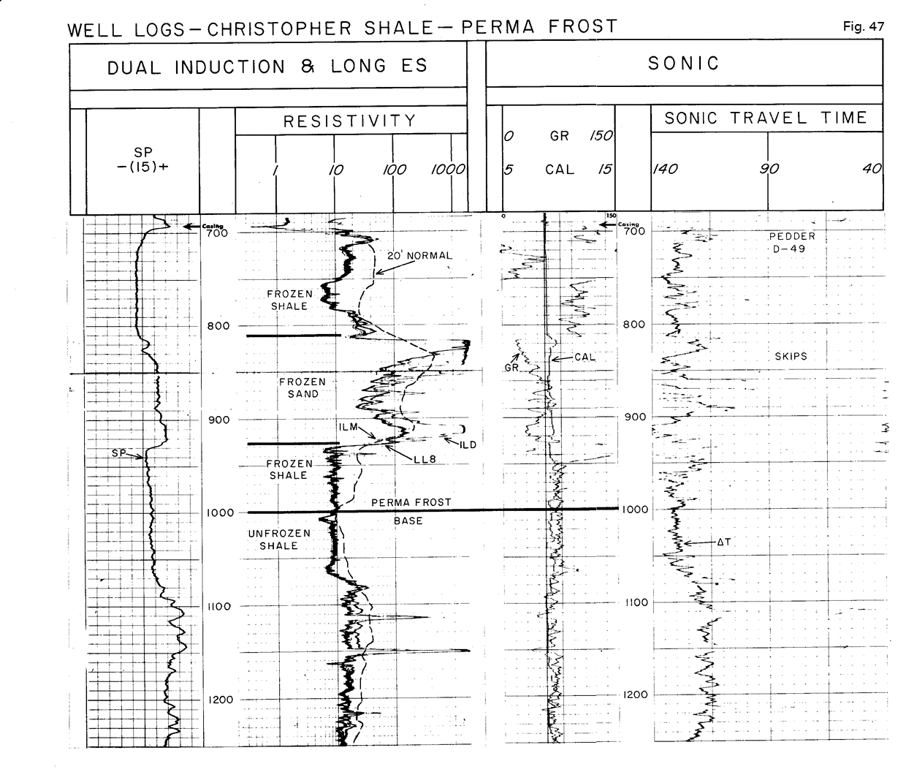
Figure 47: Well Logs: Christopher Shale Permafrost
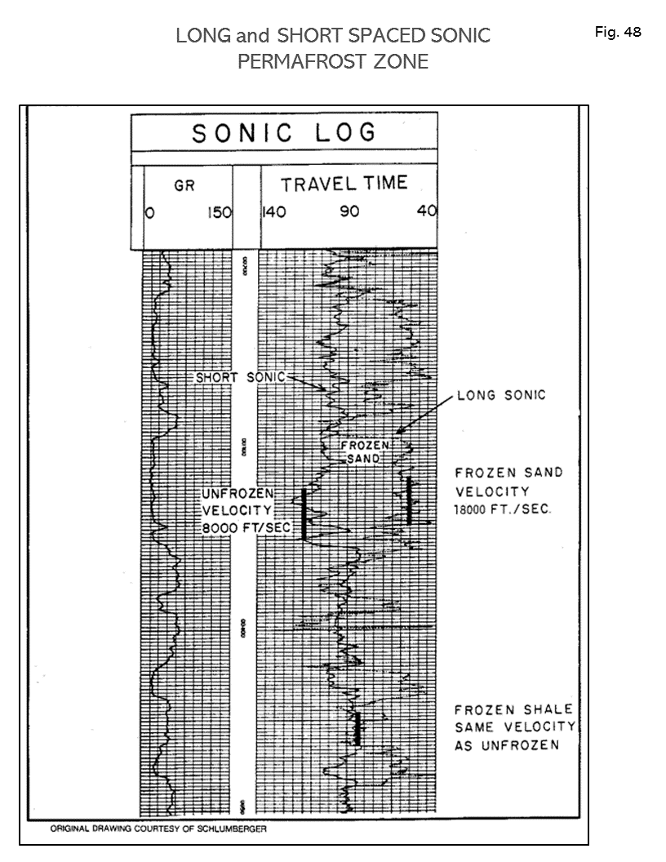
Figure 48: Long and Short-Spaced Sonic, Permafrost Zone
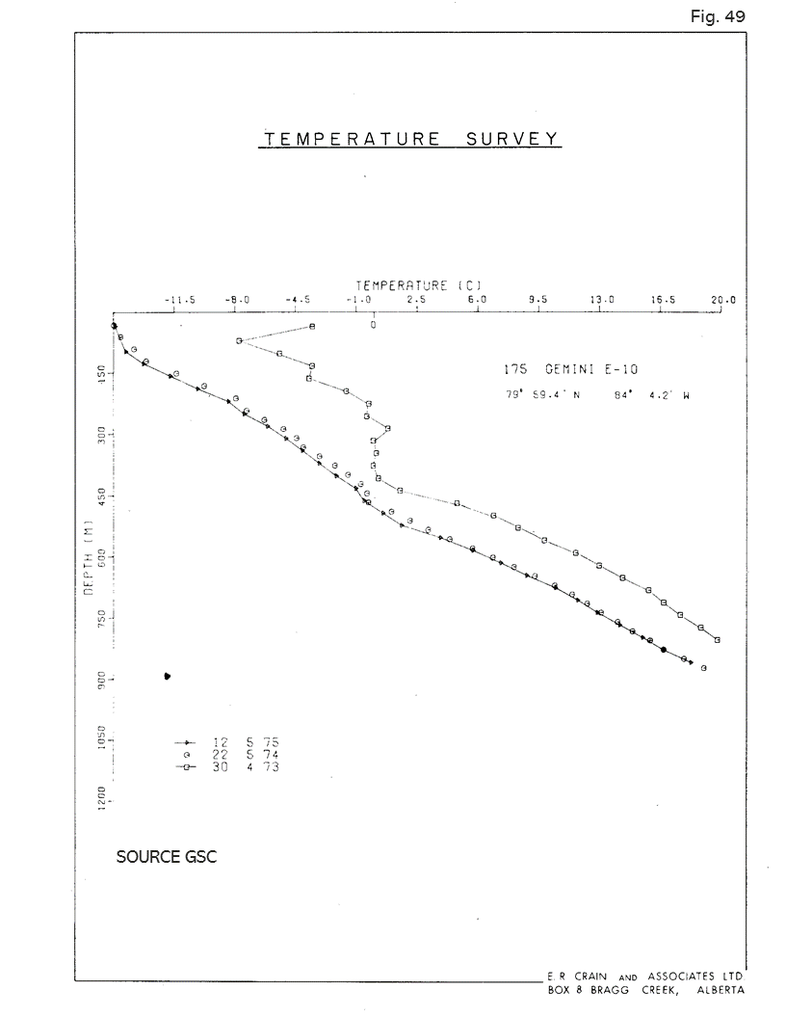
Figure 49: Temperature Survey, Temperature vs Depth
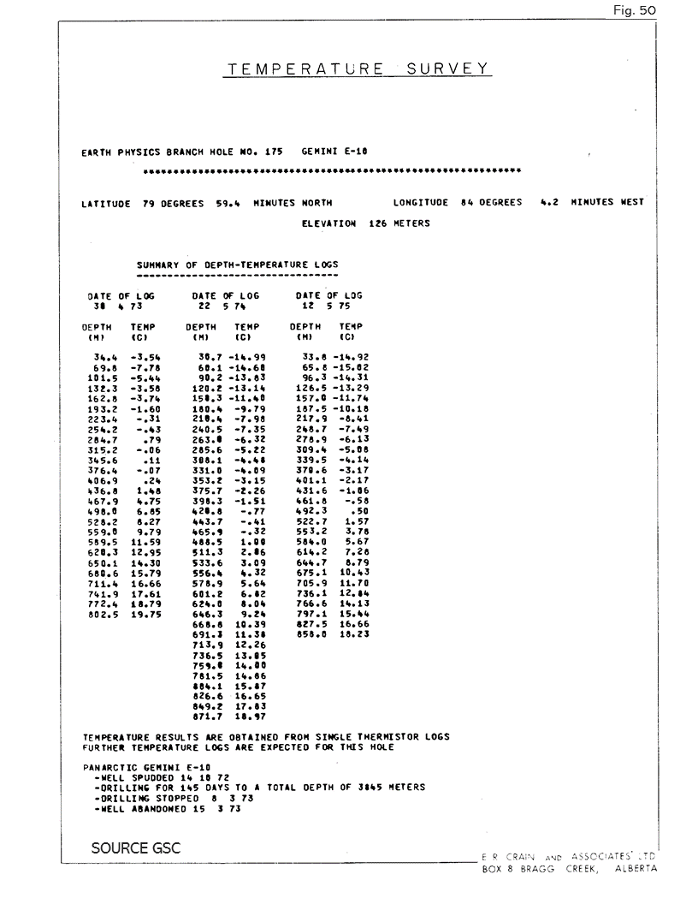
Figure 50: Temperature Survey Data
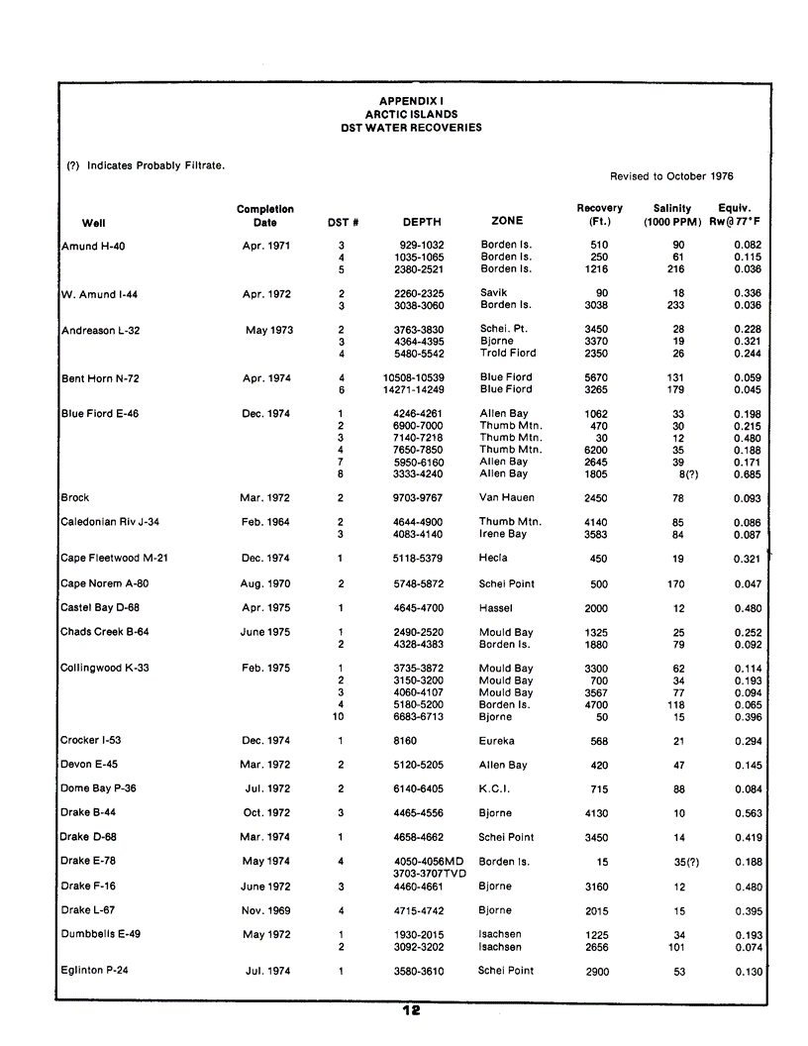
Appendix 1: Arctic Islands DST Water Recoveries
