THE LOG/MATE EVALUATION SYSTEM
E. R. Crain, P.Eng.
D. W. Curewn, P.Eng
E. R. Crain and Associates Ltd.
Presented by E. R. Crain at the 7th Formation Evaluation Symposium of the Canadian Well Logging Society in Calgary, 21 – 24 October 1979. This electronic version was created Jan 2021. Colour images from the 1977 brochure were added at the end of this version to provide a better appreciation of LOG/MATE capability.
Author’s Note: The first Log/Mate system was operational in summer 1976 and commercial sales began in early 1977. Log/Mate was the first desktop “personal computer” system for log analysis, on the market 5 years before IBM “invented” the PC. Forty-two systems were sold in Canada and USA before the business was sold in 1982.

ABSTRACT
The LOG/MATE Evaluation System was designed to fulfill a specific need within our organization for a fast, reliable, easy to use, portable, and reasonably sophisticated log analysis computer system. In addition, high-quality graphical and tabular output was required that needed no further drafting or assembly. The system was programmed in HPL on a Hewlett-Packard 9825 computer, with the necessary peripherals (4-colour plotter, digitizer, printer and floppy disc).
Log analysis procedures included the well-known shaley-sand and complex lithology crossplot techniques, as well as the bulk volume water method, and a facility to shale-correct sonic, neutron, or density logs.
Ease of use was our primary goal, so the major software effort was aimed in this direction. The programmable function keys available on the microcomputers, such as the 9825, were essential to this goal, since they remove the need for the end-user to know anything about computer languages or system commands.
Log/Mate is an interactive system that responds more quickly than a time-share computer system and at a lower cost. It permits a high degree of feedback at all interpretation stages, unlike batch processing methods. Intelligent use of the function keys and optimal software logic provide an almost unlimited variety of analysis techniques – which can be tailored specifically for individual cases.
INTRODUCTION
Log analysis aided by computer technology is not a very new phenomenon. It has been with us since the early 1960’s, when a small number of in-house systems were developed and run sporadically. There were serious drawbacks to those early systems, such as cost of program development, lack of adequate log data, expensive hardware and mediocre graphics. Turnaround time was slow and the user had to be prepared to learn and use the job control language of his computer.
For most, the thrill soon wore off and the systems fell into disuse.
A breakthrough seemed to occur in 1968 and several good systems appeared on the horizon both commercially available and in-house. A year later time-share programs were described, notably LOGAN on the GE (General Electric) system and the Sproule package at CDC (Control Data Corp).
The problems and economics were also being discussed at length but the lack of digitized data was a major deterrent. Schlumberger and Dresser published their system descriptions of Coriband and Epilog (respectively) in 1971 and Saraband in 1972 (and had been running analyses on precursors of these systems as early as 1970). No major new commercially available system has been described in the literature since 1972, although various in-house time-share systems have surfaced.
Time-share did not save computerized log analysis. Slow terminal response time and the need to know a fair amount of “computerese” (or system language) continually reduced the ranks of believers, as they lost patience with the systems they used – whether it was a commercial service or an in-house package.
The service company programs can be compared to batch processing jobs and suffer from the ills of batch processing, since the end-user drops the jobs off and doesn’t see it again for a few days or a few weeks. They are also fairly expensive and they require modern logs. None of these systems are or were technically unsound – they merely could not address adequately the problems of cost, turnaround time and ease of use, which are reasonable criteria for assessment of system sustainability.
In response to these problems, analysts turned to programmable calculator methods in 1974-1975. This provided an interim solution, but the lack of adequate printout, data storage, and the volume of key strokes required to run many intervals mitigated against widespread acceptance.
WHY LOG/MATE?
With this background in mind, we built a “shopping list” for a new system.
First the system had to be portable (that is, to an office or a rig). It had to be easy to use – much easier for the end-user than any existing system. In other words, no computer or system language needed to be memorized, and data entry had to be reduced to a minimum of bother.
The interpretation methods had to suit a variety of problems as well as our personal style of work. There had to be a minimum of middlemen, that is, the batch processing centre had to go. This would assist in attaining fast turnaround.
The programs had to be locally modifiable and updated regularly in order to be responsive to changing job requirements and techniques. Above all it had to be affordable and reliable – our business couldn’t tolerate a large financial investment or significant downtime.

HARDWARE
To be affordable, the system was based on stand-alone microprocessors, with a good complement of readily available peripherals.
This unfortunately ruled out the hobby computer at the time.
Hewlett Packard equipment was selected because it is the lightest available and has a reputation for reliability. Our first system consisted of only an HP 9825A computer and an HP 9827A plotter (which also acted as a digitizer). The computer has 24,000 bytes of random access memory for user programs and data, as well as 40,000 bytes of read-only memory for the system controller and language interpreters. The computer has a built-in tape drive and a printer, and weighs only 26 pounds – so it truly is portable. The plotter is a four-colour pen style with an 11 x 17 plotting bed, and weighs 40 pounds.
A digitizer, a full width printer, and a floppy disc were each added at about 4 month intervals to create the system we now run. Our software is designed to accept any or all of the optional peripherals in order to retain the portable nature of the package. Each of these additional peripherals are small, and the whole system still fits on a desk top. A wide variety of printers are available, as well as a printer/plotter. Several models of digitizer can be used.
INTERPRETATION SOFTWARE
From a log analyst’s point of view, the software has to do a number of basic things. Full shale and lithology corrections are available, as well as the ability to handle any reasonable log suite – whether old or new logs, with Metric or English units, on half scale or full scale, using Xerox copies, field prints or telecopies. Full edit and re-scaling facilities are included for obvious reasons.
The system is self-prompting with English language questions and answers. Because of the instant response of the stand-alone computer, and the “audit trail” which indicates program status and intermediate results, a very close symbiotic relationship can be achieved between the computer and the analyst.
PRINTER OUTPUT
Most computer printouts tend to be too bulky for easy filing or handling. We have therefore incorporated a number of options to provide only that amount of paper needed for the job at hand.
These are:
- Detailed Listing – raw data, answers and quality control information.
- Answer Listing – major answers only plus cumulative porosity-feet and hydrocarbon-feet.
- Log Summary Listing – Summary of Answer listing with averages and totals.
- Constants Listing – all constants entered.
- Core Data Listing – same format as Core Lab report.
- Core Data Summary – same format as Log Summary
- Seismic Listing – converts log values into geophysical terms, shows integrated time vs. depth.
These listings, which form the final report, are not essential to all analyses.
PLOTTER OUTPUT
Log/Mate plotter output is one of its most important assets and is extremely flexible – any input or output curve can be plotted on any scale in any of 4 tracks, in any of 4 colours, and in any of 7 dash-dot codings, under user control. A default value for every option is built-in so that standard plots can be made with an absolute minimum of effort.
Plots can be at any depth scale, with or without grid lines and headings, and with typed annotation if desired, thus eliminating the need for drafting staff. An example is shown in Figure 1. The volumetric presentation of the reservoir in track 3 is easy for non-log analysts to visualize. While our standard presentation has water saturation in track 2 and permeability or grain density or porosity on detailed scale in track 1, the user can specify any curves he needs to illustrate his analysis.
Since most log analysis results are ultimately compared to core analysis, we built in a core data entry, average plot program, so that both core and log data can be compared on depth plots or crossplots. An example of a core vs log overlay is shown in Figure 2, from the Falher section in a Deep Basin well. This type of plot is used to adjust log interpretation parameters so that core porosity matches log porosity in both clean and shaley sections. In most cases a satisfactory match is found, unless the core is badly broken or upside down.
A tar assay presentation is also useful where rock and fluid weights are plotted instead of volumes. Such a plot is shown in Figure 3.
Raw data plots are normally provided, as well, to illustrate gas effect, shale values, depth control problems, and edited portions of the logs as illustrated in Figure 4. This particular plot has four curves on a compatible porosity scale, which we call a Porosity Playback Log. Compatible scales often identify mis-scaled or mis-calibrated logs, and help to determine water resistivity.
The plots discussed above are usually displayed in four colours, which improves clarity considerably compared to the black and white versions shown in this paper. The dashes for the shale coding are not a normal presentation, but can be added at any time with the annotation feature on all Log/Mate plots. Detailed grid lines (preprinted on the plotter paper) have been omitted for clarity.
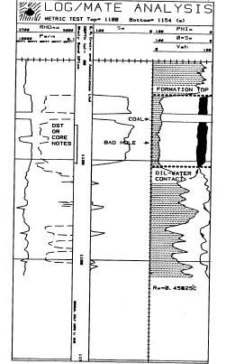 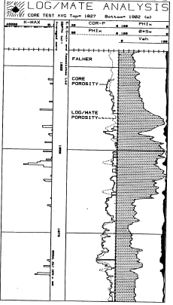
FIGURE 1: Typical Depth Plot Fig 2: Depth Plot with Core Overlay
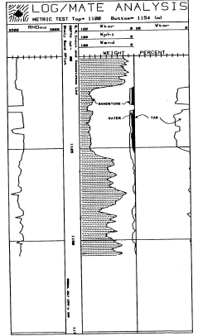 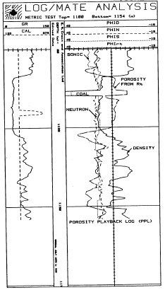
FIGURE 3: Tar Sand Plot – Mass Fraction FIGURE 4: Typical Raw Data Plot

4-D CROSSPLOTS
Much interpretation depends on comparison of one log type or result to another or with core data. To aid this comparison a unique feature called the 4-D crossplot was developed by us. The usual histograms, X-Y plots and Z-plots, can be run as well, but the 4-D, or four dimensional, plot allows you to portray a fourth variable on a Z-plot by using the colour of the point as the value of the fourth parameter. Thus both frequency and Z-plots can be combined on one graph or the fourth dimensions can be hole size, shale volume, water saturation or any other input or output parameter. Log data, core data or both can be entered into such a plot.
An example is shown in Figure 5. Here the X and Y axis are neutron and density porosity respectively. The Z-axis is shale volume (Vsh) scaled between 0 and 9. The W-axis, or fourth dimension, is the frequency of occurrence of the X-Y pairs.
Within the interval plotted:
- Black numbers occurred only once
- Red numbers occurred twice
- Blue numbers occurred three times
- Green numbers occurred four or more times
Over 90000 different 4-D plots can be made – of which we commonly use only 10.
A second type of 4-D Plot is shown in Figure 6. Here the X-axis is water saturation, the Y-axis is porosity. The Z-axis and W-axis are as before. These plots are used to identify potential water cut problems.
A third type is shown in Figure 7. Core porosity (COR-P) is plotted versus log analysis porosity (PHIx) with the Z-axis and W-axis as before. While this plot indicated a fairly wide spread in the correlation, this information combined with the core vs log overlay of Figure 2 shows that the results compare favourably.
Figure 8 presents a typical histogram of density log readings versus frequency of occurrence. These are used to normalize logs from well to well and to identify matrix and shale parameters. The W-axis is a function of hole size in this case. Bad hole points would be discounted before picking parameters from the histogram.
Since the colour is missing on the reproduction of these plots, the virtues of 4-D plots may not be readily apparent.
OTHER FEATURES
For those who do enjoy the hands-on feel of programming their own custom processes or modifications, Log/Mate permits the user to either modify a program or data and store it for future use, or to change data or programs from the keyboard for a once only “fix”. Obviously, the user needs to know something of the computer language as well as the Log/Mate program and data file structure in order to do this. We encourage such experimentation but it is not a necessity.
As an example of the versatility of the system, all the plots in this paper, and the view graphs for the verbal presentation were made on the plotter – no drafting was needed.

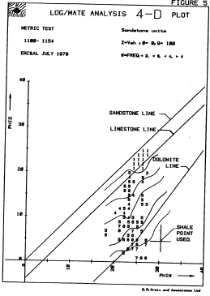
FIGURE 5: 4-D Density Neutron Crossplot FIGURE 6: 4-D Porosity Saturation Crossplot; both plots: Z-axis = Vsh (0 to 9), W-axis = Frequency (Blk=1,Red=2,Blu=3,Grn=4)

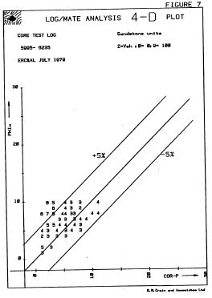 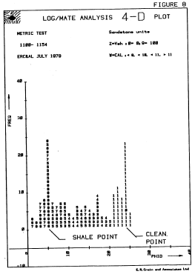
FIGURE 7: 4-D Core vs Log Porosity FIGURE 8: Frequency Histogram - Density

ECONOMIC CONSIDERATIONS
A typical zone of 200 to 400 feet in length can be digitized, computed, plotted, and printed in a little under two hours with Log/mate. Jobs can be controlled by a professional log analyst and run by a full time technician, leaving the analyst free to do other chores while the job is being run. Jobs with core data will take nearly twice as long due to the key punching and editing needed on the core data.
Table 1 below illustrates our cost experience for the last 9 months on the Log/mate system. Professional time has been charged at $50 per hour for a 7 hour day, which figure includes costs of all benefits, office space and corporate overhead. The Technician time has been charged at $20 per hour including those items mentioned above plus overtime, and the computer at $25 per hour, including all expendable supplies, maintenance, and amortization or lease costs.
Since the system was designed to handle short zones at the expense of longer ones, Log/mate is very cost competitive for zones up to 1000 feet or so. Beyond this the cost per foot is comparable to other commercial services, but it can provide significantly better turn-around times instead.

TABLE 1: Log/Mate Economics
Job ID |  | Number of Zones | Analyst Days | Tech Hours | Computer Hours | Cost  C $ | Feet | Match to Core | Unit Cost  $/ft
W |  | 150 | 45 | 392 | 274 | 32000 | 28000 | No | 1.16
H |  | 160 | 32 | 257 | 301 | 23800 | 32000 | Yes | 0.75
D | 140 |  | 30 | 503 | 491 | 32800 | 31500 | Yes | 1.04
Long Wells
A |  | 3 | 4 ½ | 39 | 35 | 3200 | 9000 | No | 0.36
K |  | 1 | 6 ½ | 30 | 46 | 4025 | 4000 | Yes | 1.00
B |  | 1 | 2 | 6 | 10 | 1075 | 3000 | No | 0.36
Short Zones
-- |  | 88 | 836 | 218 | 300 | 24400 | 18000 | Half | 1.36
 |  | 543 | 156 | 1445 | 1457 | $121300 | 125500 | -- | 0.97
 |  | Average cost per zone – all job types = $223.39

CONCLUSIONS
The major breakthrough in Log/Mate is the “Ease of Operation” of this system, coupled with low cost – brought about by the use of micro-processor technology together with a hardware feature called programmable function keys. This eliminates the need for the user to know anything about computers, or computer system languages. For that matter, the user doesn’t even have to be an expert log analyst, although it helps to know something about the subject. The user pushes one of 24 buttons describing the action he wishes to take and answers a few English language questions which determine precisely, and exclusively, how that one task is to be performed by Log/Mate. He repeats this for each task and re-runs any portion that is not satisfying (changing constants or methods as needed).
The problems of slow response time, poor overall turnaround time, inflexible software, and fixed format graphics have been greatly reduced.

VIEW 1977 LOG/MATE COLOUR BROCHURE
ON FOLLOWING PAGES
