Evolution Of Dipmeter Tools

E. R. (Ross) Crain, P.Eng.
Spectrum 2000 Mindware Ltd
Calgary AB
Published in Canadian Well Logging Society Journal, Dec 1992.
A version of this paper forms part of Chapter 19 of Crain’s Petrophysical Handbook.
Author’s Note: Most of the dipmeter data processing techniques described here are still in use today. Please see Part 2 (self-published) for more information on the latest tools and techniques. ERC Jan 2005.

Abstract
During a project for a client which involved the use of dipmeters, it became apparent that I didn't know enough about the tools or processing techniques to adequately solve the geologic problems presented. This was true in spite of running and using dipmeters in the past, so I decided that a review of the subject was needed to refresh my memory.

Unfortunately, the original technical papers and service company handbooks covering dipmeter related topics fill six 3-ring binders (3 inches each). This was too much to absorb.

After sketching out a brief set of notes, it was clear that dipmeter analysis had grown more and more complicated as the tools became more sophisticated. My notes also grew to a size and complexity to match.

After nearly three years of organizing, condensing, and amplifying these notes, they have become a compact, useable guide to analysis of dipmeters of all ages and types. Even with this effort, my notes became book sized and have been incorporated as four chapters of Volume 2 of The Log Analysis Handbook, soon to be published by Pennwell Books (if I ever get the rest of the book finished).

This two part series is an extract from the "Dipmeter Theory and Data Processing" chapter. It covers everything you ever wanted to know about dipmeter tools and computer displays, but were afraid to ask your supplier. I have attempted to provide an impartial review, but trade names and suppliers names are mentioned where appropriate. If any service company feels short changed by my treatment of their tools and techniques, I would appreciate receiving updated information from them.

If you have as poor a memory as I have, you may find this review useful when analyzing dipmeters. I don't think anyone, except a service company salesman, could remember all the variations which have been produced over the years.

Part 2, to be published in the next CWLS Journal, will cover dipmeter presentations, and the arithmetic of dip manipulations. For my treatment of how to analyze dipmeter patterns, you'll have to wait for the book.

Introduction
Sedimentary rock layers can be contorted by geologic forces to form structural and stratigraphic traps in which hydrocarbons may accumulate. How can we learn more about the type of trap, the extent of the reservoir, and possible drilling locations to pursue the play?

The key link is a logging tool called the dipmeter, which provides data that can tell us about the dip angle and dip direction of the rock layers. These results in turn allow us to analyze rock structures as seen in one or more boreholes.

One of the major sources of information for developing exploration plays is, of course, data in existing well files. Logging tool design and data presentation have evolved dramatically over the sixty year history of logging. As a result, the log analyst will be faced with a wide variety of data quality, depending on the age of the well file. For this reason, we review the evolution of dipmeter tools, dipmeter calculation methods, and dipmeter presentation methods in considerable detail.

If you plan to use existing dipmeter data for serious exploration, you must be aware of the differences and limitations of each tool.

While the primary source of structural information from logs is the dipmeter, corroborative evidence from correlation to offset wells, oriented core data, and seismic data is needed to confirm or deny some analyses. There is often more than one plausible solution to the analysis of structural problems.

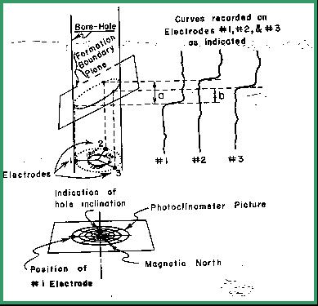
Evolution of the Dipmeter Concept
In the beginning, there were no dipmeters. Dip magnitude and direction of rock strata was assessed by knowing the subsea elevation of a distinctive rock layer in three or more wells which were closely spaced. The equation of a plane is defined by the X, Y, and Z coordinates of three points, so the elevations and well locations were sufficient data to define dip. Subsurface mapping of clearly defined formation markers is widely used today to estimate both regional and local dips. Measurement of dip in outcrop is also widely used to assist in mapping overall basin structure. Neither of these methods will find structures located between the control points because there is insufficient data.
In 1933, attempts were made to evaluate dip by analyzing resistivity anisotropy effects on a modified electrical log. The resistivity of a layer is usually lower parallel to the bed than perpendicular to it. By taking resistivity measurements with suitably arranged electrodes, the dip direction of thick, well stratified beds could be found. The dip angle had to be known from cores, and the hole direction had to be measured. This was possible using a device called an electromagnetic teleclinometer, which sent a signal up the logging cable proportional to the tool's deviation from the vertical. From this data, a crude dipmeter survey was presented. It is doubtful that any copies survive in well files. More modern data is often available in any event.
FIGURE 1: Photoclinometer
for recording dipmeter data
The anisotropy dipmeter was supplanted in 1943 by a tool using three simultaneous spontaneous potential measurements oriented 120 degrees apart around the circumference of the logging tool. Using the same principle that three points define a plane, the tool provided sufficient data, along with bit size, deviation, and direction, and tool orientation in the hole, to calculate dip. The three points were taken as the bed boundaries defined by the SP curve from each electrode.
The balance of the data came from a photoclinometer survey taken at stations near the top and bottom of the recorded intervals of the dipmeter curves. A schematic example of the concept is shown in FIGURE 1. The photoclinometer consisted of a magnetic compass, a ball bearing in a graduated curved dish, and a camera that photographed these components on demand.
This sounds simple. However, the magnitude of dip which is of interest in exploration is from a fraction of 1 degree to vertical. This poses serious constraints on tool design and data analysis. For example, a regional dip of about 50 ft/mile is equivalent to 1/2 degree dip. Local structure or drape over deeper erosional surfaces may modify this dip to flat or 1/2 degree in another direction. In some areas this is significant and could define the trapping mechanism. The dipmeter device, the recording process, and the curve correlation methods must have sufficient resolution to enable us to see this small difference.
A bed dipping at 1/2 degree across a 9" borehole will be less than l/10 inch higher on one side of the hole than on the other. The displacement between curves shown on Figure 1 will be less than 0.1 inches if recorded at 12 inches per foot of borehole. If recorded at 5 inches per hundred feet, a normal detail logging scale, this displacement would be only 0.0004 inches on the film. As a result, scales of 60 inches per 100 feet were used. Now the 1/10 inch displacement is represented by 0.005 inches - a measurable distance on the film.
Due to the relatively round shape of the SP curve at most bed boundaries, this level of resolution was not achieved with the SP dipmeter. Moreover, the tool was useless in carbonates where SP does not develop well. The only dips presented were those from major bed boundaries where dip was steep enough to be obvious.
Although the SP dipmeter was abandoned quickly in favour of three resistivity curves, the photoclinometer survived well into the 1960's as a directional survey tool. A sample is shown in Figure 2. In addition to the photographs of the compass and deviation ball, typed listings of computed results and a plan of the well track were presented (Figures 3 and 4). Since the well bore often deviated, without any help from the drilling crew, to keep the bit perpendicular to the formation dip, the directional survey data was sometimes used as a guide to dip.
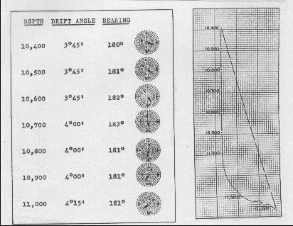
FIGURE 2: SP photoclinometer dipmeter log presentation circa 1943.
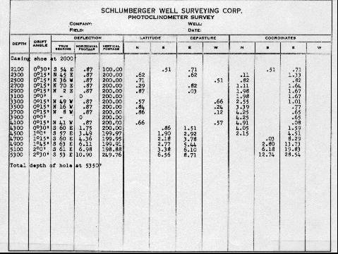
FIGURE 3: SP photoclinometer dipmeter listing circa 1943.
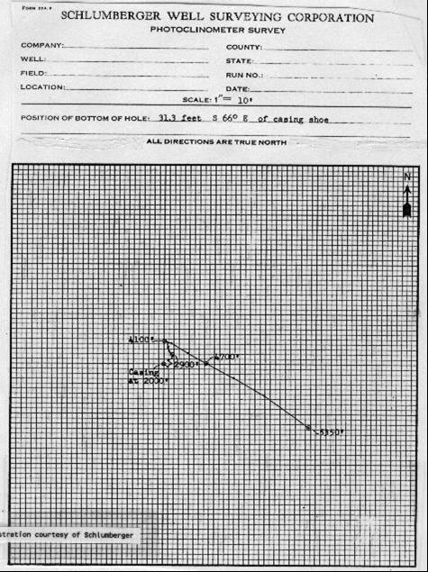
FIGURE 4: Photoclinometer directional survey presentation circa 1943.
The resistivity dipmeter used three laterolog curves instead of SP curves, mounted on the same rubber arms as were used for the SP version. Accuracy was better in hard rock areas. A sample is shown in Figure 5. Both SP and resistivity dipmeters were only recorded over selected intervals, chosen by observation of the other open hole logs. Only short intervals where there is lots of curve action were suitable for dip computation.
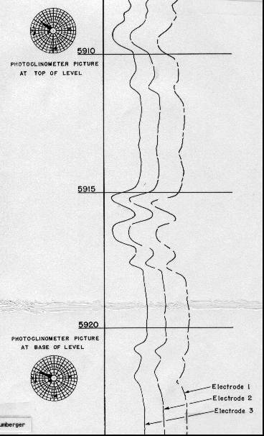
FIGURE 5: Laterolog photoclinometer dipmeter log presentation.
Typical computed results from the SP or resistivity dipmeter are shown in Figures 6 and 7. Although rare, examples can be found in files for wells drilled in the 1940's.
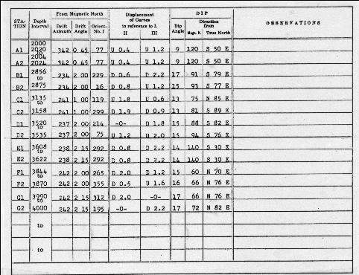
FIGURE 6: Computed dipmeter results circa mid-1940's.
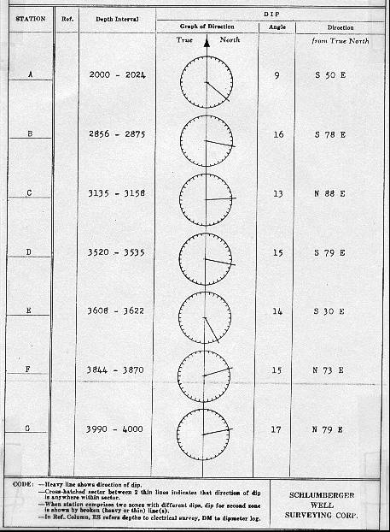
FIGURE 7: Computed dipmeter results circa mid-1940's.
In 1950, better accuracy was obtained by a newly designed dipmeter utilizing three microlog resistivity pads. Now a continuous log could be made, and with very detailed resolution from the microlog pads, a fine scale dipmeter was a reality. In 1952, the microlog pads were replaced with microlaterolog pads which measured conductivity instead of resistivity.
Orientation data was recorded simultaneously and continuously with a device called a poteclinometer. Poteclinometer is a contraction of the word potentiometer (a variable resistor) and inclinometer - this word sounds a lot like the earlier photoclinometer. Directional output from this device is an electrical signal instead of photographs. Data consisted of hole deviation angle, relative bearing (which describes the angle to the high side of the hole from pad number one), and the azimuth (which describes the angle between magnetic north and pad number one). This is sufficient data to orient the dip azimuth and the direction of hole deviation. The algebra is described later in this Chapter.
This eliminated the need to stop the tool to take pictures with the photoclinometer. Directional surveys run with this equipment were also more accurate, but considerably more expensive.
The optical comparator was also developed during this period (see next section for details of its use). This increased dip accuracy further by reducing errors in measuring the offset between traces.
The computed data was presented in the same tabular and graphical fashion as previously (Figures 6 and 7), but with considerably higher frequency. However, by 1958, some hardy souls were plotting individual dips as small arrows on a graph of dip magnitude versus depth. The direction of the arrow represented the dip direction relative to a compass rose with north at the top, as in Figure 8. This was the precursor to the now common arrow plot, sometimes called a tadpole plot, generated by computer. Computer plotting was first seen around 1961.
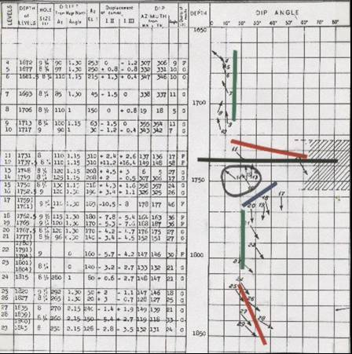
FIGURE 8: Computed microlog dipmeter results circa mid-1950's.
The first attempts to legitimately use detailed dip data for stratigraphic evaluation occurred around 1955. An example of the difference in data quality and quantity between short interval and continuous data is shown in Figure 9. The raw data was recorded at 60 inches of log for 100 feet of wellbore, or 1:20 scale, shown half size in Figure 10. Literally miles of this photographic paper was developed, processed, and sifted through the optical comparator each month. Most of it has deteriorated or been destroyed and is not available for re-computation.
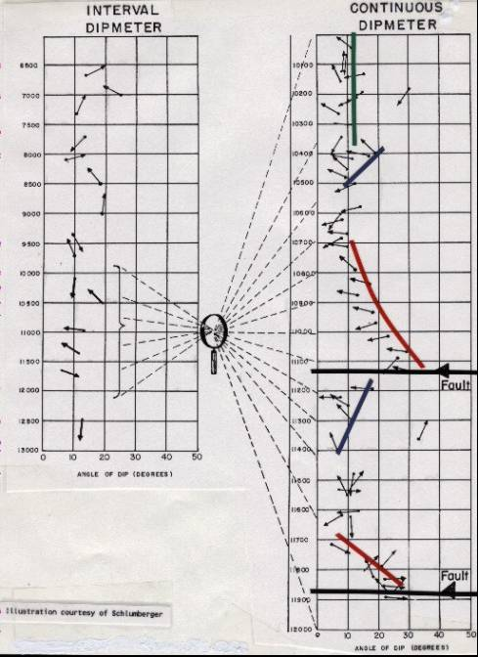
FIGURE 9: Long and short interval computed dipmeter results circa late-1950's.
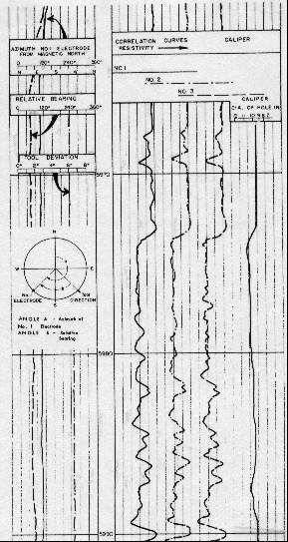
FIGURE 10: Expanded scale paper log of raw dipmeter curves late-1950's.
Fortunately, beginning in 1961, dipmeters were recorded on digital magnetic tape, reducing and finally eliminating the need for the detailed paper logs. The offsets between traces were derived by computer correlations, leading to a whole new language: correlation window, step length, search angle, etc.
Modern Dipmeters
In 1969, a new four pad high resolution dipmeter was introduced. The electrodes had even finer resolution than the microlaterolog pads and the electronics were improved to transmit data at a higher rate, so that the well could be logged faster and finer bedding features could be recorded. Four pads allowed for calculation of four different sets of 3-point planes as well as a four point curved surface or a "best fit" flat surface. Program logic could compare all results and eliminate bad correlations, or grade the results to show how well the different results matched.
A special "speed button" on one pad provided information to the program to compensate for minor speed differences as the tool moved up the hole. These variations created scatter in the computed results (Figure 11). In addition, a synthetic resistivity curve was generated from the dip curves, to be used as a correlation curve.
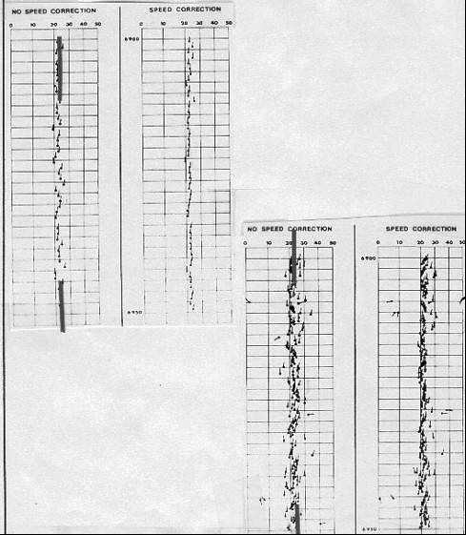
FIGURE 11: Computed dipmeter results circa 1969 showing effect of speed correction.

The geometry of a four pad device is shown schematically in Figure 12 and the arrangement of tool components in Figure 13. Typical raw data curves and an answer plot are found in Figure 14.

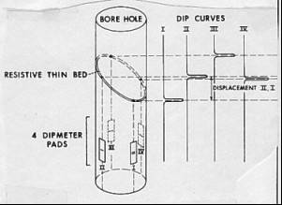

FIGURE 12: Geometry of four pad dipmeter.

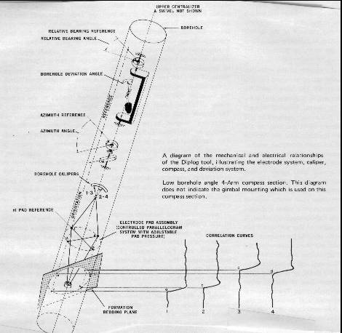
FIGURE 13: Arrangement of tool components for 4-pad dipmeter
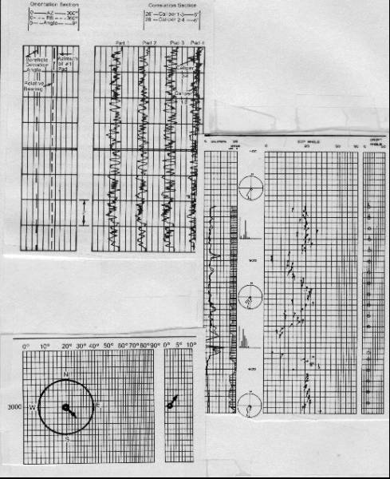
FIGURE 14: Typical raw data curves and an answer plot circa 1970.
In 1975, secondary computer processing, called CLUSTER (Schlumberger trademark) or SHIVA (Gearhart trademark), were developed to validate the results from the standard program. Other secondary programs were developed to enhance stratigraphic features, notably GEODIP (Schlumberger trademark). These processes are described later.
About 1980, three axis accelerometers and three axis magnetometers replaced the magnetic compass, relative bearing, and hole azimuth potentiometers. However the log still presented these three curves, derived now from the solid state sensors instead of the more failure prone electromechanical devices.
A further refinement in 1983 created the stratigraphic high resolution dipmeter. An additional electrode set was added to each pad giving eight dip correlation curves instead of four. With this number of measurements, the results can be presented more often, as many as 10 or 20 per foot if desired, instead of the more usual 1 or 2. Better speed correction is provided by accelerometer data from sensors inside the tool. Typical raw data plot is shown in Figure 15. A six arm dipmeter has also been developed to meet the need for stratigraphic information, with a lower cost tool.
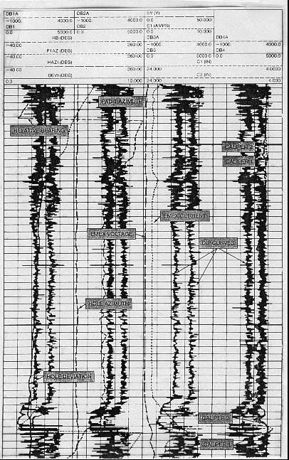
FIGURE 15: Raw log curves on stratigraphic high resolution dipmeter (SHDT) circa 1980.
Three dip computation modes are available from the stratigraphic high resolution dipmeter. First is the usual pad to pad correlation, which benefits from the extra redundancy of two electrodes per pad. This is called Mean Squares Dip or MSD, and often is used for structural or regional dip analysis. The dip is a weighted average of all pad to pad dips. In strongly parallel beds, the result is very good, but in cross bedded formations with varying dip, the average dip has little significance, except to show overall direction of dip.
Second is called Continuous Side by Side or CSB dip correlation using only the individual electrode pairs on each pad. Dip vectors from adjacent electrode pairs are used to define dip. CSB dips respond to short interval, low contrast changes often characteristic of internal layering in clastics, but also will respond to high contrast structural dips. It is very useful for structural dip analysis in high angle apparent dip, greater than 50 degrees. In finely bedded rocks exhibiting cross bedding, considerable detail can be shown if the correlation length and step distance are kept fairly short.
Third are pad to pad correlations using a pattern recognition rather than cross-correlation system. This is called Local Dip or LOC dip and responds to non-repetitive events such as erosional surfaces or breaks in the depositional sequence. A comparison of the three modes with normal high resolution dipmeter results is shown in Figure 16. It is now possible to analyze data with a resolution of a few inches and compare it to core data (Figure 17).
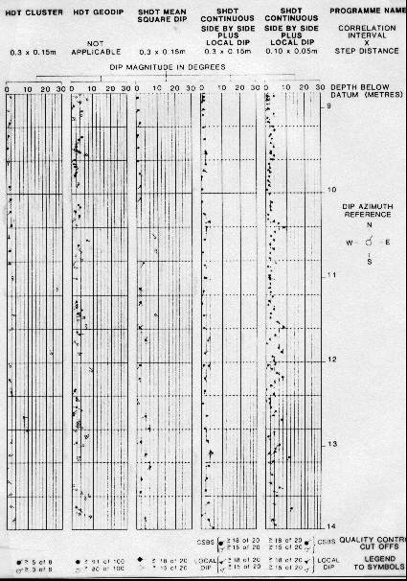
FIGURE 16: MSD, CSB, and LOC dips from same recorded curves.
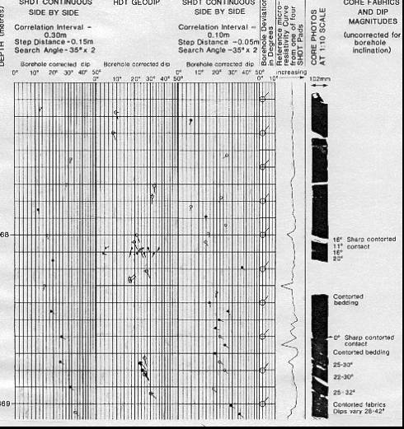
FIGURE 17: High resolution dips compared to core.
In 1986, the "ultimate" dipmeter was developed, called the formation microscanner. Using an additional 27 electrodes on each of two pads of the dipmeter; each pad records 27 microresistivity curves spaced 1/10 inch apart on the borehole surface. Each pad covers a 2.8 inch wide portion of the circumference of the well bore. Several passes over the interval will often provide virtually complete coverage of the rock face.
A microscanner tool with fewer (sixteen) electrodes per pad, but with four or eight imaging pads, is now available, and provides better coverage of the well bore wall than the two pad version. The electrodes are smaller, allowing for higher resolution, but are spaced to provide the same wall face coverage, about 2.5 inches per pad. In an 8 inch diameter hole, electrode coverage is about 80% and in a 6 inch hole is greater than 100%. This overcomes one of the major complaints about the FMS, namely the number of passes needed to obtain a complete image of the well bore. More detail on this tool can be found in Chapter Nineteen.
The resistivity traces are translated into images based on their relative resistivity values, in either black and white or colour. The gray scale or colour spectrum can be stretched or squeezed in the computer to enhance certain features, such as porosity, fractures, or shale laminations. Images can be plotted at the same scale as the core photographs for comparison. A sample is given in Figure 18.
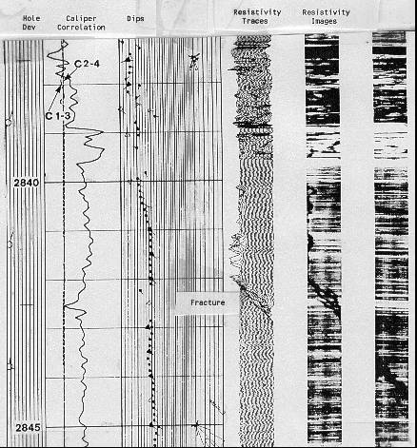
FIGURE 18: Formation microscanner dips, raw curves and image log.
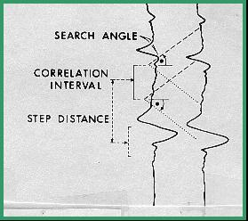
The primary use of the tool is for identification of irregular features, such as vugs and fractures, for accurate sand counts in thin bedded zones, and for identifying stratigraphic features. If sufficient rock face is imaged, dips can be found by digitizing the bedding planes visible on the microscanner image, or by automatic computation using all valid image traces.
Note that a planar, dipping, bedding plane will trace a sine wave on a circumferential image, such as those made by the microscanner or a borehole televiewer. The dips found by FMS dip processing are superior to CSB or LOC dips because a larger number of resistivity traces can be used in the calculation. They can be computed automatically and displayed on the FMS image. In addition, calculated dips can be edited or removed, and new bed boundary correlations picked with a mouse on an interactive CRT image. Thus dips that pass or fail preconceived processing criteria can be deleted or added as the analyst desires. An example of this technique is shown as a case history in Chapter Seven.
A microscanner has about 10 times the spatial resolution of a televiewer and 500 times the amplitude resolution, due to the difference in contrast between the resistivity and acoustic impedance ranges measured by the respective tools.
Schlumberger introduced a dipmeter for use in nonconductive mud systems in 1988. It uses micro induction resistivity measurements instead of the usual electrical resistivity pads. A knife blade electrode, or scratcher pad, version is available from several suppliers In 1989, a 4 arm focused acoustic dipmeter was introduced by Atlas Wireline, with a resolution of about 1 cm.
Basic Continuous Dipmeter Calculations
The computation of dipmeter data has been handled in one of three general ways: manual processing, combination of manual and computer processing, and total computer processing.
Manual correlation and computation methods were developed first and there are several different methods of doing the work. The dipmeter curves must first be correlated; this may be done by slipping a print of a log under the film used to make the print and measuring the depth displacement between peaks and valleys on the curves. Pad number one is used as a reference to measure displacements to each of the other curves.
Another method of curve correlation uses an optical comparator, a system of mirrors and lenses which allow the user to optically lay one curve over another and shift it up and down. The amount of shift is measured mechanically on a dial and is recorded as the displacement.
After these correlations have been made, the azimuth of the number one electrode, the borehole deviation angle, the relative bearing, and the borehole diameter from the calipers are recorded. This information, plus the depth, is necessary to compute the dip angle and dip direction of a point referenced to magnetic north. Because true dip is referenced to true north, we must also account for magnetic declination of the region.
Mathematical formulas to solve this geometric puzzle are given later in this Chapter. The manual calculation of dip magnitude and direction with the above information was made in several ways: by using a calculator and trigonometric tables, a scientific programmable calculator (after 1970) with trig functions, a mathematically derived physical computing device (in other words, an analog computer), or stereographic nets, the latter being the most common manual method used in the past. A very small amount of hand calculator work is still done today.
Another method of dipmeter computation utilized manual correlation and computer reduction of the data. This type of processing was originally developed to minimize turnaround time and to allow the tedious, time consuming computation and plotting of results to be performed by a digital computer. This may still be done today for re-computation of continuous dipmeters recorded on paper, or on 7 track digital tapes (which are unreadable by most modern computers) for which the paper records are still available.
The most recently developed system of computation is computer correlation and calculation from data on digital magnetic tape. The data from the magnetic tape is entered into a digital computer and processed. In the correlation program, the digital information representing the dipmeter curves is stored in memory and the data from one trace is compared to the other traces to determine the vertical displacement between the traces. After these displacements are calculated, the tool orientation information is used to compute the actual formation dips.
The standard correlation process is performed by a mathematical function called cross-correlation, in which the offset distance between events on two curves are found. The distance between the center and the maximum amplitude on the correlogram indicates the displacement between the two curves. The offsets for all curve pairs are then adjusted to obtain the offsets relative to the center of the correlation interval. More exotic forms of correlation, some based on pattern recognition theory, are used in the newer programs.
The length of the portion of the curve being correlated is called the correlation interval, correlation length, or correlation window. Correlation interval is usually between one and four feet, but can be smaller or larger. The correlation is calculated at regular intervals along the log. The distance between correlations is called the step distance and is usually 1/2 to 1/4 of the correlation interval. One dip value is calculated at the center of each correlation window, and the dip value is plotted at each step distance.
FIGURE 19A: Dipmeter computation definitions.
In order to determine how far up and down each adjacent curve the correlation is to be performed, a search angle is defined. In moderate structural dip the search angle is usually 45 degrees, but if expected dips are low, the angle can be reduced to eliminate noise, or spurious dips caused by erratic wiggles on the curves. Some computer programs use a search length instead of a search angle. In steep dips, a higher search angle is required. These terms are illustrated in Figure 19A.
The number of dips computed from computer processed logs can be any density required for a particular purpose. For structural analysis, normal densities range from one computation every one or two feet to one computation every ten feet. In those instances where additional information is required, such as for stratigraphic analysis, points as close as every few inches can be computed.
The usual way to describe these parameters is in the form CORR x STEP x ANGLE. For example a 4 x 1 x 45 process uses a 4 foot correlation, a 1 foot step, with a 45 degree search angle. The recommended defaults for dipmeter processing are:
Low angle structural dip: 4 x 2 x 45 e.g. normal or reverse faults, folds
High angle structural dip: 8 x 4 x 80 e.g. overthrust faults, recumbent folds
Sand body stratigraphic dip: 2 x 1 x 30 e.g. beach, bar, channel, drape
Complex stratigraphic dip: 1 x 0.5 x 30 e.g. submarine fan, scree slope, turbidite
A fourth parameter is sometimes used to indicate that the program can search farther up the curve if no correlation is found. This is shown as:
4 x 2 x 35 x 2
which allows the program to use a 70 degree search angle after failing at 35 degrees.
The effect of a shorter correlation interval is shown in of Figure 19B, where only regional dip is found in the long interval case, and stratigraphic dip is superimposed on the regional when a short interval is used.
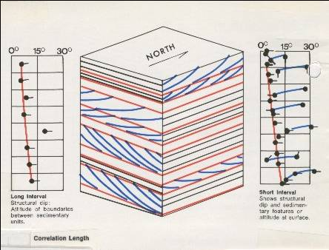
FIGURE 19-B: Regional and stratigraphic dipmeter computation using different correlation interval.
The problem with dip determination by cross-correlation is that it does average all dips found in the correlation interval. If both structural and stratigraphic dips are present, the average may not reflect either of them correctly, regardless of the correlation interval. Regional dip is therefore usually chosen in a nearby shale or bedded carbonate thick enough to give an accurate result, without interference from stratigraphic events.
Many dipmeters have been computed with inappropriate parameters and could be improved by re-computation with a better choice of values. The defaults shown above are just starting points. In particular, parameters for steeply deviated holes may need considerable experimentation and variation throughout the hole.
Handling Correlation Closure Error
To compute the displacements between the wiggles on a three curve continuous dipmeter, we could correlate at each computation level, defined by the correlation length, a segment of curve 1 with curve 2 first, and then correlate a segment of curve 2 with curve 3. The two displacements found would be sufficient to determine the dip. However, we might just as well have correlated curves 2 and 3 then curves 3 and 1, or curves 3 and 1 and then 1 and 2. All three combinations of displacement pairs should in theory define the same bedding plane, and the same dip. If they do not, a closure error exists.
In manual correlations, one could correlate three pairs, determining three displacements. For perfect closure, the algebraic sum of the displacements must be zero. Usually, because of the inaccuracy of the optical comparator, a small closure error existed. This error could then be distributed among the three displacements as a small correction before final determination of the dip. In practice, this was an onerous task, and two pairs were often picked with no attempt to determine closure error.
In automatic correlations, two kinds of closure errors can occur: small ones due to minor variations in shape between the three curves, and large errors. Small errors are handled as for manual computation.
When a large error exists, it is because at least one of the correlations is in error - the same geological event is not being picked on all three pairs. In manual correlation, a large error was usually fixed by re-picking one of the correlated curves. For an automatic computation, we have to choose between three possible computable dips, only one of which may be correct. There are no strong mathematical rules to choose the correct dip. If closure error is large, the usual procedure is to compute no result and display no dip arrow.
The three arm tool is also vulnerable to adverse hole conditions. If one curve degenerates, for instance when one pad fails to make a good contact with the borehole wall, the computation of dip cannot be made at all. This happens often in deviated holes or in out-of-round holes, resulting in more intervals with no result.
High Resolution Dipmeter
Four and six arm tools are less vulnerable to hole problems. These are called high resolution dipmeters. If one curve is unusable, any three others may still be used to determine dip. Also, the two (or three) independent sets of arms fit elliptical holes better. For these reasons, four and six arm tools have become the preferred dipmeter in recent years.
Six curve pair correlations can be attempted between four curves. The adjacent curve pair displacements are designated respectively as h12, h23, h34, and h41, and the diagonal displacements as h13 and h24. These six displacements can in turn be paired in thirteen different ways to provide thirteen dip evaluations for the same level. For the six arm dipmeter, 15 pairs are possible, leading to additional redundancy. The result from each combination is referred to as a dip determination. In recent practice, however, only four or five correlations are made, leading to a maximum of eight possible dip determinations per level. This reduces computer time.
Four arm closure error (Ec) is given by the algebraic sum of the four adjacent curve displacements:
1: Ec = h12 + h23 + h34 + h41
For perfect closure, Ec = 0.
Three arm closure error can also be computed on a four arm or six arm dipmeter. In this case, closure error is given by the algebraic sum of two adjacent curve displacements and their associated diagonal displacement. This error is distributed around the displacements in proportion to the amount of each displacement.
Handling Correlation Planarity Error
When four or six arm closure exists, or has been created by distributing the error, another error, the planarity error can be measured among the four adjacent curve displacements. Because opposite pairs of pads in the four pad array form a parallelogram, the displacement observed between curves 1 and 2 should be the same as that between curves 4 and 3, and the displacement between curves 2 and 3 should be equal to that between curves 1 and 4. Thus, for perfect planarity:
1: h12 = -h34 and h23 = -h41
When four arm closure error is zero, planarity error (Ep) is defined as:
2: Ep = h12 + h34 - h23 - h41
For perfect planarity, Ep = 0. Similar equations exist for the six arm dipmeter.
If closure error is zero and planarity is not zero, then several things may be possible. One is that the bedding may not be planar, such as in the case of festoon current bedding or aeolian dune surfaces. Other possibilities are lack of pad contact with the hole wall and possible miscorrelations. The latter are,
in fact, quite likely.
The flow chart in Figure 20 shows the complex logic involved in Schlumberger's high resolution dipmeter program. It handles the closure and planarity problems in numerous ways, based on the number and quality of correlations found. The output listing from this program is shown in Figure 21. Notice that some of the logic choices are coded on the listing and others on the arrow plot by use of alternate symbols, indicated on the bottom of Figure 21.
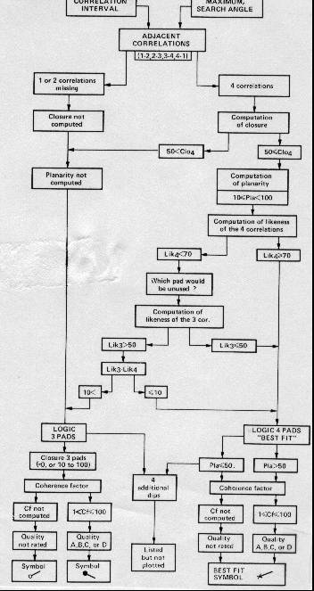
FIGURE 20: Dipmeter computation flowchart.
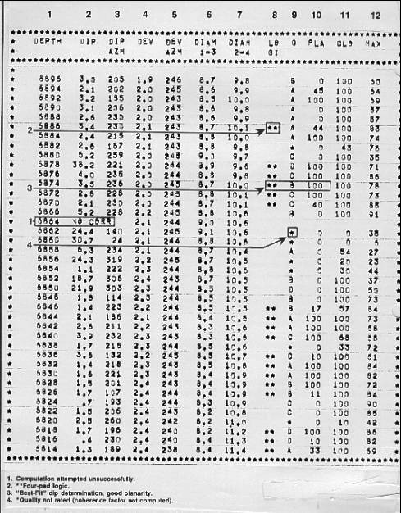
FIGURE 21: SHDT dipmeter computation output listing.
Dips can also be coded and presented in such a way as to indicate the fact that they are non-planar. This would help an analyst interpret the bedding, as shown in the example in Figure 22, which was processed using Gearhart's OMNIDIP program.
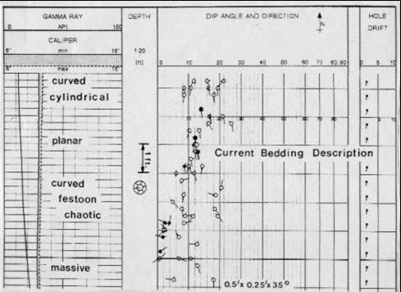
FIGURE 22: Coding non-planar dips helps interpret sedimentary bedding.

Determining Dip By Clustering and Pooling
The early approach for automatic determination of dip from a four arm dipmeter, described above, was quite arbitrary. The selection procedure was based on:
1. a distribution of closure errors
2. the elimination of the correlation curve associated with the worst (lowest) correlation coefficient, resulting in a three arm dip determination or, if no curve fitted this description, a compromise (average) among the four possible solutions resulting from the planarity error.
None of these approaches used any geological knowledge or any sophisticated statistical aids in the solution.
The cluster approach for dip selection was developed by Schlumberger to help eliminate the problem of closure and planarity errors. The CLUSTER program name is a registered trademark of Schlumberger. The CLUSTER program does no curve correlation; it operates on output data from an existing dipmeter program. The best reference is “Cluster - A Method for Selecting Most Probable Dip Results”, V. Hepp and A. Dumestre, SPE Paper 5543, 19726.
The CLUSTER method assumes that correlations are valid if they repeat when the correlation window is moved over a small step distance. If a dominant anomaly exists, it controls the correlation on at least two adjacent dip computations, and it follows that the dominant anomaly defines the same dip value for as long as it is included inside the correlation window.
The scattergram of points shown on Figure 23 presents an illustrative plot of all the dips computed from all the retained displacement pairs of ten computation levels. Each dip is plotted at a location on the plot defined by its magnitude and azimuth, and coded to represent a weight indicating the quality of the correlation. There is a great deal of scatter, indicating the noisy nature of the correlated curves. However, two concentrations of points of greater consistency, marked Cluster 1 and Cluster 2, are present.
Redundant dip results thus allow us to choose groups of dips which show some stability throughout the zone and to choose the displacement combinations which contribute dips to the group. Since Cluster 1 represents the greatest concentration of dips, it should be nearest to the dip defined by the dominant anomaly.
If no displacement pair contributes to Cluster 1, then perhaps a contribution is made to Cluster 2 and this, also, should be a valid dip, even though the indication of consistency is not as strong. Failing this, the displacement information must be regarded as meaningless. For such levels no results will be printed on the CLUSTER output listing.
In the example of Figure 23, ten levels were grouped together from an arbitrarily selected interval. In the actual clustering procedure an attempt is made to group levels together in a meaningful fashion into short intervals or zones. Zoning is achieved by testing the stability of successive adjacent curve displacements in the input listing.
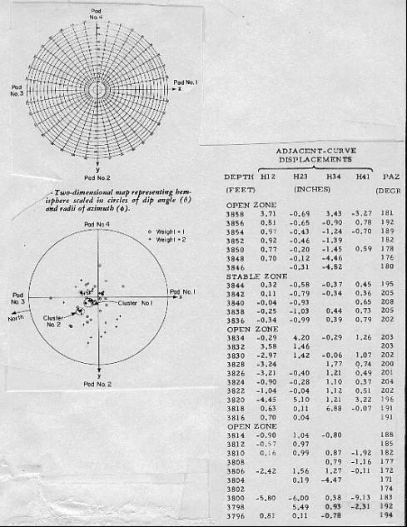
FIGURE 23: Detailed output from clustering of dip data.
The test for stability checks the displacement value in the next level upwards to see if it is similar to the current one. If this test is satisfied, over several consecutive levels in at least two contiguous adjacent curve displacement columns, the zone is stable. Zones that do not satisfy these criteria are called open zones. The two types of zones are merely a convenient way to break up the interval for clustering. Both kinds of zones can provide meaningful dips, depending on the quality of the correlations.
Zoning is a preliminary sorting procedure. Both stable and open zones are subsequently treated in the same fashion. Zone length can vary from one to fourteen consecutive displacements. No indication of the zoning used is shown in the output arrow plots or the standard output listing.
The correlation coefficient measured along with the displacement correlation is an important criterion of the quality and is not ignored in the choice of good correlations. To account for this, the dip points placed on the scattergram are weighted according to a coefficient called the level weight. A greater weight raises the contribution of retained dip determinations and enhances their chances of being selected as candidates for clustering.
If the quality of the correlation reported for the level by the source dipmeter program is good, the contribution to the level weight is 3, if fair, it is 2, if poor, it is 1. If the level shows four arm closure (a double asterisk on the original listing), weighting is doubled. Thus, the level weight varies from 1 (poor) to 6 (excellent).
Clusters thus identify the probable ranges of dips for the zone. The program returns to each dip level in turn and retains only those dip determinations which fall within one of the clusters. If one is found in the highest ranked cluster, it is retained, and if there are two or more, their vector average is retained. If none are found, the program can expand the area included in the cluster. If cluster expansion fails, the cluster of next lower rank is checked.
It may happen that no contribution is found from a level to any of the defined clusters, in which case this level is considered to have no result. Similarly, if no clusters are found at all within the zone, no result is shown on the output listing. This occurs when the data are so poor that no meaningful displacement combinations can be made.
Since clustering only uses data from a previously applied dipmeter program, it cannot find new correlations and it cannot find dips where none were found on the original. It may be possible to obtain new results in "no result" intervals by reprocessing the original dipmeter with new parameters.
A typical set of input data to CLUSTER is shown in Figure 24 and output for the same interval is shown in Figure 25.
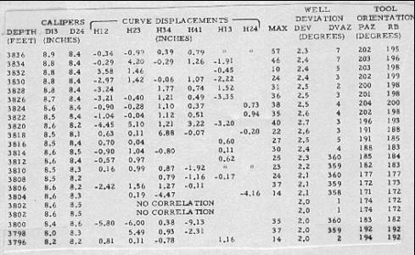
FIGURE 24: Input data to dip clustering program.
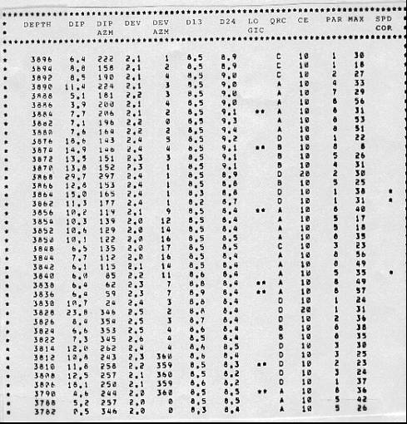
FIGURE 25: Output data from dip clustering program.
The process of dip retrieval that has just been described systematically attempts to provide one dip for each correlation window. However, the basic idea of the method is that consecutive correlation intervals must overlap, in order that dominant anomalies can affect the clustering process. As a result, it is quite usual that the same dip is repeated twice when the overlap between consecutive levels is 50 percent of the correlation length, or four times when the overlap is 75 percent.
Users of dipmeter surveys should train themselves to recognize doublets or quadruplets as representing a single anomaly. However, it would be nice if the computer would do the same and represent it by a single dip result, at the midpoint between the depths of the two or four component levels. This is accomplished by pooling clustered dip results.
POOLING
Pooling consists of testing the results from successive levels, up to a number of levels called the pooling constant and controlling whether their angular dispersion does not exceed a fixed value, called the pooling angle. If the test is satisfied, the component dips are replaced by their vector sum, the pooled vector. Its dip magnitude and azimuth are converted to geographic coordinates and printed out at the mean depth, together with other data about the computation. The sample in Figure 26 can be compared to the un-pooled results in Figure 25.
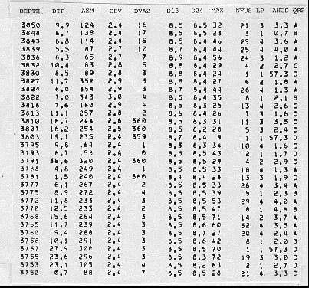
FIGURE 26: Output data from dip pooling program.
Two separate output files are created: one for the clustered data and one for clustered and pooled data. Thus, in reality, two different dipmeters are created from the same data, using different rules in their analysis.
Figure 27 (left side) shows an arrow plot for clustered and pooled results. The arrows with black circles represent high quality ratings. Usually a blackened circle corresponds to pooled results; however, it is possible that a non-pooled result from a high quality level could plot as a blackened circle.
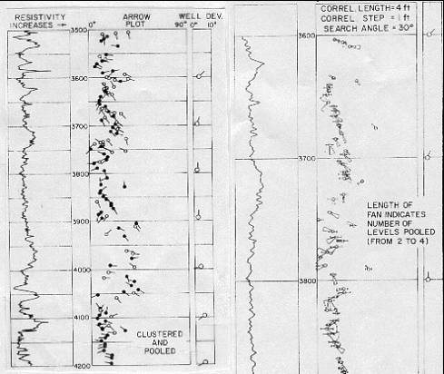
FIGURE 27: Dip plot of clustered and pooled data (left), dip fan or range plot (right).
Pooled results are generally plotted on 1 or 2 inch per 100 feet depth scale. This can be done since there are fewer arrows to plot. Thus, one use of pooling is to provide a dip record on a depth scale commonly used for correlation. Usually, structural analysis is all that can be accomplished with this plot.
The arrow plot represents dip magnitude and azimuth from the output listing at their proper depth. However, it does not represent the effect of uncertainties, as represented by the dispersion of dip values and their directions in the original data. The fan plot is a method to present this knowledge as the quality indicator instead of the more usual open or filled circles. A sample is shown on the right side of Figure 26.
In the fan plot presentation, a small circle surrounds the center value of dip magnitude. A small line segment extends on both sides from a lower to a higher dip magnitude value, essentially indicating an error bar. In similar fashion, a fan extends from a lower to a higher dip azimuth value. These values are determined from the combination of the pooled dip magnitudes and azimuths and the angular dispersion parameters. They encompass all values within one standard deviation from the mean. The length of the fan represents the number of dips used in the statistic. Thus, it is probable that the true dip is contained inside the possible values within the fan, both in magnitude and azimuth.
The same value of the angular dispersion parameter may correspond to a nearly closed fan at high values of dip to a wide open fan near zero dip magnitude. When angular dispersion exceeds dip magnitude, the azimuth value cannot be specified with any kind of certainty and no fan is drawn.
Pattern Recognition For Dip Calculations
In 1977, Schlumberger developed a dipmeter program that used pattern recognition instead of cross correlation to find dip angle and direction. The aim of the program, called GEODIP, was to reproduce, as much as possible, the ability of the human eye to recognize and match similar details on curves which are usually, but not necessarily, nearly identical. Dresser Atlas offers a program called STRATADIP which is similar in concept to GEODIP.
The following description was paraphrased from “An Approach to Detailed Dip Determination Using Correlation by Pattern Recognition”, P. Vincent et al, SPE Paper 6823, 1977.
One of the objectives of GEODIP is to overcome the rigidity of the fixed correlation interval procedure and provide a density of information more closely related to the geological detail seen on cores. There was also the feeling that the dipmeter raw data contained more information than was actually being used, even by the improved processing achieved with clustering and pooling. After all, the electrodes had a resolution of 0.2 inches and often one or two foot data was being presented.
Many features, such as peaks and valleys, are identifiable by eye from curve to curve on the dipmeter. These features have various thicknesses (from one inch to several feet), amplitudes, and shapes. Each feature may be considered to be the signature of a geological event in the depositional sequence. Moreover, the dip of the bedding is not necessarily constant, and may sometimes vary rapidly. The method of correlation by pattern recognition is best adapted to automatically detect these curve features, to recognize them from curve to curve, and to derive dips for the boundaries of each individual feature.
Different curve features of the same type are often very similar and easy to confuse. The human correlator avoids this ambiguity by constant eye movements to confirm or invalidate hypothetical correlations. In so doing, the correlator implicitly, often unconsciously, applies some logic rules which are integrated into the perception process. In the GEODIP method, equivalents of such rules and safeguards are included, as far as they have been recognized, in the program logic. Programs of this type have been called expert systems, or knowledge based systems, because they contain the rules of experienced analysts.
The method is constructed around a basic law justified by geological conditions of deposition, the rule of non-crossing correlations. This rule states that the layers are deposited one over another, so that they can wedge out but they cannot cross. The consequence is that if Event A appears above Event B on one curve, it cannot appear below B on another one. This rule induces a certain interdependence between all of the correlations. In this method, the correlations are not viewed as independent realities, but as parts of a more general structure having internal organization and rules.
Where only two curves are considered, it is a simple matter to recognize crossover correlations and disregard them. But when more than two curves are involved, as in Figure 28, complex logic is required within the computer program to perceive that the correlation (A1, A2), is inconsistent with the correlations (B1, B3) and (C2, C3). Actually, it is the set of the three correlations which is, as a whole, inconsistent. It cannot be inferred, from what is shown, which one is incorrect.
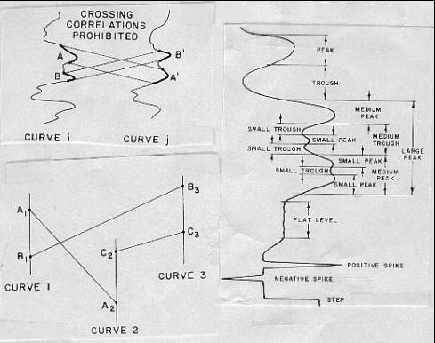
FIGURE 28: Dip curve pattern recognition definitions.
The goal of the computer logic is to select the largest set of curve to curve correlations that does not include any crossovers or implied crossovers. To meet this goal, a branch of modern mathematics called the theory of partially ordered sets has been applied to the description and consistency checking of sets of correlations between curves. While this theory is necessary to properly implement on a computer the rule of non-crossing correlations, an understanding of the mathematics is not needed to appreciate what it achieves.
The method of correlation by pattern recognition is composed of two main phases:
1. feature extraction (detection of curve elements)
2. correlation between similar features
In phase one, each curve is analyzed individually with reference to a catalog of standard patterns or types of curve elements, such as peaks, troughs, spikes, and steps, and is decomposed into a sequence of such elements. At the end of the feature extraction phase, the curves are replaced by their description in terms of elements.
Each element is associated with one or two boundaries which give the position of the element on the initial curve as well as a pattern vector, which is a series of numbers characterizing the shape of the element. The pattern vector for a peak contains a description of its:
1. average (P1)
2. maximum (P2)
3. position of maximum, Xm, relative to boundaries, B1 and B2,
given by P3 = (Xm - X1) / (X2 - X1)
4. maximum minus average (P4)
5. balance left/right inflection point smoothed derivative values (d1 and d2),
given by P5 = -(d1 /d2) / (1 + d1 / d2)
6. left jump (P6)
7. right jump (P7)
8. balance left/right jump,
given by P8 = -(P6 / P7) / (1 + P6 / P7)
9. width of peak (P9)
Other features have their own unique list of parameters in their pattern vector.
In the correlation phase, the method tries to successively match elements of one curve to similar elements of the others. The objective is to recognize the same geological event as it appears on different curves. The basic criterion is the comparison of pattern vectors. To find these correlations, a coefficient is computed which is a measurement of the likeness between any two elements, using the following equation:
1: L = SUM ((Pai - Pbi)^2)
Where:
L = likeness coefficient
Pai = ith parameter for an element in curve A
Pbi = ith parameter for a similar type element in curve B
Low values for L mean a high degree of likeness.
Then, the procedure attempts successive correlations according to a built in order of precedence: large troughs, then large peaks, then medium troughs,...
The program retains already accepted higher precedence correlations in order to forbid crossing them in further attempts with correlations of lower rank.
When two elements are considered to be a match, the corresponding upper and/or lower boundaries are then correlated. The resulting dips are computed from the displacements measured between these correlated boundaries and not those measured between the elements themselves.
At the beginning of the correlation phase, an initial search angle, corresponding usually to the highest value of expected dip magnitude, is imposed. The initial search distance is computed from the input search angle, the orientation parameters, and the diameters measured by the tool at the particular level. As correlations are made and accepted, the search distances are modified, as necessary, to avoid crossing correlations.
It may happen that no large element can be correlated with any large element of the same type on the search curve. To handle these cases in following passes, requirements are relaxed, for instance, by authorizing the correlation of a large element of the base curve with a medium element of the same type on the search curve. On the other hand, the correlation of unlike elements, such as peaks with troughs, is forbidden.
Thus, the correlation phase proceeds by successive passes, searching first for the most obvious correlations, those having the lowest likeness coefficients. Each time a correlation is retained, it is memorized in order to limit subsequent search lengths for correlations with higher likeness coefficients.
Pattern recognition correlation is also used in determining the velocity correction, allowing almost inch-by-inch detection of speed variations.
Figure 29 shows the graphic presentation made by automatic plotter. Because of the large number of dip results found, a depth scale of 1/40 (30 in. per 100 ft.) or 1/24 (50 in. per 100 ft.) is used instead of the usual 1/240 or 1/200 scales. This uncommon depth scale is better adapted for the high resolution available for very thin beds. The semi-horizontal lines connecting the traces represent the correlation of element boundaries. Figure 30 shows a typical listing from this program.
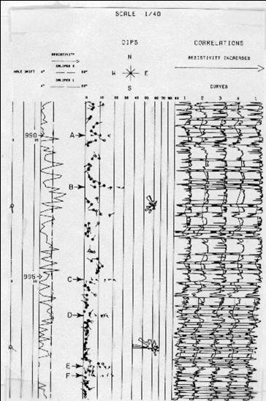
FIGURE 29: Output plot for pattern recognition dip program GEODIP.
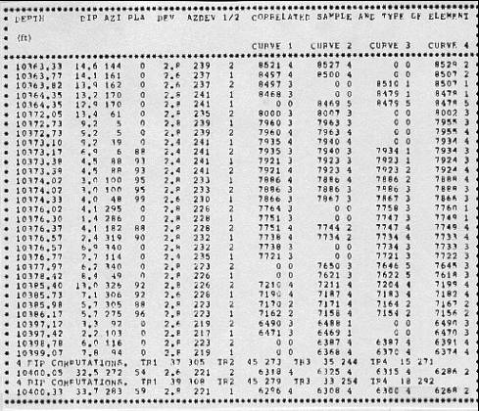
FIGURE 30: Output listing for pattern recognition dip program GEODIP.
With GEODIP there is no quality rating of the dip determination. The visual display of the curves and the correlations enable analysts to decide for themselves about the reliability of the correlations according to the character of the curves. Comparison to core data is one way to check the validity of the results of stratigraphic analysis. Figure 31 illustrates one such comparison.
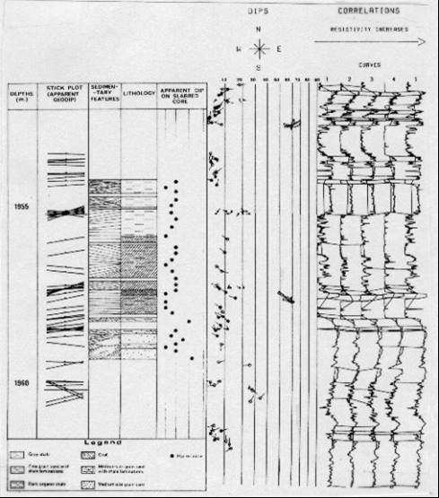
FIGURE 31: Core comparison to pattern recognition dip program GEODIP.
Stratigraphic High Resolution Dip Calculations
From the above discussion, it is apparent that a program that combined both structural information as in pooled clusters and stratigraphic correlations as in GEODIP would be a good idea. The SHDT and its companion computation program, DUALDIP, provide this, with three independent computations of formation dip. This allows the possibility of adapting the interpretation to the specific problem of interest, whether structural, sedimentary, or sand body geometry. SHDT and DUALDIP are Schlumberger trademarks. The three calculation modes described below were extracted from “Applications of the SHDT Stratigraphic High Resolution Dipmeter”, Yves Chauvel et al, Trans SPWLA, 1984.
1. MSD Dips (Mean Squares)
These result from all the possible cross correlations between couples of sensors, giving up to 28 curve displacements at each level. The correlations are done in the standard way, and require definition of correlation length, step distance, and search angle. A plane is then fitted through all the available results, using a repetitive logic of discarding the most distant displacements and then refitting. This results in either:
- a good quality dip (full arrowhead) if distances from mean are small and few displacements are discarded.
- a low quality dip (open arrowhead) or no dip at all, if distances from mean are large and/or many displacements are discarded.
There is no vertical continuity logic or clustering routine in the MSD computation, and each level is autonomously processed. The clustering is thus replaced by an analysis of the local scattering of the displacements. This method benefits from the ample redundancy available from 28 displacements, while two would be enough to define a dip, reducing the possibility of producing random dips or noise correlations.
2. CSB Dips (Continuous Side-by-Side)
While the MSD dips respond to major geological events, the CSB focuses on fine details very much like a geologist studies the sedimentation of a sequence through the inspection of a core. Each pair of twin curves (e.g. electrodes 1 and 1A) is cross correlated on a fine interval (typically, 12" x 3"). This gives a vector parallel to the dip plane. Another vector is found at the same depth by cross correlation of an adjacent pair of twin curves (e.g. 2-2A). Taken together, the two vectors define a dip plane. The CSB dips will be as dense as the step length chosen permits (e.g. up to 4 per foot for a 12" x 3" computation).
With only four side-by-side correlations, the only cross check available is to verify that, for a planar bed, the displacements obtained from opposite pairs of curves (e.g. 1-1A and 3-3A) should be equal in value and opposite in sign. This occurs if closure error is zero. If this is the case, any combination of these displacements yields the same dip and any orthogonal pair is used to produce the dip at that depth. If this is not the case, a window is opened around the level under examination, and the vertical continuity of the displacements within the window is checked. The orthogonal pair showing the smoothest continuity within the window is selected for dip computation.
Whether a good quality dip (full arrowhead), a low quality dip (open arrowhead), or no dip is output, is a function of the quality of the side-by-side correlations established and of the vertical continuity of the displacements.
3. LOC Dips (Local Derivative)
An event detection logic is used on the eight curves to establish pinpoint correlations between events on the curves. As in GEODIP, the computer processing uses a derivative filter to obtain absolute dips independent of dips at other depths, similar to what could be found by manual correlation. There are however a few differences.
To be retained as a LOC dip, an event has to be recognized on at least 7 of the 8 curves, while the GEODIP logic requires only 3 out of the 4 curves. Thus the LOC dip logic is more demanding than the GEODIP logic, which explains why generally fewer LOC dips are obtained than GEODIP results on comparison runs.
The LOC dips are further refined by a cross correlation made on a 12" interval, while GEODIP results are computed directly from the spot events on the curves. This cross correlation involves the eight curves and includes a repetitive best fit and rejection logic as in the MSD computation, with similar criteria for quality coding (full or open arrowhead).
A measurement of the planarity is derived from each of the possible dip planes at any level. The retained value corresponds to the surface which best approximates the set of these planes. By convention, a perfectly planar surface has a planarity of 100.
Some events are recognized on only some of the dip curves. In this case, the available correlations are traced across the applicable curves, with an optional notation of "F" (Fracture) or of "P/L" (Pebble/Lens) for single pad events or two/three pad events, respectively. These interpretations, however, are not to be considered as certain, but rather as possible.
Due to their origin (pad-to-pad correlations), the LOC dips have meaningful lateral significance. If structural dip is present, it will normally be seen by the LOC dips rather than by the CSB dips. Generally the statistical agreement between the LOC and the MSD dips can be expected to be quite good.
DUALDIP is the computer program which produces the standard SHDT result presentation. This includes CSB and LOC dips, the eight dip curves, the synthetic resistivity and gamma ray curves, calipers and hole drift data. The depth scale is usually 1/40, and as an option the MSD dips can be added to this output. A sample was shown earlier as Figure 16 and is repeated here as Figure 32.
FIGURE 32: MSD, CSB, and LOC dips from SHDT dipmeter.
Structural interpretation is done using the MSD dips. Due to the logic used, namely cross correlation made using long intervals, the MSD dips are the ones likely to represent laterally significant and vertically consistent geological events. For optimum use of the MSD dips, a reduced scale (1/200) plot is normally produced. This plot is also the single SHDT product when no fine scale studies are contemplated.
The prime objective of the SHDT tool design is to improve the ability to provide reliable answers to sedimentary interpretation problems. While the rules of interpretation remain essentially the same as in HDT interpretation, there are additional possibilities. Among the information that can be retrieved by visual analysis of the dip curves, reconstructed resistivity, and dip arrows are:
- type of lithology (shale, sand, conglomerate) from the shape and likeness of the curves.
- fining upwards, coarsening upwards sequences. This is done by analyzing the resistivity variations across the sequence, either with the dip curves themselves or with the synthetic resistivity curve. Other open hole logs, such as the gamma ray (combinable with SHDT), are useful here. Care should be exercised using the resistivity, however, since fluid saturations have to be accounted for when inferring grain size variations from resistivity gradients.
- homogeneous bodies (no apparent bedding) as opposed to finely striated, laminated bodies.
- parallel vs nonparallel bedding. This is especially important in sandstones, and has found recent applications to the study of turbidites.
- correlation lines: some correlations involve the eight resistivity curves, some do not. The most appropriate interpretation (pebble, lens, fracture, other) will be made on the basis of the dip curves (conductive or resistive anomaly, number of pads involved, etc.).
- fractures: open fractures will show as isolated conductive spikes which may or may not correlate with similar spikes on other dip curves.
Some of the important uses of the CSB dips are:
- determination of bedding angle and direction in those (frequent) cases where they do not show as MSD (or LOC) dips. This is the case, for example, in coarse grained sandstones where bedding is only indicated by minute changes of resistivity, and not by the existence of large contrasts. This is also very common in evaporitic sequences.
- determination of the direction of sediment transport, a corollary to the above. This is especially interesting in severe cases of cross bedding, when the only dips produced by long interval correlations generally correspond to those of the individual sedimentary units, seen at their interfaces, and not to the actual current bedding surfaces.
- conventional sedimentary interpretation (red, blue patterns, direction of sand body thickening, etc.). All of this can be done on an almost microscopic scale.
CSB dips are also very useful, and often better than MSD dips, in high angle apparent dips, when longer correlation intervals are used.
LOC dips can be used to study such features as:
- nonparallel bedding, for example, when the upper and the lower boundaries of thin beds do not have the same dip. In cases of poor planarity, the event recognition logic will be too tight for a LOC dip to be produced, and the MSD curves may then provide the answer. This is particularly important if this bed is to be found in another well, or when looking for the direction of updip or downdip thickening.
- cross bedding: the LOC dips will see the interfaces between the individual sedimentary units, when apparent. This dip may not coincide with the angle and direction of deposition in cross bedded formations (e.g. tabular bedding, foreset beds).
- turbulence of deposition, when causing non-planarity of bedding.
The MSD dips are normally not used for sedimentary studies, being the result of an averaging of the dip curve anomalies over the length of the correlation interval. They are usually presented on the DUALDIP plots, however, for structural reference. The vertical (depth) scale used for stratigraphic work makes it difficult to see structural patterns in the MSD data.
Conclusions
The evolution of the dipmeter over the last 60 years has created a wealth of variety in the data acquisition methods, presentation styles, and computation methods. The uses have remained constant: to define structural and stratigraphic features of sedimentary rocks. Numerous techniques to aid the analyst have been presented; each individual must choose the one best suited to the problem to be solved.
Although dipmeter analysis can be ambiguous, sufficient geological constraints, local knowledge, and experience serve to improve skills and speed analysis. Modern computer processing, in particular dip removed arrow plots and stick plots, are essential ingredients. Image processing techniques, while relatively new, have proven useful because of their visual impact. However, the analysis of structure and stratigraphy from dipmeter data still depends on the basics: dip angle, dip direction, and a plausible model that fits the data.
Bibliography
Dipmeter Tools
1: The microlog continuous dipmeter; de Chambrier,P.; Geophysics, v. 18, no. 4, p. 929-951, 1953
2: The poteclinometer and the microfocused devices; Bricaud,J.M., Poupon,A.; 5th World Petroleum Congress, 9 p., 1959
3: Schlumberger continuous dipmeter; Perez,A.A., Hartsell,W.H., Gilreath,J.A.; Series #8, 29 p., 1960
4: The continuous recording of dipmeter surveys; Thibodaux,J.B.; Pan Geo Atlas Corporation Service Report, 5 p., 1963
5: The high resolution dipmeter tool; Allaud,L.A., Ringot, J.; Society of Professional Well Log Analysts: The Log Analyst, p. 3-11, 1969
6: The high resolution dipmeter reveals dip related borehole and formation characteristics; Cox,J.W.; Society of Professional Well Log Analysts 11th
Annual Logging Symposium, 26 p., 1970
7: Continuous dipmeter; WEC; 17 p., 1971
8: HDT troubles; Schlumberger; Interoffice memo, 35 p., 1977
9: Slim hole dipmeter; Wroot,R.W.; 7th Formation Evaluation Symposium of Canadian Well Logging Society, 12 p., 1979
10: Dipmeter validity in deviated boreholes; Fitzgerald,D.D., Theriot,J.C., York,P.L.; Society of Professional Well Log Analysts: The Log Analyst, p. 8-18, 1980
11: Advances in diplog instrumentation; Johnson,W.M.,Jr., Angehrn,J.; 8th Formation Evaluation Symposium of Canadian Well Logging Society, 13 p., 1981
12: Stratigraphic high resolution dipmeter tool; Schlumberger; Manual, 23 p., 1983
13: The six arm dipmeter a new tool for detailed reservoir description; Goetz,J.F.; 10th Canadian Well Logging Society, 29 p., 1985
14: Micro-induction sensor for the oil based mud dipmeter; Kleinberg,R.L., Chew,W.C., Chow,E.Y., Clark,B., Griffin,D.D.; 62nd Annual Technical Conference of Society of Petroleum Engineers, p. 189-201, 1987
15: The oil based mud dipmeter tool; Dumont,A., Kubacsi,M., Chardac,J.L.; Society of Professional Well Log Analysts 28th Annual Logging Symposium, 15 p.,1987
16: Measuring RXO and dip in oil based mud with the six arm dipmeter; Chemali,R., Su,S.M., Goetz,J.F.; Society of Professional Well Log Analysts 30th Annual Logging Symposium, 25 p., 1989
Dipmeter Processing
1: Automatic computation of dipmeter logs digitally recorded of magnetic tapes; Moran,J.H., Coufleau,M.A., Miller,G.K., Timmons,J.P.; 36th Annual Technical Meeting Society of Petroleum Engineers American Institute of Mining Metallurgical Engineers, 19 p., 1961
2: Supplementary computer programs for dipmeter analysis; Matthews,R.R., Mooney,T.D., Haynie,R.B., Albright,J.C.; Society of Professional Well Log Analysts, 19 p., 1965
3: An accurate method of low angle dip calculation; Schoonover,L.G.; Society of Professional Well Log Analysts 14th Annual Logging Symposium, 15 p., 1973
4: Computer recognition of diplog patterns a tool for stratigraphic analysis; Schoonover,L.G.; Society of Professional Well Log Analysts 15th Annual Logging
Symposium, 12 p., 1974
5: Cluster: a method for selecting the most probable dip results from dipmeter surveys; Hepp,V., Dumestre,A.C.; 50th Annual Technical Meeting of Society of Petroleum Engineers of American In stitute of Mining Metallurgical Engineers, SPE 5543, 1975
6: Geodip: an approach to detailed dip determination using correlation by pattern recognition; Vincent,Ph., Gartner,J.E., Attali,G.; 52nd Annual Technical Meeting of Society of Petroleum Engineers of American Institute of Mining Metallurgical Engineers, SPE 6823, 1977
7: True vertical depth, true vertical thickness and true stratigraphic thickness logs; Holt,O.R., Schoonover,L.G., Wichmann,P.A.; Society of Professional Well Log Analysts 18th Annual Logging Symposium, 19 p., 1977
8: The log analyst and the programmable pocket calculator; Bateman,R.M., Konen,C.E.; Society of Professional Well Log Analysts: The Log Analyst, p. 3-9, 1978
9: A simplified true vertical thickness (TVT) calculation using a programmable
pocket calculator; Smith,S.W., Keen,D.; Society of Professional Well Log Analysts: The Log Analyst, p. 28-32, 1979
10: Formation dip determination - an artificial intelligence approach; Kerzner,M.G.; Society of Professional Well Log Analysts: The Log Analyst, p. 10-22, 1983
11: SHIVA processing: the integration of fundamental geological principles with dipmeter computations; Enderlin,M.B., Epps,D.S., Yuratich,M.A.; Society of Professional Well Log Analysts: The Log Analyst, 22 p., 1985
12: Effect of tool rotation on the computation of dip; Waid,C.C.; Society of Professional Well Log Analysts 28th Annual Logging Symposium, 22 p., 1987
13: A rule based approach to dipmeter processing; Kerzner,M.G.; 63rd Annual Technical Conference of Society of Petroleum Engineers, p. 239-251, 1988
14: Dipvue analysis package; Atlas Wireline; Brochure, 1 p, 1988
15: The effects of noise on interval correlation methods; part 1: accuracy and precision; Waid,C.C., Faraguna,J.K., Easton,S.B.; 63rd Annual Technical Conference of Society of Petroleum Engineers, p. 227-238, 1988

