MYTH-INTERPRETATION
PART 4
E. R. Crain, P.Eng.
Spectrum 2000 Mindware Ltd
Published in CWLS InSite Jun 2006.
Myth #4: Density Logs Read Porosity In Sandstones
“Sandstone” describes a rock texture, not a mineral. Clean (clay-free) sandstones may be 100% quartz, or may contain no quartz at all, as in the Gilwood, Keg River, and Bakken sandstones in Western Canada. Most sandstones contain quartz plus other minerals, plus clay or shale. So sandstones seldom have the physical properties associated with pure quartz, although a myth to the contrary pervades our industry.
The myth emanates from the pre-calculator, pre-computer days of the late 1960’s when the density log was marketed as the “magic bullet” for visual log interpretation. It has been perpetuated by thousands of quick-look log analysis seminars given by log analysts who don’t check their work against core data.
This myth has several log analysis corollaries, such as “Density porosity in a sandstone when recorded on a Sandstone Scale, is a good estimate of effective porosity” or “The density log doesn’t need any shale corrections”. Like many myths, these two statements are actually true in very limited areas, but not true in most of the world.
The shale (or clay) volume correction is zero only when the shale density is precisely the same as the matrix density of the shale-free sandstone fraction. Since this is almost never true, we might as well admit that shale corrections are always necessary, and let the computer do the appropriate work.
Correcting for shale is only half the battle. The other half is to correct for the mineral composition of the sandstone fraction. In most carbonate reservoirs, the lithology is usually reasonably well known from sample descriptions or can be determined from log response, so this step is relatively straight forward. However, this is not true in sandstones because the mineral makeup of the sand is not usually described in much detail.
There is a universal trend to give sandstones the physical properties of pure quartz, but this is almost universally not appropriate. Most sandstones contain other minerals such as mica, volcanic rock fragments, calcite, dolomite, anhydrite, and ferrous minerals, as well as the shale and clay described above. All of these minerals have densities higher than quartz. If a sandstone is assumed to be pure quartz when it is not, the commonly used properties of quartz will provide pessimistic porosity answers. Typical “heavy sands” will appear to be 2 to 4% porosity lower than core porosity – this could be 10 to 20%, or more of your oil/gas-in-place!
Most charts and tables in textbooks, technical papers, and service company chartbooks show the word "sandstone' when they really mean "quartz". Authors who present quartz properties for “sandstone” are misleading their audience into believing these properties are constant for all sandstones. In more than 40 years of petrophysical analysis, I have never seen a thin section or XRD report that gave an assay of 100% quartz in any petroleum reservoir. A 100% quartz sand is very rare. If anyone doubts this statement, look at the PEF curve in a clean sand. If it reads more than 1.8, you have “quartz plus other things” in your sandstone.
There is a story (it may even be true) that reserves for the early North Sea discoveries were seriously underestimated because the (high density) mica in the sands was not accounted for properly. The engineers used density log porosity without correcting for the real matrix density. If true, good engineering practice would have undersized all the offshore equipment. Cash flow, net present value and rate of return on investment would have been significantly reduced.
If the myth that sandstone has the physical properties of pure quartz is perpetuated, there will be more economic blunders of this type. Most Lower Cretaceous and Triassic/Jurassic sandstones in Western Canada suffer from the heavy mineral problem so, as my Grade 7 teacher was too fond of saying, “Govern yourself accordingly!”
There are, of course, log analysis models that prevent the underestimation of porosity from the density log, but they generally require a decent computer program and a trained analyst. Some people change the matrix density in the porosity calculation from 2.65 to 2.68 gm/cc, but this only moves the problem from one sandstone to another.
A better approach is to use a log analysis model that doesn’t need to know the matrix properties. The shale corrected complex lithology density neutron crossplot model does an excellent job, but the conventional shaly sand density neutron crossplot model does not (but it is still widely used because its name suggests that it is an appropriate model). Calibration of any log or combination of logs to core porosity will also do a good job, as will some probabilistic models if you can provide rational mineral properties for the non-quartz fraction.
Figure 1, provided courtesy of Schlumberger, shows a sample of a log suite in the Nordegg sandstone. Notice the large separation between the density (red curve) and neutron porosity (black short dash), even though the sand is clean according to the gamma ray log. The core porosity (blue dots) and CMR total porosity (solid grey) are about halfway between the two conventional porosity curves, which is where the complex lithology model would also put the porosity. The shaly sand model would place the porosity equal to, or below, the density porosity – definitely not a good model to use in a heavy sand.
The PE (black heavy dash) varies between 1.8 and 4.5 showing the heavy mineral content. Sample descriptions beside the log indicate that quartz, calcite, and anhydrite would be a good starting point for a three mineral model. This is a fairly extreme example of the heavy mineral problem, but even the Cardium, Viking, and Upper Mannville suffer to some extent when heavy minerals are not accounted for.
Conclusion: density log porosity is not a good indicator of effective porosity when heavy minerals are present, which is most of the time. The myth that it is a good model should be shelved once and for all. The standard shaly sand density neutron crossplot is similarly useless in heavy sands because the heavy minerals are converted to clay volume, reducing the porosity even further below the measured density porosity. Use the complex lithology model. It works well whether there are heavy minerals or not, and handles shale corrections reasonably well.

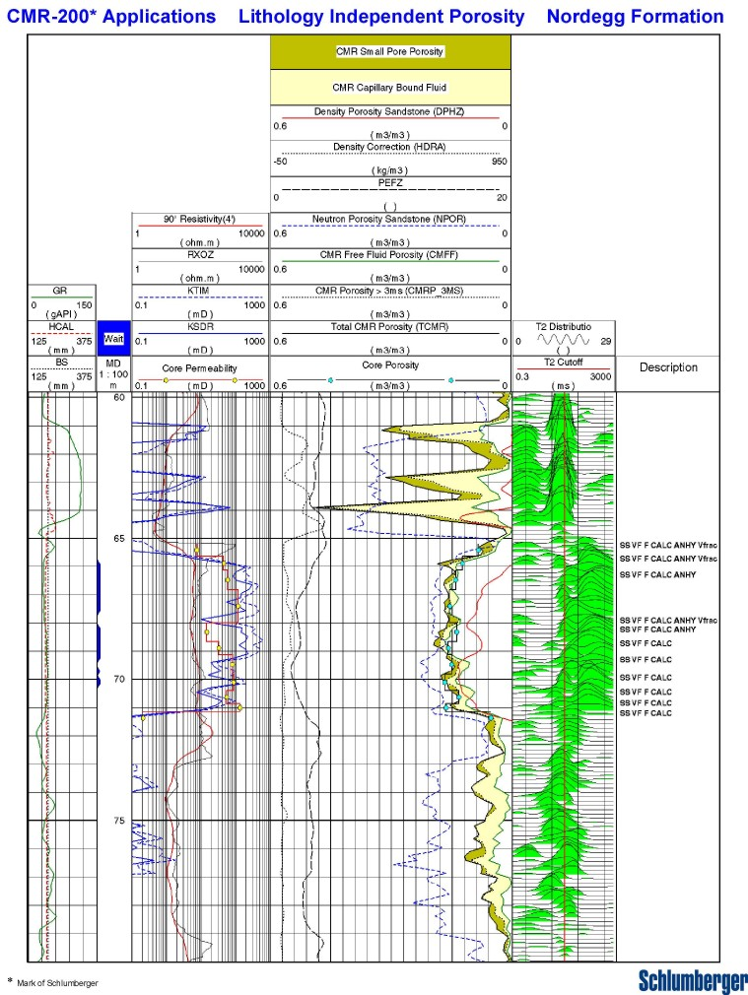Figure 1: Log segment in a heavy sandstone showing separation between density and neutron porosity curves. Core porosity is significantly higher than density porosity, a common occurrence when sandstone is assumed to be pure quartz. (Illustration courtesy of Schlumberger)

