THEY CAME FROM OUTER SPACE

E. R. (Ross) Crain, P.Eng.
Spectrum 2000 Mindware Ltd
Published in CWLS InSite May 2010, CSPG Reservoir Oct 2011.
THE LONGEST LOG
As of February 1, 2009, Voyager 1 is about 108.60 AU (16.247 billion km, or 10.095 billion miles) from the Sun (add 0.32 billion mi or 0.52 billion km per year). It has passed the termination shock, entering the heliosheath, with the current goal of reaching and studying the heliopause, the boundary of the solar system.
INTRODUCTION
A log is a record of some observation versus time or distance, presented on an X-Y coordinate graph, a written narrative, or an audio or video report. Pilots, truckers. taxi-drivers, and tourists all keep logs. So do oil well drillers and other intrepid explorers who walk the Moon or operate robots on or near other planets. We even have logs from interstellar space. The Voyager 1 spacecraft, launched in Sept 1977, has recorded logs over the longest distances yet measured.
The documented geological record of the Earth is the longest time-based record so far, unless you want to count the less-well documented history of the Universe beginning before the Big Bang.
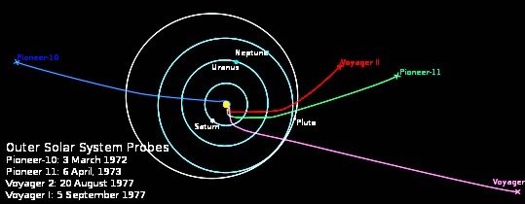
Figure 1: Trajectories of Voyager and Pioneer spacecraft as they leave the solar system. Voyager 1 is rising above the ecliptic and Voyager 2 is dropping below it. Who knows what these logging tools will find? Pioneer 10 and 11 are leaving more slowly and in opposite directions, but neither is still logging what they see.
To celebrate the 40th Anniversary of the Apollo 11 moon-walk by Buzz Aldrin in July 1969, let's look at the Lunar logs run 2 years after that famous "Giant Leap for Mankind".

FIRST LOGS ON THE MOON
Lord Kelvin's temperature / heat flow experiments in 1846 (and onward) were duplicated by Apollo 15 astronauts on the lunar surface in June 1971. The holes were only 1.5 to 3.2 meters deep and the logging tool was stationary, but the results were recorded versus depth, so these surveys are the first petrophysical logs recorded off planet Earth.
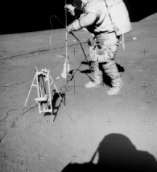
Figure 2: Dave Scott of Apollo 15 running the first logs on the Moon in 1971
Apollo 17 astronauts repeated these temperature surveys and Apollo 16 and 17 crews also ran surface resistivity (EM style) surveys, similar to Conrad Schlumberger's early work in France.
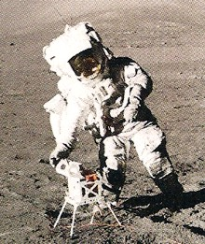
The lunar results: "The Moon is very dry". Golly, who would have guessed that? But don't despair. The moon has been mapped for neutron absorption and some areas absorb neutrons better than others. Hydrogen, hydrocarbon, or water? Or some other absorber (like iron for example)? Who knows.
Figure 3: Harrison "Jack" Schmidt deploying the Surface Electrical Properties (SEP) during Apollo 17 mission, 1972

Below are samples of the temperature logs taken during Apollo 15 in 1971.

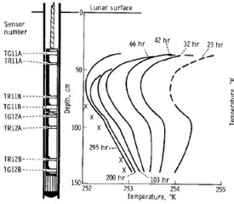 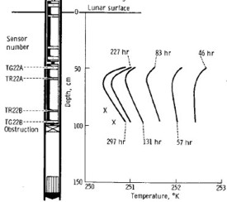
Figures 4 and 5: First logs on the Moon, Apollo 15, 1971. These temperature versus depth logs parallel similar surveys by Lord Kelvin in 1869. The lunar temperature probes continued to transmit data to Earth after the astronauts left the Moon. On Terra, we were just beginning to record logs in digital form, and were a couple of years from sending digital logs by satellite to processing centers. X's represents projected stabilized temperature profile.
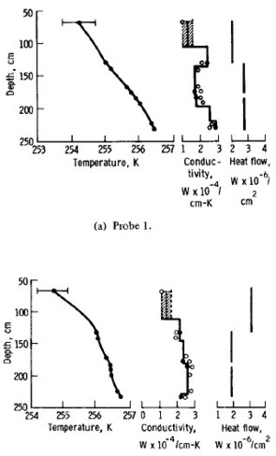
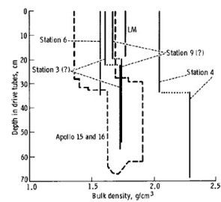
Figure 7: Apollo 17 density logs measured on core
samples (depths are in centimeters).
Figure 6: Apollo 17 temperature log, adjusted for diurnal variations, with derived thermal conductivity log.
Shallow cores were taken during Apollo 15, 16, and 17 missions. Rocks were also analyzed in-situ with X-Ray fluorescence and photography. Samples of rocks were returned to Earth and subjected to myriad tests, much as we have done for many years on Earth in the oil and mineral business. Sample lunar cores are illustrated below.
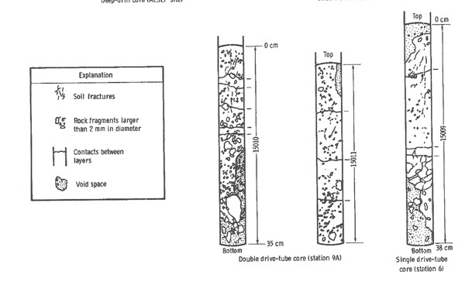
Figure 8: Sketches of cores taken by Apollo 17 crews on the Moon, 1972. Each core image is about 30 to 38 cm
in length. Both driven and drilled cores were taken in the lunar soil.
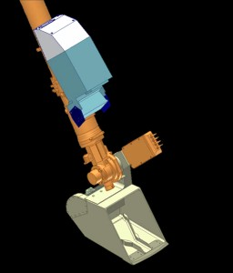
FIRST LOGS ON MARS
The Thermal and Electrical Conductivity Probe (TECP) on the Mars Phoenix Lander was designed to measure petrophysical properties on and near the surface of Mars. Physical properties of the near-surface of Mars were recorded during a 5 month period from June to October 2008.
Phoenix was equipped with a miniature back-hoe (called the Robotic Arm or RA for short) to dig trenches and deliver soil samples to other experiments inside the space craft. The TECP probe was mounted on the pivot at the RA scoop so it could be pressed into the surface soil or the wall of a trench.
Figure 9: TECP is the 4-pin device above the Robotic Arm scoop near
center of picture, the needles are 15 mm long
The TECP is adapted from the commercial KD-2 multi-purpose probe made by Decagon Devices. The four-pin probe determines electrical conductivity by a two-pin LC (dielectric constant) approach and a redundant four-pin van der Pauw technique. The 4 pin EC method is similar to the Schlumberger four electrode AMNB surface resistivity electrode arrangement from the early 1900's.
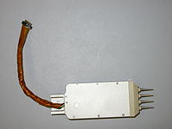
Thermal conductivity is measured by a pulse-decay method using a heater and a thermocouple pair embedded in the pins.
Figure 10: Commercial version of the TECP device
The primary purpose of the TECP was to measure the concentration and nature of water in Martian soils in solid, “non-frozen,” liquid, and vapor states. Other objectives were to determine changes in the reservoirs of water when soil is freshly exposed and to characterize the movement of water in and out of the soil by measuring atmospheric humidity, temperature, and wind speed above the surface. Sounds a lot like reservoir evaluation and monitoring.
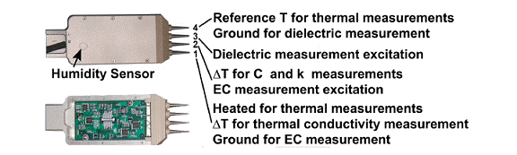
Figure 11: Photograph of the TECP instrument (top) and with the external cover removed to allow access to the
electronics board (bottom). For each needle, the numerical designation and functionality are identified.
There are hundreds of ASCII data files available with the results of the TECP measurements, recorded versus time and day of acquisition. None appear to have been plotted versus depth in the trenches that were dug by the robotic arm. However there are lots of images that are strikingly similar to resistivity microscanner images.
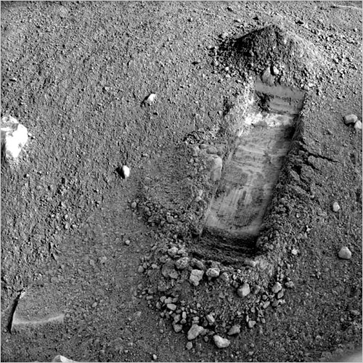
Figure 12: True colour photo image of a Mars Phoenix trench. White areas are believed to be water ice, as
they appear to sublimate slowly after exposure to the Martian atmosphere. Samples were
processed in the Thermal Evolved Gas Analyzer (TEGA).
Phoenix was purposely placed on the Martian Arctic Plain. It is cold there, but not impossibly so - a mere 70 C colder than the Canadian Arctic Islands, where we have found more than 17 Tcf of natural gas. So who is ready to drill on Mars?
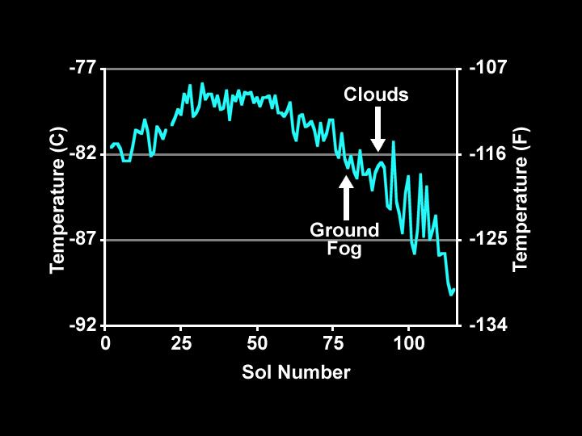
Figure 13: A log of minimum daily temperature for 120 Martian days (Sols) recorded by the Canadian built Phoenix MET station.
The meteorological station on Phoenix was designed to monitor changes in water abundance, dust, temperature, and other variables in the Martian atmosphere. The Canadian Space Agency, York University, University of Alberta, Dalhousie University, Optech, and the Geological Survey of Canada designed and monitored the science operations of the station, which was built by Canadarm maker MacDonald Dettwiler and Associates Ltd. of Richmond, B.C.
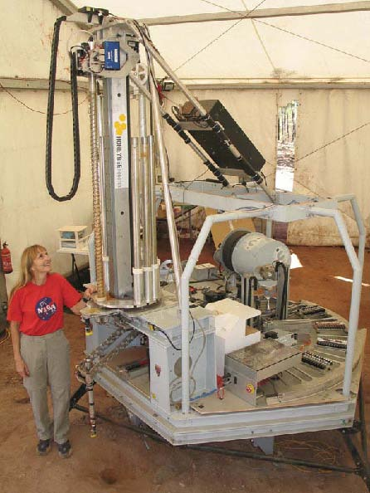
FUTURE LOGS IN OUTER SPACE
After Phoenix comes MARTE, a proposed stratigraphic drilling program for Mars. Mars Astrobiology Research and Technology Experiment (MARTE) performed a field test simulating a robotic drilling mission on Mars in September 2005. The experiment took place in Minas de Riotinto in southwestern Spain, a highly relevant Mars analog site. The experiment utilized a 10 m class dry auger coring drill, a robotic core sample handling system, onboard science and life detection instruments, and a borehole inspection probe, all of which were mounted to a simulated lander platform.
Figure 14: Prototype robotic drilling rig for Mars
The prototype robot drilling/coring/logging machine reached 10 meters. Plans for 100 meter capability are in the works. The objective is to advance the search for life on Mars, but where there is life, there is a possibility of hydrocarbons. There is methane in the Martian atmosphere and spectroscopy mapping indicates carbonate rocks, as well as the more obvious lava, dust, and other sediments. Interested parties can apply HERE for drilling concessions.
MARTE can drill, core, and run neutron and fluorescence logs. Neutron logs see water and ice; fluorescence logs see bacteria. The Ames tool is so sensitive, it can see a single bacterium. The core samples can be analyzed on the drilling platform, then stacked for future examination. The remote sensing core analyzer can face or saw core samples, run spectrography, and prepare powder samples.
The borehole inspection system (BHIS) runs the neutron probe, a panoramic microscopic imager, and spectrometer. The borehole neutron log (BneuP) measures both thermal and epithermal neutron count rates. A surface version of the tool, to be carried on a Mars rover, is called (you guessed it) SneuP. It is intended as a dowsing machine, looking for hidden near surface water or ice deposits.
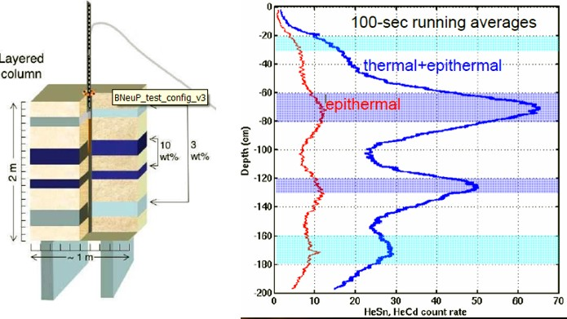Figure 15: Sample of a BneuP log run in a manmade ice / soil test pit.
It's all real and working (almost). We just have to get it there and get to work.
REFERENCES
All image credits: NASA/JPL http://www.jpl.nasa.gov/
Moon Logs
http://history.nasa.gov/alsj/a15/as15psr.pdf
http://history.nasa.gov/alsj/a16/as16psr.pdf
http://history.nasa.gov/alsj/a17/as17psr.pdf
Mars Logs
http://www.nasa.gov/mission_pages/phoenix/main/index.html
Future Mars Logs
www.nasa.gov/centers/ames/research/exploringtheuniverse/marsdrill.html
www.nasa.gov/centers/ames/multimedia/images/2005/martedrill.html
www.lpi.usra.edu/meetings/leagilewg2008/presentations/oct31am/Stoker4010.pdf

