UNICORNS IN THE GARDEN OF GOOD AND EVIL
PART 2 – Coal
E. R. (Ross) Crain, P.Eng.
Spectrum 2000 Mindware Ltd
Published in CSPG Reservoir, Dec 2010.
Unicorns are beautiful, mythical beasts, much sought after by us mere mortals. The same is true for petrophysical models for unconventional reservoirs. This is the second in a series of review articles outlining the simple beauty of some practical methods for log analysis of the unusual.
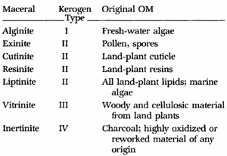
COAL BASICS
Coal is a term used to describe a wide range of organic compounds. Bituminous coal is an organic sedimentary rock formed by diagenetic and submetamorphic compression of peat bog material. It has been compressed and heated so that its primary constituents are macerals.
Figure 1: Correlation between kerogen type, its source, and its maceral name. Macerals are organic matter names, somewhat akin to mineral names in the non-organic world
The carbon content of bituminous coal is around 60 to 80%; the rest is composed of water, air, hydrogen, and sulfur, which have not been driven off from the macerals. Bituminous coal or black coal is relatively soft, containing a tarlike substance called bitumen. It is of higher quality than lignite coal but of poorer quality than anthracite coal.
Lignite, often referred to as brown coal, is a soft brown fuel with characteristics that put it somewhere between coal and peat. It is considered the lowest rank of coal, used almost exclusively as a fuel for steam-electric power generation. Lignite has a carbon content of around 25 to 35%, a high inherent moisture content, sometimes as high as 66%, and an ash content ranging from 6% to 19% compared with 6% to 12% for bituminous coal.
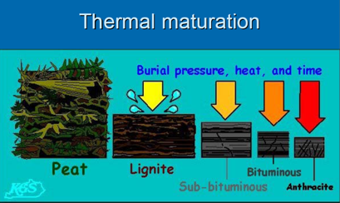
Figure 2: Coal rank depends on thermal maturity (courtesy Kansas Geological Survey)
Anthracite is a hard, compact variety of mineral coal that has a high luster. It has the highest carbon content, between 92% and 98%, and contains the fewest impurities of all coals, despite its lower calorific content. Anthracite is the most metamorphosed type of coal. The term is applied to coals which do not give off tarry or other hydrocarbon vapours when heated below their point of ignition.
PROXimate analysis
Proximate analysis of coal is a simple laboratory method for determining the components of coal, obtained when the coal sample is heated (pyrolysis) under specified conditions. The coal sample is extracted from a core and placed quickly in a canister to preserve as much gas as possible.
As defined by ASTM D 121, proximate analysis separates the coal into four groups:
1. moisture,
2. volatile matter, consisting of gases and vapors driven off during pyrolysis,
3. fixed carbon, the nonvolatile fraction of coal
4. ash, the inorganic residue remaining after combustion.
Fixed carbon is also called carbon, dry coal, pure coal, or dry ash-free coal. The latter term is the most descriptive - dry ash-free is often abbreviated as "daf" or "DAF".
Moisture is an important property of coal, as all coals are mined wet. Groundwater and other extraneous moisture is known as adventitious moisture and is readily evaporated. Moisture held within the coal itself is known as inherent moisture and is analyzed quantitatively. Adventitious moisture is removed in the lab by evaporation in air.
Moisture may occur in four possible forms within coal:
1. surface moisture: water held on the surface of coal particles or macerals
2. hydroscopic moisture: water held by capillary action within the microfractures of the coal
3. decomposition moisture: water held within the coal's decomposed organic compounds
4. mineral moisture: water which comprises part of the crystal structure of hydrous silicates such as clays
Total moisture is analyzed by loss of mass between an air-dried sample and the sample after driving off the inherent moisture with heat. This is achieved by any of the following methods;
1. heating the coal with toluene
2. drying in a minimum free-space oven at 150 °C (302 °F) within a nitrogen atmosphere
3. drying in air at 100 to 105 °C (212 to 221 °F)
Methods 1 and 2 are suitable with low-rank coals but method 3 is only suitable for high-rank coals as free air drying low-rank coals may promote oxidation.
Volatile matter in coal refers to the components of coal, except for moisture, which are liberated at high temperature in the absence of air. This is usually a mixture of short and long chain hydrocarbons, aromatic hydrocarbons, and some sulfur. In Australian and British laboratories, this involves heating the coal sample to 900 ± 5 °C (1650 ±10 °F) for 7 minutes in a cylindrical silica crucible in a muffle furnace. American procedures involve heating to 950 ± 25 °C (1740 ± 45 °F) in a vertical platinum crucible. These two methods give different results and thus the method used must be stated.
Fixed carbon content of the coal is the carbon found in the material which is left after volatile materials are driven off. This differs from the ultimate carbon content of the coal because some carbon is lost in hydrocarbons with the volatiles. Fixed carbon is used as an estimate of the coke yield from a sample of coal. Fixed carbon is determined by subtracting the mass of volatiles, determined above, from the original mass of the coal sample.
Ash content of coal is the non-combustible residue left after coal is burnt. It represents the bulk mineral matter after carbon, oxygen, sulfur and water (including from clays) has been driven off during combustion. Analysis is fairly straightforward, with the coal thoroughly burnt and the ash material expressed as a percentage of the original weight.
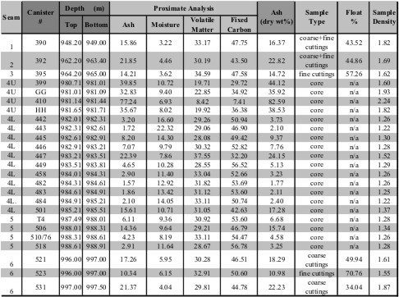
Figure 3: Example of Proximate Analysis of several coal seams - data is in Weight %
Float – Sink Analysis is used to separate non-coal cavings from cuttings samples. The crushed material is placed in a liquid with a density of 1.75 g/cc. The coal fraction is floated off and the non-coal sinks and is removed. Some mineral (ash) in the coal may sink, reducing the apparent ash content. By comparing the ash analysis to the float – sink analysis with that from core analysis, the gas contents can be normalized to reflect true ash contents of the coal cuttings.
Vitrinite is the most common component of coal. It is also abundant in kerogen, derived from the same biogenic precursors as coals, namely land plants and humic peats. Vitrinite forms diagenetically by the thermal alteration of lignin and cellulose in plant cell walls. It is therefore common in sedimentary rocks that are rich in organic matter, such as shales and marls with a terrigenous origin. Conversely, carbonates, evaporites, and well-sorted sandstones have very low vitrinite content. Vitrinite is absent in pre-Silurian rocks because land plants had not yet evolved.
Vitrinite reflectance was first studied by coal geologists attempting to determine the thermal maturity, or rank, of coal beds. More recently, it is used to study sedimentary organic matter from kerogen. It is sensitive to temperature ranges that correspond to hydrocarbon generation (60 to 120°C). This means that, with a suitable calibration, vitrinite reflectance can be used as an indicator of maturity in hydrocarbon source rocks. Generally, the onset of oil generation is correlated with a reflectance of 0.5 to 0.6% and the termination of oil generation with reflectance of 0.85 to 1.1%
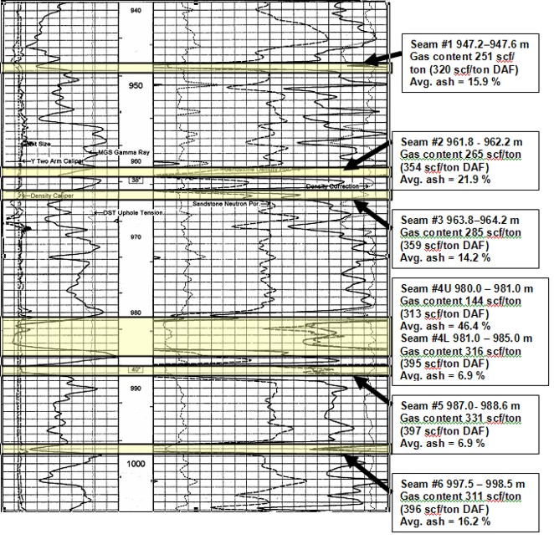
Figure 4: Example of well log showing location of coal layers analyzed by proximate analysis. Log curves are GR, CAL, PE, neutron, density, density correction.
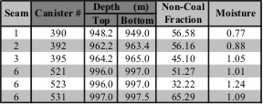
Figure 5: Summary table of Proximate Analysis for the example of Figures 3 and 4

VISUAL ANALYSIS OF COAL LOGS
Finding coal on logs is pretty easy. High values of neutron porosity, density porosity (low density), high sonic travel time (low velocity), and high resistivity are the clues. Gamma ray is low for good quality coal and increases with clay (ash content)..
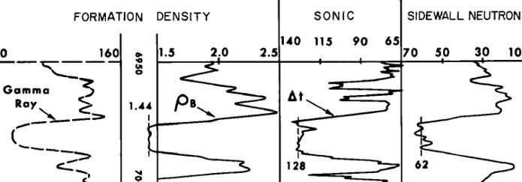
Figure 6: Visual analysis of logs for coal is relatively unambiguous. High neutron porosity, high density porosity (low density), high sonic, high resistivity, and clean gamma ray mean coal. Thresholds on each curve are used to trigger a coal flag. Three or more flags is a pretty good indication of the presence of coal. Some coals are very dirty (shaly) so the gamma ray and resistivity may not trigger.
COAL ANALYSIS MODELS
The use of well logs for analyzing coal deposits dates back many years. Most methods are based on a multi-mineral model which solves for moisture, volatile components, fixed carbon, and ash. These are the same components determined from coal cores or sample chips by proximate analysis.
One log analysis model calculates a 3-mineral model from PE, density, neutron, sonic crossplot methods and solves for the fraction of lignite, bituminous coal, and anthracite (or peat). With this breakdown, the coal matrix density can be determined, and the other parameters follow from this value:
1: DENSMAcoal = Vlignite * 1.19 + Vbituminous * 1.34 + Vanthracite * 1.47
An alternative method is a 3-mineral model using ash, fixed carbon, and moisture. The GR is used to obtain Vclay, making a 4-mineral model relatively easy. Both models can be solved by crossplots. Examples are shown in Figure 7.

MATRIX PARAMETERS FOR 3-MINERAL MODEL - COAL TYPE
DENSMA PHIN DTC DTCMA PE
g/cc frac us/ft us/m us/ft us/m
Anthracite 1.47 0.41 105 345 48 157 0.16
Bituminous 1.24 0.60+ 120 394 44 144 0.17
Lignite 1.19 0.54 160 525 50 164 0.20
Peat 1.14 0.26 0.25

MATRIX PARAMETERS FOR 3-MINERAL MODEL - COAL COMPOSITION
DENSMA PHIN DTCMA PE
g/cc frac us/ft us/m cu
Ash (Quartz) 2.65 0.00 55 182 1.8 Could vary if other minerals (eg calcite) are also present
Ash (Clay) 2.18 - 2.35 0.25 80 250 3.5 Includes clay bound water, varies with clay mineral
Carbon 1.19 - 1.47 0.60 120 394 0.2 Varies with coal type (dry, ash-free value)
Water 1.00 1.00 200 656 0.1 Free water or "moisture", excludes clay bound water

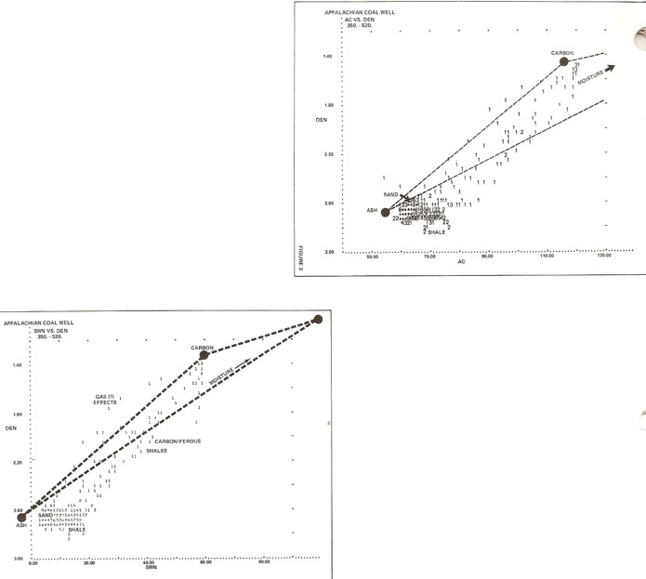
Figure 7: Density neutron crossplot for coal analysis (bottom left), density sonic crossplot (top right). End points are Ash, Fixed Carbon, and Water. Data points show the ash in this coal is mostly clay (log data falls to the right of the Ash point). DENSma – Uma and Mlith – Nlith crossplot models can also be used. (illustration from COAL EVALUATION USING GEOPHYSICAL WELL LOGS, Walter H. Fertl and Marvin R. DeVries, CWLS Symposium, 1977.

The mineral end points are not firm, so some experimentation and sample descriptions are needed. If a 3-mineral model is not possible, the analyst must decide on the correct coal type.
A dry clay model can also be used, but the water term will include the clay bound water, not just the free water. It can be removed by subtracting clay bound water from the total to get the free water answer.
The ash data points may vary with clay type and other noncombustible mineral content, so crossplots of lab ash content (by volume) versus log readings can help pin down these values.
CALCULATING COAL PROPERTIES
The following equations are found in the coal assay literature and are based on correlations between core analysis values and log data. Parameters can be tuned by making your own crossplots. Standard 3- and 4- mineral models using simultaneous equations, DENSma-Uma crossplots, or Mlith-Nlith crossplots (or equivalent math) are probably more practical when the core data correlations are not available.
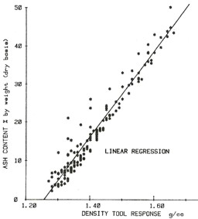
Initial results are in volume fractions and are converted to weight fractions by using the density of each component.
Ash Content:
2: Vash = (DENS - DENSMAcoal) / (2.5 – DENSMAcoal)
OR 2a: Vash = 0.65 * (DENS - 1.00)
Figure 8: Equations specific to a project area can be obtained by crossplotting ash content vs density log readings. This plot generated Equation 2a

Fixed Carbon (dry coal):
3: Vfcarb = 0.512 * (1.0 – Vash)
Moisture (free water):
4: Vwtr = 0.461 – Vash

Volatile Matter:
5: Vvolatile = 1.0 – Vash - Vfcarb – Vwtr
Numerical Example:
Given: DENSMAcoal = 1.24 DENS = 1.36 g/cc
Vash = 0.10
OR Vash = 0.23
Vfcarb = 0.36 0.39
Vwtr = 0.47 0.23
Vvolatile = 0.07 0.15

All proximate analysis results are reported in weight fraction or percent. To convert log analysis volume fractions to weight fractions, use the following:
6: WTash = Vash * DENSash
7: WTfcarb = Vfcarb * DENSfcarb
8: WTwtr = Vwtr * DENSwtr
9: WTvolatile = Vvolatile * DENSvolatile
10: WTcoal = WTash + WTfcarb + WTwtr + WTvolatile
Mass fractions are as follows (multiply by 100 to get weight percent):
11: Wash = WTash / WTcoal
12: Wfcarb = WTfcarb / WTcoal
13: Wwtr = WTwtr / WTcoal
14: Wvolatile = WTvolatile / WTcoal
Weight percent is often used in reports:
15: WT%ash = 100 * Wash
16: WT%fcarb = 100 * WTfcarb
17: WT%wtr = 100 * WTwtr
18: WT%volatile = 100 * WTvolatile
Where:
DENS = density log reading in a coal (g/cc)
DENSMAcoal = matrix density of a coal (g/cc)
DENSxxx = density of a component (g/cc)
Vxxx = volume fraction of a component (fractional)
WTxxx = weight of a component (grams)
Wxxx = mass fraction of a component (fractional)
WT%xxx = weight percent of a component (percent)

Numerical Example:
Given: DENSMAcoal = 1.24 DENS = 1.36 g/cc
Volume Density Weight Mass Fraction
Ash 0.10 2.65 0.25 0.21
Fcarb 0.36 1.24 0.57 0.48
Wtr 0.47 1.00 0.37 0.31
Volatile 0.07 0.00 0.00 0.00
Coal 1.00 1.19

COAL ANALYSIS EXAMPLES

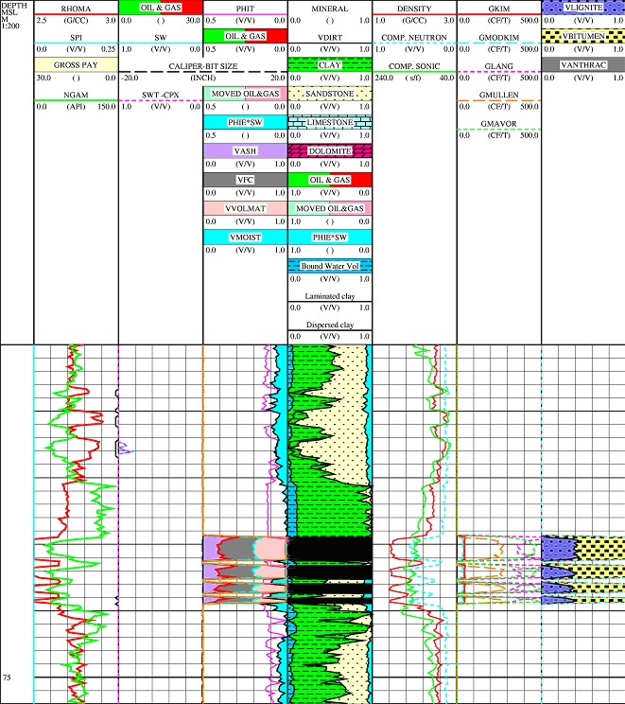
Figure 9: Example of coal log analysis results using a 3-mineral model for coal type (lignite, bituminous, anthracite) in right hand track. Zones outside the coal are analyzed with conventional oil and gas models.
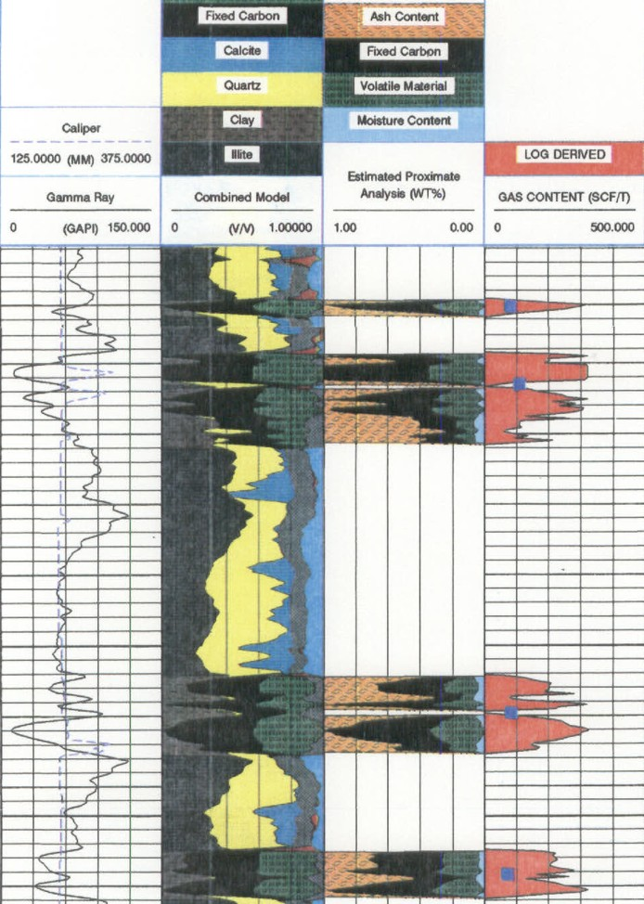
Figure 10: Log analysis of an Alberta Foothills coal using a model for coal composition (fixed carbon, volatiles, moisture, and ash (2nd track from the right). These results can be calibrated to the proximate analysis from lab measurements. (example courtesy of Schlumberger).

