**UNICORNS IN THE GARDEN OF GOOD AND EVIL  
PART 4 – Shale GAS**

E. R. (Ross) Crain, P.Eng.  
Spectrum 2000 Mindware Ltd  
  
  
*Published in CSPG Reservoir, Feb 2011*

***Unicorns are beautiful, mythical beasts, much sought after by us mere mortals. The same is true for petrophysical models for unconventional reservoirs. This is the fourth in a series of review articles outlining the simple beauty of some practical methods for log analysis of the unusual.***

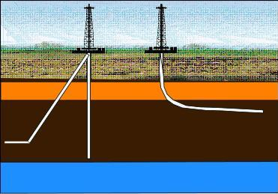**Shale gas BASICS**Shale is a fine-grained, clastic sedimentary rock composed of mud that is a mix of clay minerals and tiny fragments (silt-sized particles) of other minerals, especially quartz, dolomite, and calcite. The ratio of clay to other minerals varies. Shale is characterized by breaks along thin laminations, parallel to the bedding. Mudstones are similar in composition but do not usually show layering within the zone.

*Figure 1: Schematic drawing of shale gas wells* 🡺

Geologists define clay as any mineral in a rock with a grain size less than 4 microns, even though the mineral may not be a clay mineral. Silt is defined as a rock with particle size between 4 and 62 microns. Silt sized particles are usually non-clay minerals and clay sized particles are usually clay minerals, although non-clay minerals may also fall into this category.

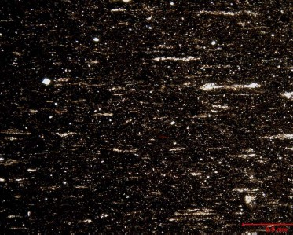 The distinguishing characteristic of gas shales is that they have adsorbed gas, just like coal beds. They also have free gas in porosity, unlike coal, which has virtually no macro-porosity. The adsorbed gas is proportional to the organic content of the shale. Free gas is proportional to the effective porosity and gas saturation in the pores.

🡸 *Figure 2: Microphoto of a gas shale*

From a petrophysical analysis point of view, clay-rich shales have traditionally been called “shales” and non-clay shales have been called “silts”. Petrophysical analysis deals with minerals, not particle size, so it is confusing to us when a zone is called a shale when the logs show little clay is present. An example is the Montney shale in northeast British Columbia. It is roughly 45% quartz, 45% dolomite, 10% other minerals (few of them are clay). The zone is radioactive due to uranium (not due to clay), so it looks a lot like shale on quick look log analysis; density neutron separation and PE values are also close to shale values. This kind of reservoir needs to be treated as a tight gas sand, as there is very little adsorbed gas.

Other so-called "gas shales", such as the Monterey Shale, the Niobrara, and Milk River, are laminated shaly sands. These sands need to be analyzed with a Laminated Shaly Sand Model, not a Shale Gas Model.  The sand laminations have good porosity and permeability. The shale laminations contain very little adsorbed gas.

Others are radioactive silts with clay and kerogen, such as the Haynesville Shale, which is 50% clay and 50% quartz and calcite. This shale has low effective porosity and very poor permeability. Total organic content is moderately high and there is adsorbed gas, so it gets treated as a true gas shale.

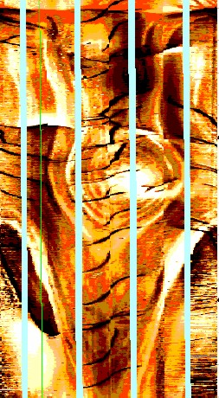Using the wrong log analysis model will produce silly results, so be sure to understand what type of "gas shale" you are dealing with.

Natural fractures in gas shales are an important component in assessing productivity. Fracture analysis using formation resistivity images and acoustic televiewer images is covered in my website at [www.spec2000.net](http://www.spec2000.net) .

*Figure 3: FMI image of fractures in a gas shale (courtesy Schlumberger)* 🡺

Below is a series of core photos of a gas shale showing the laminated nature of shale. Gas is adsorbed in the microporosity on the clay surfaces. The natural fractures along the shale partings help move gas to the well bore when well bore pressure is below formation pressure.

*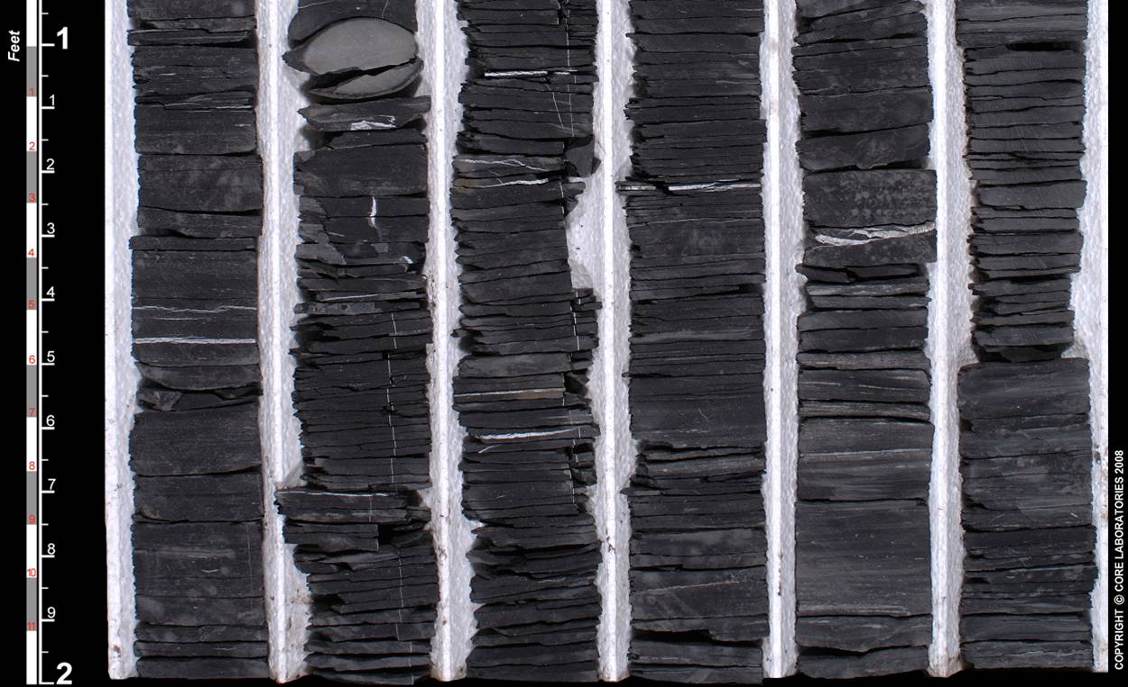  
Figure 4: Core photo of gas shale - about 50% clay, 50% quartz plus calcite, 10 - 15% total porosity, 3 - 6% effective porosity, < 0.001 mD permeability.*

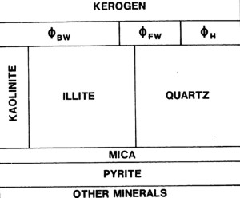***Figure 5: Petrophysical model for a gas shale* 🡺**

**The log analysis model for shale gas is more complicated than for conventional reservoirs. The total organic content (kerogen) is the source of the gas and also takes up space. This space has to be segregated from the clay bound water and conventional porosity. The diagram at right illustrates these basic components. The conventional porosity can hold free gas and irreducible water. The clays hold the clay bound water as well as adsorbed gas is in the microporosity on the clay surfaces.**

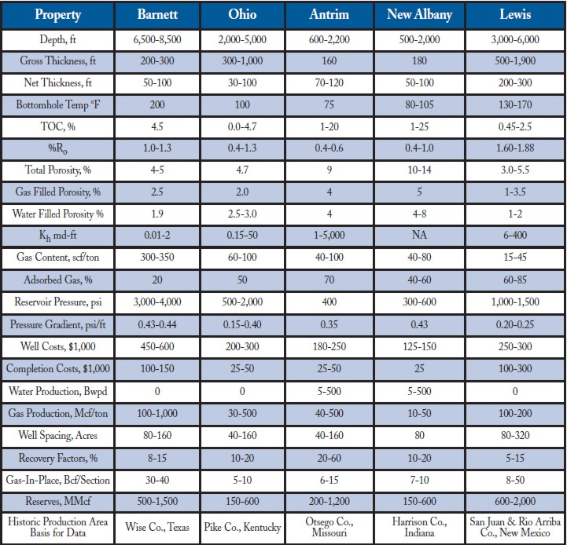  
*Figure 6: The best way to appreciate the unique properties of gas shale reservoirs is to look at the statistics, especially with respect to free and adsorbed gas, 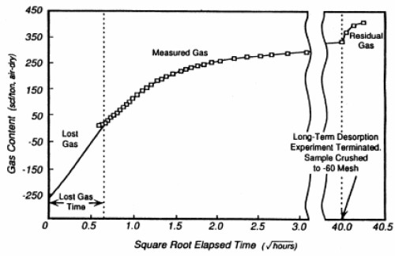porosity, permeability, and costs.*

**Sorption isotherms: SHALE GAS**  
**Sorption isotherms indicate the maximum volume of methane that a gas shale can store under equilibrium conditions at a given pressure and temperature.***Figure 7: Sorption isotherm for a gas shale* 🡺

**The direct method of determining sorption isotherms involves drilling and cutting core that is immediately placed in canisters, followed by measurements of the volume of gas evolved from the shale over time.**

**Lab units are usually g/cc but these are often reported as scf/ton of rock. When the sample no longer evolves gas, it is crushed and the residual gas is measured.**

**SHALE  Gas In Place - adsorbed**  
**Gas in place calculations in gas shales are done in two parts: adsorbed gas and free gas.**

**Adsorbed gas in place is calculated from the isotherm curve, or from the actual gas content found in the lab, by using shale bed thickness and shale density as measured by well logs:**  
**1: GIPadsorb = KG6 * Gc * DENS * THICK * AREA**

**Where:**  
**GIPadsorb = gas in place (Bcf)**  
**Gc = sorbed gas from isotherm or coal analysis report (scf/ton)**  
**DENS = layer density from log or lab measurement (g/cc)**  
**THICK = layer thickness (feet)**  
**AREA = spacing unit area (acres)**  
**KG6 = 1.3597*10^-6**   
  
**If AREA = 640 acres, then GIP = Bcf/Section (= Bcf/sq.mile)**  
**Multiply meters by 3.281 to obtain thickness in feet.**  
**Multiply Gc in g/cc by 32.18 to get Gc in scf/ton.**

Typical shale densities are in the range of 2.20 to 2.60 g/cc.   
  
Recoverable gas can be estimated by using the sorption curve at abandonment pressure (Ga) and replacing Gc in Equation 1 with (Gc - Ga).

**SHALE Gas In Place - FREE GAS**  
**Free gas is determined by conventional log analysis using standard techniques. However it is more difficult to choose the parameters than for conventional reservoirs. Shale volume is the most important starting point, usually calibrated to X-Ray diffraction or thin section point counts. The basic mineral mix is also developed from this data. Unless shale volume is reasonably calibrated, nothing else will work properly.**

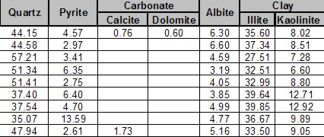  
*Figure 8: XRD analysis of a silty gas shale. Notice clay-quartz ratio averages about 60:40. XRD data is usually in weight percent, so a little arithmetic is needed to get volume fractions.*

**Effective porosity is best done with the shale corrected density neutron complex lithology model. Here again good control is necessary. Core analysis in low porosity environment needs some care and humidity control is important.**

**Water saturation is best done with the Simandoux equation. Dual water models may also work, but may give silly results when shale volume is high. Special core analysis capillary pressure is needed to calibrate water saturation. Again, due to the low porosity, special lab procedures are needed. Some shale gas reservoirs have moderate to high water saturations, others can have very low values.**

**Permeability is usually in the micro- to nano-Darcy region. Again special lab procedures are needed. Micro- and nano-CT scanning with post processing can generate all these values from core or sample chips.**

**Free gas in place is calculated from the usual volumetric equation:**  
      2: Bg =  (Ps * (Tf + KT2)) / (Pf * (Ts + KT2)) * ZF   
**3: GIPfree = KV4 * PHIe * (1 - Sw)  *THICK *  AREA / Bg**  
**4: GIPtotal = GIPadsorb + GIPfree**

**Where:**   
**AREA = reservoir area (acres)**  
**Bg = gas formation volume factor (fractional)**  
**GIPfree = original free gas in place (Bcf)**  
**GIPtotal = total gas in place (Bcf)**  
**PHIe = effective porosity (fractional)**  
**Sw = water saturation in un-invaded zone (fractional)**  
**THICK = layer thickness (feet)**  
**Pf = formation pressure (psi)**  
  Ps = surface pressure (psi)  
  Tf = formation temperature ('F)  
  Ts = surface temperature ('F)  
  ZF = gas compressibility factor (fractional)  
  KT2 = 460'F  
**KV4 = 0.000 043 560**  
  
**If AREA = 640 acres, then GIP = Bcf/Section (= Bcf/sq.mile)**  
**Multiply meters by 3.281 to obtain thickness in feet.**

**SHALE GAS EXAMPLE**

*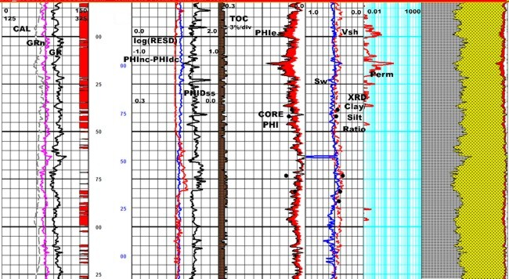****Figure 9: Log analysis in a silty gas shale. XRD shows Vsh = 0.40 to 0.45, so parameters were chosen to achieve this. Core porosity is available and shale properties were adjusted to achieve a good porosity match to core. TOC is not large so adsorbed gas will be relatively small. No capillary pressure data was available so free gas saturation is not calibrated.***