**A HISTORY OF OIL and GAS IN CANADA  
  
E. R. (Ross) Crain, P.Eng.  
Spectrum 2000 Mindware Ltd**

*Published in English in Azerbaijan Oil Industry Magazine, Oct 2011.*

The history of oil and gas in Canada is not well known, even to Canadians. Often overshadowed by the larger producers of Saudi Arabia, Russia, and the United States, Canada ranking sixth behind these countries, plus Iran and China, Canada’s production exceeds 3.5 million barrels per day and continues to grow, unlike many other major producers such as Mexico, Venezuela, and the North Sea. Canada exports more than 2 million barrels per day to the United States by pipeline, more than any other single country.

**Peter Pond was the first non-aboriginal to report the discovery of oil in Canada in 1778 at what is now the Athabasca oil sands. These oil sands comprise the bulk of Canada’s current proven oil reserves, as well as its productive capacity. Canadian oil sands contain 200 to 400 billion barrels of recoverable oil (the estimate varies depending on the oil price that is assumed in the calculation).**

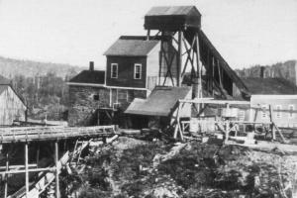Canada produced some shale oil from deposits in New Brunswick in the mid-1800's. The mineral was called Albertite and was originally believed to be a form of coal.

*🡸 Figure 1: Albert Mine, near Moncton, New Brunswick, c. 1850's, produced oil from shale before conventional oil was discovered in Ontario in 1858 and Alberta more than 50 years after that.*

Later, the nature of the mineral and its relation to the surrounding oil shale was described correctly.

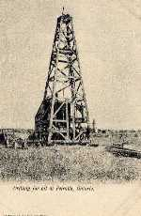Abraham Gesner used Albertite in his early experiments to distill liquid fuel from coal and solid bitumen. He is credited with the invention of kerosene in 1846, and built a significant commercial distillery to provide lighting oil to replace whale oil in eastern Canada and USA. In the 1880's, shale oil was abandoned as a source of kerosene in favour of distillation from liquid petroleum.

*Figure 2:* ***Early oil well at Petrolia, Ontario, Canada c. 1860's 🡺***

**Canada's first commercial oil wells were found in Oil Springs and Petrolia, near Sarnia, Ontario, in 1858, a year before Edwin Drake's discovery at Oil Springs, Pennsylvania. Both the Oil Springs discoveries were known before these dates from flowing seeps.**

**The subsequent development of Canada's first petroleum refining complex at Petrolia in Ontario is a little known part of the industrial saga of the oil industry. During the period 1861 to 1897, nearly the entire requirement of Canada for crude oil, lubricants, waxes, kerosene, gasoline, and a widening range of chemicals for food, medicine, and industry was produced here. From 1863 to 1870, Canada was a major exporter of crude and refined products to the United States and Europe.**

**The contribution that Canadians made to the world's petroleum industry during the same period is even less appreciated. Men trained in the production, transportation, refining, and administration of this new resource, took their knowledge and skills to every corner of the world, opening many of the great oil fields that are still major suppliers of crude. They laboured on every continent in a hundred different countries. And the tradition continues to this day.**

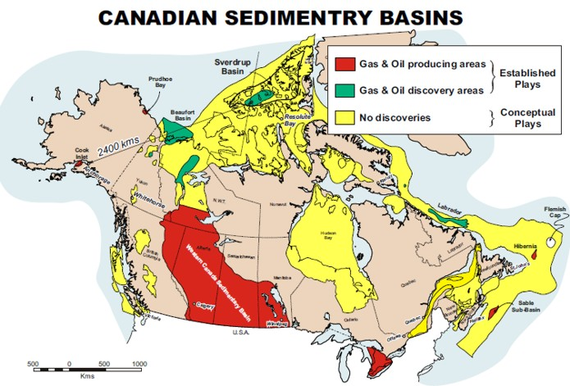 *Figure 3:* **Map of Canada, showing main producing basins (red shading), discovered but undeveloped basins (green), and prospective sedimentary areas (yellow). Canada is the second largest country in the world, stretching more than 5000 kilometers east to west, and a similar distance north to south.**

**New Brunswick achieved commercial production of conventional oil at Stoney Creek in 1884, although it was pretty minor by early Ontario standards, and these wells continued in production until modern times. Quebec, Prince Edward Island, onshore Nova Scotia, and onshore Newfoundland never found commercial quantities of oil or gas.**

**The first gas well in Alberta was drilled in 1883 at Alderson (then known as Langevin Siding), near Medicine Hat, by the Canadian Pacific Railway. They were, of course, looking for water. This well struck gas, caught fire, burned down the rig injuring one man who had to jump off, and was abandoned. A second well, the following year, again struck gas (it was only 8 feet away from the first one) and produced off-and-on for about 40 years. These, and similar wells, came to the notice of the Canadian government.**

**Dr. George Dawson of the Geological Survey of Canada, collected information on the wells at Langevin Siding and others, and presented a paper to the Royal Society of Canada in May, 1886. The paper was called "On Certain Borings in Manitoba and the Northwest Territory". The paper contained detailed sample descriptions of the wells - possibly the first "well logs" in Western Canada.**

**By the early 1890s several more wells had been drilled in the Medicine Hat area, producing gas for homes and factories. Rudyard Kipling, the famous British author, on a visit in the early 1900’s admitted that he liked Medicine Hat but "It has all hell for a basement!".**

**By 1908, development of the Bow Island gas field led to the first pipelines to deliver natural gas to Alberta communities. Construction of a 16-inch pipeline from southwest of Medicine Hat to Calgary began in April 1912 and was completed in only 86 days. A second leg reached Lethbridge in July 1912. This was spearheaded by Eugene Coste, Canada's first natural gas engineer. He had discovered the first commercial gas well in Essex County Ontario in 1888.**

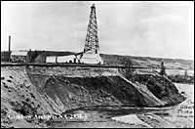**The Alberta oil boom didn't begin until 1914 with the drilling of Dingman #1 near Turner Valley. A replica of the drilling rig lives at Heritage Park in Calgary. This wet gas success started a stock market flurry that died less than a year later with the loss of most of the investors' money.**

*Figure 4:* ***Dingman #1, Turner Valley, Alberta, Canada, 1914 🡺***

**The well was the precursor for the deeper zone discovery drilled ten years later. Royalite #4 put Turner Valley on the oil and gas map for real.**

**In 1919, Imperial Oil geologist Ted Link, a crew of six drillers and an ox named "Nig" made a six-week, 1900 kilometer journey northward by railway, river boat, and on foot to the site now known as Norman Wells NWT, along the Mackenzie River. The ox helped to build a log house and put the drilling rig in place before being butchered to provide food for the winter. Drilling resumed in the spring with the world's most northerly oil discovery coming in August 1920.**

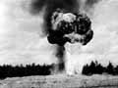**Between 1920 and 1947, there were a dozen or so significant oil discoveries in the Cretaceous of Alberta, but no "elephants", and nothing very deep. Vern Hunter drilled Imperial Oil's Leduc #1 Devonian oil discovery in 1947, ending a long dry spell in the Alberta search.**

*Figure 5:* ***Leduc #1, Leduc, Alberta, Canada, 1947 🡺***

**Although minor shows were found much earlier, 1951 saw the first commercial oil discoveries in Manitoba and British Columbia, followed by Saskatchewan in 1953. Over the next 20 years, Canada became self-sufficient in oil and gas.**

**As early as 1921, Dr. Karl Clark pioneered the extraction of oil from tar sands by the hot water process. He built pilot plants in 1930 at Clearwater, Alberta and in 1949 at Bitumont under the auspices of the Alberta Research Council. Great Canadian Oil Sands Ltd (later Suncor) began production of the Athabasca tar sands north of Fort McMurray in 1967.**

**Shell drilled offshore British Columbia in 1967, but found nothing. A few years later, the BC Government placed a moratorium on further drilling that has not been lifted.**

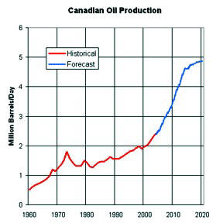**On the other frontiers, hydrocarbons were found offshore Nova Scotia (gas at Sable Island, 1967, oil at Cohasset, 1973), offshore Newfoundland (oil at Terra Nova, 1984), offshore in the Beaufort Sea and MacKenzie Delta (gas at Taglu, 1971, oil at Amauligak, 1978), onshore and offshore in the High Arctic Islands (gas at Drake Point, 1969 - oil at Bent Horn, 1974). It took between 20 and 30 years for some of these to come on-stream, and Beaufort / MacKenzie / Arctic are still shut-in, waiting on pipelines.**

*Figure 6: Canada’s oil production continues to increase and will reach 5 million barrels per day in a few years 🡺*

**Canada's steady increase in production contrasts markedly with production declines in nearly every other oil-producing country.**

**Canada's conventional oil production peaked in 1974, but oil sands production has replaced the decline. Current capacity in the tar sands has brought Canadian production to more than 3 million barrels per day, with a target of 5 million by the year 2020.**

**The majority of Canadian production is exported to the United States by pipeline. Canada is the largest single supplier of US oil needs, a fact not well appreciated by US citizens of either country, or by the rest of the world.**

**Aside from the oil sands, another significant reason for increased production is that small independent oil companies, operating under a favourable free-enterprise tax system and rule of law, are content to produce from thin, low productivity, low quality reservoirs. The risk of political upheaval or confiscation is very low.**

**These same independent companies are now investing in unconventional reservoir development, such as coal bed methane, shale gas, tight oil, and shale oil, further increasing Canada’s self-sufficiency and export markets.**