PETROPHYSICS IN THE GREEN ECONOMY
PART 2 – Carbon dioxide: storage and monitoring
E.R. Crain, P.Eng.
Published in CSPG Reservoir Sep – Oct 2022

INTRODUCTION
Selection, evaluation, and monitoring carbon dioxide storage reservoirs is a multi-disciplined task, in which petrophysics plays a vital role. Most of the discussion about CO2 also applies to natural gas (CH4) and hydrogen (H2) storage reservoirs. This article describes the special properties of CO2, storage reservoir criteria, the role of petrophysics, followed by visual and quantitative log analysis methods, and an example from a CO2 monitoring project using the fast neutron cross section measurement.
Carbon dioxide (CO2) is a chemical compound occurring as a colorless non-combustible gas with a density about 153% of that of dry air. It has a sharp and acidic odour and taste at high concentrations (e.g. carbonated water), but at atmospheric concentrations it is odourless and tasteless. Because CO2 is heavier than air, it can collect in low or enclosed spaces, asphyxiating occupants due to lack of oxygen.
CO2 has no liquid phase at pressures below 518 kPa. At 101 kPa, the gas deposits directly to a solid (dry ice) at temperatures below −78.5°C; the solid sublimes to gas above this temperature. Liquid CO2 forms only at pressures above 518 kPa. The density of dry ice increases with decreasing temperature and ranges between 1550 and 1700 kg/m3 below −78 °C.
Most elements and simple compounds can exist in the gas, liquid or solid phase depending on temperature and pressure. A few can exist in a fourth phase, as a supercritical fluid when above a critical temperature and pressure. The critical point for CO2 is 31.1 C and 7.38 MPa, above which the distinction between the gas and liquid phase disappears, entering the supercritical fluid phase. A supercritical fluid behaves like a gas, moving easily through porous media, but has densities more like liquids. Density of supercritical CO2 is 600 to 800 kg/m3.
Geological CO2 storage makes use of these special supercritical properties, allowing for efficient transportation and injection of CO2 into underground reservoirs.
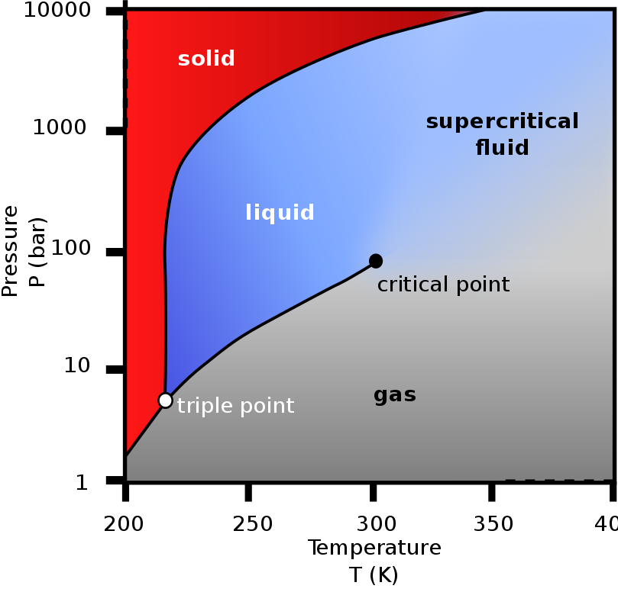
FIGURE 1: Phase diagram of carbon dioxide (Wikipedia)
SOURCES AND USES OF CARBON DIOXIDE
Carbon dioxide occurs naturally in our atmosphere in trace amounts, about 412 ppm by volume, compared to pre-industrial levels of 280 ppm. CO2 is one of several green house gases (GHGs) that are implicated in global warming and climate change. Reducing CO2 emissions and CO2 capture and storage (CCS) to mitigate these issues are goals of industry and government.
Natural sources of CO2 include volcanoes, forest fires, hot springs, geysers, dissolution of carbonate rocks, and decay of organic matter, including landfills and backyard compost. It is soluble in water and occurs naturally in groundwater and all surface water bodies.
Human sources include combustion of wood, peat and other organic fuels, fossil fuels, and unwanted by-product of many industrial processes, such as manufacture of cement, steel, and plastics. Agriculture and food processing is a large CO2 emitter, mostly unrecognized because it is so dispersed across the planet.
Major uses of carbon dioxide are as a feedstock for synthetic fuels and other chemicals. It is used in welding, fire extinguishers, pressurizing agents, enhanced oil recovery (EOR), and as a solvent. It is the key ingredient in carbonated drinks. The solid form (dry ice) is used as a refrigerant and as an abrasive in a much less messy form of sand-blasting.
Carbon dioxide is essential for all plant life, which generates the oxygen essential for human existence. However, too much of a good thing is turning into a bad thing, so we must learn to reduce emissions and to store what we can’t reduce in a safe place, instead of into the atmosphere.
CARBON STORAGE IN GEOLOGICAL FORMATIONS
Geological sequestration refers to the storage of CO2 underground in depleted oil and gas reservoirs, saline-water bearing formations, or deep, un-minable coal beds. The storage capacity of these reservoirs worldwide is enormous, estimated as large as 20,000 Giga tonnes of CO2.
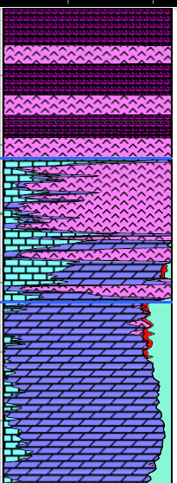
As CO2 is captured from an industrial source, such as a cement plant, steel mill, or oil refinery, it is compressed to about 10 MPa so that it becomes a supercritical fluid. In this form, the CO2 is easy to transport via pipeline to the storage location. The CO2 is then injected into an underground porous reservoir, where it will remain as a stable supercritical fluid.
At these storage conditions, the density of supercritical CO2 is 600 to 800 kg/m3, lighter than water, so it will rise to the top of the reservoir and be trapped by the caprock above the reservoir. As more CO2 is injected, it will spread laterally until the reservoir has been filled to its capacity.
A good reservoir for carbon dioxide storage is one with medium to high porosity and permeability, with no faults or fractures, and a well defined structural or stratigraphic trap. The seal or caprock is usually a thick shale, an evaporite such as halite or anhydrite, or a subsurface lava flow like basalt.
FIGURE 2: Porosity-lithology depth plot showing evaporite caprock and porous carbonate suitable for a CO2 storage reservoir
If there are faults or fractures, there is a strong possibility that the CO2 could migrate to other reservoirs, causing economic loss to others, or a leak to the surface, which could be dangerous to life in the surrounding area.
The dominant monitoring technique to date is time-lapse 3-D seismic imaging to locate the CO2 plume in the reservoir. Well logs run periodically in monitoring wells are also widely used.
PETROPHYSICS FOR CARBON STORAGE PROJECTS
Petrophysics has a large role to play in the green economy. Hundreds of thousands of legacy wells have been drilled in the past, in search of fossil fuels. These wells penetrate reservoirs which may find new life by defining potential storage for carbon capture and storage (CCS). The competent petrophysicist can analyze these old wells with key suitability criteria in mind, to validate mechanical earth models (MEM), which tend to be more heavily weighted towards seismic inputs. Seismic can give a good overview of the reservoir, but only petrophysics can fill in the details that can determine success or failure of the project.
Identifying a container for CO2 is the most important step in the process; a suitable site ensures the injected CO2 will stay where it is supposed to be for the foreseeable future.
The key criteria for which petrophysical analysis can provide ground truth for the reservoir model are: shale characterization, porosity, permeability, mobility and saturations. Including legacy wells means better definition of the areal extent of the potential container. Once the container has been selected and the most porous and permeable zones selected for injection well locations, the petrophysicist will run logs to evaluate the well for fractures and casing / cement integrity. In the final phase, the petrophysicist will evaluate the monitor wells to assess how well the CO2 has entered the pore space.
Due to the risk to life from a CO2 leak to surface, there is no room for amateurs or novices in this work. Expert petrophysical advice should be sought and be acted upon at every stage in the project development and operation.
Here are the stages in the development of a carbon storage reservoir that require competent petrophysical analysis, coupled with other geoscience and reservoir engineering work.
PHASE 1: Find a Suitable Storage Reservoir
Criteria: thick competent caprock, no faults or fractures, no barriers to vertical flow (shale or anhydrite interbeds), thick porous and permeable reservoir (saline water bearing or depleted oil or gas zone), structural or stratigraphic trap (area, volume, spill point), economics, proximity to CO2 source.
Action Items: prepare complete reservoir study, integrating geological, geophysical, and petrophysical analysis (with mechanical properties calculations) on all available wells (including entire caprock sequence), prepare structural maps and cross sections, pore volume calculations, depth-pressure-temperature profiles.
PHASE 2: Locate and Evaluate Injection Well(s)
Action Items: select injection well location(s) based on reservoir model, drill through best porosity to optimize CO2 injection rate, run and analyze full log suite, run resistivity image log to find unexpected fractures, run ultra- sonic cement integrity log to find leaks or channels, repair as needed. Run Pulsar (induced gamma ray spectroscopy with fast neutron cross section) for comparison to same log in monitor wells.
PHASE 3: Run Baseline Well Logs In Monitor Wells
Action Items: In open hole run resistivity image log to find unexpected fractures. In cased hole, run ultra- sonic cement integrity log to find leaks, repair as needed. Before CO2 injection begins, run baseline logs over storage reservoir, entire caprock, and 1000 meters above caprock.
Option 1: Pulsar log, generically known as the advanced pulsed neutron log, which includes gamma ray (GR), neutron porosity (TPHI), capture cross section (SIGMA), and fast neutron cross section (FNXS). Best for quantitative CO2 analysis. Also capable of elemental capture and inelastic spectroscopy for matrix rock and fluid identification.
Option 2: Standard pulsed neutron (TDT) log which includes gamma ray, neutron porosity, capture cross section.
Option 3: Gamma ray, shear and compressional sonic, neutron porosity, cased hole density**, cased hole resistivity** (** = optional but desirable)
PHASE 4: Run Time Lapse Logs to Monitor CO2 Plume Development
Action Items: run same logs as Stage 3, use visual analysis rules in text below to determine if CO2 has reached this monitor well. Run monitor logs over same interval as baseline logs. Look for evidence of leaks through and above caprock.
VISUAL LOG ANALYSIS RULES FOR CO2
If CO2 is present at a monitor well, then the time-lapse log data in the CO2 plume will be different than the baseline log, in which no CO2 was present.
These rules are based on the log response to CO2 compared to water-filled porosity, highlighted in Table 1.
For Pulsar log:
gamma ray (GR) will be unchanged from baseline values
neutron porosity from Pulsar (TPHI) will be much lower or negative
capture cross section (SIGMA) will be much lower
fast neutron cross section (FNXS) will be lower
See Figure 3 to estimate approximate CO2 saturation using TPHI and FNXS. FNXS is a measurement independent of hydrogen index which primarily responds to the atomic density of the formation; it provided an additional method for CO2 detection and quantification, and it enables solving for more complex scenarios when integrated to other rock properties, such as neutron porosity.
For pulsed neutron (TDT) logs:
gamma ray (GR) will be unchanged from baseline values
neutron porosity from TDT (TPHI) will be much lower or negative
capture cross section (SIGMA) will be much lower
The following rules are for conventional logs run through casing:
gamma ray (GR) will be unchanged from baseline values
shear sonic (DTS) will be unchanged
compressional sonic (DTC) will be higher
resistivity (RESD) will be higher
density (DENS) will be lower (density porosity (PHID) will be higher)
neutron porosity (PHIN) will be much lower or negative

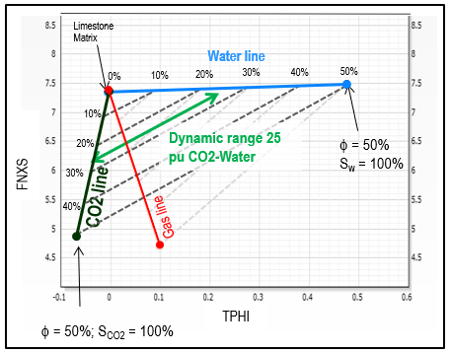
FIGURE 3: TPHI vs FNXS crossplot for estimating carbon dioxide saturation Sco2
QUANTITATIVE METHODS FOR CO2 LOG ANALYSIS
Quantitative analysis of carbon dioxide saturation (Sco2) is possible using capture cross section (SIGMA), neutron porosity (TPHI), or fast neutron cross section (FNXS) using the classic log response equation by substituting CO2 parameters for the hydrocarbon terms. CO2 has zero hydrogen index so TPHI reads total porosity only if the zone is 100% wet. For a zone filled with super-critical CO2, TPHI will read near zero porosity. SIGMA and FNXS also have very different properties for CO2 compared to those for water, so all three terms can be used as CO2 saturation indicators. See Table 1.
Here is the log response equation for the SIGMA measurement with only CO2 and water in the porosity:
1: SIGMA = PHIe * Sw * SIGw (water term)
+ PHIe * (1 - Sw) * SIGco2 (carbon dioxide term)
+ Vsh * SIGsh (shale term)
+ (1 - Vsh - PHIe) * Sum (Vi * SIGi) (matrix term)
Where:
SIGco2 = log reading in 100% carbon dioxide
SIGi = log reading in 100% of the ith component of matrix rock
SIGMA = log reading
SIGsh = log reading in 100% shale
SIGw = log reading in 100% water
PHIe = effective porosity (fractional)
Sco2 = carbon dioxide saturation in reservoir (fractional)
Sw = water saturation in reservoir (fractional)
Vi = volume of ith component of matrix rock
Vsh = volume of shale (fractional)
WS(ppm) = water salinity NaCl equivalent (parts per million)
This equation is solved for Sw by assuming all other variables are known or previously calculated:
2: SIGw = 22.0 + 0.000404 * WS(ppm)
3: SIGm = Sum (Vi * SIGi)
4: PHIe = TPHI from baseline log before CO2 injection OR from open hole logs
5: SWtdt = ((SIGMA - SIGm) - PHIe * (SIGco2 – SIGm) - Vsh * (SIGsh - SIGm))
/ (PHIe * (SIGw - SIGco2))
6: Sco2 = 1 - SWtdt
Similarly for FNXS:
7: FNXSm = Sum (Vi * FNXSi)
8: SWfnxs = ((FNXS-FNXSm)-PHIe*(FNXSco2-FNXSm)-Vsh*(FNXSsh-FNXSm))
/ (PHIe * (FNXSw - FNXSco2))
9: Sco2 = 1 - SWfnxs
And for TPHI:
10: TPHIm = Sum (Vi * TPHIi)
11: SWtphi = ((TPHI-TPHIm)-PHIe*(TPHIco2-TPHIm)-Vsh*(TPHIsh-TPHIm))
/ (PHIe * (TPHIw - TPHIco2))
12: Sco2 = 1 – SWtphi
The FNXS model has the best resolution for CO2 monitoring. FNXS values for helium and nitrogen are reported to be similar to CO2 so the Pulsar log can be used to evaluate helium wells through casing. Other uses include monitoring natural gas and hydrogen storage reservoirs.

CO2 LOG ANALYSIS EXAMPLE
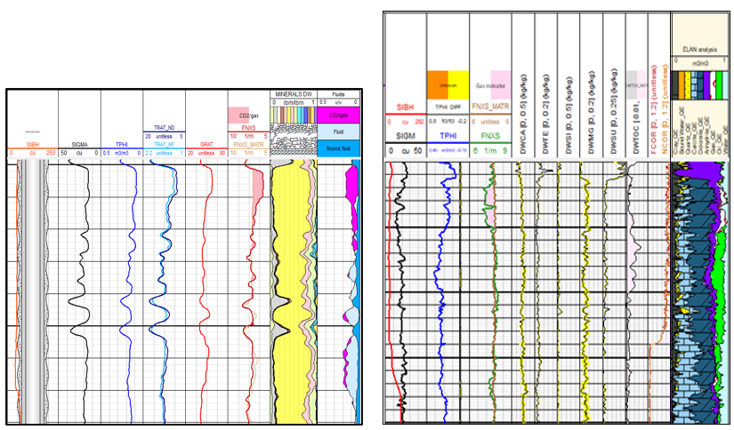FIGURE 4: Examples of CO2 detection and quantification at current reservoir condition. Different gas indicators are presented, including Sigma, Neutron count rates and porosity, Fast Neutron Cross Section, and its deviation from Fast Neutron Cross Section of matrix components in presence of gas. SIGMA, TPHI, FNXS end points calculated based on gas density and composition. Lithology and porosity are measured based on induced gamma ray spectroscopy combined to TPHI and FNXS, eliminating the need for open hole logs.

TABLE 1: NUCLEAR PROPERTIES FOR PULSAR LOGS
Material | Sigma  (c.u.) | TPHI | FNXS (1/m)
Quartz | 4.55 | –0.03 | 6.84
Calcite | 7.08 | 0.00 | 7.51
Dolomite | 4.70 | 0.03 | 8.51
Orthoclase | 15.82 | –0.05 | 6.33
Albite | 7.65 | –0.04 | 6.69
Anhydrite | 12.45 | –0.03 | 7.14
Pyrite | 90.53 | 0.01 | 6.60
Bituminous Coal | 15.79 | 0.68 | 7.72
Dry Illite | 20.79a | 0.22 | 8.06
Wet Illite | 21.00 a | 0.34 | 8.02
Dry Smectite | 14.36 a | 0.29 | 8.36
Wet Smectite | 19.23 a | 0.68 | 8.60
Kerogen (CH 1.3g/cc) | 20.18 | 0.98 | 9.07
CH4 (0.05 g/cc) | 2.50 | –0.05 | 0.67
CH4 (0.15 g/cc) | 7.50 | 0.21 | 2.01
CH4 (0.25 g/cc) | 12.50 | 0.47 | 3.36
Oil (C3H8 0.5g/cc) | 18.21 | 0.78 | 5.44
Oil (C3H8 0.6g/cc) | 21.85 | 0.97 | 6.53
Diesel (CH1.8 0.89 g/cc) | 23.30 | 1.08 | 7.98
CO2 (0.6 g/cc) | 0.03 | –0.12 | 2.24
Water 0 ppm | 22.2 | 1.00 | 7.800
Water 200,000 ppm | 97.2 | 0.90 | 7.36
ACKNOWLEDGEMENTS
Thanks to Chiara Cavalleri of Schlumberger for contributing content for this article, including Figures 3 and 4, and Table 1. Thanks also to Sandra Bleue for acting as research assistant on the Pulsar log and the fast neutron cross section (FNXS) measurement.

REFERENCES
- Fast Neutron Cross-Section Measurement Physics and Applications
Tong Zhou, David Rose, et al
SPWLA 57th Annual Symposium, 25 – 29 June 2016
- CO2 Data, Phases, Sources, Uses
Various Wikipedia pages

