PETROPHYSICS IN THE GREEN ECONOMY
PART 8 – NON-METALLIC MINERALS: PRODUCTS WE STILL NEED
E.R. Crain, P.Eng.
Published in CSPG Reservoir Sep – Oct 2023

INTRODUCTION
This article covers petrophysical analysis of economically significant non-metallic sedimentary minerals such as halite, gypsum, trona, and sulphur. These minerals may be exploited for their commercial value. They may be encountered while drilling for oil and gas, possibly causing some confusion as to the true effective porosity. A characteristic of these minerals is their low density, very high resistivity, and very low gamma ray response. These can be mistaken for porous hydrocarbon zones. Some have near zero neutron porosity response, but others have water of hydration with a corresponding specific neutron response.
Potash minerals (sylvite, carnallite, langbeinite, polyhalite, kainite) and coal analysis are covered in previous articles by the author.
Halite, gypsum, and trona occur as relatively pure bedded minerals, thick enough to be resolved by well logs. These can be identified by their specific mineral properties using lithology triggers. Alternatively, the mineral properties can be used in 2- or 3-mineral models, simultaneous equations, or multi-mineral probabilistic models.
In sulphur bearing rocks, lithology triggers will not work, and the more sophisticated methods must be used. Crossplots, shown below, may also be helpful in confirming or eliminating possibilities.
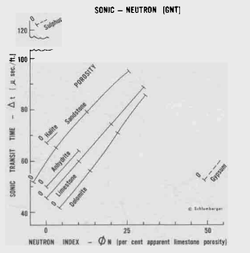 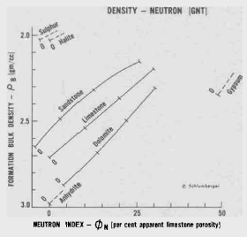
FIGURES 1 and 2: Sonic-Neutron (left) and Density-Neutron (right) crossplot charts for determination of lithology and porosity
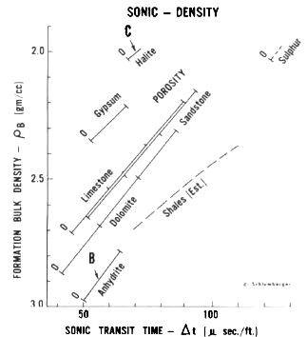
FIGURE 3: Sonic-Density crossplot chart for determination of lithology and porosity.
HALITE – ANHYDRITE MODEL
Halite or Rock Salt (NaCl) occurs in vast beds of sedimentary evaporite minerals that result from the drying up of enclosed lakes and oceans. Salt beds may be hundreds of meters thick and underlie broad areas. In the United States and Canada, extensive underground beds extend from the Appalachian basin of western New York through parts of Ontario and under much of the Michigan Basin. Other deposits are in Ohio, Kansas, New Mexico, Nova Scotia, Alberta, and Saskatchewan. Much of Europe into North Africa and western Asia are underlain by salt beds. In most cases, other evaporites, such as anhydrite (CaSO4) and potash minerals, may be mixed or interbedded with the salt.
Salt domes are masses of salt that have been squeezed up from underlying salt beds by the weight of overlying rock, coming closer to or breaching the surface. Some domes are gypsum, not halite, but are still called "salt domes" because gypsum is technically a salt, although it is not very soluble and tastes terrible. Salt domes may contain anhydrite, gypsum, and native sulphur, in addition to halite. They are common along the Gulf coasts of Texas and Louisiana and are often associated with petroleum deposits. Germany, Spain, the Netherlands, Romania and Iran also have salt domes. Salt glaciers exist in arid Iran where the salt has broken through the surface at high elevation and flows downhill.
When exposed to water, anhydrite readily transforms to gypsum, (CaSO4·2H2O) by the absorption of water. This transformation is reversible, with gypsum forming anhydrite by heating to around 200 °C (400 °F) under normal atmospheric conditions.
Halite is used to preserve and flavour food and is essential for life. Industrial products are caustic soda and chlorine. Salt is used in many industrial processes including the manufacture of polyvinyl chloride, plastics, paper pulp, and many other products. Of the annual global production of around 200 million tonnes, about 6% is used for human consumption.
Salt can be derived from subsurface mining, solution mining, and evaporation of seawater. Some mines produce a million tons a year or more. Abandoned solution mines can be used for storage of natural gas as they are virtually leak proof. Specialized radial acoustic surveys are used to map the 3-D geometry of the cavern to assess its volume and potential risks.
HALITE – ANHYDRITE EXAMPLE
Visual Analysis Rules:
Halite: gamma ray = near zero, resistivity = very high, density = 2030 (2.03 g/cc),
PE = 4.7, DTC = 200 (67 us/ft), neutron = near 0.0
Anhydrite: gamma ray = near zero, resistivity = very high, density = 2970 (2.97 g/cc),
PE = 5.0, DTC = 164 (50 us/ft), neutron = near 0.0
These pure mineral values will vary by a small amount due to occluded water and other mineral inclusions.
The following example illustrates the two common methods for analyzing salt beds:
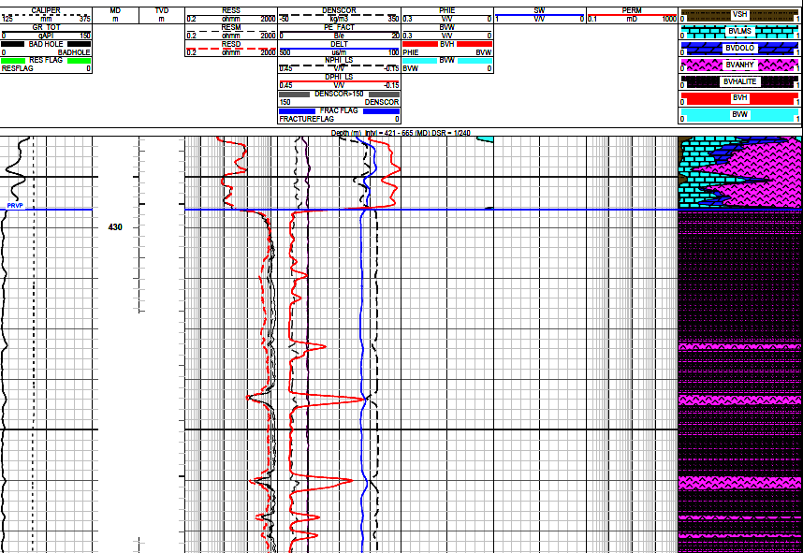
FIGURE 4: This example shows a very short portion of a log analysis of a salt with interbedded anhydrite. The top 20 meters uses a calcite-dolomite-anhydrite model with a PE-density-neutron 3-mineral model. A halite-anhydrite 2-mineral model could have been used in the salt in the lower portion of the image. However, results were determined using lithology triggers instead, giving sharper definition to the bed boundaries. Porosity in the salt is assumed to be zero so no hydrocarbons are present. Note the low gamma ray, high resistivity, and near zero neutron porosity. Density is near 3.0 g/cc in anhydrite and near 2.0 g/cc in salt.
GYPSUM MODEL
Gypsum (CaSO4·2H2O) is deposited from lake and sea water, as well as in hot springs, from volcanic vapors, and sulphate solutions in veins. It is often interbedded with the minerals halite, anhydrite, and sulphur-bearing limestone. When exposed to water, anhydrite readily transforms to gypsum by the absorption of water. When gypsum is heated in air it loses water and converts first to calcium sulphate hemihydrate, (bassanite), often simply called "plaster" and, if heated further, to anhydrous calcium sulphate (anhydrite).
It is used as a fertilizer, and as the main constituent in many forms of plaster, blackboard chalk, and wallboard. It is the hydrated form of anhydrite. A fine-grained version of gypsum is known as alabaster, used in sculpture.
Gypsum is moderately water-soluble (2.0–2.5 g/l at 25 °C compared to 360 g/l for halite) and, in contrast to most other salts, it exhibits retrograde solubility, becoming less soluble at higher temperatures.
A good example of an exposed gypsum deposit is White Sands, New Mexico. A breached gypsum dome on Melville Island (Barrow Dome) in the Canadian High Arctic was the subject of a native sulphur exploration program in 1969. The sulphur was limited to erosion remnants on the surface. The author was project manager, and a minor oil discovery was made at shallow depths on the south side of the dome.
Gypsum is produced from open pit mines throughout Europe, South Asia, Indonesia, Brazil, Canada, and USA. Some is produced as a by-product of smokestack scrubbers at coal fired power plants.

GYPSUM EXAMPLE
Visual Analysis rules:
Halite: gamma ray = near zero, resistivity = very high, density = 2030 (2.03 g/cc),
PE = 4.7, DTC = 200 (67 us/ft), neutron = near 0.0
Anhydrite: gamma ray = near zero, resistivity = very high, density = 2970 (2.97 g/cc),
PE = 5.0, DTC = 164 (50 us/ft), neutron = near 0.0
Gypsum: gamma ray = near zero, resistivity = very high, density = 2235 (2.35 g/cc),
PE = 4.0, DTC = 173 (52 us/ft), neutron = 0.49
These pure mineral values will vary by a small amount due to occluded water and other mineral inclusions.
Log analysis parameters for gypsum are somewhat similar to coal but PE of coal is less than 1.0 and gypsum is near 4.0.

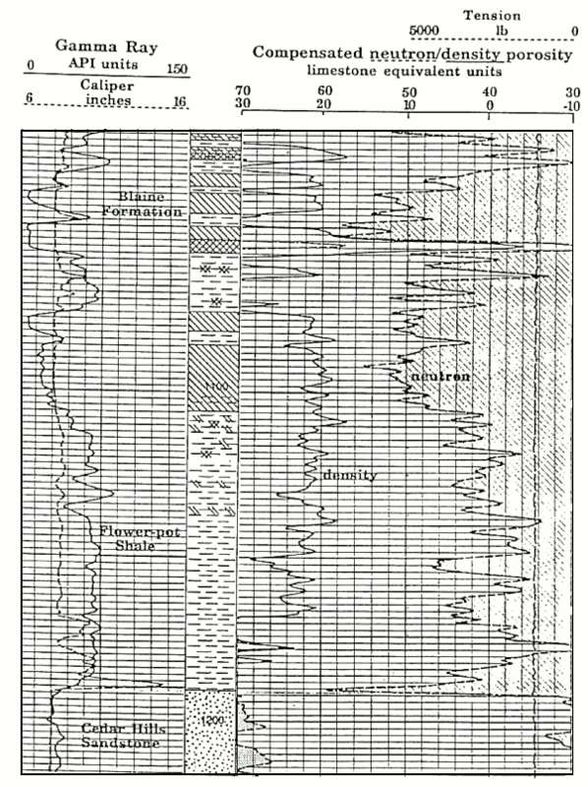
FIGURE 5: Gypsum example from western Kansas (image courtesy KGS). Porosity scale is -10 to 30 percent with backup from 40 to 70 percent. Gypsum is recognized by its low gamma-ray value, very high neutron porosity exceeding 60% (due to the hydrogen contained in its water of crystallization) and density of 2.35 g/cc. The gypsum beds of the Blaine Formation are obvious on the example log section, and can be distinguished immediately from anhydrite, which has a neutron porosity of near zero and a heavy density of 2.98. An anhydrite bed is located at a depth of 1055 feet.

TRONA MODEL
Trona (Na2CO3•NaHCO3•2H2O) is an evaporite mineral formed in seasonal lakes, now buried under more recent sediments, some as deep as 1500 meters. Trona is found at Owens Lake and Searles Lake in California, the Green River Formation of Wyoming and Utah, the Makgadikgadi Pans in Botswana, and in the Nile Valley in Egypt. Kenya, Turkey, and China are also home to significant trona resources. Most trona is recovered by subsurface mining, but small amounts are produced from brine wells, and by solution mining.
A related carbonate mineral, nahcolite, has the composition of sodium bicarbonate (NaHCO3). It is mined in conjunction with or separately from Trona in some areas.
Trona is the primary source of sodium carbonate (Na2CO3) in the United States and to a lesser extent elsewhere. Sodium carbonate is also known as "soda ash" and is rare in nature. It has many domestic and industrial uses, such as manufacturing glass, chemicals, paper, detergents, and textiles. It is also used to condition water, remove sulphur from flue gases, lignite coals, natural gas, and liquid hydrocarbons, and as a food additive.
When trona is heated to 500'C, both water and CO2 are driven off. This is followed by recrystallization from aqueous solution leaving sodium carbonate suitable for delivery to industrial customers. The USA has a vast reserve of trona, so it uses the heating of trona to produce about 25% of the world's supply. The alternate method of production is known as the Solvay process. It produces sodium carbonate in large quantities from halite (sodium chloride) and limestone (calcium carbonate). China produces nearly 50% of the world's supply, using both methods.
Many trona deposits are composed of multiple thin beds interspersed with marl or clay. Logs may have difficulty resolving beds less than 1 to 2 meters thick.
TRONA EXAMPLE
Visual Analysis rules:
Marl / Clay: gamma ray = 50 -100, resistivity = low, density = 2300+/- (2.30 g/cc),
PE = 3.5, DTC = 328 (100 us/ft), neutron = 0.30 - 0.40
Trona: gamma ray = near zero, resistivity = high, density = 2080 (2.08 g/cc),
PE = 0.7, DTC = 213 (65 us/ft), neutron = 0.35
These pure mineral values will vary by a small amount due to occluded water and other mineral inclusions.
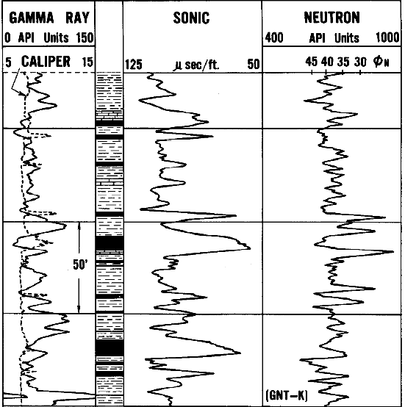
FIGURE 6: An ancient log from the Green River formation, Wyoming, contains beds of trona. The properties of this mineral are sufficiently different from the surrounding marl formation that logs clearly locate the trona beds. The beds of trona are indicated by black shading. Marl is indicated by high GR and high sonic travel time, trona by low GR and lower sonic. Neutron for both is near 0.35 to 0.40, helping to eliminate other possible minerals in the clean intervals. Modern density neutron and high-resolution resistivity logs would materially improve the visual interpretation.
SULPHUR MODEL
The element Sulphur is a non-metallic element, and, like halite, it is essential for life. In its native form, sulphur is a yellow crystalline solid. In sedimentary rocks, it is synthesized by anaerobic bacteria acting on sulphate minerals such as gypsum in salt domes. Significant deposits in salt domes occur along the Gulf of Mexico, and in evaporites in eastern Europe and western Asia. Salt domes are associated with traps for oil accumulation, so in drilling for oil considerable sulphur was discovered in the same wells.
In salt domes, the sulphur is usually a physical mixture with limestone, forming up to 50+% of the bulk volume of the rock. Some water filled porosity may be present. More complex mineral mixtures may also complicate the scene.
Elemental sulphur can also be found near hot springs and volcanic regions in many parts of the world, especially along the Pacific Ring of Fire; such volcanic deposits are currently mined in Indonesia, Chile, and Japan.
Salt dome sulphur was mined by the Frasch process, in which superheated water was pumped into a native sulphur deposit to melt the sulphur, and then compressed air returned the 99.5% pure melted product to the surface. The melting point of sulphur is 115'C so considerable energy was expended in heating the sulphur zone. Throughout the 20th century this procedure produced elemental sulphur that required no further purification. Due to a limited number of such sulphur deposits and the high cost of working them, this process for mining sulphur has not been employed in a major way anywhere in the world since 2002.
Today, sulphur is produced mostly from petroleum, natural gas, and related fossil resources, from which it is obtained mainly as hydrogen sulphide (H2S). Known as an organosulphur compound, it can be upgraded to produce near pure sulphur, resulting in the large yellow blocks of sulphur seen beside gas processing plants. The sulphur is shipped from here by truck or train to the many industrial firms that use it.
If the use of fossil fuels is reduced over the next several decades, as government mandates insist, sulphur from this source will also decrease – we may end up using the Frash process again or maybe there is a cheap way to pull sulphur out of gypsum (CaSO4.2H2O).
Elemental sulphur is used mainly as a precursor to other chemicals. Approximately 85% is converted to sulphuric acid (H2SO4). The principal use for the acid is the extraction of phosphate ores for the production of fertilizer. Other applications include oil refining, wastewater processing, and mineral extraction. Sulphur itself is used in the manufacture of cellophane, rayon, medicines, and insecticides, Sulphates are used as a bleach for paper, as a component of Portland cement, and as fertilizer.
Petrophysical analysis of logs for sulphur exploitation is no longer common, but we still need to be able to recognize it. Sulphur looks a lot like porosity on sonic and density logs, and with the high resistivity, it can be mistaken for a hydrocarbon zone based on standard visual analysis rules. There are some rules below that might help avoid this problem.
Quantitative methods reduce the risk of misinterpretation. Three-mineral simultaneous equation model with calcite, sulphur, and water will work, using sonic, density, and neutron data. If another mineral is present, such as anhydrite or gypsum, lithology triggers or a fourth equation using the PE curve can be added.
By using the characteristic mineral and water properties in the response equations for the limestone-sulphur case, we get:
1: Vsulphur = (PHID - PHIN) / 0.40
OR 2: Vsulphur = (PHIS - PHIN) / 0.53
Where:
PHID = density porosity on a limestone scale (fractional)
PHIN = neutron porosity on a limestone scale (fractional)
PHIS = sonic porosity on a limestone scale (fractional)

SULPHUR EXAMPLE
The above equations lead to some simple visual rules for a calcite-sulphur mixture:
1. PHIN = actual water filled porosity
2. PHID = PHIN = Limestone, with no sulphur, with water or oil depending on resistivity
3. PHID > PHIN = limestone, with sulphur
4. PHID << PHIN = anhydrite, no porosity, no sulphur
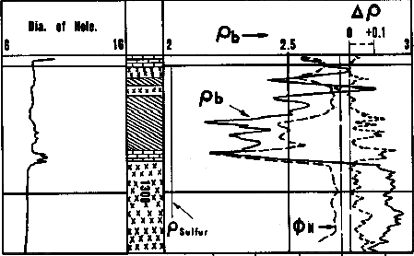
FIGURE 7: Ancient density neutron overlay in sulphur bearing rock. Diagonal crosshatch sulphur zone, bricks = limestone, xxxx’s = anhydrite.
REFERENCES
1. Defining Evaporite Deposits with Electrical Well Logs
R. P. Alger and E. R. Crain,
Trans Northern Ohio Geological Society - Second Symposium on Salt, Cleveland, 966
2. Log Evaluation of Non-Metallic Minerals
M.P. Tixier and R.P. Alger, SWSC, 1967, Geophysics Vol 35 #1, 1970
A PERSONAL NOTE
M.P. Tixier and R.P. Alger were the senior log interpretation wizards in Schlumberger during the 1950s and 1960s. They taught the SWSC in-house log interpretation school in Houston. I attended in October 1963 and was amazed by their skill and knowledge. Some of it stuck; as I write this, I celebrate my 60th anniversary working with and writing about the many and varied uses for well logs. This series on Petrophysics in the Green Economy is dedicated to their memory as we continue to find even more new uses.

